“Tasks that used to take 10 days reduced to 1–2 days” GIST hosts ‘2026 Administration AX Innovation Competition’ and showcases AI administrative innovation models developed by members
- Discovering AI utilization achievements in business efficiency and data-driven operations… 8 outstanding cases selected and awarded
- Financial closing shortened from 10 days to 1–2 days, evaluation reports from several months to a few days… Service improvements such as a 24-hour academic chatbot
- Reviewing the application of verified best practices to actual administrative tasks… Winning teams provided with the opportunity to attend ‘CES 2027’
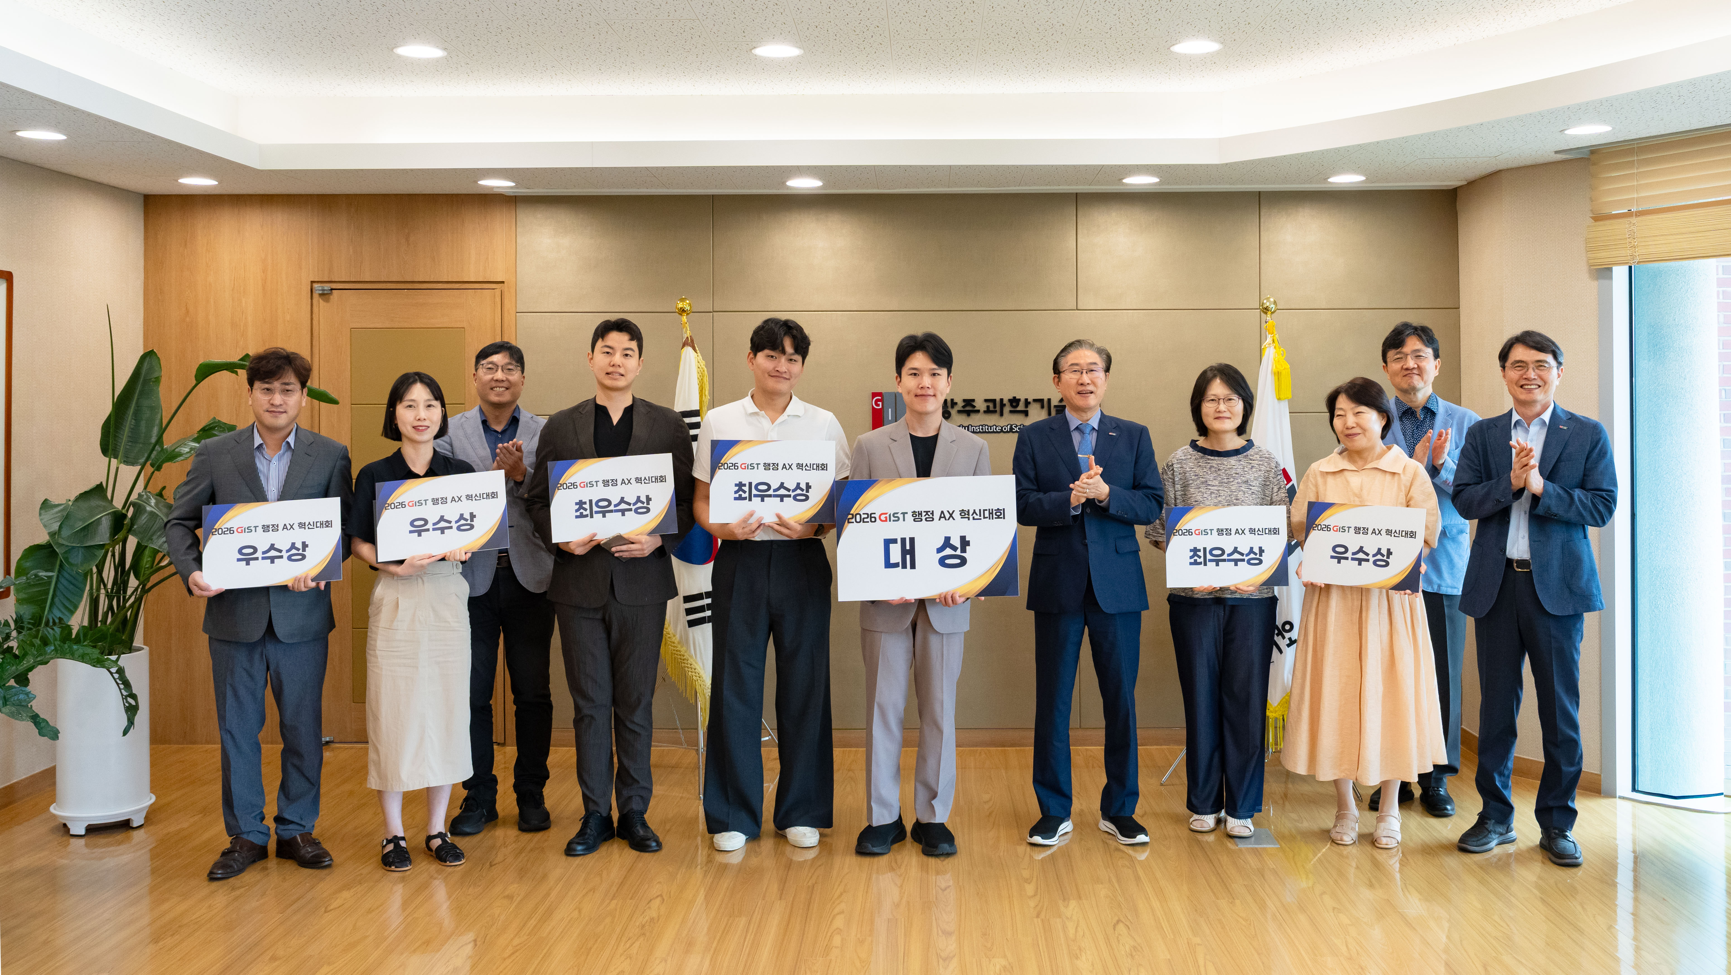

▲ President Kichul Lim (fifth from the right) and the award winners pose for a commemorative photo at the awards ceremony for the ‘2026 GIST Administrative AX Innovation Competition,’ held at the GIST Administration Building on Tuesday, August 11.
The Gwangju Institute of Science and Technology (GIST, President Kichul Lim) announced that it held the awards ceremony for the ‘2026 GIST Administrative AX Innovation Competition’ on Tuesday, August 11, at the GIST Administration Building. The ceremony recognized eight teams for outstanding cases that generated tangible results, such as work efficiency and service improvement, by integrating artificial intelligence (AI) into administrative tasks.
This competition is significant in that, rather than relying on the development of separate external systems, administrative staff members directly discovered ways to utilize AI in their respective workplaces and applied them to actual tasks to achieve results.
* AX (AI Transformation): Refers to fundamentally innovating an organization's way of working by incorporating artificial intelligence.
GIST held this competition to keep pace with the trend of AI transformation (AX) rapidly spreading throughout society, to create an intelligent work environment by utilizing AI in all administrative tasks, and to establish a ‘GIST-type AX administrative innovation model.’
The competition was conducted in a two-stage format linking ‘Track 1,’ which involves establishing AI utilization strategies, and ‘Track 2,’ which involves applying selected strategies to actual work to verify performance; it ran from March to July.
A total of eight teams participated in the Track 2 presentation evaluation held on Wednesday, July 15. These included six teams in the ‘Work Efficiency Field,’ which aimed to improve work procedures such as automating repetitive tasks, document creation, and regulation review, and two teams in the ‘Data-Driven Operations Field,’ which focused on enhancing data utilization through demand forecasting and risk factor detection.
The evaluation panel selected the Grand Prize, Top Excellence Award, and Excellence Award winners by comprehensively assessing actual work performance, innovation, reproducibility, and potential for dissemination within the organization.
At the awards ceremony held on the same day, the ‘AI Evaluation Report Automatic Generation System’ won the Grand Prize. The Grand Prize was awarded to three projects: ‘Administrative Innovation Delegating to AI Colleagues (Agents)’, ‘User-Centric, Proactive Bulletin Board G-Cruiser’, and ‘Introduction of AI Chatbots for Academic Administration’.
Four projects were selected for the Excellence Award: ‘Generative AI-Based Bilingual Administrative Guidance Process’, ‘Zero Omission of Overseas Business Trip Documents AI Assistant Pre-Verification System’, ‘AI Overtime Verification System’, and ‘HR Insight Dashboard: Cursor Collaborative Reconstruction of HR Space-Time’.
This competition also confirmed the potential for AI to shorten work hours and improve working methods in actual administrative settings.
Examples presented included reducing the time required for monthly financial settlement tasks from approximately 10 days to just 1-2 days, and shortening the drafting period for evaluation reports—which previously took several months—to just a few days. The task of drafting administrative notices in both Korean and English, which previously took tens of minutes per case, can now be completed within minutes.
In addition, examples of administrative service improvements that members can directly experience were showcased, such as consolidating scattered campus announcements into a single email every morning and building an AI chatbot that responds to academic inquiries 24 hours a day, with current students participating in the development process.
Chung-wan Seo, a senior administrative officer in the Finance Team and a participant in the Grand Prize winning team, stated, "I confirmed that even non-majors can make new attempts using AI if they have ideas for their work and the will to improve."
Young-hyun Joo, an administrative officer at the College of Engineering and a participant in the winning team, explained, “Automation is not about replacing people, but rather a tool to preserve and disseminate know-how accumulated during work processes.” He added, “The core idea is to implement individual experience and know-how in a repeatable form so that consistent work quality can be maintained even if the person in charge changes.”
To ensure that the outstanding cases discovered through this competition do not remain one-off achievements, GIST plans to hold a performance sharing session in the second half of this year to share best practices with its members and to expand verified cases throughout the organization.
In particular, the plan is to gradually introduce verified best practices into actual administrative tasks after further reviewing their security and stability.
President Kichul Lim stated, “The key to the transition to AI lies not in the technology itself, but in members working in new ways and creating change.” He added, “I hope this competition serves as an opportunity for creative ideas and challenges to lead to innovation in daily work.”
Meanwhile, the winning teams will be awarded prize money of 700,000 won for the Grand Prize, 500,000 won each for the Top Excellence Prize, and 200,000 won each for the Excellence Prize. The Grand Prize team will also be provided with the opportunity to attend ‘CES (Consumer Electronics Show) 2027,’ the world’s largest IT and consumer electronics exhibition held in Las Vegas, USA.

