“Finding Answers Through Convergence Together, Rather Than Alone” GIST AI-ACE InnoCORE Research Group holds ‘2026 Performance Sharing and Capacity Building Workshop’
- Review of research achievements since launch and strengthening of the Co-Lab cooperation system
- Strengthening research competitiveness through intellectual property acquisition strategies and AI practical training for protein structure analysis
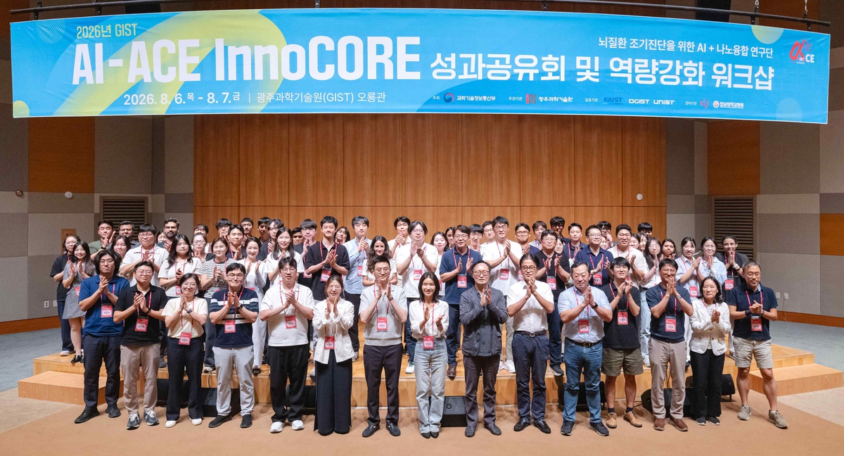

▲ Participants of the ‘2026 Performance Sharing and Capacity Building Workshop,’ held on Thursday, August 6 and Friday, August 7, are posing for a commemorative photo.
The Gwangju Institute of Science and Technology (GIST, President Kichul Lim) announced that the AI+Nano-Convergence InnoCORE (AI-ACE InnoCORE) Research Group for the Early Diagnosis of Brain Diseases (Director Eunji Lee) held the ‘2026 Performance Sharing and Capacity Building Workshop’ at GIST’s Oryong Hall for two days, from Thursday, August 6 to Friday, August 7.
Following the first workshop held last March, this event was attended by approximately 90 people, including 35 mentor professors from the four leading science and technology institutes and participating organizations, 50 postdoctoral researchers (InnoCORE Fellows), and external speakers. The participants reviewed research achievements over the past year, strengthened the collaborative research (Co-Lab) system based on multi-mentoring, and operated educational programs to enhance research capabilities.
The AI-ACE InnoCORE Research Group, launched in September 2025 with support from the Ministry of Science and ICT, is led by Professor Eunji Lee of the Department of Materials Science and Engineering. The group is developing next-generation precision medicine technologies that fuse artificial intelligence (AI) with nanotechnology and is fostering research personnel in AI + S&T convergence.
With the goal of early diagnosis of degenerative brain diseases, the research group is developing core technologies that combine ‘nanomaterials’ that detect changes in protein structure in ▴ Sub-division A (Artificial Peptide), ▴ ‘nano-optical devices’ that detect protein signals in Sub-division C (Collective Intelligence), and ‘▴ AI algorithms’ that analyze and predict changes in protein structure in Sub-division E (Emerging Devices).
At the performance sharing session held on Thursday, August 6, the session began with a report on the research group's operational achievements by Director Eunji Lee. Sub-field leaders—Professor Jae Young Lee of the Department of Materials Science and Engineering (Sub-field A), Professor Hyunju Lee of the Department of AI Convergence (Sub-field C), and Professor Hyeon-Ho Jeong of the Department of Electrical Engineering and Computer Science (Sub-field E)—presented their respective research achievements and current status.
Fellows Sung-il Lim and Da-young Lee, who were selected as winners of the Outstanding Poster Award at the workshop last March, presented the development process of their award-winning research and the results of their follow-up studies. Fellow Sung-il Lim is scheduled to be appointed to Sookmyung Women's University in September.
Following this, invited speaker Professor Min-kyung Baek of the School of Life Sciences at Seoul National University discussed AI-based protein structure prediction technology and its potential applications in the bio field, while Professor Seung-jae Lee of the Seoul National University College of Medicine introduced the latest research trends on the molecular mechanisms by which brain inflammation causes degenerative brain diseases.
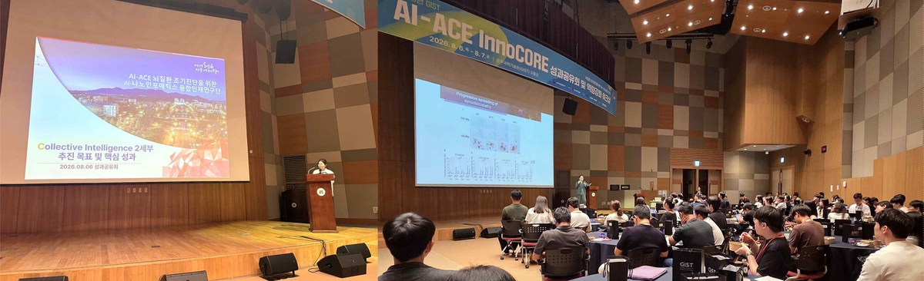

▲ (Left) Mentor Hyunju Lee of the Department of AI Convergence at GIST, leader of Sub-field C (Collective Intelligence), presents her research achievements to date and explains plans for future collaborative research. (Right) Invited speaker Professor Seung-jae Lee of Seoul National University College of Medicine is giving a lecture on the molecular mechanisms by which brain inflammation causes degenerative brain diseases.
In the ‘Achievement Sharing Session,’ approximately 50 Fellows reviewed the progress of the ‘Co-Lab’ initiative through poster presentations and discussions, and discussed future directions for cooperation.
The ‘Co-Lab’ is the research group’s representative cooperation model, in which Fellows proactively conduct convergent research and generate research outcomes through multi-mentoring by the four major science and technology institutes, industry-academia-research institutes, and world-renowned mentor professors.
On the second day, Friday, August 7, specialized training was conducted on patent strategies for research results and strengthening AI-based research capabilities.
Patent Attorney Yong-hoon Kim of the Intellectual Property Office delivered a lecture on the topic of "Patent Discovery Strategies," followed by a hands-on workshop led by Instructor Kim Hyun-min of Amazon Web Services (AWS) on "Protein Engineering Using AI."
Through this training, the research group enhanced its practical capabilities to connect excellent research achievements with securing intellectual property rights and commercializing technology, while also strengthening its ability to apply cutting-edge technologies, such as AI-based protein design, to the field.
Eunji Lee, Director of the AI-ACE InnoCORE Research Group (Professor of Materials Science and Engineering), stated, "This achievement sharing session was a meaningful occasion to review the group's accomplishments over the past year and to explore future directions for cooperation with participating institutions, including the four major science and technology institutes. In particular, there is an increasing number of cases where the group's outstanding fellows are being appointed to leading domestic and international universities, research institutes, and companies." She added, "We will continue to work closely with mentor professors and fellows to present a new paradigm for AI convergence research and continuously generate world-class research results."

