GIST faculty startup LEECELL Co., Ltd., signs MOU with POSCO International
- Signing of MOU following 1 billion won investment by POSCO CVC Fund… Cooperation for global commercialization of next-generation solar cell films begins in earnest
- Comprehensive cooperation for global expansion, from sharing overseas market information to market development and establishing joint business models
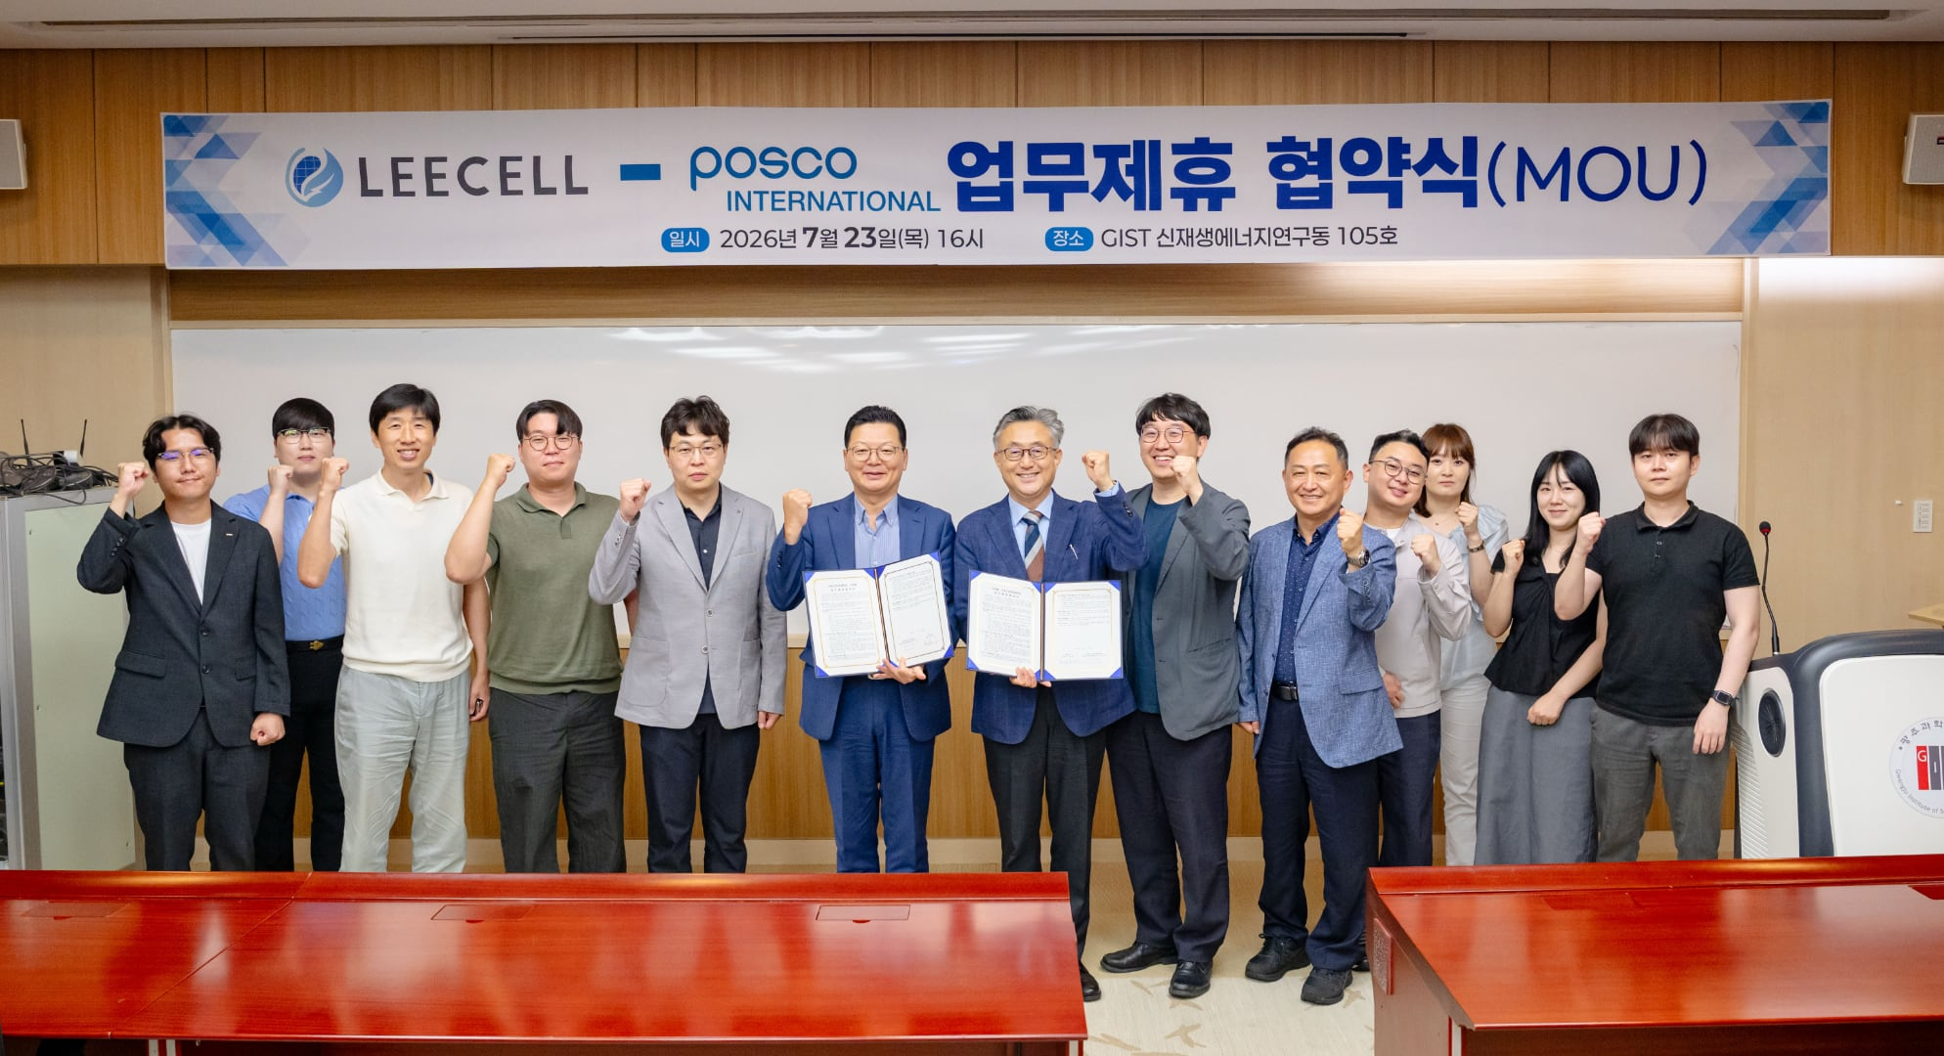

▲ Group photo commemorating the MOU between LEECELL Co., Ltd. and POSCO International. Officials from LEECELL Co., Ltd. and POSCO International are posing for a commemorative photo after signing a Memorandum of Understanding (MOU) for the entry of next-generation solar cell films into overseas markets at the GIST Renewable Energy Research Building on Thursday, July 23. (Sixth from the left in the first row) Kwanghee Lee, CEO of LEECELL Co., Ltd., and (Fifth from the left in the first row) Sung-soo Lee, Head of Industrial Materials Business Division at POSCO International.
The Gwangju Institute of Science and Technology (GIST, President Kichul Lim) announced on Thursday, July 23, at the GIST Renewable Energy Research Building, that LEECELL Co., Ltd. (CEO Kwanghee Lee, Distinguished Visiting Professor at the Department of Materials Science and Engineering at GIST), a faculty startup, signed a Memorandum of Understanding (MOU) with POSCO International to enter overseas markets for next-generation solar cell films.
Prior to this, in June, the ‘POSCO International CVC (Corporate Venture Capital) Fund*’ managed by POSCO Technology Investment invested 1 billion won in LEECELL Co., Ltd., laying the groundwork for cooperation between the two companies.
The signing ceremony was attended by LEECELL CEO Kwanghee Lee and Chief Technology Officer (CTO) Hongkyu Kang (Deputy Director of the GIST Research Institute for Solar and Sustainable Energies), along with other officials, as well as Sung-soo Lee, Head of the Industrial Materials Division at POSCO International, and representatives from POSCO Technology Investment, POSCO Holdings, and POSCO Wide. They discussed strategies for entering overseas markets and plans for future cooperation.
This agreement was pursued to establish a business foundation for next-generation solar cell films and to build a cooperative overseas marketing system utilizing global networks.
* CVC (Corporate Venture Capital) Fund: A venture investment fund established and managed by a company to strategically invest in promising startups.
LEECELL is a faculty-led startup founded in 2022 by Distinguished Visiting Professor Kwanghee Lee, developing next-generation solar cell films based on GIST's source technology and research infrastructure.
The next-generation solar cell film developed by LEECELL is lighter and more flexible than conventional silicon solar cells, allowing it to be applied to curved surfaces. It is also characterized by its ability to generate electricity even in low-light environments, such as indoor lighting.
Last June, at the recommendation of the Korea Development Bank, the company participated in ‘NextRise 2026, Seoul,’ a leading domestic startup expo, to showcase its next-generation solar cell film technology to domestic and international investors and industry stakeholders.
It is also expanding its application fields to include ▴ low-light photovoltaics, ▴ building-integrated photovoltaics (BIPV), ▴ agro-photovoltaics, and ▴ mobility-integrated photovoltaics.
Under the agreement, the two companies will pursue the following: ▴ jointly exploring strategies for the overseas expansion of next-generation solar cell films; ▴ conducting overseas marketing and identifying new buyers; and ▴ pioneering overseas sales channels and establishing joint business models.
POSCO International will provide support by offering overseas market information and identifying potential buyers. The two companies plan to continuously identify business opportunities that reflect the specific market characteristics and customer demands of each country, and expand cooperation by focusing on sectors with high market potential and business viability.
With this agreement, LEECELL plans to accelerate its expansion into the global market by leveraging POSCO International’s global business capabilities and overseas network.
CEO Kwanghee Lee stated, “This agreement is a significant opportunity to further strengthen the foundation for entering overseas markets by combining the technological prowess of next-generation solar cell films with POSCO International’s global business capabilities.” He added, “Through close cooperation between the two companies, we will actively identify new buyers and overseas business opportunities, enhance our global competitiveness, and establish a foundation for sustainable growth.”

