GIST hosts 'Open GIST Science Lab' 58 high school students from Honam region experience science and engineering majors
- Participation of students recommended by 33 high schools in the Honam region… Special lectures and experiments conducted in 5 majors including AI, electrical and computer engineering, physics and optical science, chemistry, and life sciences
- Direct experience of GIST's educational and research environment… “An opportunity to think concretely about major selection”
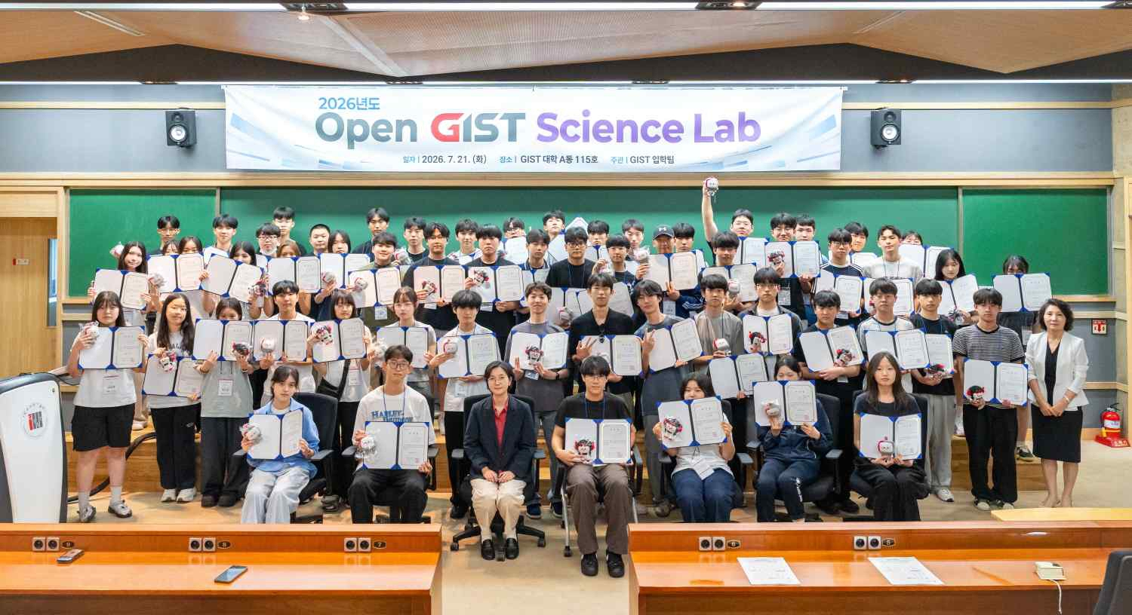

▲ Officials from the GIST Office of Student Affairs & Admissions pose for a commemorative photo with 58 second-year high school students from the Honam region after the ‘Open GIST Science Lab’ event on Tuesday, July 21. (Third from the left in the first row) Soo Jong Lee, Dean of Student Affairs & Admissions at GIST.
The Gwangju Institute of Science and Technology (GIST, President Kichul Lim) announced that it held the ‘Open GIST Science Lab’ on Tuesday, July 21, to provide high school students with an opportunity to explore science and engineering majors.
The ‘Open GIST Science Lab’ is a career exploration program operated annually by GIST for second-year high school students in the Honam region who are interested in science and technology. This year, 143 students from a total of 78 schools applied, and 58 students from 33 schools participated.
Participating students took part in activities such as an introduction to ▴ GIST and its admissions process, ▴ meetings with current students, ▴ and special lectures and experiments by major, using the time to deepen their understanding of their fields of interest and concretely plan their career paths.
The event began with a welcoming address by Admissions Team Leader Mi-yeon Kim, followed by an introduction to GIST’s undergraduate programs and admissions process. This was followed by a special lecture on AI and semiconductors by Professor Duk-Jo Kong of the Graduate School of AI Policy & Strategy.
In addition, GIST’s global talent development programs were introduced, and current students who had participated in overseas university exchanges shared their experiences of studying abroad and life in the local environment.
During the subsequent Q&A session with current students, various questions regarding GIST college life, academics, and career paths were exchanged. Students also had lunch with the students at the Second Student Union Building, engaging in free-flowing communication.
Students participated in pre-registered major programs among GIST’s undergraduate majors: artificial intelligence (AI), electrical and electronic engineering and computer science, physics and optical science, chemistry, and life sciences. They attended special lectures and conducted practical exercises under the guidance of lab instructors and teaching assistants.
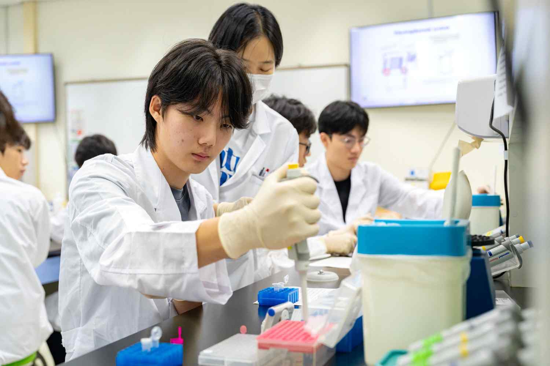

▲ Participants are engaging in an experiment during the ‘chemistry major’ session while listening to an instructor’s explanation.

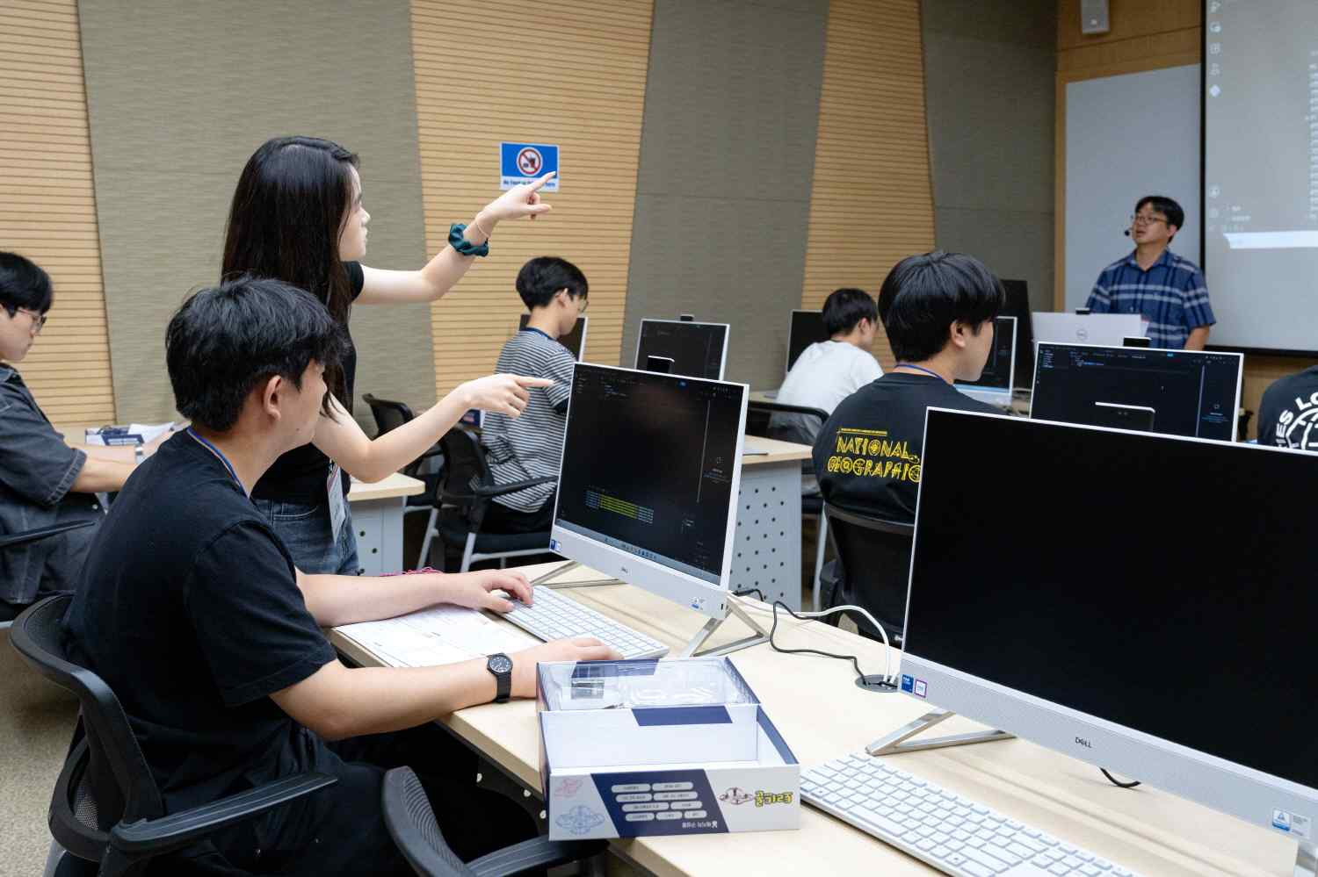

▲ Participants are engaging in a practical exercise during the ‘AI major’ session while listening to a teaching assistant’s explanation.
Participants stated, “It was meaningful to be able to experience firsthand through experiments what we had only encountered in textbooks,” adding that it “served as an opportunity to think more concretely about choosing a major.”
They also shared their impressions, noting that “it was beneficial to experience GIST’s research environment and campus atmosphere firsthand.”
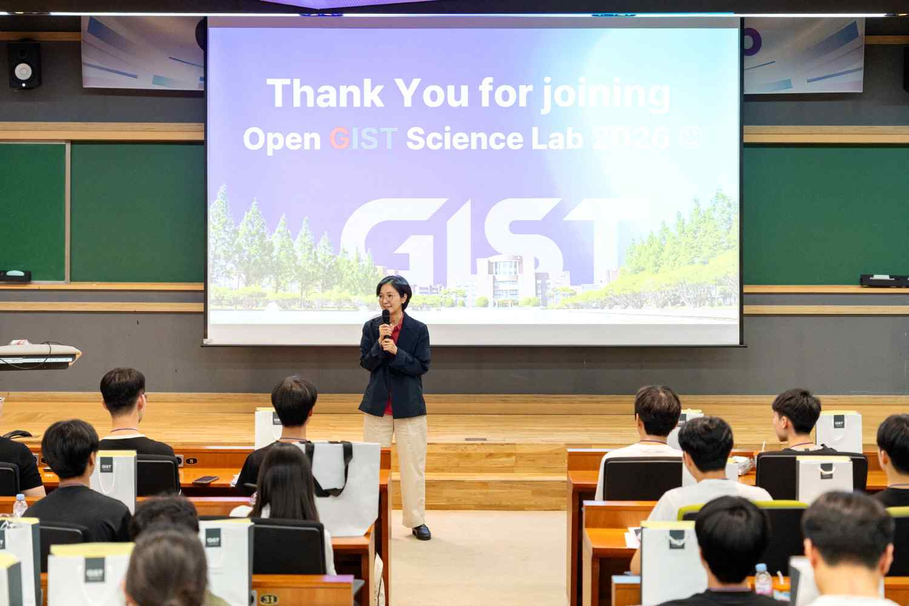

▲ Lee Soo Jong Lee, Dean of Student Affairs & Admissions at GIST, explains the importance of experiments and questioning to participants of the ‘Open GIST Science Lab.’
Soo Jong Lee, who organized the event, said, “The experience of students asking questions and conducting experiments directly in the laboratory can serve as a starting point to transform vague interest into a concrete career path,” and added, “We will continue to actively open GIST’s educational and research sites so that high school students in the Honam region can discover the diverse possibilities of science and technology.”
Meanwhile, the GIST Student Affairs & Admissions team is striving to attract outstanding science and technology talent by operating various career experience and admissions promotion programs, including the ‘Open GIST Science Lab,’ ‘High School Visit Admissions Briefings,’ and ‘Open GIST College.’

