GIST sets up 'nest' at MIT to fully launch global physical AI joint research
- Establishment of ‘GIST-MIT Human-Centered Physical AI Interaction Research Center’ at MIT… Global cooperation begins in earnest
- Substantive cooperation intensifies across the two countries, ranging from on-site research visits and joint symposiums in the U.S. to the Seoul ICML Joint Workshop
- Joint research pursued in the fields of robot learning, biosignal AI, and multimodal data
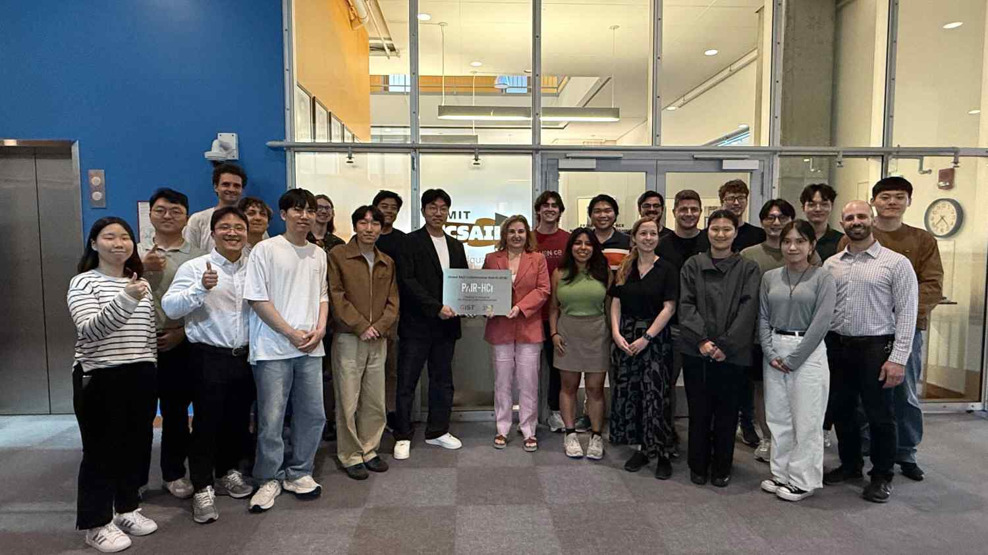

▲ Attendees pose for a commemorative photo holding the plaque at the unveiling ceremony of the ‘GIST-MIT PAIR-HCI Center’ held at MIT CSAIL on Wednesday, May 20.
The Gwangju Institute of Science and Technology (GIST, President Kichul Lim) announced that the ‘GIST-MIT Physical AI Research for Human-Centered Interaction (PAIR-HCI Center),’ jointly promoted by Professor SeungJun Kim’s research team from the Department of AI and the Massachusetts Institute of Technology (MIT) Computer Science and Artificial Intelligence Laboratory (CSAIL), is fully activating a global cooperation system by establishing a physical base within MIT and promoting joint workshops.
The PAIR-HCI (Physical AI Research for Human-Centered Interaction) Center is part of the ‘Project to Establish Cooperation Hubs with Excellent Overseas Research Institutions,’ supported by the Ministry of Science and ICT and the National Research Foundation of Korea. It aims to develop ‘human-centered physical AI interaction technologies’ that people can trust and utilize by combining the research capabilities of GIST and MIT from July 2025 to December 2030.
In particular, GIST and MIT have continued joint research and researcher exchanges since 2021, and the establishment of this center will serve as an opportunity to further advance their cooperative framework.
On Wednesday, May 20, a plaque unveiling ceremony was held at the Stata Center, where MIT CSAIL (Computer Science and Artificial Intelligence Laboratory) is located, to establish a local joint research base for the PAIR-HCI Center. The event was attended by Daniela Rus, Director of MIT CSAIL, and researchers from GIST.
The space will be utilized as a collaborative hub for regular research meetings between researchers from both institutions, medium- and long-term visiting research, joint experiment design, researcher exchanges, and joint symposiums.
GIST researchers visited MIT from Saturday, May 2 to Tuesday, June 2 to conduct research. During the joint research symposium held during this period, they shared research achievements and technological trends in the field of human-centered physical AI—▴ including Software Defined Vehicles (SDVs), ▴ autonomous driving, ▴ robotics, ▴ eXtended Reality (XR), and ▴ virtual interfaces—and discussed directions for follow-up joint research.
* software defined vehicle (SDV): A smart mobility solution where software controls and manages a vehicle's driving performance, convenience features, and safety.
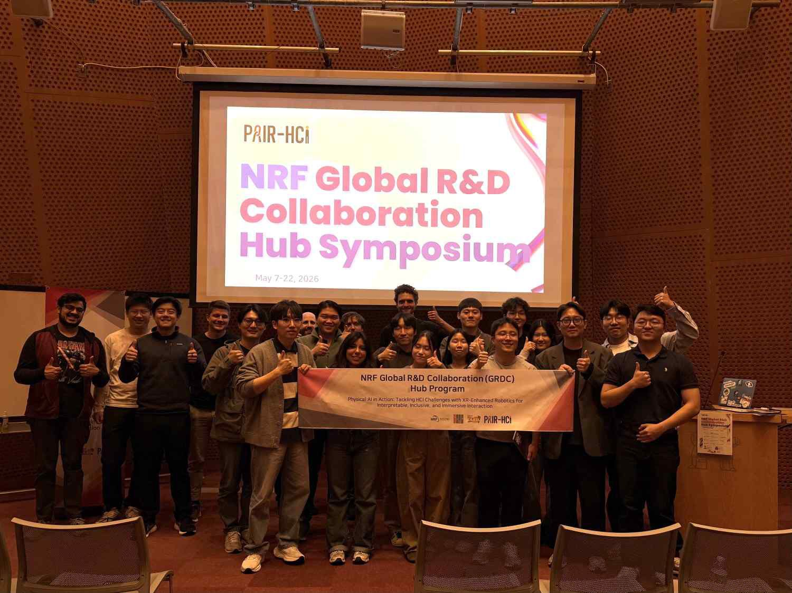

▲ Taking a commemorative photo at the ‘GIST-MIT PAIR-HCI Joint Research Symposium’ held at MIT CSAIL in May.
This research collaboration has also extended to Korea. GIST researchers held a joint workshop with MIT researchers who visited Korea for the International Conference on Machine Learning (ICML 2026), which was held at COEX in Seoul from Monday, July 6 to Friday, July 10.
At the workshop, GIST researchers introduced technologies for user state recognition and human-centered interaction in SDV, autonomous driving, robotics, and XR environments, while MIT researchers shared their latest research findings, including robot simulation and generative AI. Through this, they explored new possibilities for collaboration in the field of physical AI.
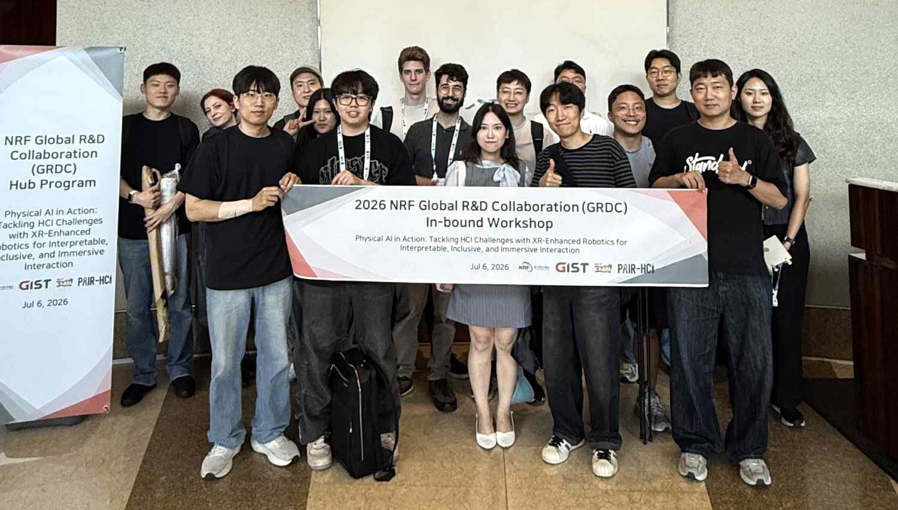

▲ Participants of the ‘GIST-MIT PAIR-HCI Joint Workshop,’ held at COEX in Seoul on Monday, July 6, pose for a commemorative photo.
Building on this exchange, the two universities plan to further expand the scope and level of their cooperation.
They have selected the establishment of simulation environments for robot learning and evaluation, biosignal-based user state understanding, and the construction of high-quality multimodal datasets as key collaborative projects, and intend to continuously expand joint experiments, publication of papers, and the exchange of research personnel.
Furthermore, the team plans to organically link MIT’s robot learning and simulation technologies with GIST’s human-centered HCI and XR design and evaluation capabilities to expand the scope of research into real-world applications such as collaborative robots, autonomous vehicles, humanoids, and mobile XR.
Professor SeungJun Kim’s research team stated, “This plaque unveiling ceremony and joint workshop are highly significant in that the PAIR-HCI Center has established a research base within MIT and created a practical global cooperation framework.” He added, “Moving forward, we will combine the strengths of GIST and MIT to develop physical AI technologies that people can trust and use, and expand them into various industrial ecosystems.”

