GIST hosts 'Bit.Na.Da.' festival connecting energy technology and citizens
- A platform for energy technology exchange bringing together universities, research institutes, companies, citizens, and even children… Operating participatory programs for future generations, such as the Energy Golden Bell and eco-friendly car races
- Also operating commercialization consultation booths to support investment attraction and technology transfer… Accelerating the creation of an energy industry innovation ecosystem
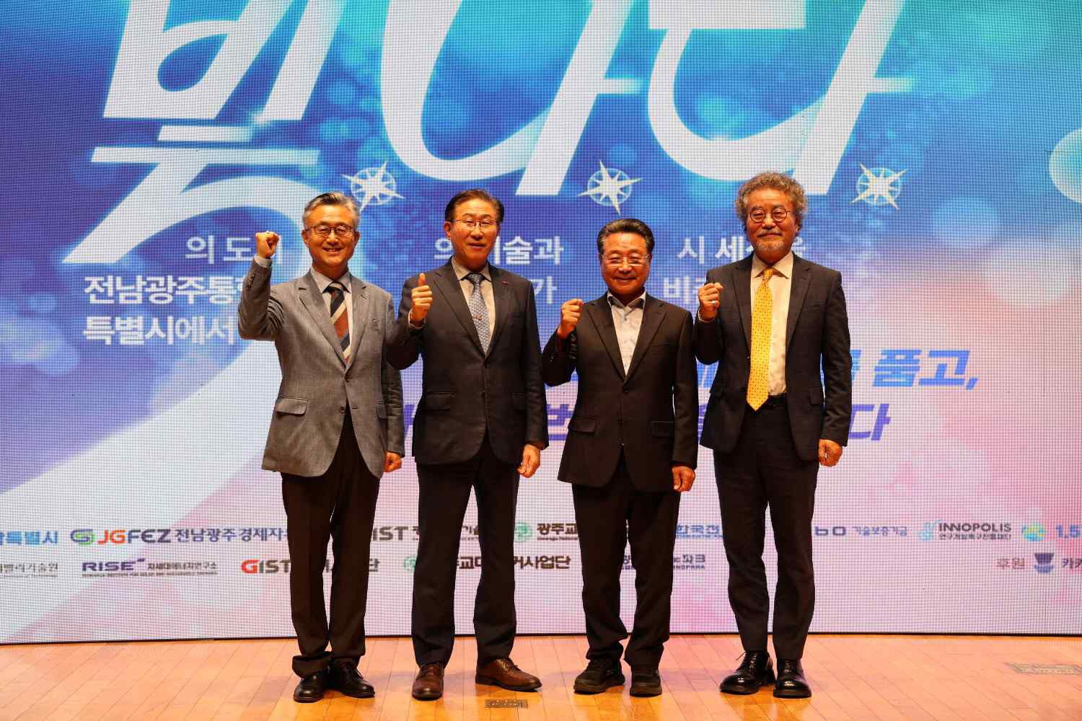

▲ Distinguished guests pose for a commemorative photo at ‘Bit.Na.Da.’ held at GIST’s Oryong Hall on Saturday, July 11. (From left) Kwanghee Lee, Director of the Energy Valley Institute of Technology; Kichul Lim, President of GIST; Yong-guk Choi, Chairman of the 1.5℃ Forum; and Seung-jun Heo, President of Gwangju National University of Education.
The Gwangju Institute of Science and Technology (GIST, President Kichul Lim) announced that it held ‘Bit.Na.Da.,’ an energy festival connecting energy technology, industry, and citizens, at GIST’s Oryong Hall on Saturday, July 11.
Under the slogan “Embracing the Energy of Jeonnam and Gwangju, Illuminating the World Once Again,” this event was organized as a platform for exchange among industry, academia, research, and government. It provided a venue for researchers from local universities and research institutes, as well as officials from companies and related organizations, to share technologies and commercialization strategies in the energy sector, while citizens participated in various energy experience programs.
In particular, with families accompanied by children making up the majority of the approximately 300 participants, the event was conducted as a citizen-participatory festival where energy technology could be experienced in an easy and fun way. Various hands-on programs and science and energy content tailored to children were offered on-site, serving as an opportunity to raise the interest of future generations in science and technology.
Representative Moon-young Lim (Gwangju Gwangsan-gu Eul), who attended the event, stated, “Energy is a crucial growth engine that will open up the future of the Jeonnam-Gwangju Integrated Special City.” He added, “I hope that diverse experiences and learning opportunities will continue so that the children who experienced energy technology today can grow into future science and technology talents and lead the region’s future.”
The event was divided into two sessions: an ‘Energy Technology Presentation’ session to share technologies and research achievements in the energy sector, and an ‘Energy Literacy’ session where citizens could directly experience energy technologies.
In the ‘Energy Technology Presentation’ session, 11 researchers from major universities and research institutions in the Jeonnam-Gwangju Integrated Special City—including GIST, Chonnam National University, Suncheon National University, and the Korea Institute of Energy and Technology (KENTECH)—participated and presented core technologies and research achievements in the energy field, such as next-generation power grids, Energy Storage Systems (ESS), and new and renewable energy.
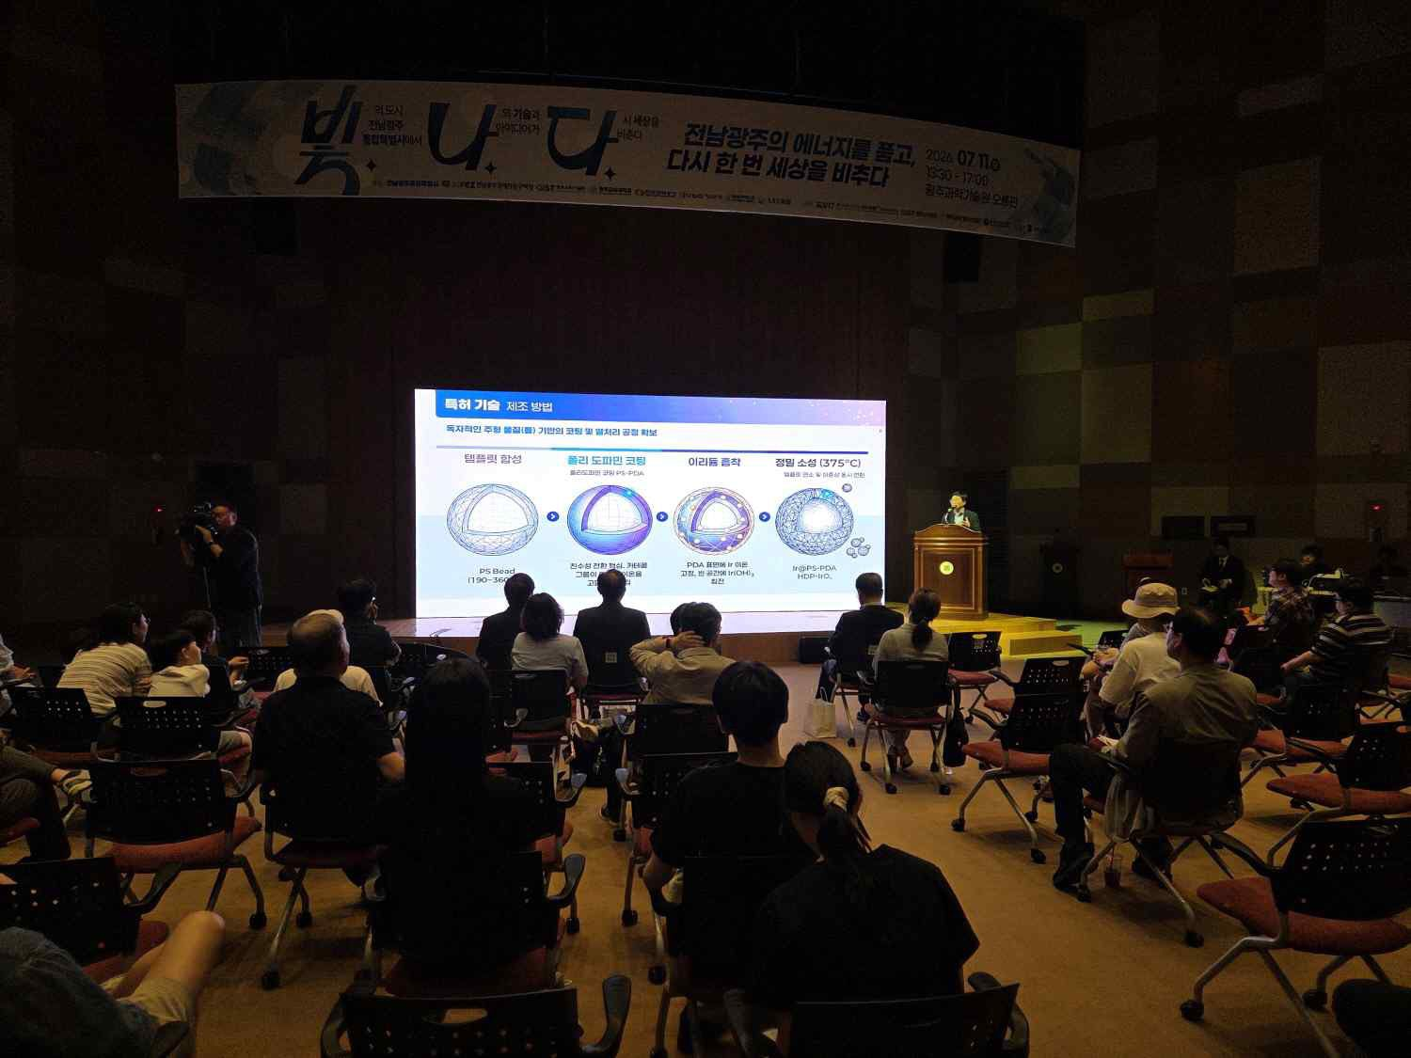

▲ Participants listen to the researchers’ technology presentations during the ‘Energy Technology Presentation’ session.
In addition, related organizations such as the Jeonnam Gwangju Free Economic Zone Authority, the Korea Technology Guarantee Fund, Gwangju Technopark, and the Research and Development Special Zone Promotion Foundation operated 1:1 consultation booths and provided information necessary for commercialization, including investment attraction strategies, technology transfer procedures, and policy fund support systems.
In the ‘Energy Literacy Session,’ various programs were operated to allow citizens to directly experience energy technology and scientific principles by linking the ‘Urban Campus Living Lab’ and ‘Neulbom Think Tank College’ projects promoted by the GIST Anchor Project Group (formerly the RISE Project).
In the ‘Family Energy Golden Bell’ and ‘Eco-friendly Car Tournament,’ organized as part of the ‘Urban Campus Living Lab’ project to solve local community problems, participants experienced energy technology by solving questions based on researchers’ presentations and by assembling and driving eco-friendly cars themselves.
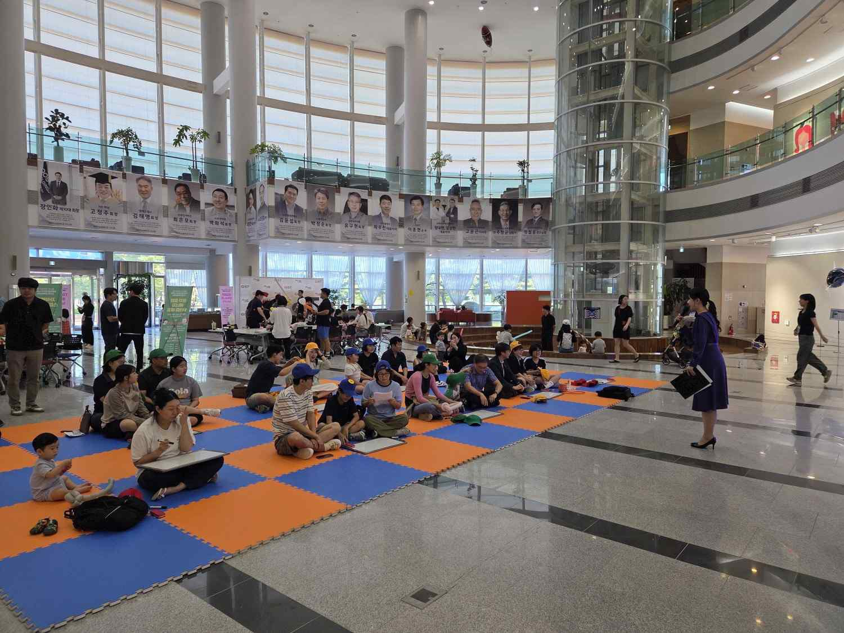

▲ Participants in the ‘Family Energy Golden Bell’ are solving energy-related quizzes.
Additionally, in the ‘Future Energy Mobility Experience,’ linked to the ‘Neulbom Think Tank College’ project designed to expand science and technology experience opportunities for elementary school students, participants had the opportunity to learn engineering principles such as buoyancy and flight by directly controlling radio-controlled (RC) helium airships.
In addition, students from Gwangju National University of Education participated as educational mentors, running programs that allowed participants to experience everyday scientific principles and energy concepts in an easy and fun way. These included ▴ building a smart energy city using magnetic blocks, ▴ experiencing the non-Newtonian fluid 'slime,' and ▴ making 'cotton candy' through thermal energy conversion.
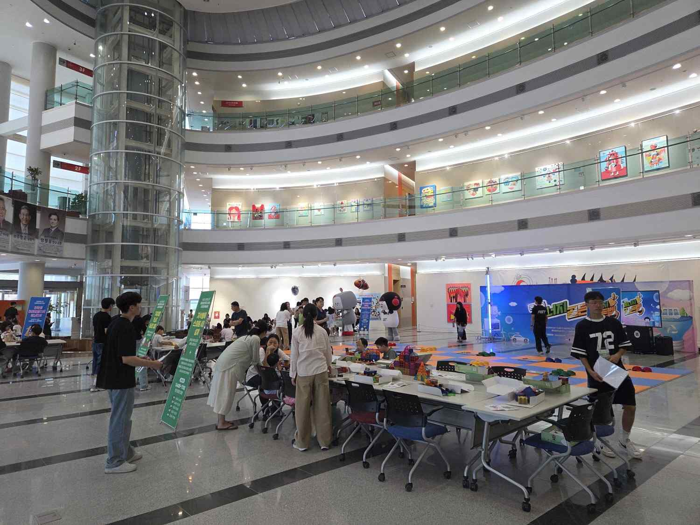

▲ Participants are engaging in the smart energy city building experience using magnetic blocks.
This event was co-hosted by the Jeonnam Gwangju Metropolitan City, the Jeonnam Gwangju Free Economic Zone Authority, GIST, Korea Electric Power Corporation (KEPCO), the Korea Technology Guarantee Fund (KOGEF), Gwangju National University of Education, the Gwangju Special Research and Development Zone Foundation, and the 1.5℃ Forum.
Furthermore, the event was held under the sponsorship of 'Kakao AI Sail,' Kakao’s initiative to foster a regional AI ecosystem, adding significance to public-private cooperation for cultivating local technical talent and revitalizing the startup ecosystem.
Kwanghee Lee, Director of the Energy Valley Institute of Technology (and Professor of Materials Science and Engineering at GIST), said, “I hope this event served as a meaningful occasion for researchers, companies, and citizens to share and communicate about the potential of energy technology together.” He added, “We will continue to support the commercialization and startup of excellent local technologies, while expanding the foundation for cooperation to foster an innovation ecosystem for the energy industry.”

