GIST Advanced Photonics Research Institute hosts the 16th International Summer School on Lasers and Laser Applications, 'SSOLLA 2026'
- 13 students and researchers from 7 Asian countries participated over 5 days… Training in the latest optical technology and tours of ultra-high-intensity laser research facilities
- Korea's only specialized research institute for laser and optical technology marking its 25th anniversary… Expanding international cooperation based on ultra-high-intensity laser research
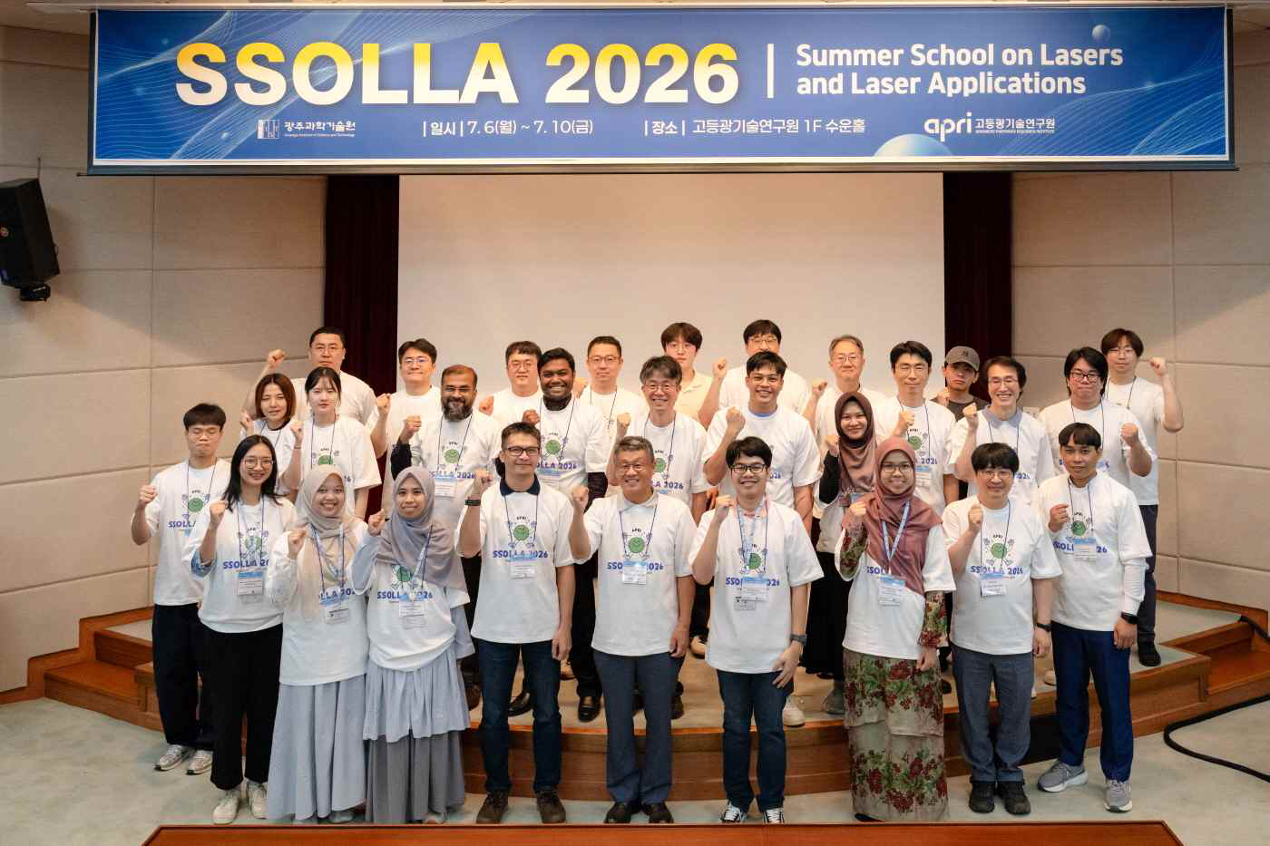

▲ Participants are taking a commemorative photo at the ‘Summer School on Lasers and Laser Applications (SSOLLA) 2026,’ hosted by the GIST Advanced Photonics Research Institute for five days from Monday, July 6 to Friday, July 10.
The Gwangju Institute of Science and Technology (GIST, President Kichul Lim) announced that the Advanced Photonics Research Institute (APRI, Director Yeung Lak Lee) hosted the ‘Summer School on Lasers and Laser Applications (SSOLLA) 2026’ for five days from Monday, July 6 to Friday, July 10, targeting international students and researchers studying lasers and optical technology.
The ‘Summer School on Lasers and Laser Applications (SSOLLA)’ is an international education and research exchange program that the GIST Advanced Photonics Research Institute has operated annually since 2010, marking its 16th edition this year.
Thirteen students and researchers from seven Asian countries, including Vietnam, the Philippines, Malaysia, Cambodia, Taiwan, Indonesia, and Bangladesh, participated in this event.
The participants, affiliated with major universities and research institutions in their respective countries such as the National University of Science and Technology (NTUST) in Taiwan, the Royal University of Phnom Penh in Cambodia, and Khulna University in Bangladesh, learned about the latest research trends and technologies in the fields of optics and lasers and exchanged knowledge and experience with international researchers.
The five-day intensive training program featured lectures covering a wide range of topics from basic laser theory to applied technology, as well as optical experiments and tours of research facilities.
The lectures covered general topics in laser and optical technology, including the fundamentals and applications of high-power and fiber lasers, nonlinear optics, nano optics, biomedical optics, quantum optics, and laser safety. Through optical experiments, participants had the opportunity to directly verify and understand the principles and concepts learned in the lectures.
In addition, a tour was arranged to examine the research infrastructure for ultra-powerful lasers firsthand by visiting the ‘Ultrashort Photonics Quantum Beam Special Research Building,’ a core research facility of the GIST Institute of Advanced Photonics, and other key laboratories.
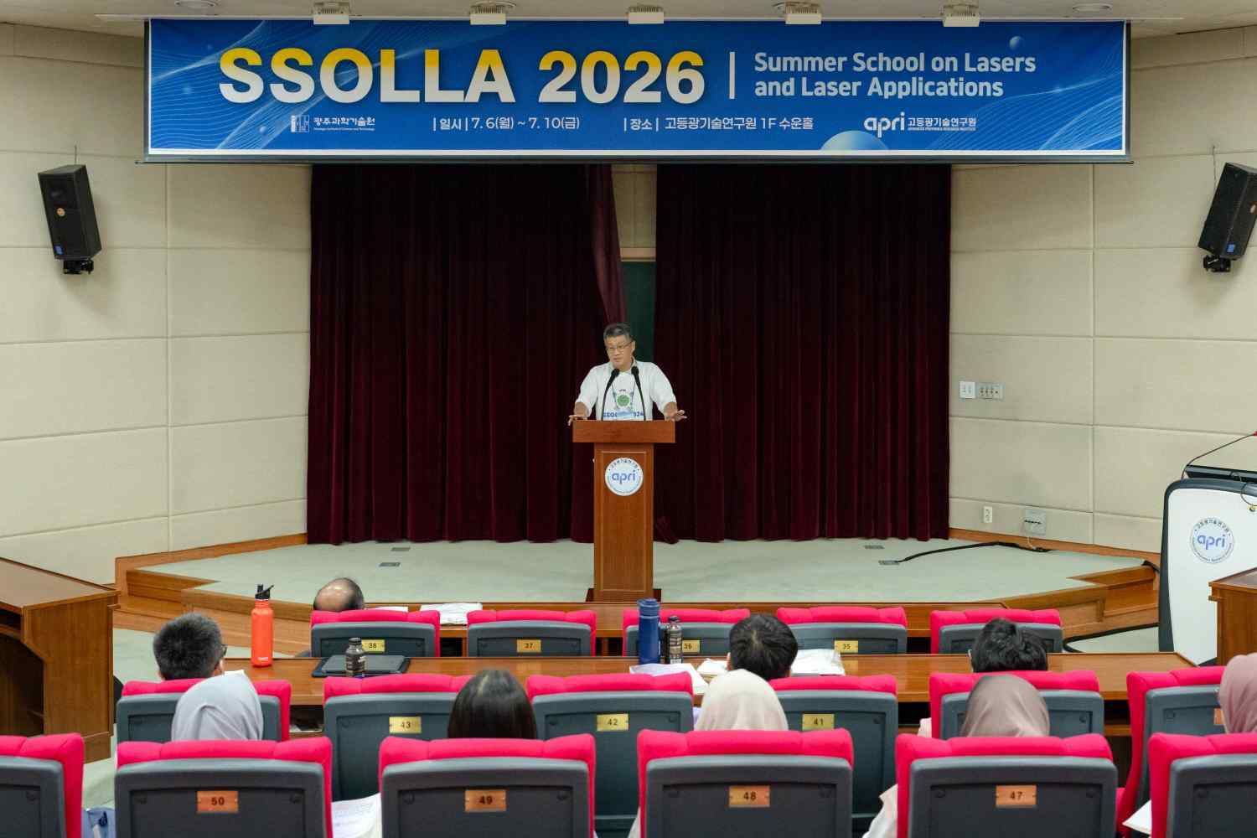

▲ Yeung Lak Lee, Director of the GIST Advanced Photonics Research Institute, delivers a welcoming address at the ‘Laser and Optical Technology Summer School (SSOLLA) 2026.’
Yeung Lak Lee, Director of the GIST Advanced Photonics Research Institute, stated, “Every year, we are committed to academic exchange with international researchers and fostering next-generation research personnel through ‘SSOLA.’ We will continue to revitalize international collaborative research in the field of photonics technology and continuously strengthen our global research network.”
Meanwhile, the GIST Advanced Photonics Research Institute, which celebrates its 25th anniversary this year, is the only research institute in Korea specializing in laser and photonics technology. It is recognized for its world-class research capabilities, including the development of an ultra-powerful laser capable of achieving an instantaneous output of 4.2 petawatts (1 petawatt = 1,000 terawatts) by concentrating massive energy in an extremely short moment (20 femtoseconds), equivalent to dividing one second into approximately 50 trillion parts.
Based on its ultra-powerful laser research facilities and international collaborative research network, the institute is continuously expanding the development of source technologies and global research cooperation in the fields of photonics science and photonics technology.

