GIST, Songwon National University, and Gwangju Institute of Industry-Academia Convergence operate global AI company linkage program in Singapore
- 34 participants, including university students, researchers, and corporate officials, took part in a global AI innovation field training program as part of the Regional Growth Talent Development System (Anchor) project… Visited Google APAC Headquarters, Amazon Web Services (AWS), and Western Robotics
- Conducted practical, hands-on training including hackathons and technical sessions… Expected to strengthen global AI practical capabilities
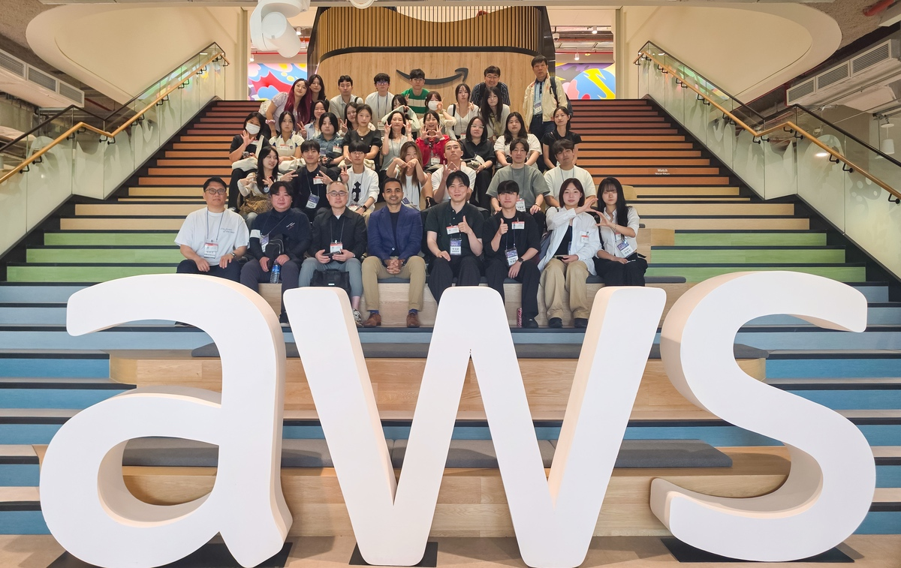

▲ Participants of the ‘2026 Global AI Corporate-Linked Convergence Program’ pose for a commemorative photo during their visit to AWS Singapore on Tuesday, June 30.
The Gwangju Institute of Science and Technology (GIST, President Kichul Lim) announced that it operated the ‘2026 Global Artificial Intelligence (AI) Corporate-Linked Convergence Program’ in Singapore for seven days and five nights from Friday, June 26 to Thursday, July 2. This program was conducted as part of the ‘Regional Growth Talent Development System (Anchor) Project (formerly the RISE Project)’ through a consortium formed in collaboration with Songwon University and the Gwangju Institute for Industry-Academic Convergence.
As AI and robotics technologies have recently established themselves as core technologies driving innovation across industries, there is a growing call to expand educational opportunities for local talents to experience global AI technology trends and the industrial field.
This program was designed to strengthen participants' practical skills and problem-solving abilities by connecting them with the research and industrial sites of global big tech companies, and to foster AI convergence talents with a global perspective.
A total of 34 people participated in the training group, including 20 students from Songwon University and 4 students from GIST, who were selected through the submission of business plans, presentations, and interviews; 4 researchers from GIST; 4 adjunct professors from companies; and 2 officials from the Gwangju Industry-Academic Convergence Institute.
Participants visited Singapore, the Asia-Pacific hub for global big tech companies such as Google and Amazon Web Services (AWS), as well as a hub for major companies and research institutions in the AI ​​and digital sectors, to experience the AI ​​industry landscape and innovation ecosystem.
Participants visited the Google Asia-Pacific (APAC) Headquarters in Singapore and AWS Singapore, attending lectures by local experts and technical sessions to examine the latest technological trends and application cases in the global AI industry.
In particular, at the Google APAC Headquarters, No-Code workshops and group hackathon programs were conducted, allowing participants to develop apps without coding. Participants took part in group missions and final presentations, receiving advice on their projects from Google technical mentors.
They also visited the robotics company Weston Robot to examine AI-based robot platforms and industrial application cases, confirming the current status of actual utilization of AI-robot convergence technology.
Jae Gwan Kim, Head of the GIST Anchor Project Group (and Director of the Startup Innovation Strategy Center), stated, “This program was a meaningful opportunity for students, researchers, and corporate representatives to directly experience the innovative technologies and advanced industrial ecosystems of global AI companies together.” He added, “We will continue to expand various international exchange programs to help local talents acquire world-class technological capabilities and global competitiveness, and we will actively utilize the network established through this program for education and industry-academia collaboration.”
Meanwhile, this program was supported by the ‘Regional Growth Talent Development System (Anchor) Project’ for a consortium formed by GIST, Songwon University, and the Gwangju Institute for Industry-Academia Convergence. The participating institutions plan to continue their cooperation for global technology exchange and the cultivation of region-specific AI talent.

