GIST launches ‘AI College’… Full-scale cultivation of national AI and semiconductor convergence talent begins
- Expansion and reorganization of the existing College of Information and Computing to establish an AI education and research platform for 1,000 students ranging from undergraduates to master's and doctoral degree holders
- Serving as a supply base for global convergence talent in alignment with the strategy to foster the Southwest region as a hub for the AI ​​and semiconductor industries
- Expansion of undergraduate admissions quota by 100 for the 2027 academic year… Advancing the pipeline connecting undergraduate and graduate programs
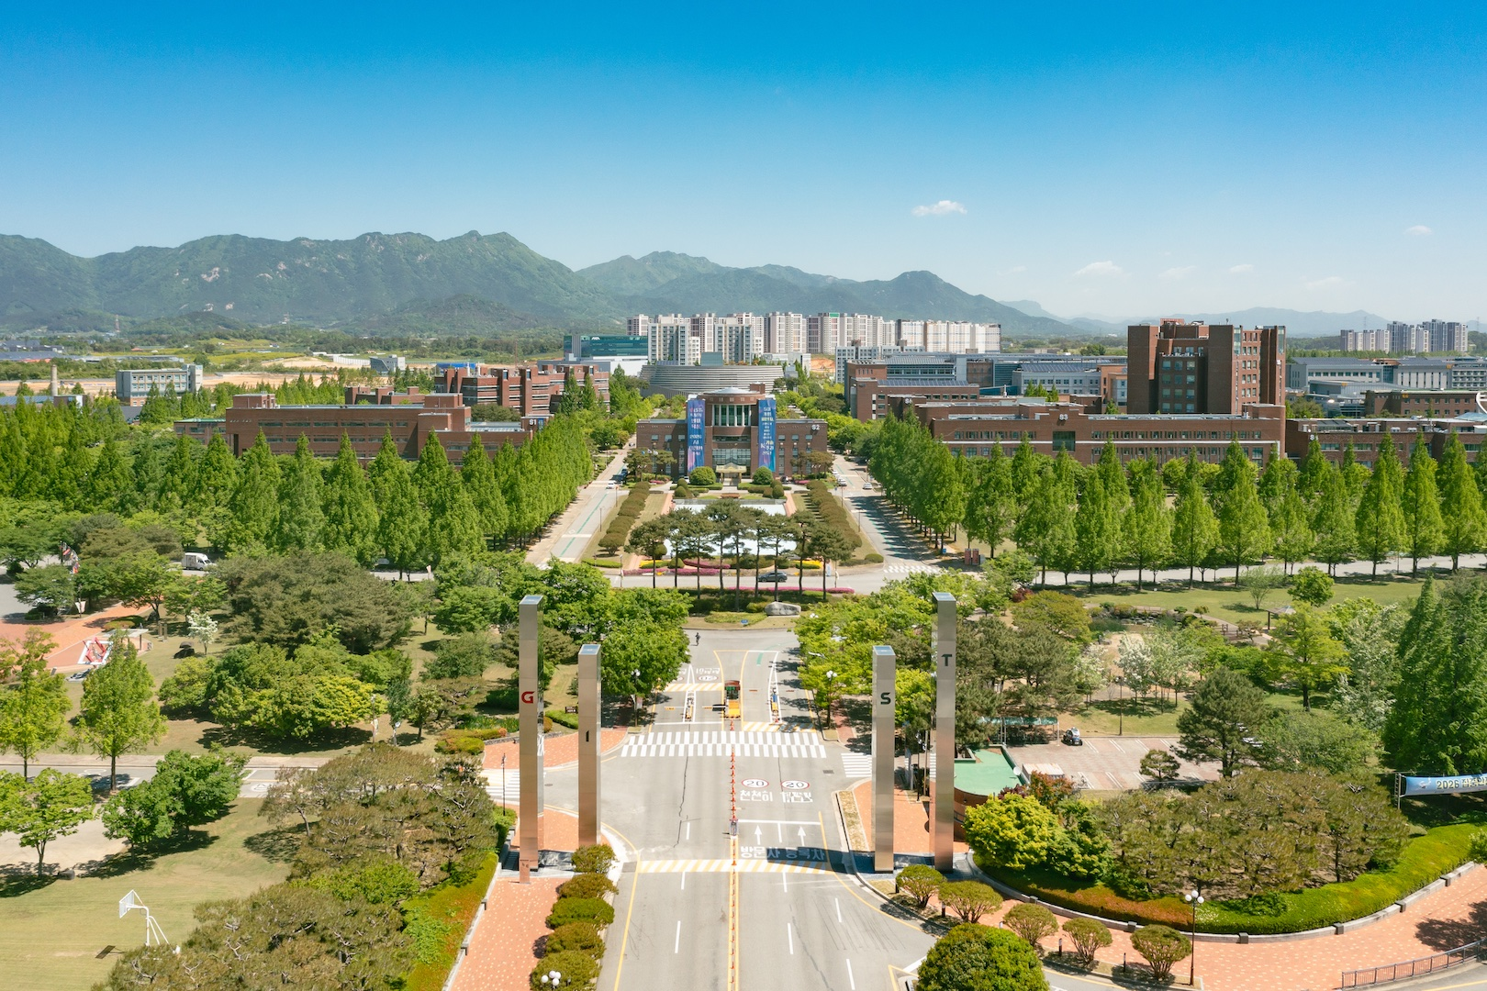

▲ Panoramic view of the GIST campus
The Gwangju Institute of Science and Technology (GIST, President Kichul Lim) announced on July 1 that it has officially launched the College of AI (Dean Jongwon Kim), an expanded and reorganized version of the existing College of Information and Computing, and has begun full-scale efforts to cultivate world-class AI and semiconductor convergence talents to support the national AI and semiconductor strategy.
With the government recently announcing a strategy to foster the Southwest region as a new hub for the AI ​​and semiconductor industries, cultivating core talents to support national AI competitiveness has emerged as a critical task. Through the launch of the College of AI, GIST plans to serve as a key hub for stably training and supplying high-level talent in the AI ​​and semiconductor fields, in line with this national strategy.
The GIST College of AI is an organization expanded and reorganized based on the existing College of Information and Computing. Upon its launch, it has established an education and research platform with a capacity of 990 enrolled students (472 undergraduates and 518 graduates). The AI ​​College consists of the ▴ Department of AI, the ▴ Department of AX, the ▴ Department of Electrical Engineering and Computer Science, the ▴ Department of Semiconductor Engineering, and the ▴ Graduate School of AI Policy and Strategy, and operates an educational system that extends from undergraduate to master's and doctoral programs.
In particular, the College of AI has established a convergence-oriented educational system that takes AI and semiconductors as its two main pillars and expands its educational scope to include AI semiconductors and systems, industrial AX (AI Transformation), and AI policy.
Based on this educational framework, the university plans to operate a convergence curriculum that encompasses AI transformation across industries—such as mobility, energy, manufacturing, and bio-healthcare—as well as AI policy and strategy, all grounded in core AI technologies and AI semiconductors. Through this, students can systematically cultivate expertise and convergence capabilities tailored to their respective majors and career paths.
Moving forward, GIST plans to further advance its AI talent development pipeline through early talent identification in collaboration with AI gifted schools, undergraduate-graduate linkage education, and industry-tailored curricula.
Furthermore, starting from the 2027 academic year, the university plans to expand the undergraduate enrollment quota to approximately 330 students—an increase of 100 from the previous year—to further strengthen the cultivation of talent in cutting-edge fields such as AI, semiconductors, and bio.
GIST plans to continuously expand education in the fields of AI semiconductors and industrial AX by linking global industry-academia collaboration with cutting-edge research infrastructure, and to develop into a leading hub for fostering AI and semiconductor convergence talent in Korea that supports the national AI and semiconductor strategy.
GIST President Kichul Lim stated, “The College of AI is not merely the creation of a new college, but a starting point for educational innovation designed to proactively respond to the national AI and semiconductor strategy and the demands of the industry.” He added, “GIST will not stop at training AI experts; we will cultivate AX talent capable of leading innovation across all industries—including semiconductors, mobility, energy, and bio—by utilizing AI, and establish ourselves as a core education and research base supporting Korea’s AI and semiconductor ecosystem.”

