“Think How to Think” From passive students to problem solvers… GIST’s educational innovation program 'INGE', a 10-year challenge
- Since its launch in 2016, established a student-centered learning culture, including PBL and flipped learning
- Students directly design and lead the budget execution of projects such as shared bicycles and nudge experiments
- "Immersion improves with greater autonomy"... Enhancing a sense of realism through community-linked service learning
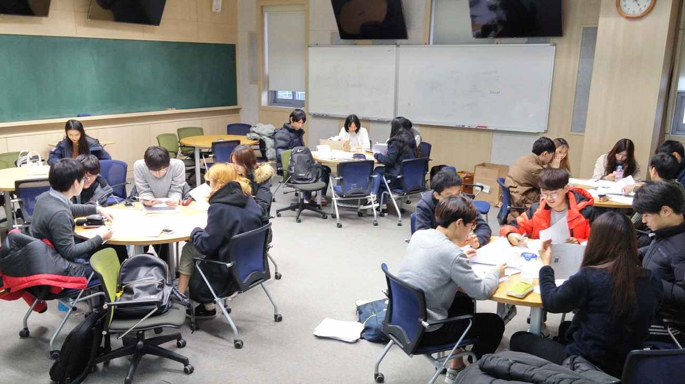

▲ A scene from the ‘Behavioral Economics 2’ class, an INGE program course. Students are seated around a round table discussing a project.
The Gwangju Institute of Science and Technology (GIST, President Kichul Lim) announced that through the ‘INGE (Initiative in New GIST Education)’ program, an educational innovation program marking its 11th year, it has fostered creative convergence talents who will lead cutting-edge science and technology and industrial innovation by establishing a learning culture where students proactively explore and collaborate.
The ‘INGE’ program is GIST’s flagship educational innovation program operated by the Office of University Support. It has been implemented since 2016 to support professors in developing and operating student-participatory classes and project-based courses.
Under the educational philosophy of ‘Think how to Think, Learn how to Learn,’ various teaching methods such as ▴ project-based learning, ▴ problem-based learning, and ▴ flipped learning have been introduced to create a learning environment where students can explore, collaborate, and grow on their own, and over the past 10 years, a total of 74 courses have been operated with the support of the INGE project.
The INGE program focuses on helping students grow from passive students into active agents who discover and solve problems.
Students directly participate in the entire process of defining problems and seeking solutions while carrying out team projects. By applying the theories learned in class to real-world assignments and refining solutions through discussion and collaboration, they cultivate creative problem-solving capabilities and convergent thinking skills.
Professor Hisam Kim (Economics) of the School of Humanities and Social Sciences, who has participated in the INGE program since its early days, operated a student-centered project class through the course "Behavioral Economics 2" in 2016.
At that time, students selected topics closely related to real life and carried out projects, such as the Shared Umbrella Project, Nudge experiments to increase survey participation rates, and plans for introducing a bicycle sharing system within GIST.
Students applied what they learned in class to real-world problems by directly designing and conducting surveys, field research, and social experiments. Professor Kim proactively led the entire project process, including participating in the drafting of research proposals and the execution of the budget.
Professor Kim stated, "At that time, various attempts were being made to fully introduce student-centered classes and project activities into the curriculum," adding, "The INGE project started as a program to realize educational innovation by applying new educational methods to actual classes."
Students who took the 'Behavioral Economics 2' course recalled that they were able to broaden their horizons by encountering diverse perspectives and experienced significant growth through the challenging process.
The INGE project is continuously evolving from initial project-centered classes to new educational methods, such as education utilizing generative AI.
Professor Eunsung Song of the Department of AI Convergence, who has participated in the INGE project since 2021, has been guiding students to carry out projects that identify and solve problems in local communities and real life through the 'Service Learning Project' course.
In actual classes, various service improvement projects were conducted, such as shopping support services for the visually impaired and a dormitory information sharing system to enhance student convenience. Students gained field-oriented problem-solving experience through the process of directly collecting user feedback and improving services.
In the second semester of this year, a new course called ‘AI Video Studio’ is also scheduled to be offered to cultivate generative AI-based content creation capabilities.
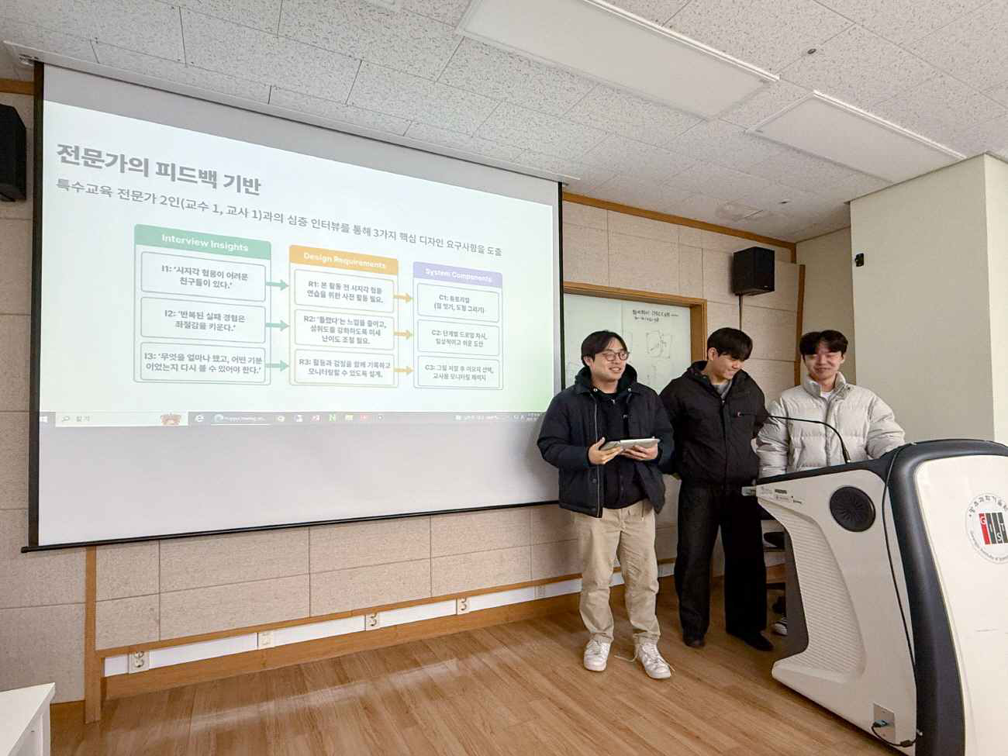

▲ A scene from the ‘Service Learning Project’ class under the INGE program. Students are presenting the results of their team projects.
Professor Song stated, “We had students take the lead in the entire process, from selecting topics and managing schedules to presenting results, and they demonstrated a much higher sense of responsibility and engagement than expected.” He added, “We were able to observe that the more autonomy we granted, the more actively they participated and grew.”
GIST plans to continue strengthening the student-centered educational environment through the INGE program and expand cutting-edge technology-based education as well as industry-and-society linked projects.
In particular, GIST intends to accelerate the cultivation of talent that will lead future society and industry by continuously pursuing educational innovations that foster the creative problem-solving capabilities and convergent thinking skills required in the era of generative AI.

