GIST selected for 5.8 billion won next-generation 'Laser Fusion' national research project
- Selected for Ministry of Science and ICT's 'Fusion Plug-in Program'... Joint research with UNIST, Korea Atomic Energy Research Institute, and others
- Development of next-generation fusion technology accelerates amid government expansion of artificial sun infrastructure... Pursuing securing source technologies for clean energy
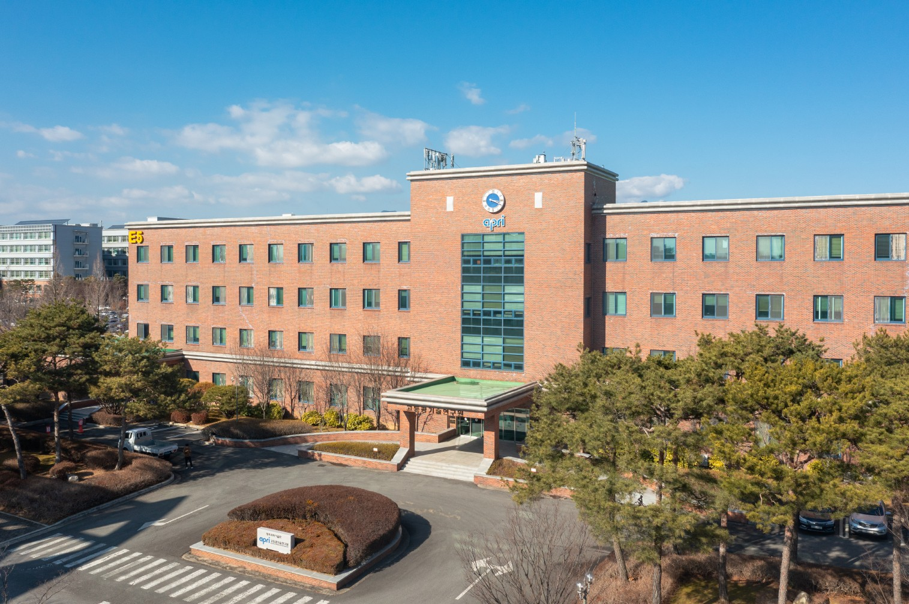

▲ Panoramic view of the GIST Advanced Photonics Research Institute
The Gwangju Institute of Science and Technology (GIST, President Kichul Lim) announced that it has been selected for the "Research on Establishing a Core Infrastructure for Laser Fusion" project under the "Fusion Plug-in Program" promoted by the Ministry of Science and ICT.
This project aims to secure core source technologies for laser fusion, which is attracting attention as a future clean energy technology, and to establish a domestic research foundation. GIST plans to use this opportunity to pursue related research in earnest.
The project will be carried out for 57 months, from April 2026 to 2030, and GIST will receive a total of 5.8 billion KRW in research and development funding. The principal investigator is Hyung-Taek Kim, a senior researcher at the GIST Advanced Photonics Research Institute (Director of the Center for Ultra-Powerful Laser Plasma Applications).
The research will be conducted jointly with GIST as the lead institution, and the Ulsan National Institute of Science and Technology (UNIST) and the Korea Atomic Energy Research Institute as participating institutions. In addition, Korea University Sejong Campus and Chosun University, among others, are also planning to participate in joint research to consolidate domestic laser fusion research capabilities.
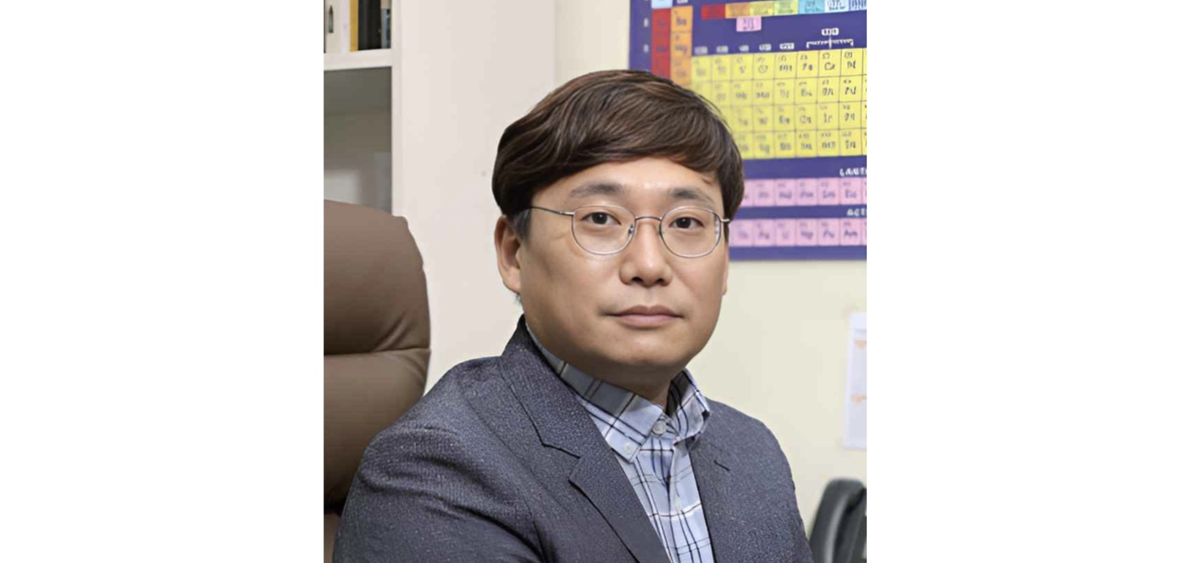

▲ GIST Advanced Photonics Research Institute Principal Researcher Hyung-Taek Kim
This project aims to verify the potential of a new fusion technology distinct from the Tokamak method, which is currently the mainstream of fusion research, and to secure core technologies necessary for the realization of future fusion power plants.
Fusion power generation is a technology that replicates the principles by which the sun generates light and heat on Earth. It is attracting attention as a promising alternative for future clean energy due to its near-zero carbon emissions and abundant fuel resources.
Laser fusion is a technology that induces a fusion reaction by focusing a super-powerful laser onto a small fuel target to instantaneously create an ultra-high temperature and high pressure environment similar to the core of the sun.
Recently, the U.S. National Ignition Facility (NIF) reported a success in which the energy obtained from the fusion reaction exceeded the laser energy input, drawing global attention to the technical feasibility of laser fusion.
- Tokamak: A representative nuclear fusion device that obtains nuclear fusion energy by confining ultra-high temperature plasma, such as that found in the center of the sun, using a magnetic field.
Recently, the government has been accelerating the expansion of large-scale research infrastructure to realize next-generation nuclear fusion energy, including the push to construct an artificial sun (nuclear fusion) research facility in Naju, South Jeolla Province. Amidst this trend, the need for technological development regarding various implementation methods for nuclear fusion energy is growing even more.
While Korea has been leading magnetic field-based fusion research centered on the Korean Superconducting Tokamak Advanced Research (KSTAR) device, the research infrastructure for laser fusion remains in its early stages.
The selection of this project is expected to serve as a significant milestone in laying the groundwork for domestic laser fusion research.
In particular, for Korea, which has a high dependence on energy imports, securing fusion technology holds great significance in terms of strengthening future energy security and achieving carbon neutrality.
Furthermore, the technologies acquired during the research process—including ultra-high-power lasers, precision optics, and plasma diagnostics and measurement—can be disseminated across various industrial sectors such as semiconductors, aerospace, national defense, and advanced manufacturing, leading to significant technological and economic ripple effects.
If related equipment and components are localized, it is expected to contribute to strengthening the competitiveness of domestic high-tech industries and fostering an industrial ecosystem.
Principal Researcher Hyung-Taek Kim said, "The selection of this project is an important opportunity to take domestic laser fusion research to the next level," and added, "I will work closely with the joint research team to secure core technologies and contribute to establishing a foundation for Korean-style laser fusion research."

