GIST partners with Synopsys to foster semiconductor talent in preparation for agent AI and HBM era
- Joint planning of specialized AI semiconductor education programs and promotion of joint research… Expanding collaboration in the semiconductor, AI, and mobility sectors
- Establishment of a full-cycle AI semiconductor education system based on global corporate partnerships… Expected to become a key hub for the Southern Region Semiconductor Cluster
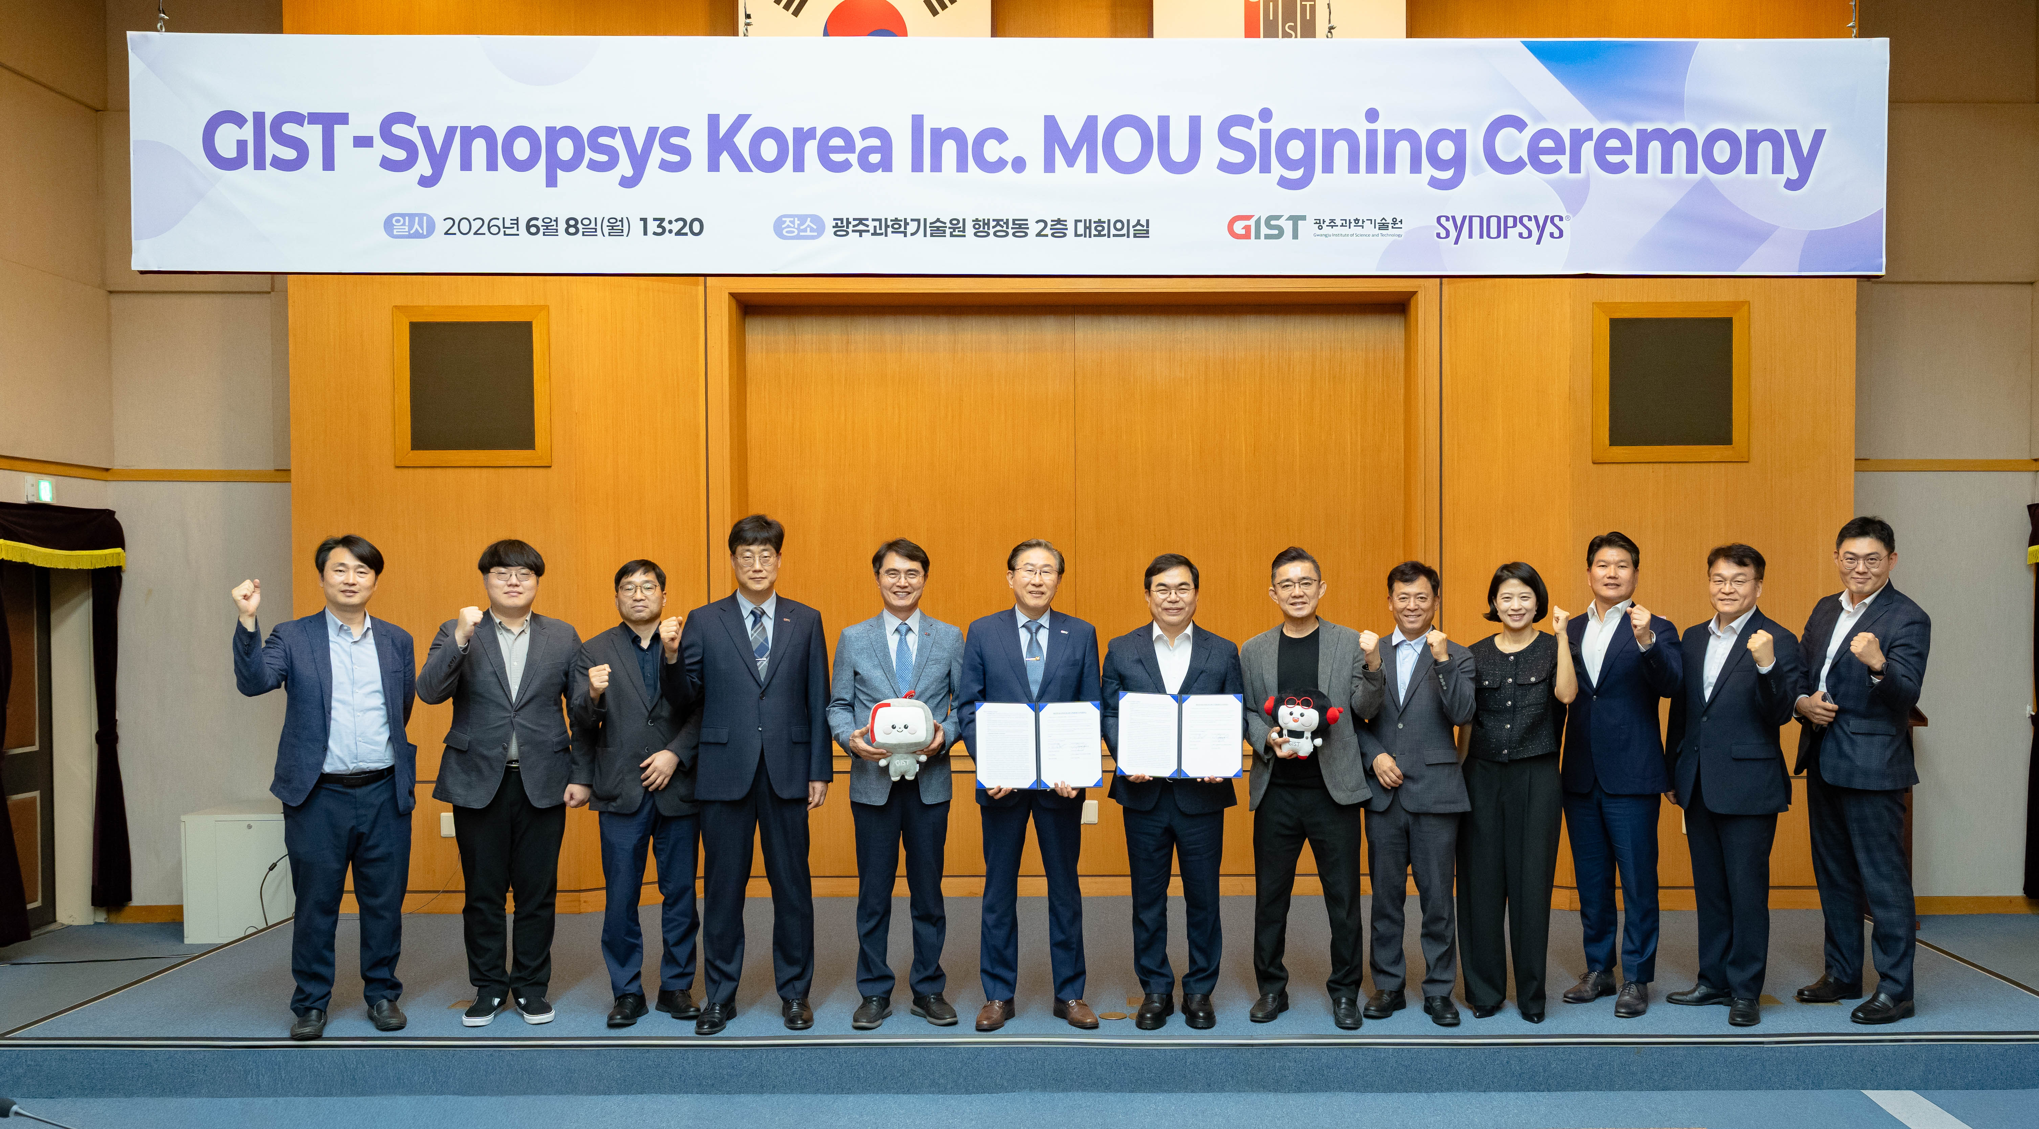

▲ On Monday, June 8, GIST President Kichul Lim (sixth from the left) and Synopsys Korea CEO Kyung-shin Soh (seventh from the left) pose for a commemorative photo after signing a Memorandum of Understanding (MOU) for fostering specialized talent in AI semiconductors and conducting joint research in the main conference room of the GIST Administration Building.
The Gwangju Institute of Science and Technology (GIST, President Kichul Lim) announced that it signed a Memorandum of Understanding (MOU) with Synopsys on Monday, June 8, in the main conference room of the GIST Administration Building, for fostering specialized talent in AI semiconductors and conducting joint research.
The signing ceremony was attended by GIST President Kichul Lim, Dean of the College of Information and Computing Kangwook Kim, Research Director Chanho Pak, Head of the Department of Semiconductor Engineering Dong-Ho Kang, and Dean of the Graduate School of Semiconductor Specialization Minjae Lee. From Synopsys, representatives from both organizations were present, including CEO Kyung-shin Soh, Executive Vice President Kyung-soo Shin, Senior Vice President Kyu-heung Kim, Director Jin-sook Kim, Deputy General Manager Yong-jin Cho, Senior Vice President Seok-yong Lim (S&A), and CEO Jin-seok Park (Synopsys partner Novel Design).
Synopsys is a leading provider of ‘Silicon to Systems’ engineering solutions that encompass everything from semiconductor design to system development and verification. Based on Electronic Design Automation (EDA), IP, and engineering simulation, the company is driving engineering innovation across industries beyond semiconductors, including AI, mobility, and energy.
This agreement was pursued to strengthen cooperation between industry and academia in response to the increasing complexity of semiconductors and the spread of AI technology, and to establish a foundation for long-term education, research, and industry collaboration linked to GIST's strategy for fostering talent in semiconductors and advanced technologies.
Through this agreement, the two institutions agreed to pursue cooperation centered on: ▴ joint planning and operation of "AI Semiconductor Specialized Education Programs"; ▴ conducting "Education Programs for Experts and Working Professionals"; and ▴ establishing "Knowledge Sharing Programs" for students, researchers, and industry.
In addition, they plan to review cooperation on human resource development programs, including education, certification, competitions, and research, and to develop these into practical cooperation models linked to regional industrial demands.
In particular, taking this collaboration as an opportunity, the two institutions intend to expand opportunities for education and knowledge sharing centered on the Silicon to Systems concept—ranging from semiconductor design to simulation, virtual verification, and digital twins—and further strengthen the foundation for industrial cooperation. Furthermore, the long-term goal is to support students so that they can acquire the design capabilities required by global semiconductor companies immediately upon graduation.
To this end, Synopsys plans to support GIST with semiconductor design infrastructure and talent development through the SARA (Synopsys Academic & Research Alliances) program.
GIST launched the Institute of Semiconductor Convergence Technology last March and has established a practical semiconductor education system linked with various global companies. Through this collaboration with Synopsys, the university has established a full-cycle education and research system encompassing AI semiconductor design, design verification, packaging, and testing. GIST aims to advance an integrated ecosystem extending from design to process, packaging, verification, and demonstration by linking this with future cooperation with Samsung Foundry.
Furthermore, GIST aims to establish a research and demonstration system integrating AI semiconductor design, advanced packaging, and design verification in conjunction with the establishment of the AI ​​Semiconductor Research Institute currently underway. It intends to leap forward as the nation's only full-cycle integrated strategic hub connecting AI algorithms, AI semiconductors, and AX demonstration.
In addition, it is expected to play a key role in the Southern Semiconductor Cluster based on collaboration with global companies such as Synopsys, Arm, NI, and Samsung Foundry.
Kyung-shin Soh, CEO of Synopsys Korea, stated, "To respond to the explosively increasing demand for memory driven by the popularization of generative AI and AI agents, advanced packaging and multiphysics technologies are required for the development of next-generation HBM." He added, "We expect that the convergence of GIST's research capabilities in semiconductors, AI, and mobility with Synopsys' Silicon to Systems engineering solutions will enable GIST graduates to acquire the skills and capabilities necessary to contribute immediately to the industrial field in an era of AI talent shortages."
GIST President Kichul Lim stated, “This collaboration with Synopsys is an important opportunity to further advance GIST’s full-cycle innovation strategy for AI semiconductors,” adding, “As a national strategic hub organically connecting AI algorithms, AI semiconductors, and AX demonstration, GIST will play a key role in strengthening the competitiveness of Korea’s AI semiconductor industry and advancing the semiconductor cluster in the southern region.”

