GIST establishes new AI College, expands admissions quota by 100... Holds joint admissions information session with 4 leading science and technology institutes
- ‘Joint Admissions Information Session for the Top Four Science and Technology Universities’ to be held at GIST Oryong Hall on Saturday, June 13
- GIST expands selection scale to approximately 330 students to foster cutting-edge talent in AI, semiconductors, and biotechnology… ‘Department of Semiconductor Engineering,’ a contract department with Samsung Electronics, to operate outside the regular quota
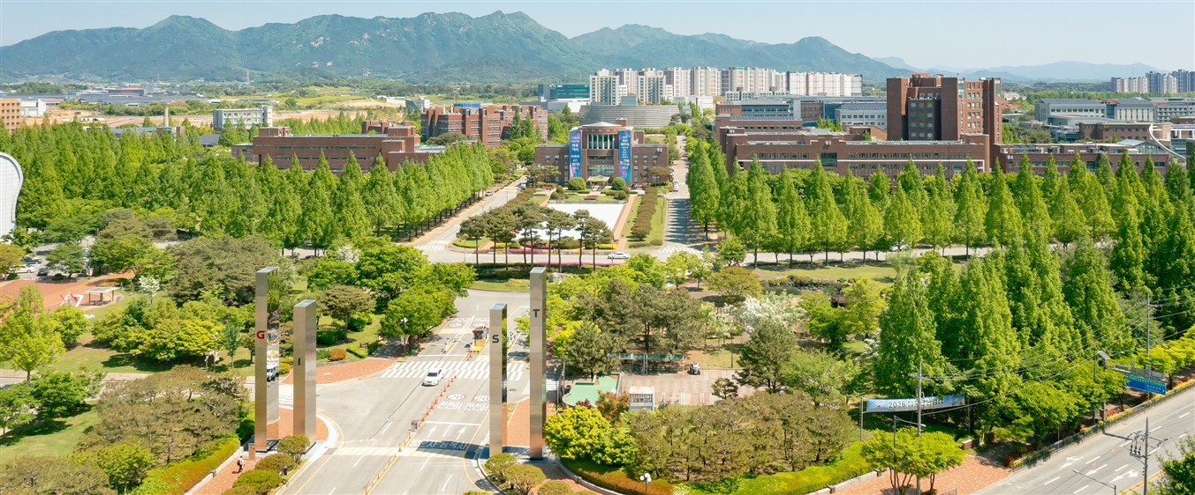

▲ Panoramic view of the GIST campus
The Gwangju Institute of Science and Technology (GIST, President Kichul Lim) announced that it will hold the ‘Joint Admissions Information Session for the 2027 Academic Year of the Four Major Science and Technology Institutes’ jointly with KAIST, DGIST, and UNIST on Saturday, June 13 at 1:00 PM in Dasan Hall on the 2nd floor of Oryong Hall
This admissions information session will proceed in the following order: ▴ attendee registration, ▴ opening remarks, ▴ guidance on undergraduate admissions for the four leading science and technology institutes, ▴ Q&A, and ▴ admissions counseling by institute.
Through this session, GIST plans to provide practical admissions information, including key details regarding the 2027 academic year admissions process, its ideal student profile and curriculum, a convergence and research-oriented educational environment, scholarship and student support systems, and career paths and research achievements after graduation.
In particular, the session will offer Q&A and individual counseling for students hoping to enroll in the four leading science and technology institutes, including GIST, to enhance their understanding of the admissions process and support customized career planning.
GIST is strengthening its AI research capabilities based on its High Performance Computing Infrastructure (HPC-AI). In addition, in the semiconductor field, the GIST Institute of Semiconductor Convergence Technology plans to operate practical education programs, such as the ‘GIST-Arm School,’ an industry-academia collaborative curriculum with global companies. Based on this, an ‘AI College’ will be established to systematically advance the AI ​​Transformation (AX) curriculum linked to the industrial field.
Accordingly, starting from the 2027 academic year, GIST plans to select a total of approximately 330 students, an increase of 100 from the previous year, and expand the cultivation of talent in cutting-edge science and technology fields such as AI, semiconductors, and biotechnology.
The Department of Semiconductor Engineering, a contract department operated in cooperation with Samsung Electronics to secure competitiveness in core semiconductor and convergence technologies and to foster high-level talent closely aligned with the industry, will select new students outside of the regular quota.
Students admitted to the Department of Semiconductor Engineering will pursue a career path that leads to employment at Samsung Electronics after obtaining a degree through an integrated bachelor's and master's program.
※
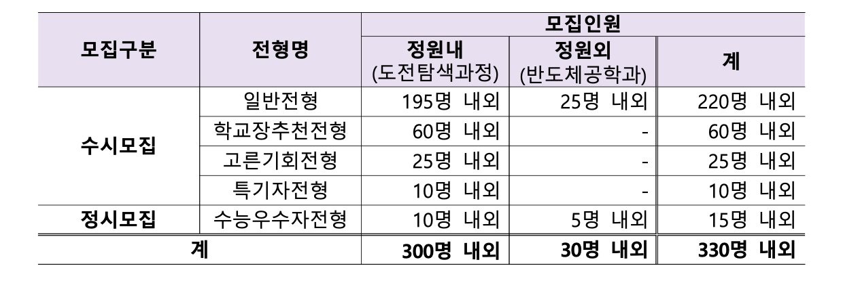
Student Affairs and Admissions Dean Soo Jong Lee, stated, “This joint admissions information session with the four leading science and technology universities is an opportunity for students hoping to enter the science and technology field to access information on the nation’s top-tier science and technology specialized universities all in one place.” She added, “Based on an educational and research environment that meets the demands of the times, such as the establishment of the College of AI and the operation of the Department of Semiconductor Engineering, GIST will do its utmost to cultivate talent that will lead future advanced industries.”
Meanwhile, detailed information regarding this admissions information session can be found on the GIST Admissions Office website (https://www.gist.ac.kr/uadm/main.html). < End >

