GIST and other top 4 science and technology institutes to support deep tech startups' global market entry
-Recruitment of participating companies for ‘2026 Emerging Tech Global Launchpad’, applications accepted until June 19
- 50 promising startups in the AI, quantum, and bio fields selected… Full support for the global commercialization cycle including overseas proof of concept (PoC), global acceleration, investment linkages, and expert mentoring
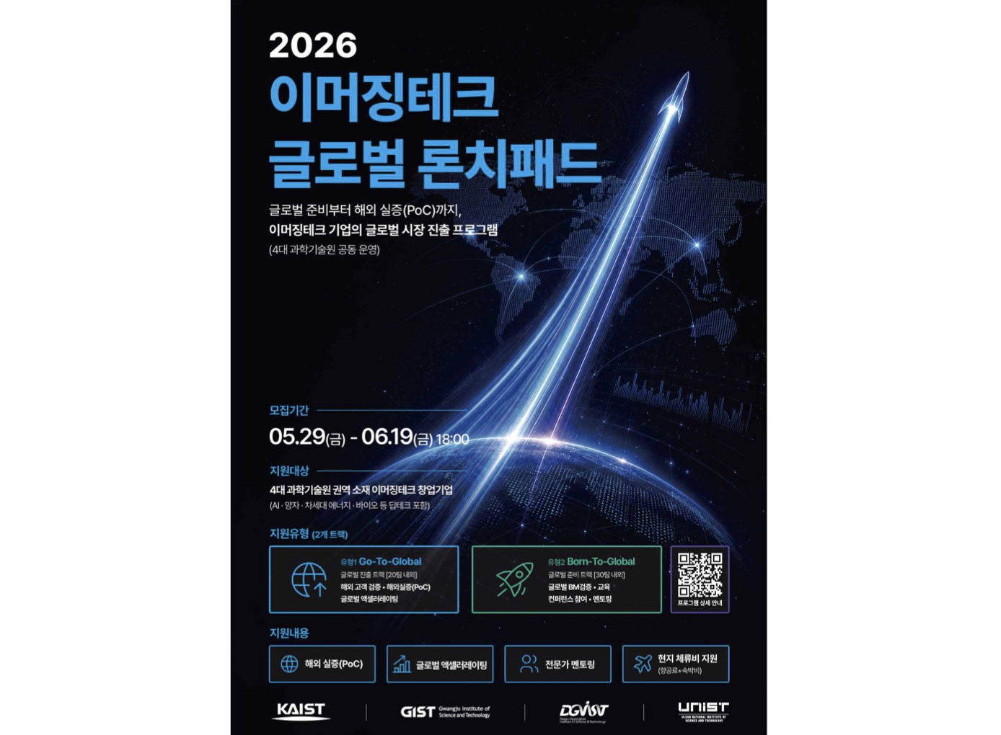

▲ Poster for the 4 leading science and technology institutes' '2026 Emerging Tech Global Launchpad'
The Gwangju Institute of Science and Technology (GIST, President Kichul Lim) announced that, with the support of the Ministry of Science and ICT, it is recruiting participating companies for the ‘2026 Emerging Tech Global Launchpad’ in collaboration with KAIST, DGIST, and UNIST.
The ‘Emerging Tech Global Launchpad’ is a program designed to support the global market entry of startups based on emerging tech fields such as AI, quantum, next-generation energy, and bio. It assists in verifying the potential for global commercialization and conducting proof-of-concept (PoC) overseas, leveraging the technological capabilities secured domestically.
The application period runs from May 29 to June 19 at 6:00 PM. Selected companies will receive comprehensive support covering the entire process of entering the global market, including overseas proof-of-concept (PoC), global acceleration, expert mentoring, connections to international conferences, and support for local living expenses (airfare and accommodation).
This program is significant in that it systematically supports the entry of regional deep tech startups into the global market by leveraging the regional startup networks and overseas cooperation infrastructures possessed by the four leading science and technology institutes.
GIST will oversee the Honam region, KAIST the Central region, DGIST the Daegu-Gyeongbuk region, and UNIST the Southeast region, planning to identify and support promising emerging tech startups in their respective areas.
Notably, if a company representative is affiliated with one of the four leading science and technology institutes, they are permitted to apply through their respective institution regardless of the company's location. This measure is intended to expand global opportunities for startups founded by faculty, researchers, and students affiliated with these institutes. The support program operates in two tracks based on the company's growth stage and readiness for global expansion: the ‘Go-To-Global Track’ and the ‘Born-To-Global Track.’
The ‘Go-To-Global Track’ targets companies that are already pursuing entry into overseas markets or attempting initial entry, selecting approximately 20 companies. Selected companies will verify their technological suitability and commercialization potential through overseas Proof of Concept (PoC) and receive support including connections with local partners, establishment of demonstration environments, global networking, and expert mentoring.
The ‘Born-To-Global Track’ is designed for companies seeking to systematically strengthen their capabilities for overseas expansion and selects approximately 30 companies. Participating companies will be provided with customized training and acceleration programs centered on the advancement of global business models (BM), the establishment of strategies to attract foreign investment, and methodologies for entering local markets.
Subsequently, the program plans to expand opportunities for overseas commercialization and network building with investors, global companies, and industry stakeholders by linking with international conferences held at global innovation hubs such as the East and West Coasts of the United States and Singapore.
President Kichul Lim stated, “For emerging tech startups to grow in the global market, it is crucial to secure not only excellent technological capabilities but also local market validation and commercialization capabilities.” He added, “GIST, together with the four major science and technology institutes, will lead the global expansion of the technology startup ecosystem in the Honam region and actively support excellent technology-based startups in the region so that they can grow into competitive companies in the global market.”
Meanwhile, the ‘2026 Emerging Tech Global Launchpad’ is an example of expanding the scope of cooperation to include support for global commercialization targeting companies, following ‘GRAVITY 2026 (Deep Tech Student Startup Integrated League),’ which is being jointly promoted by the four major science and technology institutes.
It is significant in that it has expanded the scope of support beyond discovering student startups to include overseas demonstration and global market entry for regionally based emerging tech startups.
Detailed recruitment schedules, eligibility requirements, and application methods can be found on the official ‘2026 Emerging Tech Global Launchpad’ information page (launchpad2026.io).

