GIST announces winners of the 3rd Science Imagination Children's Art Contest
- 230 entries received from elementary school students nationwide at the competition held on Saturday, May 16… Children’s imagination for future science and technology draws attention
- Established as a family-friendly science and culture festival… 56 winning entries on display at Oryong Art Hall
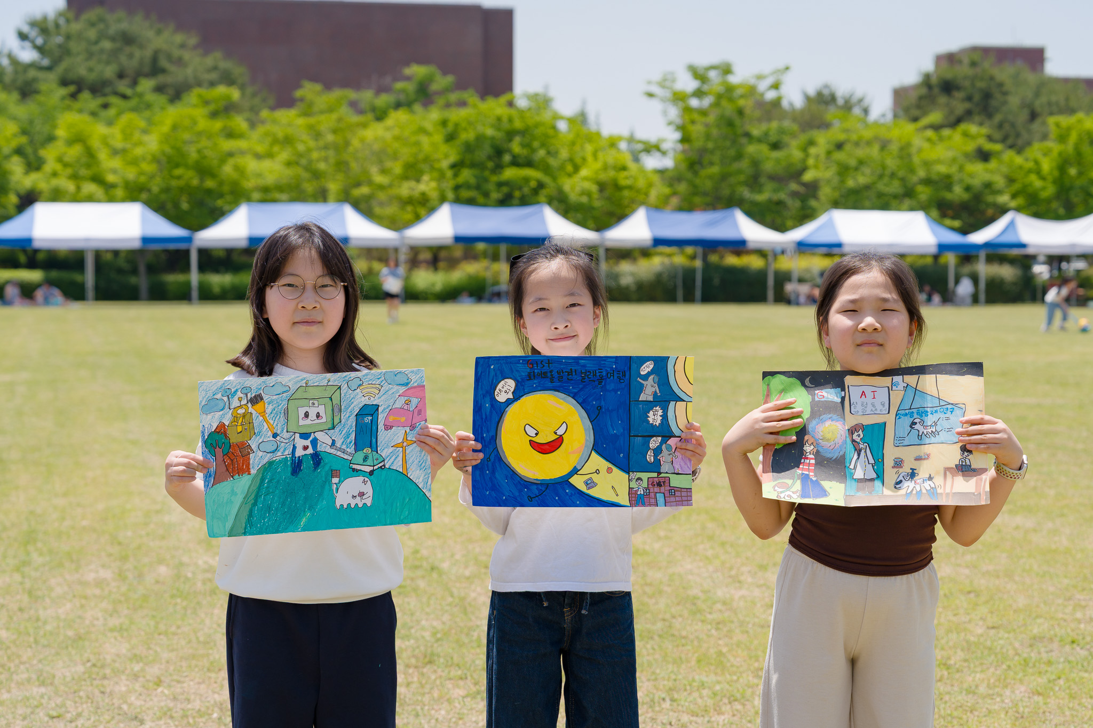

▲ Children participating in the ‘3rd GIST Science Imagination Children’s Art Contest’ are posing for a commemorative photo holding their own artworks.
The Gwangju Institute of Science and Technology (GIST, President Kichul Lim) announced the selection of 56 final winners for the ‘3rd GIST Science Imagination Children’s Art Contest,’ which was held successfully on Saturday, May 16.
A total of 230 entries were received from elementary school students nationwide for this contest, and 56 works were selected as final winners following evaluation by a panel of professional judges.
The Grand Prize (GIST President’s Award) was awarded to ▴ Jae-woo Um (Gwangyang Jecheol Nam Elementary School) in the lower grades category and ▴ Han-gyeol Ko (Misan Elementary School) in the upper grades category.
The Gold Prize (GIST Foundation Chairman's Award) was awarded to ▴ Da-hyun Kim (Suwan Elementary School) and ▴ Yul-ha Jeon (Jeseok Elementary School) in the lower grades division, and ▴ Na-yun Kim (Seoul Jamsin Elementary School) and ▴ So-dam Jung (Hanam Jungang Elementary School) in the upper grades division.
The Silver Prize (GIST Foundation Chairman's Award) was awarded to ▴ Yu-an Oh (Kyungyang Elementary School), ▴ Geon-ha Lee (Suwan Elementary School), and ▴ Jae-hee Lee (Hanaram Elementary School) in the lower grades division, and ▴ Min-woo Kang (Hwajungnam Elementary School), ▴ Da-eun Seo (Wolgok Elementary School), ▴ Ha-eun Jo (Songbit Elementary School), and ▴ Seon-woo Hong (Daejeon Saemirae Elementary School) in the upper grades division.
The Bronze Prize (GIST Vice President for Public Affairs Award) was awarded to ▴ Hyeon-jun Gu (Jeongam Elementary School) and 4 others in the lower grades division, and ▴ Hyo-jun Kim (Juwol Elementary School) and 3 others in the upper grades division, while the encouragement award (GIST Dean of International and Public Affairs) was awarded to ▴ Un-chan Kim (Unri Elementary School) and 6 others in the lower grades division, and ▴ Hwan-hee Kim (Jeongam Elementary School) and 6 others in the upper grades division.
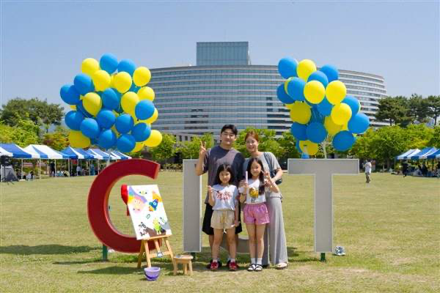

▲ A family is taking a commemorative photo at the venue of the ‘3rd GIST Science Imagination Children’s Art Contest.’ The two daughters also participated in last year’s contest, adding further significance to the event.
Honorable Mentions (GIST Oryong Art Hall Art Director Award) were selected: ▴ Do-yoon Kim (Jeongam Elementary School) and 9 others in the Lower Grades Division; and ▴ Kadathala Lithisha (Jeongam Elementary School) and 9 others in the Upper Grades Division.
The winning works are scheduled to be exhibited for approximately one month, until June 26 (Friday), on the 3rd floor of ‘Oryong Art Hall,’ an exhibition space within ‘Oryong Hall,’ a multi-purpose building on campus operated by GIST as a venue for community exchange and cooperation.
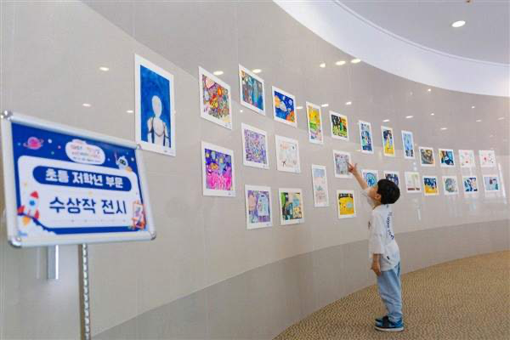

▲ A child points to and looks at their own artwork at Oryong Art Hall, where the exhibition of winning works from the ‘3rd GIST Science Imagination Children’s Art Contest’ is being held.
The ‘GIST Science Imagination Children’s Art Contest,’ which has established itself as a representative regional science and culture event spreading the values ​​of sharing and mutual growth, was held this year amidst high interest, following the successful 2nd contest held last year.
On this day, approximately 500 people, including the participants' families, visited the GIST campus. Children freely captured their imagined visions of the future society on canvas throughout the lawn plaza in front of the Central Library, using themes such as space, AI, robotics, mobility, and energy.
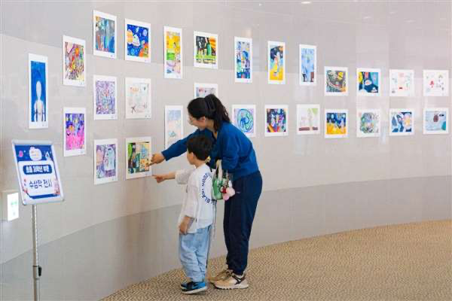

▲ A child examines artwork with their mother at the Oryong Art Hall, where the winning entries of the ‘3rd GIST Science Imagination Children’s Art Contest’ are on display.
This art contest unfolded as a science and culture festival for families to enjoy together, going beyond a simple competition by running various related programs and hands-on activities.
In particular, the ‘Principles of Airships Learned with Balloon Robots’ program, led by Jong-won Lee, CEO of the GIST student startup ‘Icarus,’ received such a great response that registration closed within just one hour of opening. Participating children experienced the principles of flight and maneuvering by directly controlling airships using wireless remote controls.
In addition, various side events were prepared, including the "Capture a Family Photo" event, where photos were taken against the campus backdrop and printed immediately, as well as cotton candy, balloon art, and bubble experiences.
Soon-im Choi, Art Director of Oryong Art Hall, who served as a judge, said, "The children's works fully captured their unique breath and energy, and it was particularly impressive how they freely and vividly expressed the scientific worlds they imagined." She added, "I hope this competition was a meaningful time for the children to naturally experience the intersection of art and science."
Meanwhile, GIST began recruiting participants nationwide on a first-come, first-served basis via its website and QR codes on posters starting April 30. As a result, approximately 250 students, including kindergarteners and elementary schoolers, applied. Despite expanding the recruitment scale by 50 compared to last year, registration closed within a week of opening, demonstrating the high level of interest.

