GIST Techno Management Business Academy (GTMBA) launches 16th Alumni Association
- Young-gui Cho, CEO of Youngjae FS Co., Ltd., appointed as President of the 16th Alumni Association… Promoting expansion of industry-academic cooperation network
- Expected to expand industry-academic cooperation based on over 620 alumni and strengthen regional industrial competitiveness
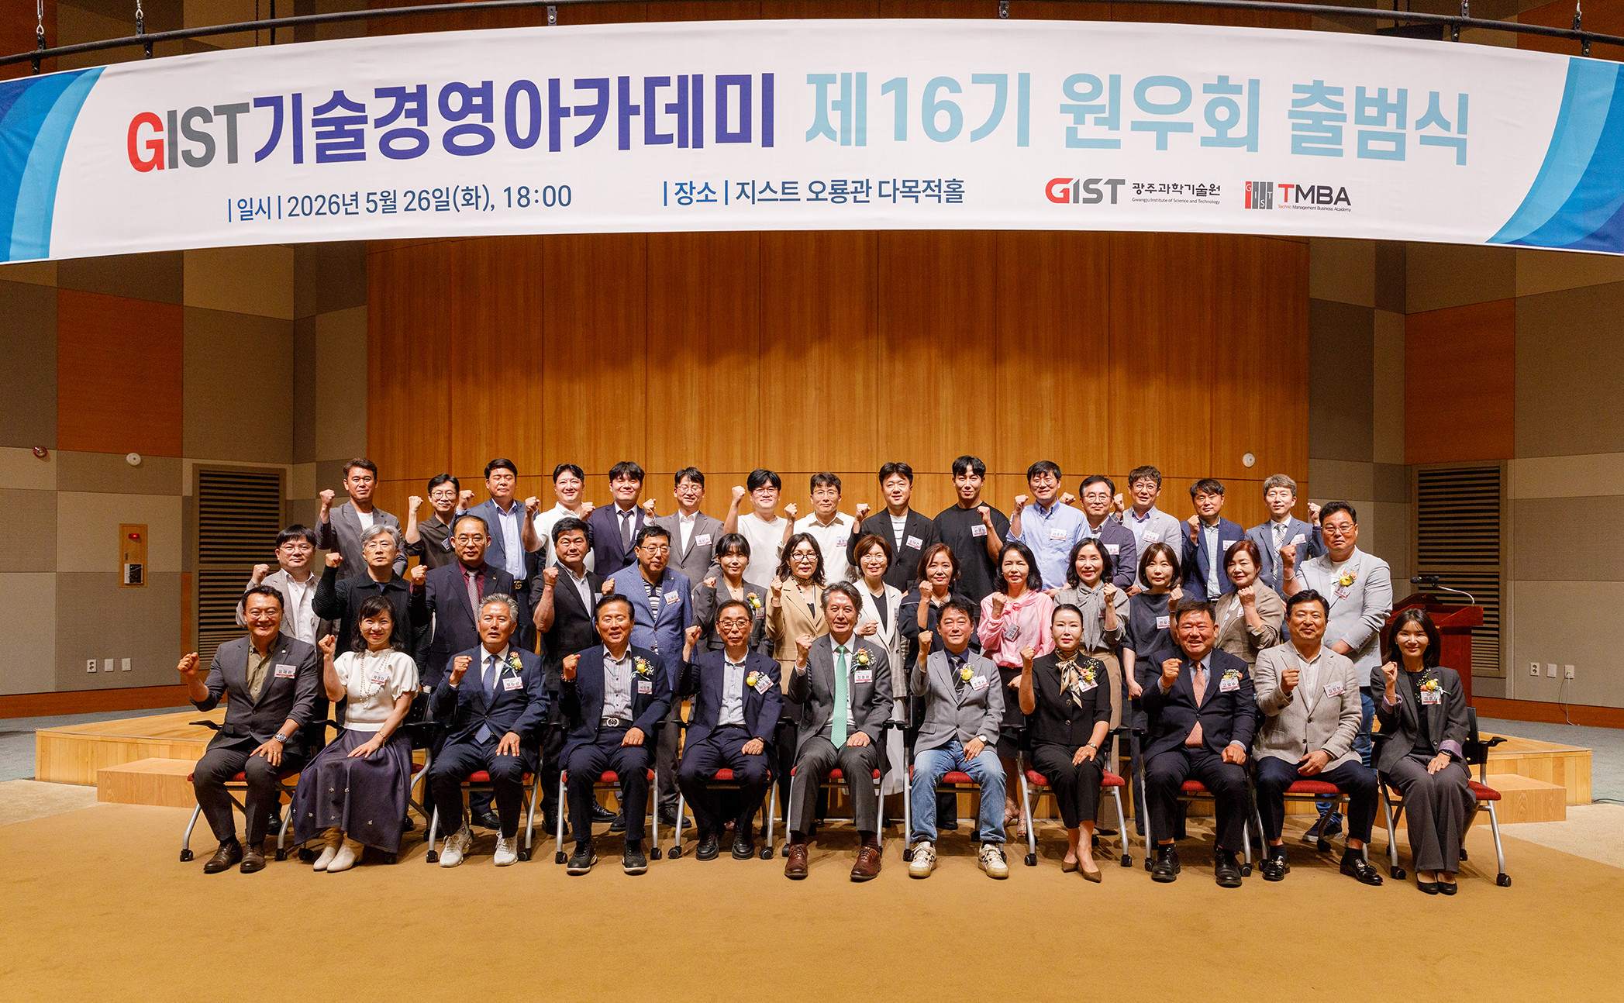

▲ Attendees pose for a commemorative photo after the launch ceremony for the 16th Alumni Association of the GIST Techno Management Business Academy (GTMBA) held on Tuesday, May 26.
The Gwangju Institute of Science and Technology (GIST, President Kichul Lim) announced that it held the launch ceremony for the 16th Alumni Association of the Technology Management Academy (GTMBA) at Oryong Hall on May 26.
Approximately 60 people attended the event to celebrate the launch, including Vice President for Public Affairs Yonghwa Chung, Academy Director Professor Eunji Lee, GTMBA alumni, and members of the 16th cohort.
In his congratulatory remarks, Public Affairs Yonghwa Chung stated, “GTMBA has grown into a network platform for executives that integrates science and technology with management, while flexibly responding to the rapidly changing business environment.” He added, “I hope this serves as an opportunity to broaden the foundation for mutual cooperation and grow together through our educational programs and various exchange activities.”
In his inaugural address, Young-gui Cho, President of the Alumni Association (CEO of Youngjae FS Co., Ltd.), stated, “GTMBA is a venue for exchange where the latest industry trends meet executive leadership.” He added, “By connecting GIST’s excellent science and technology infrastructure with the business capabilities of our alumni, we will expand mutually beneficial industry-academia cooperation and contribute to the development of the regional industrial ecosystem.”
In his congratulatory remarks, Seong-su Ko, President of the General Alumni Association, said, “Let us further strengthen bonds among alumni and create synergy for mutual growth as reliable partners so that GTMBA can leap forward to become a top-tier academy representing Korea beyond the region.”
Since its opening in 2010, the GIST Academy of Technology Management has established itself as a leading executive education program in the region, producing over 620 business leaders active in diverse fields including business, politics, the public sector, research, and industry.
Furthermore, through an innovative curriculum designed to respond to rapidly changing market environments, it supports the expansion of students' future visions while contributing to the revitalization of the regional industrial ecosystem through practical technology matching and industry-academia collaboration.
The executive team and key executives of the 16th cohort are as follows.
▴ Chairman: Young-gui Cho, CEO of Youngjae FS Co., Ltd. ▴ Senior Vice Chairman: Sook Jung, CEO of Mana Co., Ltd. ▴ Auditor: Bok-hee Cho, General Director of Y-Sikjae Muan Co., Ltd. ▴ Advisors: Woon-hwa Noh, CEO of Geoglobal Co., Ltd.; Mi-sook Kang, CEO of Geumpo Co., Ltd. ▴ Vice Chairmen: Mi-kyung Park, CEO of Hanmac Chemical Co., Ltd.; Kwon-cheol Choi, CEO of Green Lawn Farming Cooperative; Yun-mo Kim, Managing Director of Kumho P&B Chemical; Hee-jung Jung, Department Head at Korea Hydro & Nuclear Power Co., Ltd. ▴ Secretary General: Chun-soo Yoon, CEO of Doosan Heavy Industries Co., Ltd. ▴ Treasurer General: Soo-young Choi, CEO of CS&D Dallae Coffee ▴ Cultural Tour Committee Chairperson: Da-won Jung, CEO of Korea Occupational Safety and Health Center Co., Ltd. ▴ Public Relations Committee Chairperson: Jong-ju Ryu, CEO of Suwan Green Energy

