GIST selected for Ministry of Science and ICT's 'Unicorn Project'... Launches commercialization of low-light photovoltaics (LPV) based on industry-academic consortium
- Faculty startup LEECELL Co., Ltd. collaborates with client company Sensing Plus Co., Ltd.… Total of 1.8 billion KRW in support for the commercialization of university source technologies
- Promoting the commercialization of next-generation distributed power technology to overcome battery replacement limitations through the demonstration of self-generating sensors for smart factories
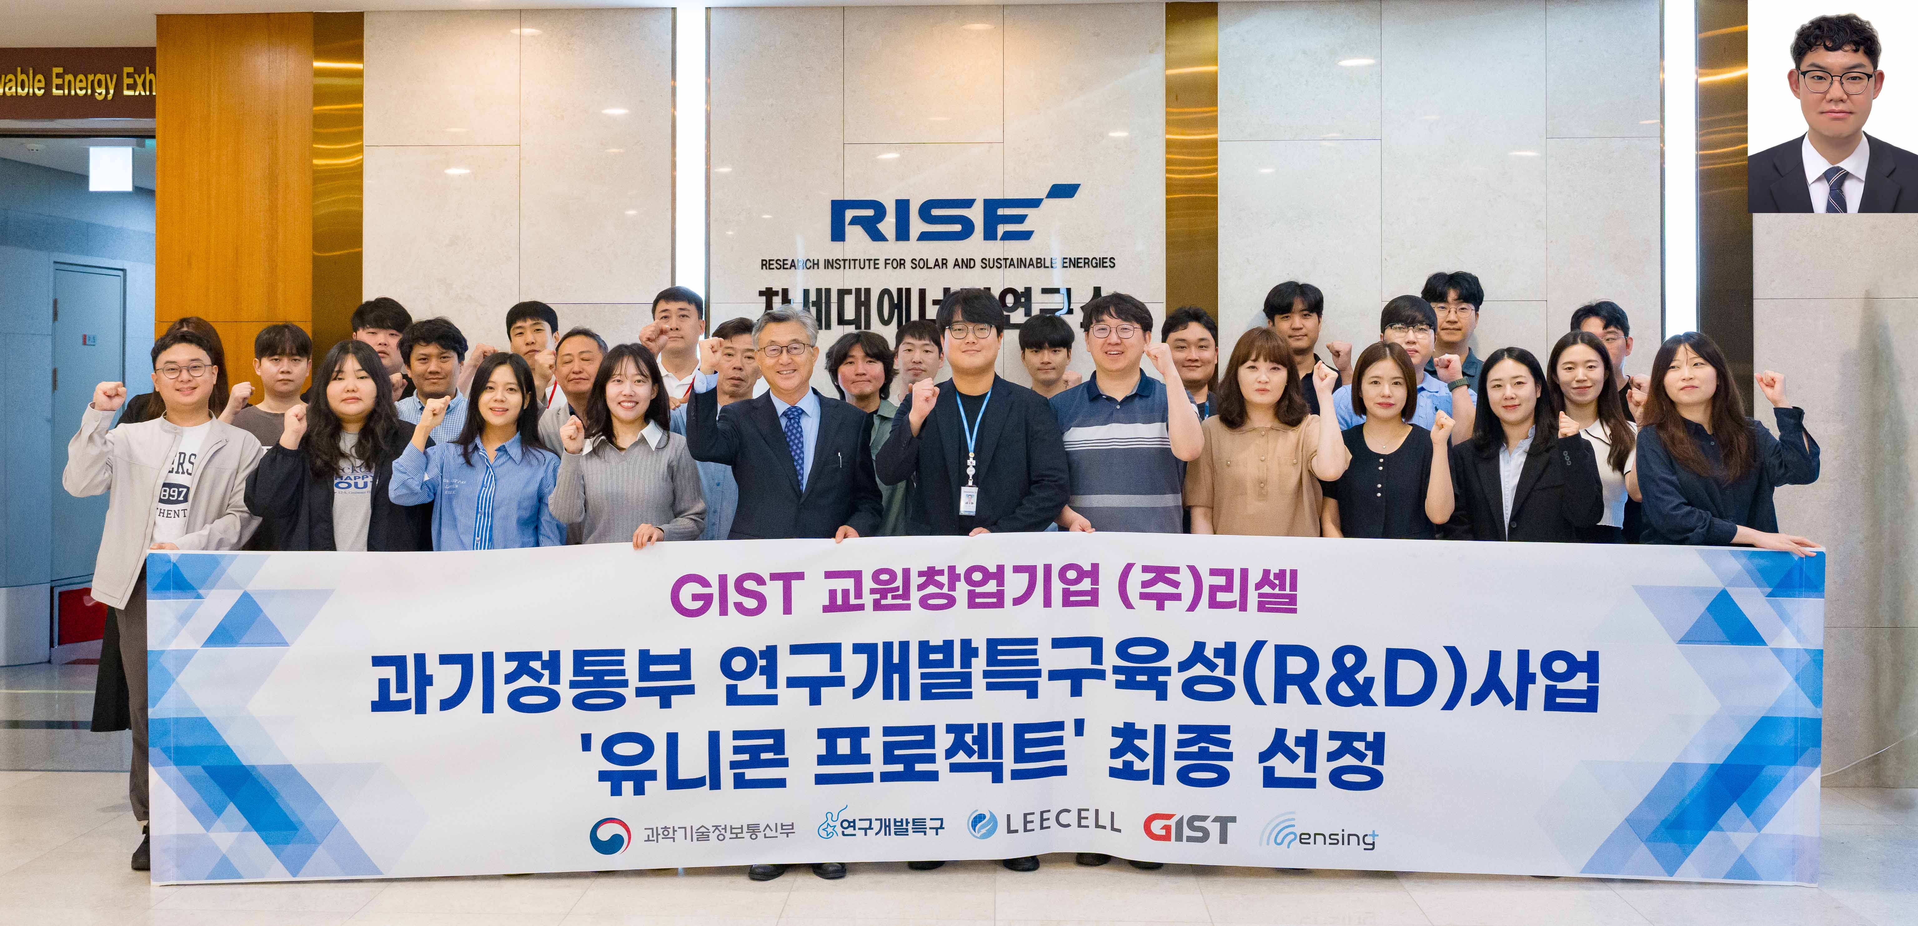

▲ GIST, LEECELL Co., Ltd., and Sensing Plus Co., Ltd. formed a consortium and were finally selected for the ‘Unicorn Project,’ a strategic technology excellence commercialization project organized by the Ministry of Science and ICT. (Top Right) Yong-wook Kim, CEO of Sensing Plus Co., Ltd.
The Gwangju Institute of Science and Technology (GIST, President Kichul Lim) announced that it formed a consortium with faculty startup LEECELL Co., Ltd. (CEO Kwanghee Lee, Visiting Distinguished Professor in the Department of Materials Science and Engineering) and Sensing Plus Co., Ltd. (CEO Yong-wook Kim) and was finally selected for the ‘Unicorn Project,’ a strategic technology research achievement commercialization support project organized by the Ministry of Science and ICT.
The ‘Unicorn Project’ is a program that supports product development and mass production to help companies pursuing commercialization using excellent research results from public research institutions grow into unicorn companies (unlisted startups with a corporate value of over 1 trillion won and less than 10 years since founding). It provides support tailored to the company's growth stage across a total of three stages.
First, it supports the attraction of initial investment and the creation of technology-based commercialization results (Stage 1), and supports product mass production and full-scale scale-up following market validation (Stage 2). Subsequently, it supports the full-cycle growth of companies by supporting technology and product advancement to secure global competitiveness (Stage 3).
LEECELL Co., Ltd., the lead company for this project, will receive a total of 1.8 billion KRW in support from April of this year to December 2027 for the development of ▴ advanced materials and processes, ▴ joint demonstration, and ▴ product marketing and promotion.
The core technology of this project, "Low-light Photovoltaics (LPV)," is a next-generation solar cell technology capable of generating electricity even in low-brightness environments such as indoor lighting. It is attracting attention particularly for its ability to power sensors and devices without a separate power supply in smart factory environments operated based on the Internet of Things (IoT) and Artificial Intelligence (AI).
GIST plans to advance the source technology for high-stability LPV core materials optimized for indoor lighting environments and transfer it to Resell Co., Ltd.
In addition, Sensing Plus Co., Ltd. plans to apply LEECELL's LPV to its industrial sensors to verify the performance and reliability of battery-free, self-generating sensors in actual smart factory environments.
Through this, it is expected that maintenance costs for smart factories will be reduced and the limitations of battery replacement will be overcome, while simultaneously laying the foundation for improved energy efficiency and the commercialization of eco-friendly distributed power generation technologies.
This project is highly significant as an industry-academia collaboration model that combines GIST’s source technology, the commercialization capabilities of faculty startups, and the field demonstration capabilities of client companies.
GIST will be responsible for technical support throughout the project, including the advancement of materials technology, technology transfer, and R&D consulting. Furthermore, it plans to support the strengthening of product competitiveness through the development of LPV-specific materials and subsequent technical support.
LEECELL Co., Ltd. will play a key role in developing, mass-producing, and commercializing LPV based on GIST’s source technology.
Sensing Plus Co., Ltd. plans to apply LPV technology to industrial safety sensors to conduct demonstration tests in a smart factory environment and secure quality data for product mass production.
Hongkyu Kang, Deputy Director of the GIST Research Institute for Solar and Sustainable Energies (and Vice President and CTO of LEECELL Co., Ltd.), stated, “The selection for this Unicorn Project is an example demonstrating the potential of a research outcome commercialization model where a university’s source technology leads to corporate product development and field demonstration.” He added, “We expect this to contribute to the creation of a next-generation self-generating sensor market by accelerating the practical application and industrial application of low-light photovoltaic technology.”

