GIST Oryong Art Hall holds 20th invitational exhibition... Artist Dong-ho Kang's 'The Imperfect Angel'
- 70 paintings crafted with the sensibility of pop art and graffiti… Open to the public until June 30
- Visualizing inner human emotions and memories through intense colors and dreamlike, symbolic imagery, offering a sense of deep immersion
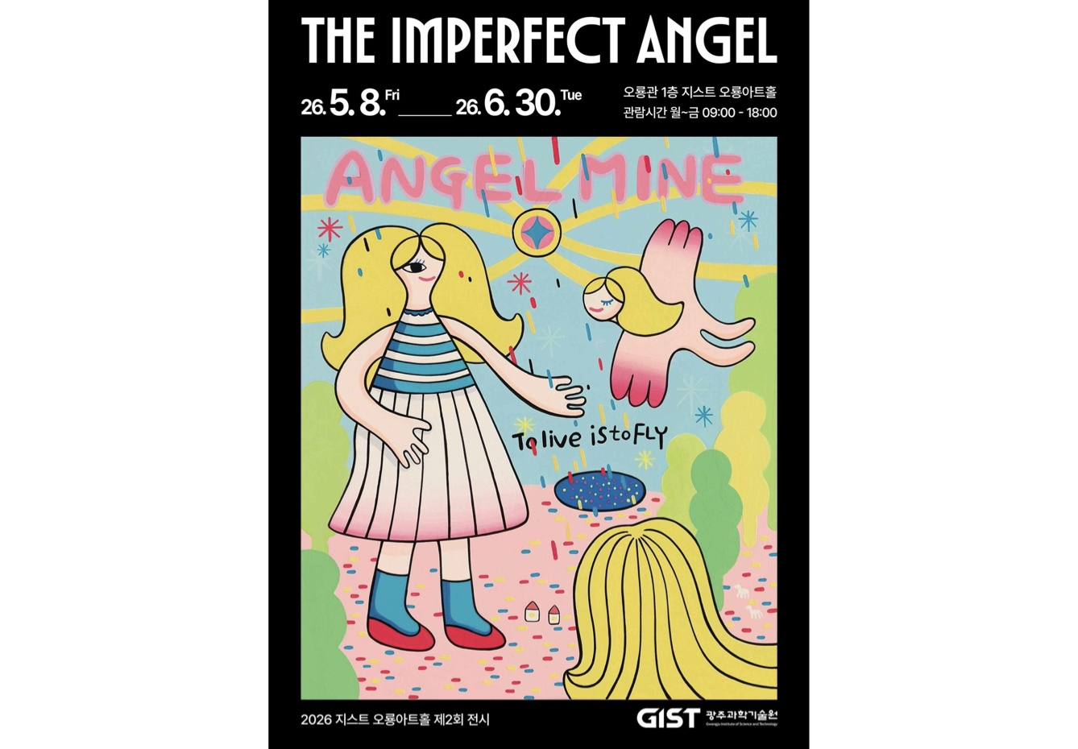

▲ Poster for Artist Dong-ho Kang's Invitational Exhibition at GIST Oryong Art Hall
"The Imperfect Angel," an invitational exhibition by artist Dong-ho Kang—who has explored inner human emotions and memories based on the sensibilities of pop art and graffiti—is currently being held at the Oryong Art Hall of the Gwangju Institute of Science and Technology (GIST, President Kichul Lim).
As the 20th invitational exhibition at Oryong Art Hall, which opened in 2022, this exhibition showcases 70 paintings that reflect the artist's emotions and personal experiences, and is open to the public from May 8 to June 30.
Artist Dong-ho Kang has sculpturally explored images of the human inner self, emotions, and memories by adding the unique visual sensibilities of pop art and graffiti to his paintings and printmaking works. He has built his own unique artistic world by reconstructing the traces of emotions and memories encountered in life through simplified forms and intense colors.
In particular, while actively utilizing primary colors and hues close to fluorescent tones, the artist creates a dreamy and surreal atmosphere to symbolically visualize emotions and inner images.
Intense colors and dreamlike images unfold within the exhibition space, allowing visitors to visually experience transcendent beings such as angels, souls, and the inner self.
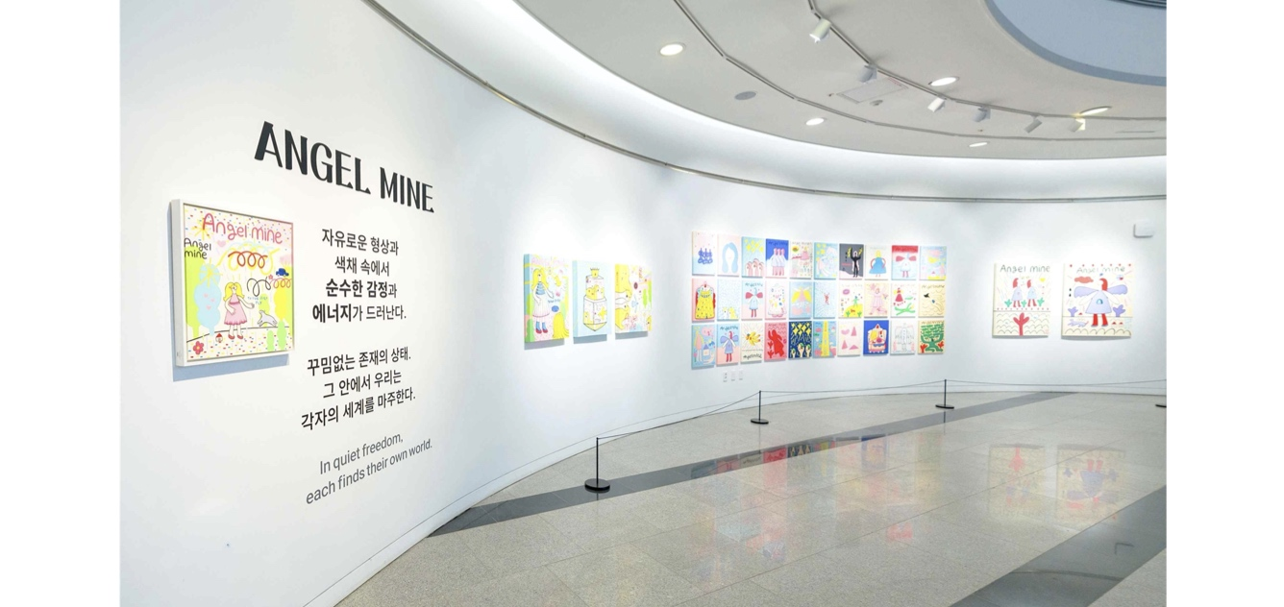

▲ A view of the exhibition "The Imperfect Angel," a solo exhibition by artist Dong-ho Kang, currently being held at the GIST Oryong Art Hall.
Artist Kang Dong-ho majored in printmaking media at Chosun University and studied art education at the university's Graduate School of Education.
Starting with his first solo exhibition "Nameless Friends" held in Gwangju in 2010, he has continued to develop his unique artistic world by holding a total of 13 solo exhibitions at major venues in Korea, including "Jeojakgeori" (2014) at the Seoul Arts Center and "Angel mine" (2022) at Gaon Gallery. In particular, the artist garnered attention in 2018 after being selected as a participating artist for the Gwangju Biennale, where they showcased experimental paintings at the National Asian Culture Center.
Furthermore, the artist continues to be active in creating works at major domestic and international art fairs, such as the Seoul Art Show, Urban Break, Daegu Art Fair, and Busan BAMA, as well as on international stages including Singapore and Taiwan.
The representative work of this exhibition, "Angel Mine," is titled by combining "Angel" and "Mine," meaning "mine." It was created inspired by the song of the same name by the Canadian alternative rock band Cowboy Junkies, which the artist frequently listened to while working.
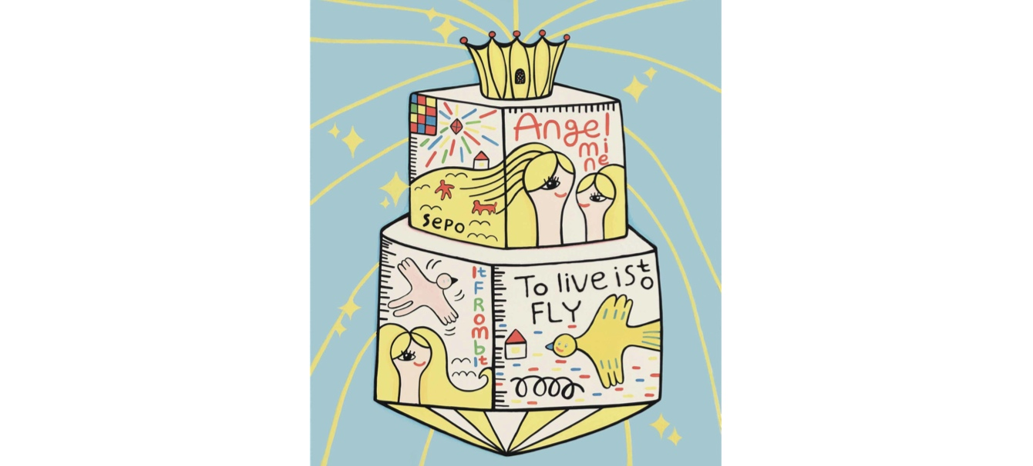

▲ Artwork from the solo exhibition of artist Dong-ho Kang at GIST Oryong Art Hall (Angel Mine, 72.7×60.6cm, acrylic on canvas, 2025). Through the ambiguous figure of a woman—whether she is an angel or a girl—the artist projects his personal dreams and hopes, unfolding them onto the canvas through a colorful series.
In particular, the phrase "To live is to fly" within the work embodies the artist's perspective and philosophy of viewing life as an act of soaring freely. This symbolizes that humans are beings who, while living with their own imperfections, ceaselessly move forward toward their own unique direction.
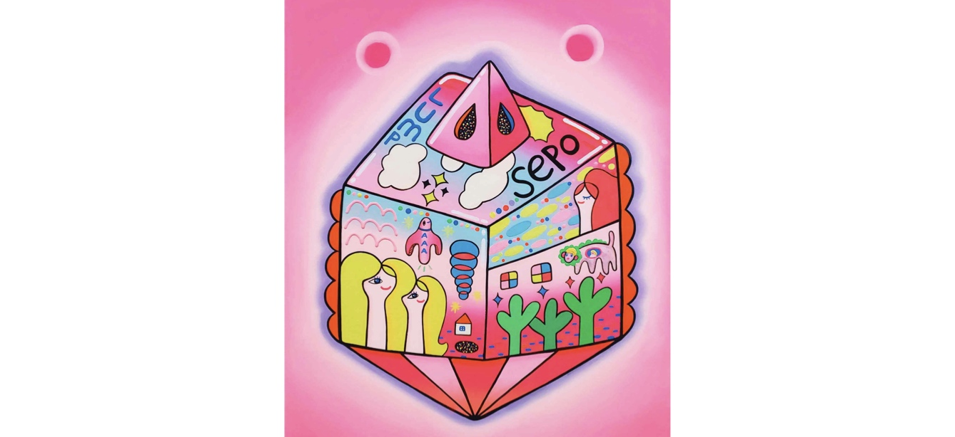

▲ Artwork from the solo exhibition of artist Kang Dong-ho at GIST Oryong Art Hall (Angel Mine, 72.7×60.6cm, acrylic on canvas, 2025)

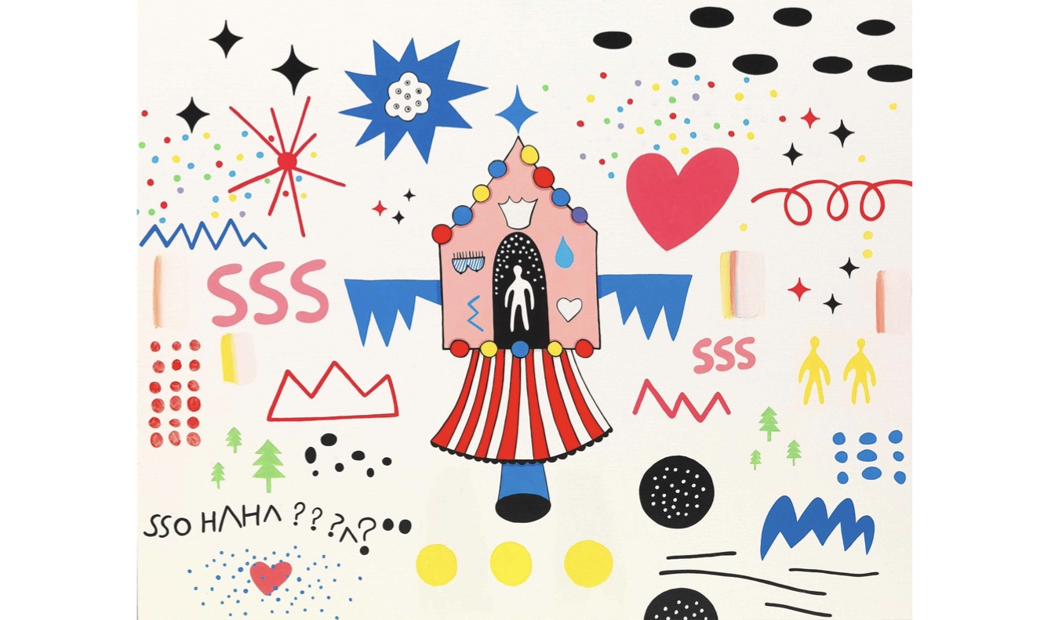

▲ Artwork exhibited at the solo exhibition of artist Kang Dong-ho at GIST Oryong Art Hall (The Beginning of a Dream, 120×97cm, acrylic on canvas, 2017). Another work, "The Beginning of a Dream," visualizes the moment when an image is born as reality and the unconscious intermingle.
For artist Dong-ho Kang, "dreams" are not merely mirrors reflecting reality, but symbolize the starting point where the unconscious transforms into visual images and reveals itself. Accordingly, he captured the ethereal fleeting moments where the unconscious and reality meet, depicting them on canvas.
Artist Kang explained, "This work expresses the ambiguous boundary where it is impossible to distinguish whether imagination exists within a dream or whether one is dreaming within imagination." He added, "I reinterpreted dreams through a sense of ceaselessly generating and transforming through the chain and collision of emerging images."

▲ A view of the exhibition “The Imperfect Angel,” a solo exhibition by artist Kang Dong-ho, currently being held at GIST Oryong Art Hall.
Artist Dong-ho Kang stated, “As imperfect beings, we live with complex emotions where joy and sorrow, hope and anxiety coexist.” He added, “I hope this exhibition serves as an opportunity for visitors to look at humans and themselves as imperfect beings just as they are, and to reflect on the emotions and memories remaining in their unconscious.”
Soon-im Choi, Art Director of Oryong Art Hall, remarked, “Artist Dong-ho Kang’s artistic world, which combines intense primary colors, a free-spirited graffiti style, and the intuitive imagery characteristic of pop art, sensuously evokes the emotions of modern people.” She continued, “I hope this exhibition becomes a time to pause briefly amidst busy daily life and listen to one’s inner voice.”
Meanwhile, Oryong Art Hall is an exhibition space established by GIST on the interior walls of the first and second floors of the multi-purpose building, Oryong Hall, to facilitate communication with the local community.
Starting with its first invitational exhibition in December 2022, it has held a total of 20 exhibitions, including this “The Imperfect Angel,” and is establishing itself as an open cultural and artistic space that connects the local community with art within the research university campus.

