GIST hosts ‘GIST Honors Dinner’ to encourage students who have brought honor to the community
- Inviting 40 current students active in various fields such as academics, research, student self-governance, and social contribution
- Promoting development into a representative traditional GIST event for recording and sharing student achievements
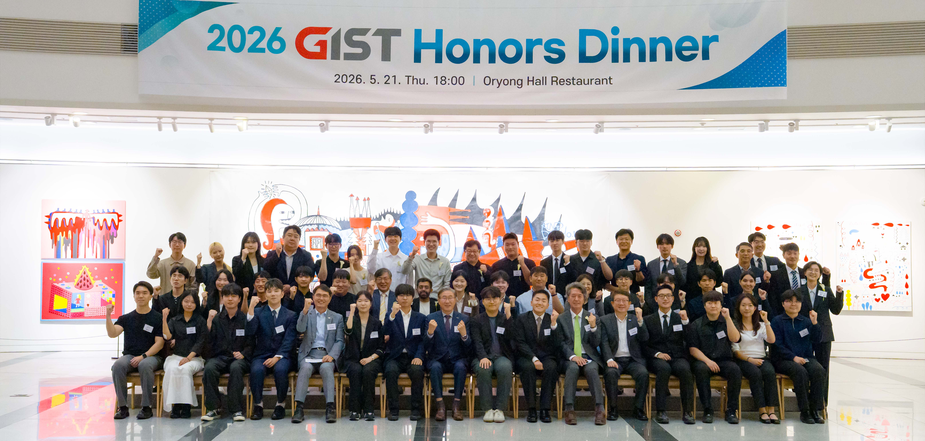

▲ Attendees pose for a commemorative photo at the ‘GIST Honors Dinner’ held at Oryong Hall, GIST, on Thursday, May 21.
The Gwangju Institute of Science and Technology (GIST, President Kichul Lim) announced that it held the ‘GIST Honors Dinner’ on Thursday, May 21, at Oryong Hall to invite and encourage current students who have contributed to the development of the school and the creation of a community culture.
Forty students who have achieved outstanding accomplishments in various fields were invited to the event following recommendations from departments and academic faculties. Key officials, including President Kichul Lim, Vice President for Academic Affairs Sungho Jeong, Vice President for R&DB Yong-Chul Kim, Vice President for Public Affairs Yonghwa Chung, and Dean of Student Affairs and Admissions Soo Jong Lee, also attended the event.
The event began with a welcoming address by Dean of Admissions Soo Jong Lee, followed by a congratulatory speech by President Kichul Lim and a dinner. It continued with a time of communication where faculty and students freely exchanged opinions on research, career paths, and campus life.
Attendees take part in the event. The students invited to this event are talented individuals who have contributed to the development and mutual growth of the GIST community in various fields, including academics and research, digital innovation, student autonomy, and social contribution.
In the field of academics and research, students such as Mu-geon Song, a doctoral student in the Department of Chemistry (development of molecular editing technology to redesign drug structures, Nature Synthesis), Chang-ui Hong, an integrated master's and doctoral student in the Department of Mechanical and Robotics Engineering (skin-penetrating optical wireless technology for implantable devices, npj Flexible Electronics), and Hee-soo Kim, a master's student in the Department of Environment and Energy Engineering (research on non-physical phenomena in AI-based weather forecasting models, npj Climate and Atmospheric Science), have showcased GIST's research capabilities to the world by publishing their research achievements in renowned international academic journals.
Leading activities in the fields of digital innovation and student autonomy also drew attention.
Hyun-seung Ryu (sophomore) and Jin-woo Park (sophomore) from the Department of Electrical Engineering and Computer Science contributed to creating a student-centered smart campus environment by developing "Ziggle," an application that allows students to check campus announcements in one place, and "PotG," a taxi ride-sharing matching service for student mobility.
Jae-hong Kim, a doctoral student at the Graduate School of AI Policy and Strategy, served as the President of the Graduate Student Council and led the University Council Steering Committee, striving to establish a foundation for communication to reflect graduate students' opinions in school operations.
In the field of social contribution, student activities spanning both domestic and international contexts received attention.
Kyung-hoon Yeom, a doctoral student in the Department of Physics and Photon Science, received a special award from the President in recognition of his meritorious service in saving lives through a swift and calm response during an accident at the Electron Stenography Laboratory in the Ultrashort Photonics Quantum Beam Special Research Building in June 2023.
Alima Kissamgalyeva (2nd year), a student in the Department of Mechanical and Robotics Engineering, personally planned and operated a study abroad information session for approximately 70 junior students at her alma mater in Kazakhstan, introducing her experiences studying at GIST and campus life. Through this, she was recognized for serving as a bridge connecting outstanding international talent with GIST.
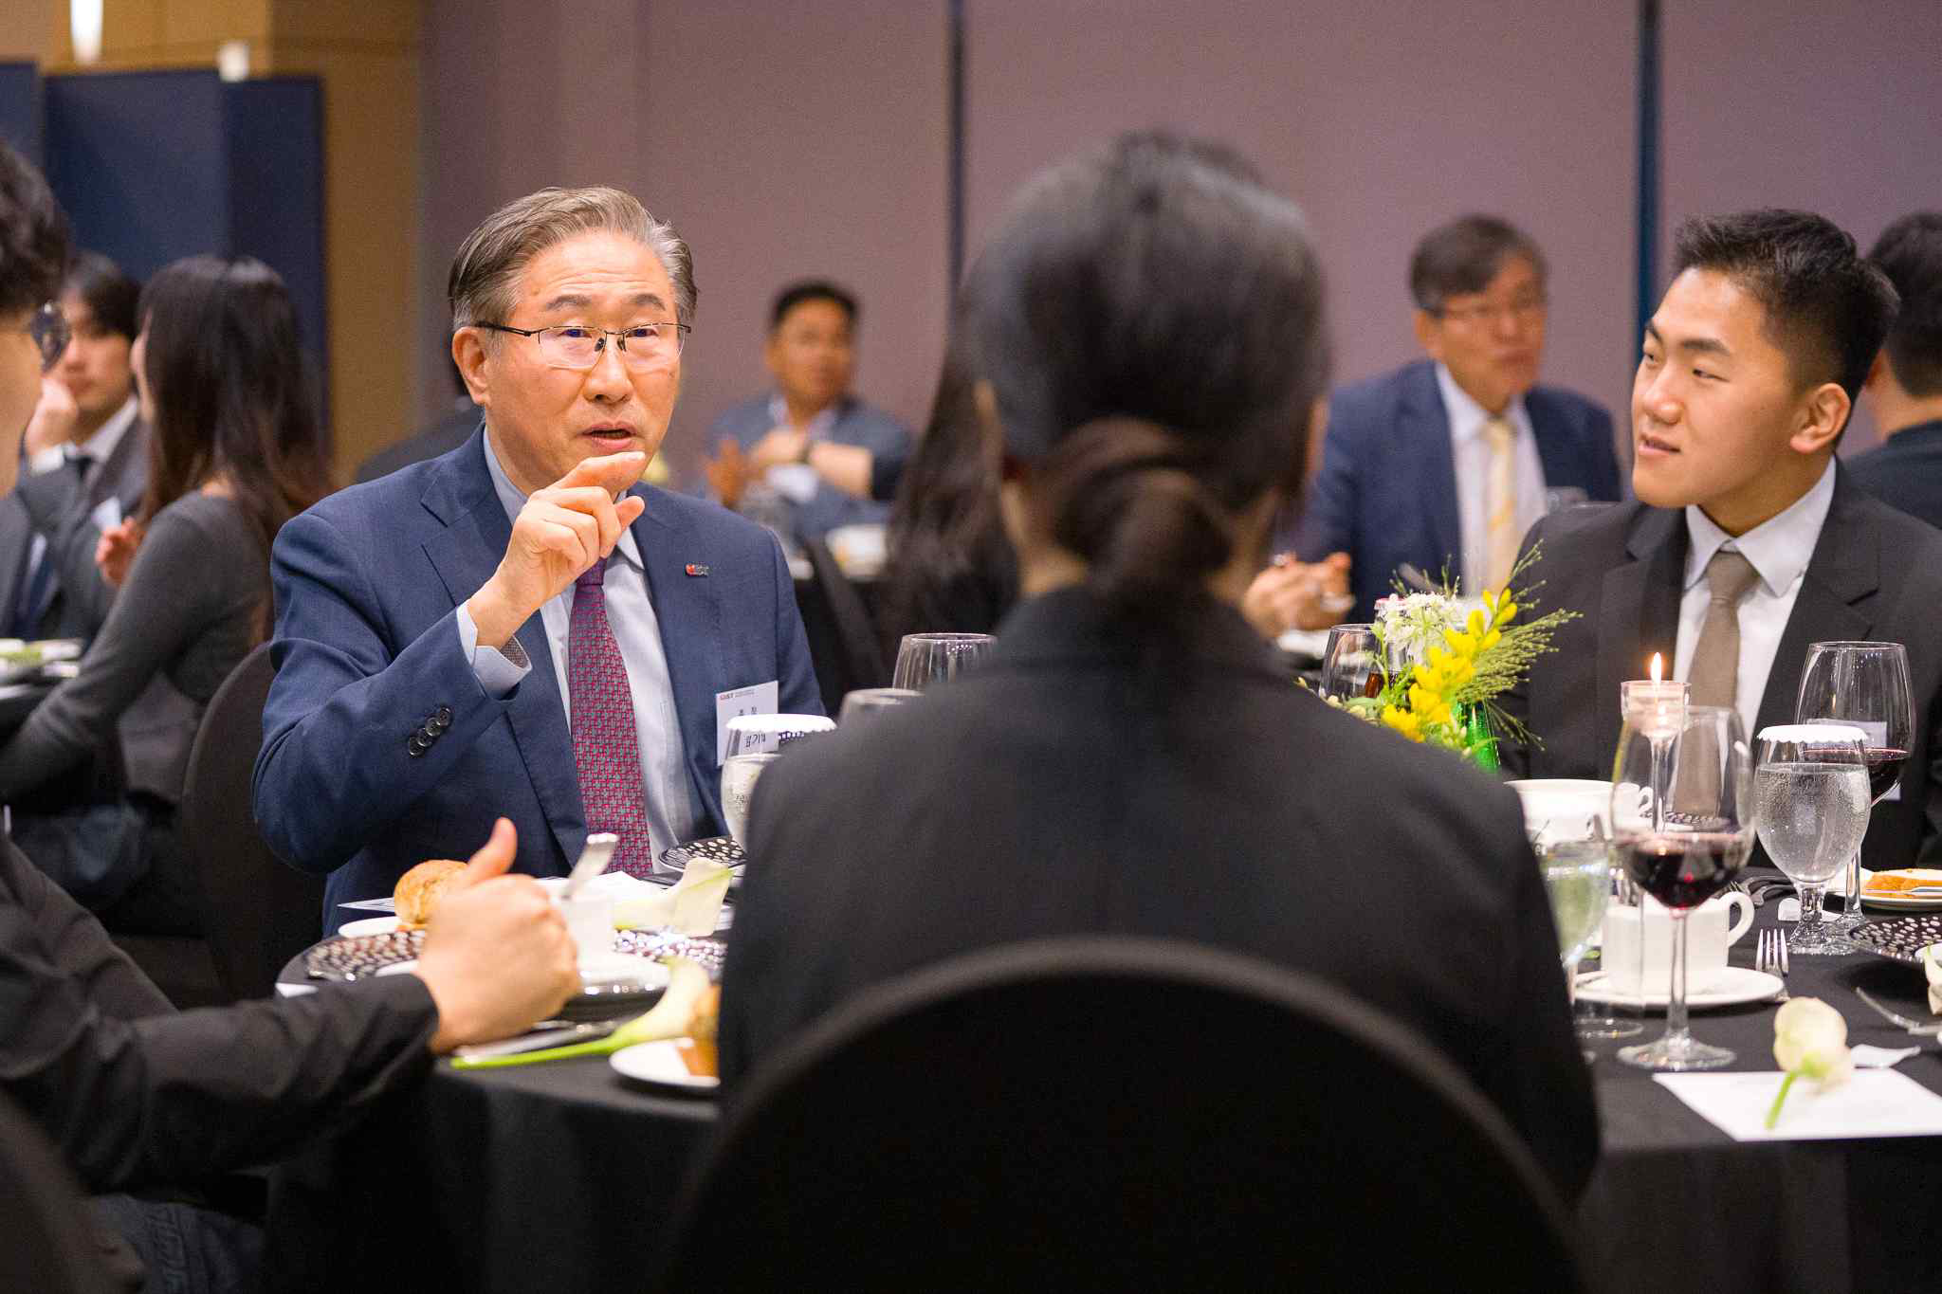

▲ President Kichul Lim shares opinions on research, career paths, and campus life with students at the ‘GIST Honors Dinner.’
GIST plans to develop this event into a representative exchange program where professors and students share the university's vision and values.
In addition, the university intends to record the list of participating students and their achievements in the newsletter every year to preserve a history of accomplishments and continue this tradition as an inspiration to junior students.
Hee-soo Kim, a master's student in the Department of Environment and Energy Engineering, shared his thoughts, stating, "Receiving official recognition and encouragement for my on-campus and off-campus activities gave me great strength. Interacting with the President, professors, and fellow students active in various fields allowed me to feel a renewed sense of pride in being a member of the GIST community."
Soo Jong Lee, Dean of Admissions and Student Affairs, said, "We plan to record the list of participating students and their achievements in the newsletter every year to preserve the significance of the event. We hope that the 'GIST Honors Dinner' will establish itself as a proud tradition unique to GIST that every student aspires to participate in at least once."
President Kichul Lim said, “Students who have elevated the school’s status and dedicated themselves to the community are GIST’s greatest pride and future,” adding, “I hope this event instills pride in the students and continues as a meaningful tradition where professors and students share the university’s vision together.”

