GIST recruits participants for Student Startup League 《GRAVITY 2026》
- GIST recruits participants for ‘GRAVITY 2026,’ a joint student startup league of the top 4 science and technology institutes… Applications open until June 10
- Strengthening support for the entrepreneurship cycle: From discovering pre- and early-stage deep tech startup teams to commercializing research results based on the Honam Region Innovation Startup Hub, demonstrating proof of concept (poc), and connecting to global expansion
- Selecting a total of 140 teams and providing support of up to 200 million won to the top 10 teams, including overseas acceleration
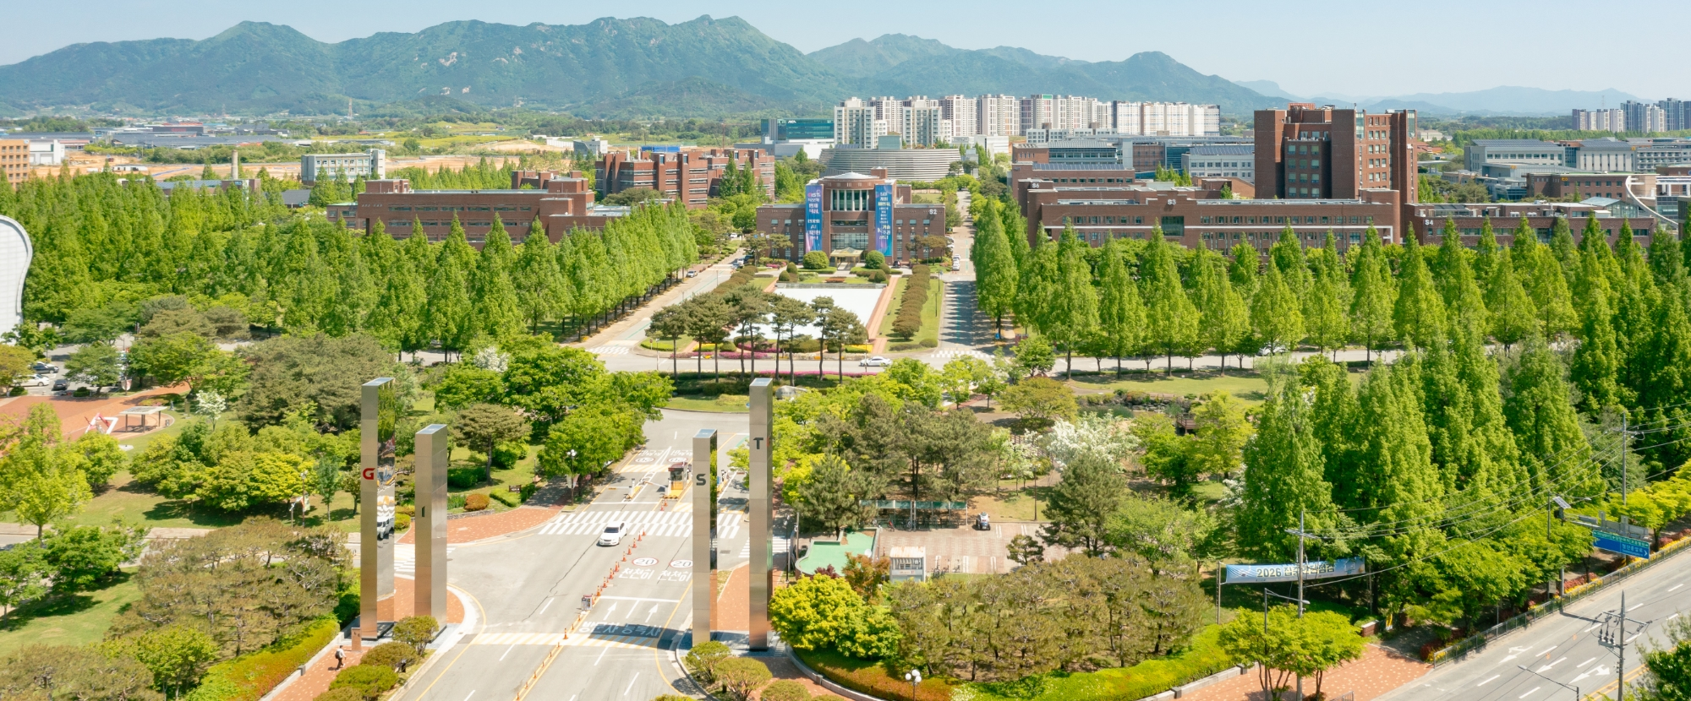

▲ A panoramic view of the GIST campus.
The Gwangju Institute of Science and Technology (GIST, President Kichul Lim) announced that it is recruiting participants for "GRAVITY 2026," an integrated student startup league for the four major science and technology institutes, in collaboration with KAIST, DGIST, and UNIST.
"GRAVITY 2026" is the largest joint startup league for science and technology institutes in Korea, designed to discover prospective and early-stage startup teams possessing excellent science and technology-based business ideas and to facilitate their entry into the global market.
Eligibility is open to prospective or early-stage startup teams (established within the last five years), including undergraduates, graduate students, and alumni affiliated with the four major institutes (GIST, KAIST, DGIST, and UNIST). Applications can be submitted via the respective institution's online registration link from May 21 to June 10.
However, considering the academic schedule, DGIST plans to extend the application period until June 15. This league holds great significance in that it integrates the deep tech startup ecosystem based on the four major science and technology institutes into a single league structure.
It is characterized by a design that covers the entire cycle, going beyond a simple startup competition to encompass actual launches and global expansion through investment attraction.
In particular, GIST plans to systematically support student startup teams by intensively discovering them, focusing on deep tech fields such as ▴ artificial intelligence (AI), ▴ bio-healthcare, ▴ aerospace, and ▴ robotics.
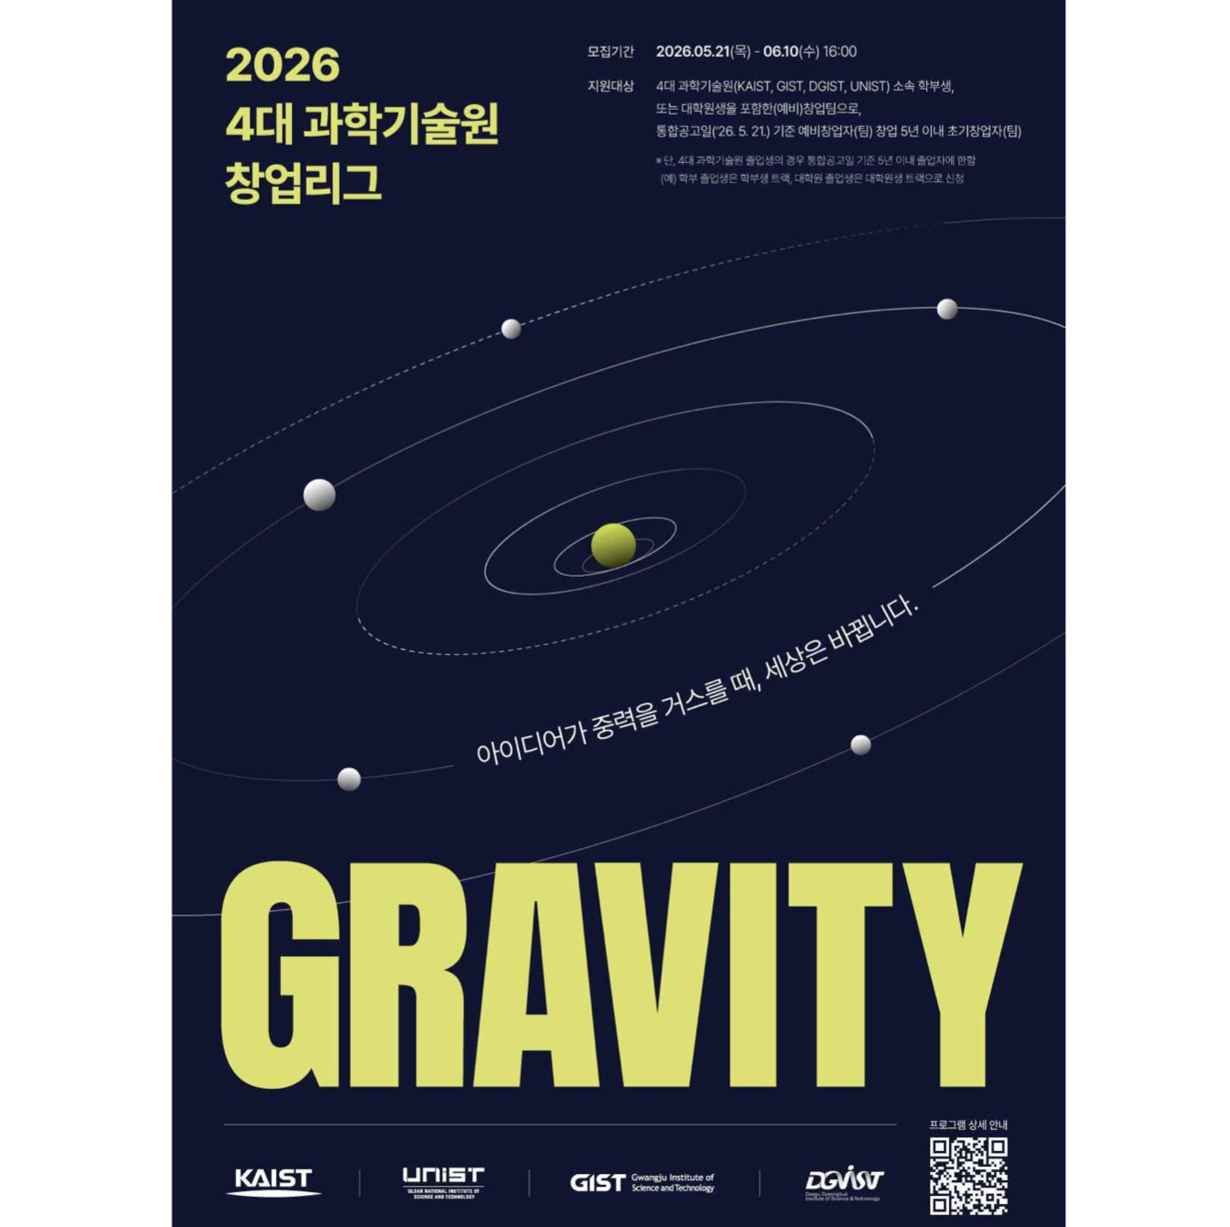

▲ Poster for the 《GRAVITY 2026》 Integrated Deep Tech Student Startup League for the four major ISTs. This league is operated separately for undergraduate and graduate students.
It proceeds in a staged structure, progressing from institution-specific preliminary and main rounds to an integrated main and final round for the four major KAISTs. In the final round, a total of 10 outstanding startup teams are planned to be selected, including 5 teams from the undergraduate league and 5 teams from the graduate league.
The 140 teams selected through the final round will receive systematic support benefits for successful startups, such as startup activity funds, expert mentoring, global acceleration programs, and customized mentoring.
In particular, outstanding startup teams will be granted the privilege of participating in an acceleration program linked with global venture capital (VC) firms. Additionally, a total of 200 million KRW in diverse support necessary for startup growth—including mentoring, investment attraction, commercialization, and overseas expansion—is scheduled to be provided.
Centered around the Korea Institute of Entrepreneurship & Innovation, GIST has systematically supported student entrepreneurial capabilities through the Center for Entrepreneurship & Innovation Strategy, the Center for Entrepreneurship Promotion, and the Center for Technology Commercialization.
Specifically, by implementing various customized support programs—such as ▴ entrepreneurship education, ▴ basic entrepreneurship training, ▴ competitions, ▴ mock and real-world startup programs, and ▴ networking programs linked with experts from industry, academia, and research institutes—GIST is generating continuous results, including 251 patent applications, 177 registered patents, and 2 billion KRW in royalty revenue as of 2025.
Furthermore, through the operation of industry-academia collaboration councils and technical guidance for industry challenges, GIST is taking the lead in resolving technical and business issues arising in the field after startups and is enhancing the achievements of technology commercialization.
GIST plans to further strengthen its accumulated capabilities in startup education, incubation, and commercialization support, as well as its industry-academia-research and global networks. Furthermore, leveraging this integrated league, the university plans to leap forward as a key hub leading the deep tech startup ecosystem in the Honam region.
President Kichul Lim stated, “GRAVITY 2026 is a practical startup platform that integrates the unrivaled research capabilities and startup infrastructure of the four leading science and technology institutes to help student startup teams grow into startups that will lead the global deep tech market.” He added, “Based on its demonstration-oriented startup support capabilities in AI and advanced technology, GIST will elevate the innovative startup ecosystem in the Honam region to the next level, while providing full support to ensure that students’ outstanding research achievements bear fruit as competitive global companies on the world stage.”

