GIST receives donation of 50,000 pyeong of land in Mt. Jirisan area from philanthropist Deung-ha Hwang… Pushing forward to develop 'Munsu Valley Campus'
- Donation of 170,000 square meters of land in Munsu-ri, Toji-myeon, Gurye-gun, Jeollanam-do, with the intention of creating a research and relaxation space for future science and technology talents
- President Kichul Lim: “Based on the donor’s wishes, we will cultivate this into a space where domestic and international researchers can interact and gain creative inspiration while upholding the value of nature conservation.”
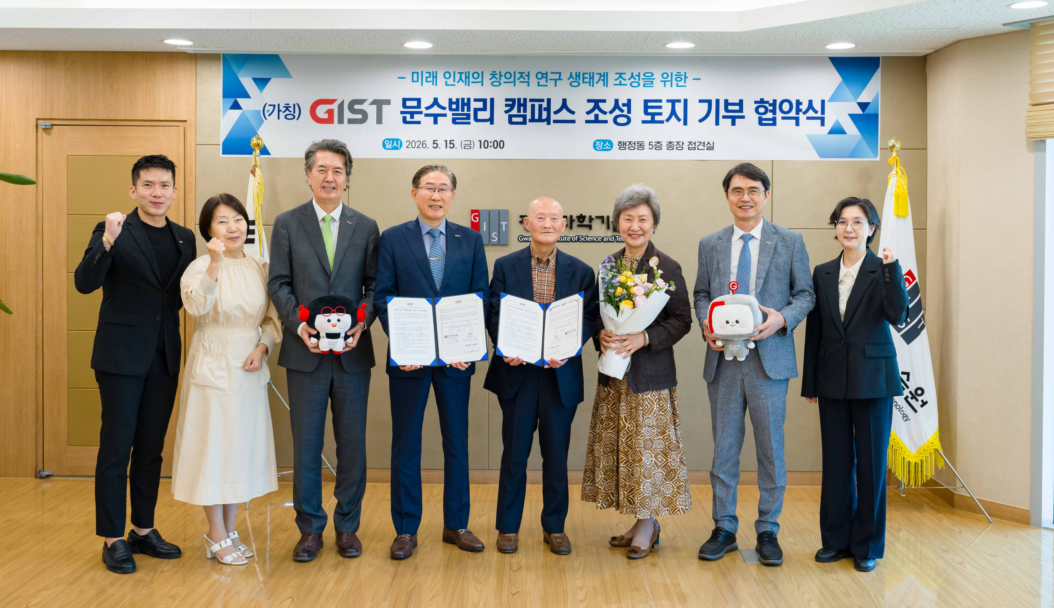

▲ Attendees pose for a commemorative photo after the ‘Land Donation Agreement Ceremony for the GIST Munsu Valley Campus’ with philanthropist Deung-ha Hwang (fourth from the right) at the Administration Building on Friday, May 15.
The Gwangju Institute of Science and Technology (GIST, President Kichul Lim) announced that it held the ‘Land Donation Agreement Ceremony for the GIST Munsu Valley Campus’ with philanthropist Deung-ha Hwang at the Administration Building on Friday, May 15, to foster future talent and establish a research ecosystem.
Through this agreement, philanthropist Deung-ha Hwang is donating land (approximately 51,000 pyeong, or 168,588m²) located in the Munsu-ri area of ​​Toji-myeon, Gurye-gun, Jeollanam-do, to GIST. The event was attended by philanthropist Deung-ha Hwang and his spouse Si-ja Jeon, as well as GIST officials including President Kichul Lim, Vice President for Academic Affairs Sungho Jeong, Vice President for Public Affairs Yonghwa Chung, Dean of Student Affairs and Admissions Soo Jong Lee, Director of the Global Engagement Division Kyung-Sook Min, and Development Fund Team Leader Seung-jae Lee.
This donation was made with the intention of contributing to the creation of an environment where future science and technology talents can harmoniously balance research and relaxation amidst nature.
Philanthropist Deung-ha Hwang expressed his hope that convergence research and international exchanges would become even more active, based on GIST's research infrastructure.
GIST plans to review the development of the ‘GIST Munsu Valley Campus (tentative name)’ utilizing the donated land.
‘Munsu Valley’ is a name combining ‘Munsu,’ symbolizing wisdom in Buddhism, and ‘Valley,’ signifying an open research ecosystem; it embodies the meaning of a space where reflection and creative research harmonize.
Furthermore, reflecting the place name ‘Munsu-ri’ where the land is located, the plan is to develop it into a model of a future-oriented research community linked to the local community.
The agreement includes provisions to respect the historical significance and value of natural landmarks cherished by the donor, such as ‘Turtle Rock’ located within the land, and to preserve and utilize them throughout the future development process.
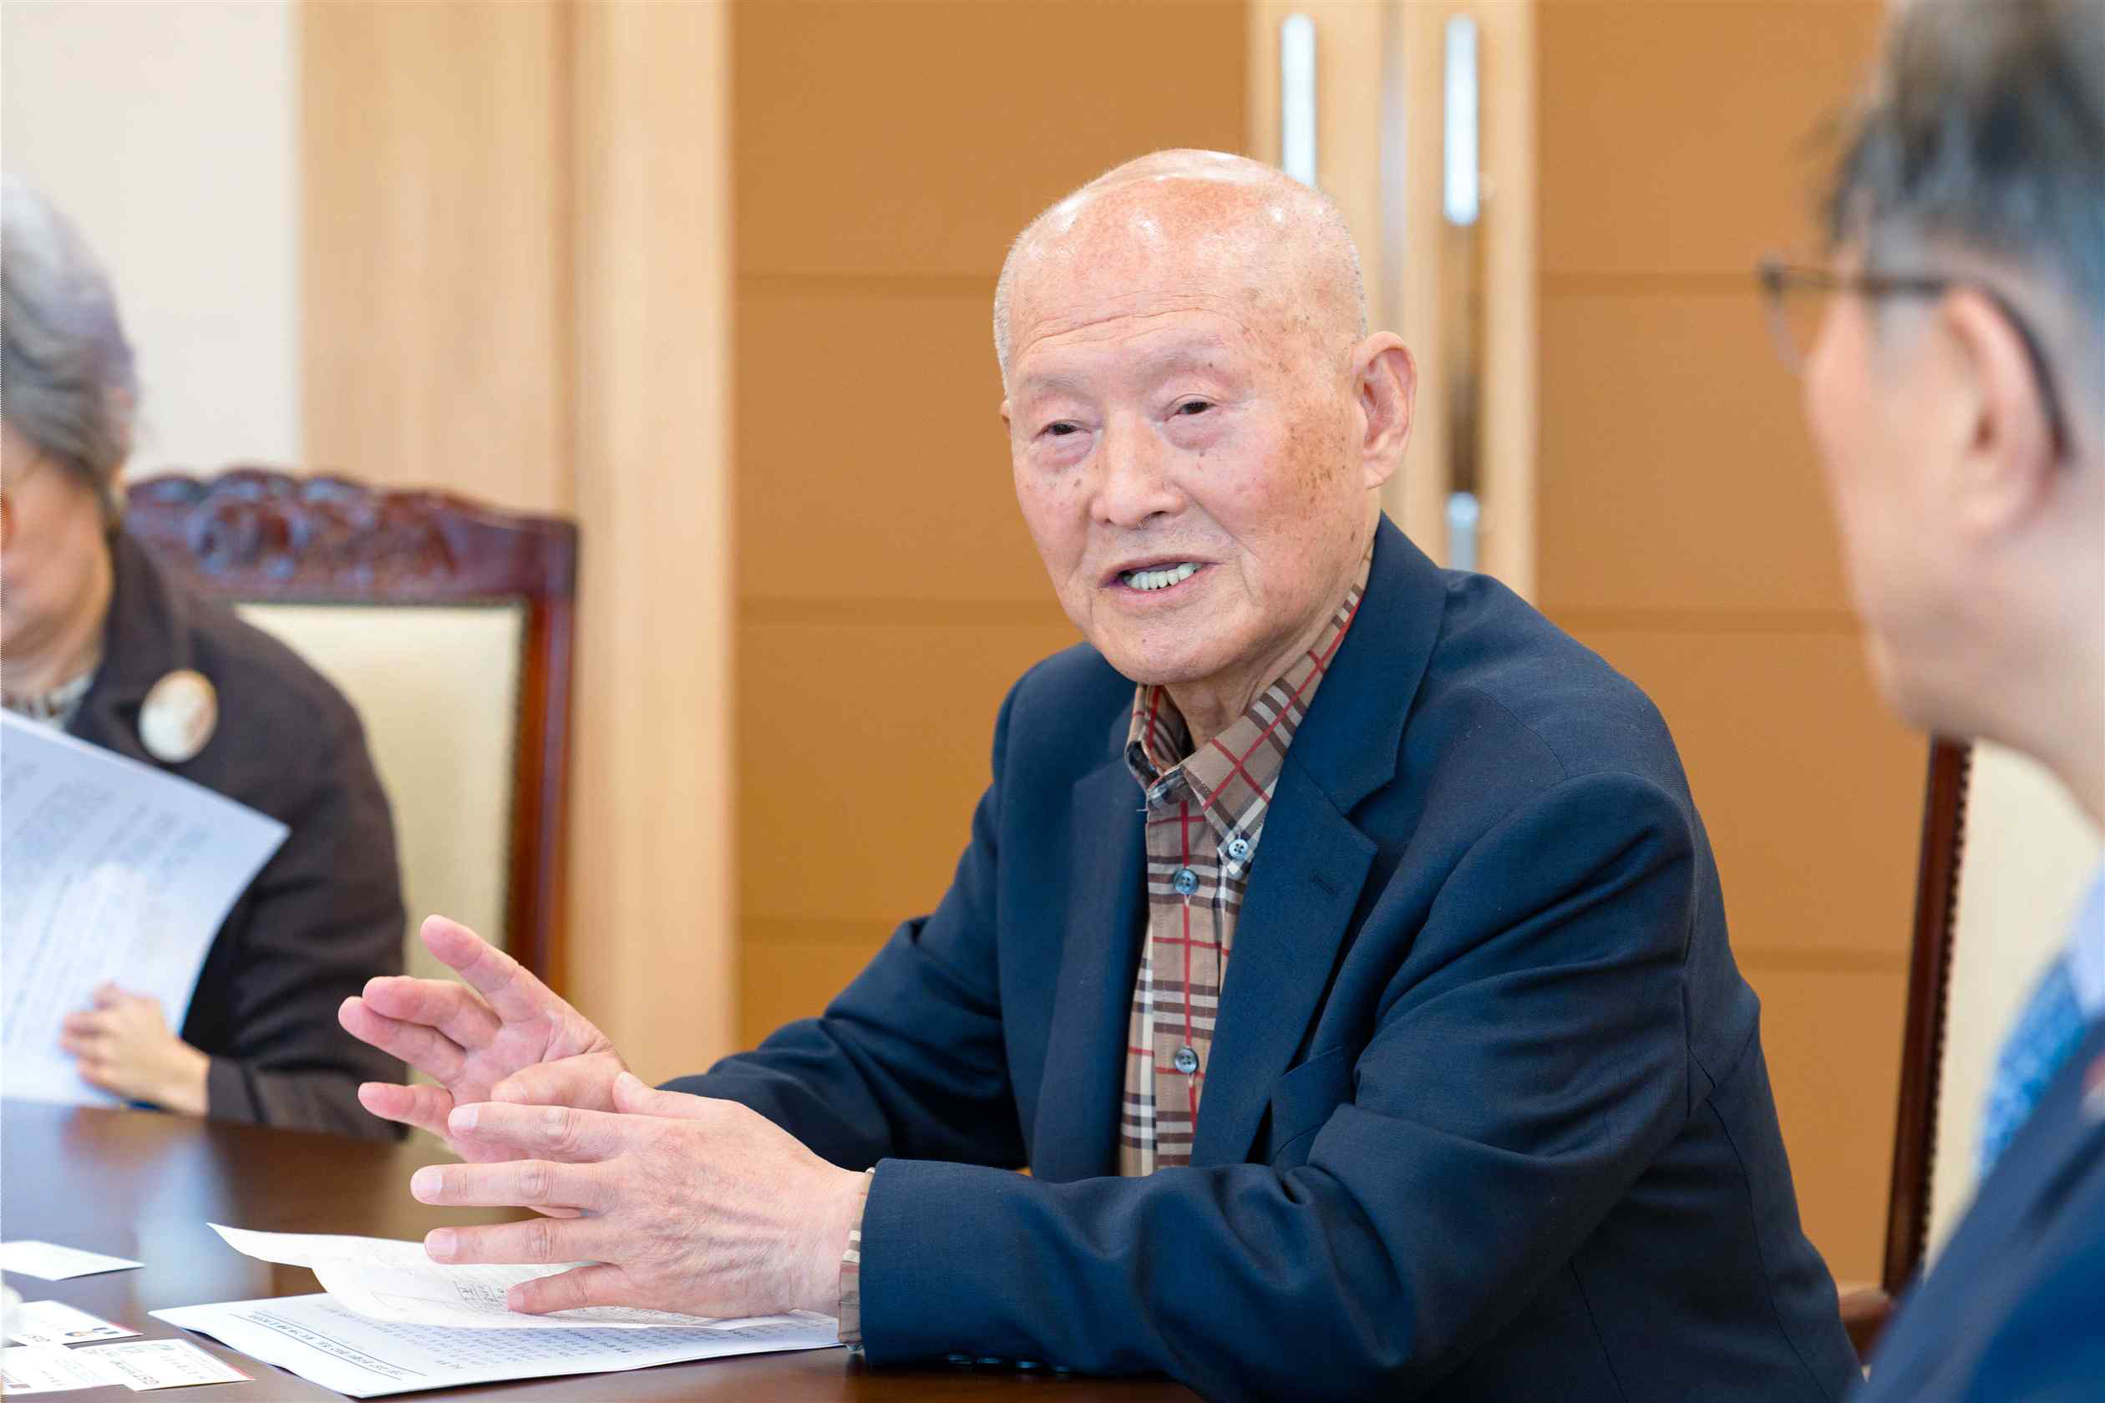

▲ Philanthropist Deung-ha Hwang delivers remarks at the land donation agreement ceremony held at the Administrative Building on Friday, May 15.
Philanthropist Deung-ha Hwang stated, “I hope that the young talents of GIST, who will serve as the cornerstone of national development, will find peace of mind and creative inspiration amidst the clear energy of Mt. Jirisan,” adding, “I hope this small act of sharing leads to a space that provides comfortable rest and inspiration to future scientists who will contribute to humanity and society.”
President Kichul Lim said, “I express my deep gratitude to Philanthropist Hwang Deung-ha for donating this precious land,” and added, “We will carefully cultivate this land, which embodies the donor’s will and philosophy, into an open research campus where domestic and international researchers can interact and conduct research together, while also recharging and reflecting amidst nature.”

