GIST and Chonnam National University launch 'K-MediST' in earnest... Investing 19.4 billion won over 5 years to cultivate physician-scientists
- Fostering over 150 medical AI and bio convergence talents over 5 years through the operation of joint degree programs and cross-degree systems
- Establishing a joint research institute within Hwasun Chonnam National University Hospital and linking it with GIST's advanced research infrastructure… Creating a virtuous cycle medical innovation ecosystem of ‘basic research-clinical trials-commercialization’ based on AI platforms and multi-omics


▲ Panoramic view of the GIST campus
The Gwangju Institute of Science and Technology (GIST, President Kichul Lim) announced that it is officially launching ‘K-MediST (Korea Medical Science & Technology),’ a project to foster Korean-style convergence talents in physician-scientists and medical scientists, in collaboration with Chonnam National University College of Medicine, Chonnam National University Hospital, and Hwasun Chonnam National University Hospital.
The K-MediST project is a physician-scientist training program jointly supported by the Ministry of Science and ICT and the Ministry of Health and Welfare, providing support to consortia selected through a nationwide open call. Among them, the ‘MIRACLE’ consortium—comprising GIST, Chonnam National University, and Chonnam National University Hospital—will receive a total of 19.4 billion KRW (16.6 billion KRW in state funding) over five years until 2030.
* MIRACLE: Medicine-Engineering Innovation and Rendezvous for Advanced Convergence and Leader Education
GIST plans to receive 6.6 billion KRW in government funding, representing approximately 40% of the total, to link research capabilities in the fields of AI, life sciences, and biomedical engineering with clinical practice, and to establish a system for training medical AI and physician-scientists.
Through this project, GIST will pursue: ▴ development of joint courses and awarding of joint degrees; ▴ establishment and operation of joint research institutes for convergence research; and ▴ joint research projects and commercialization.
First, GIST and Chonnam National University College of Medicine will open a joint degree program to cultivate more than 150 convergent talents over the next five years and develop more than 16 joint courses.
In addition, GIST offers courses in artificial intelligence (AI), omics (analysis of advanced bio-data such as genomics and proteomics), and biomedical engineering to residents and medical students at Chonnam National University College of Medicine. It also operates a cross-disciplinary joint degree program (MD-PhD, PhD) in which graduate students from GIST’s Department of Biomedical Science and Engineering complete the clinical medicine and pathophysiology curriculum at Chonnam National University College of Medicine.
In particular, the university plans to intensively cultivate physician-scientists and medical AI convergence talents by operating detailed tracks in the fields of immuno-oncology, regenerative medicine, and multimodal medicine (integrated analysis of various medical data) that combine medicine and AI.
Furthermore, it will establish a joint research institute spanning approximately 1,332 square meters within the Future Medical Innovation Center at Hwasun Chonnam National University Hospital and secure a total of 18 dedicated faculty members, including 6 physician-scientists and 12 medical scientists. The university also plans to promote convergence research that spans from basic research to clinical application by utilizing GIST’s advanced research infrastructure.
Furthermore, the foundation for technology transfer and startups is being established with the goal of publishing over 30 SCI-level papers and filing 22 patent applications and registering 8. In particular, the plan is to strengthen the full-cycle support system, centered around the GIST Technology Commercialization Center, covering everything from the discovery of joint research results to commercialization and startups.
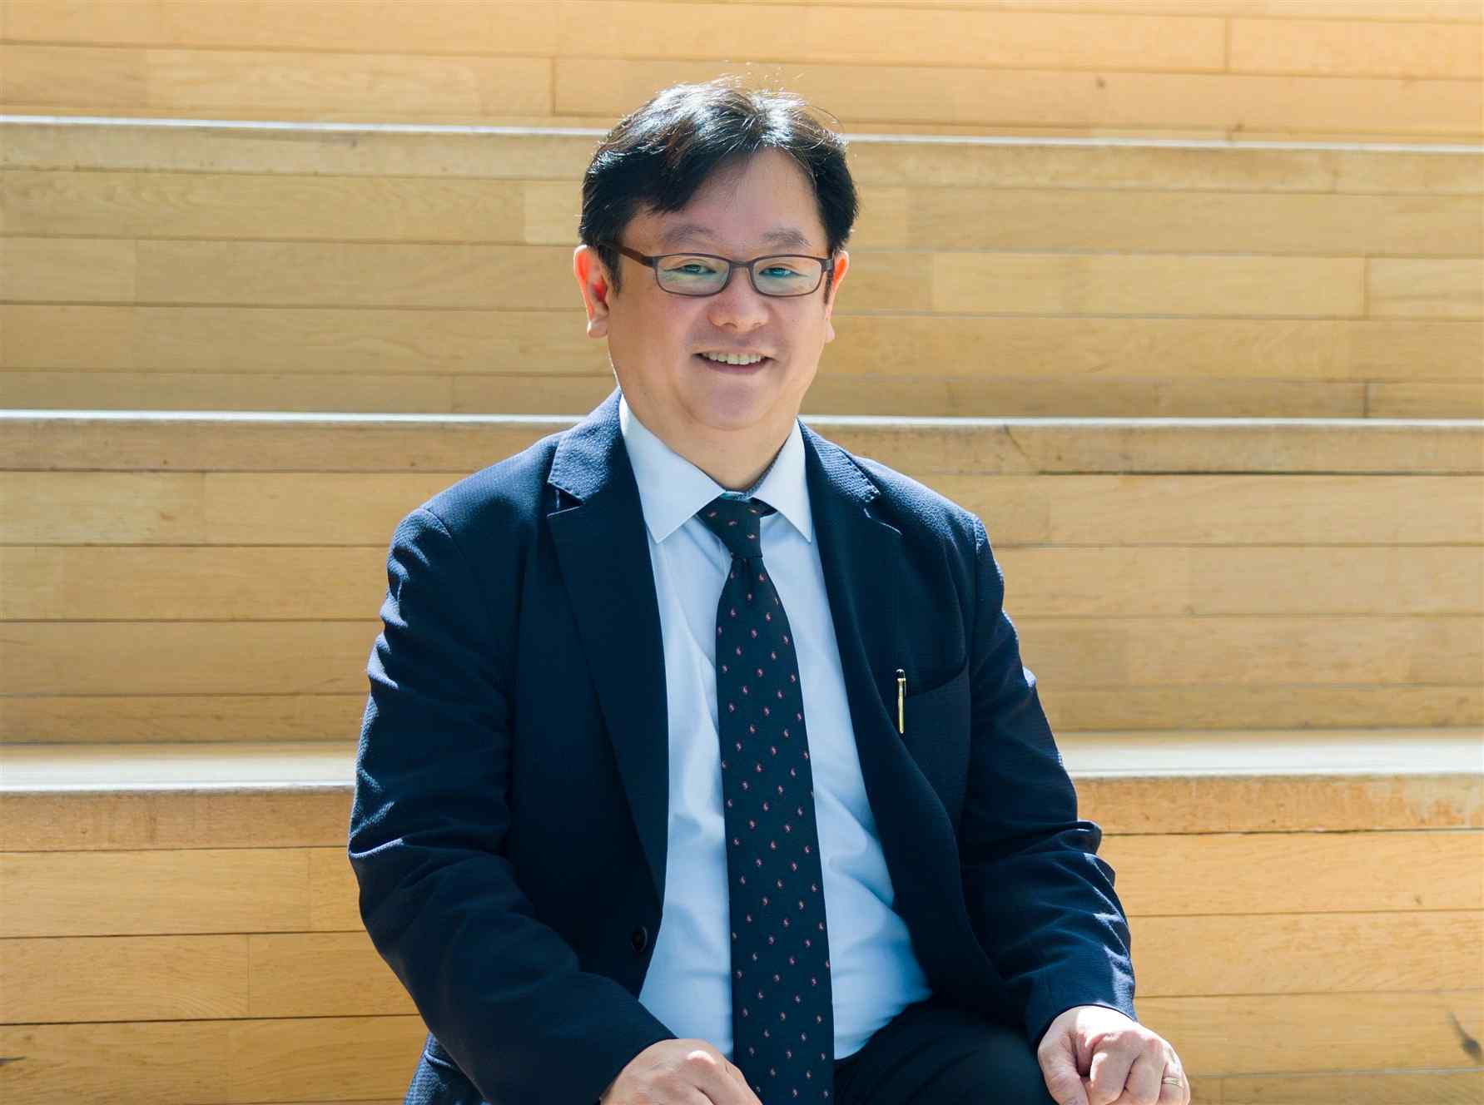

▲ Tae Kim, Director of the MIRACLE Project (Dean of the Department of Biomedical Science and Engineering at GIST)
GIST has been building a foundation for cultivating convergent talents who will lead future healthcare by linking world-class basic science research capabilities with clinical practice.
GIST established the Biomedical Engineering major in 2008 to foster talent in the field of next-generation precision medicine, and has produced a total of 237 professionals to date, including 97 Ph.D. graduates and 140 Master's graduates.
In particular, over the past 17 years, GIST has consistently fostered translational physician-scientists capable of connecting real-world medical issues to research projects, awarding doctoral degrees in science and engineering to 27 licensed physicians (MDs).
GIST plans to establish a virtuous cycle of "basic research followed by clinical application" that links unmet needs in the medical field to research projects and applies and validates them in clinical practice. Through this initiative, more than 80 collaborative research projects are expected to be pursued over the next five years.
Furthermore, the university plans to promote initiatives such as ▴ improving early diagnostic accuracy, ▴ identifying targets for precision treatments, and ▴ developing new drugs and treatment technologies based on precision medicine. It aims to establish a medical innovation ecosystem in the Gwangju and Jeonnam regions where the clinical application and industrialization of research outcomes form a virtuous cycle. This is expected to expand the physician-scientist infrastructure, currently centered in the Seoul metropolitan area, to regional areas and contribute to balanced national development.
In particular, over the past 17 years, GIST has awarded doctoral degrees in science and engineering to 27 MDs, while consistently cultivating translational physician-scientists capable of connecting real-world medical issues to research projects.
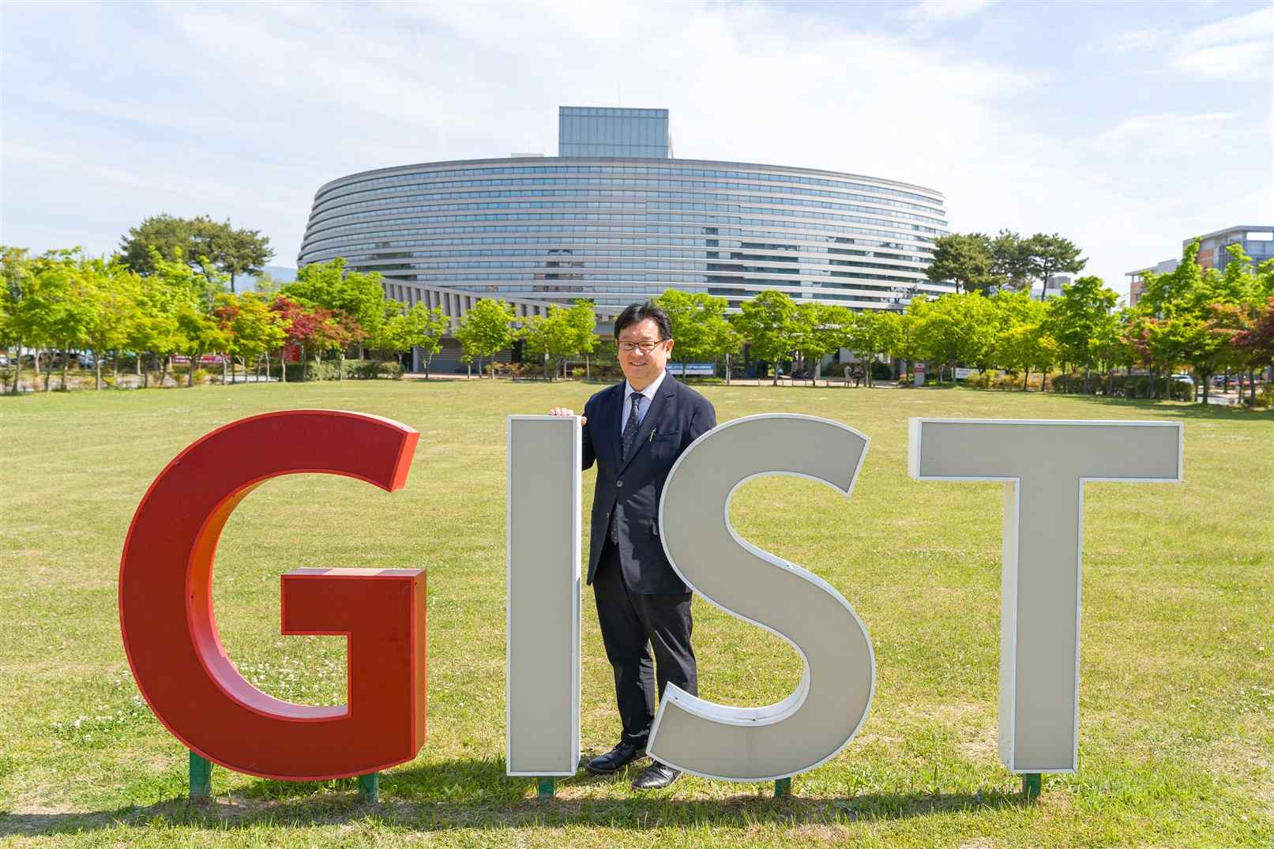

▲ Tae Kim, Director of the MIRACLE Project (Dean of the Department of Biomedical Science and Engineering at GIST)
Kim Tae, Director of the MIRACLE Project (Dean of the Department of Biomedical Science and Engineering at GIST), stated, “Even after the project ends, GIST plans to continue promoting the dissemination of research results, industrialization, talent cultivation, and international cooperation based on a 10-year roadmap that encompasses the entire medical ecosystem.” He added, “Based on our accumulated experience in training physician-scientists and medical scientists, we will successfully carry out the K-MediST project and leap forward as a global medical science hub.”

