GIST launches ‘World’s First Perovskite Solar Cell Commercialization Strategic Research Group’... Promoting commercialization of next-generation solar cells
- Development of large-area (0.72m²) high-efficiency and high-stability modules and commencement of full-cycle research on next-generation solar cell technology
- Establishment of an integrated research system encompassing materials, devices, modules, processes, and demonstration… Strengthening global technological competitiveness
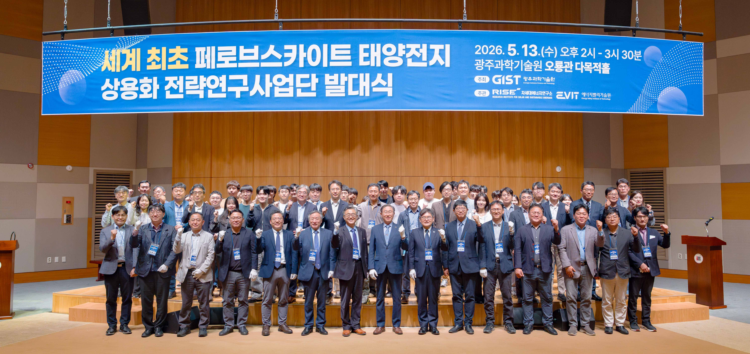

▲ Attendees pose for a commemorative photo at the launching ceremony of the ‘World’s First Perovskite Solar Cell Commercialization Strategy Research Group,’ held at Oryong Hall on Wednesday, May 13.
The Gwangju Institute of Science and Technology (GIST, President Kichul Lim) announced that it held the launching ceremony for the ‘World’s First Perovskite Solar Cell Commercialization Strategy Research Group’ (hereinafter the Strategic Research Group) at Oryong Hall at 2:00 PM on Wednesday, May 13, to lead the commercialization of next-generation solar technology.
This event served to officially announce the launch of the research group, which will lead the industrialization of next-generation solar cells, to both internal and external audiences, while simultaneously declaring the full-scale commencement of a research system focused on demonstration and mass production based on industry-academia-research collaboration.
Approximately 100 people attended the event, including key officials such as Min-jae Ko, President of the Korean Photovoltaic Society; Jin-ho Park, Acting President of the Korea Institute of Energy and Technology; Young-jib Kim, President of the Asia Science Park Association; and Min-sung Cho, Managing Director of Dongwoo Finechem; as well as GIST President Kichul Lim; Kwanghee Lee, Head of the Strategic Research Group (Professor of Materials Science and Engineering); Dean Eunji Lee with the Office of International and Public Affairs; and KwangSup Eom, Director of the Research Institute for Solar and Sustainable Energies, along with faculty, staff, and students.
Perovskite solar cells, which convert light into electricity, are attracting attention as a future eco-friendly energy technology due to their high efficiency and low production costs.
However, existing technologies face limitations in commercialization because they maintain high performance only in small, laboratory-scale devices and have not secured the long-term operational stability and large-area mass production process technologies essential for actual industrialization.
The project group's core objective is to develop high-efficiency and high-stability perovskite solar cells to a level suitable for actual industrial application.
By establishing an integrated research and development system that encompasses the entire process from material development to the fabrication, demonstration, and mass production of large-area (0.72m²) modules, the group plans to expand technology that was previously confined to the laboratory stage into mass-production modules capable of large-scale manufacturing.
Furthermore, the group plans to secure stability that meets international standards and launch technology verification and demonstration projects to realize the world's first commercialization.
In particular, centered around GIST, the group intends to establish an integrated cooperative system that covers the entire cycle from securing source technology to producing commercial products, based on industry-academia-research collaboration involving Ulsan National Institute of Science and Technology (UNIST), Korea Institute of Industrial Technology (KITECH), Korea Electric Power Research Institute (KEPRI), Gwangju Technopark, and LEECELL Co., Ltd.
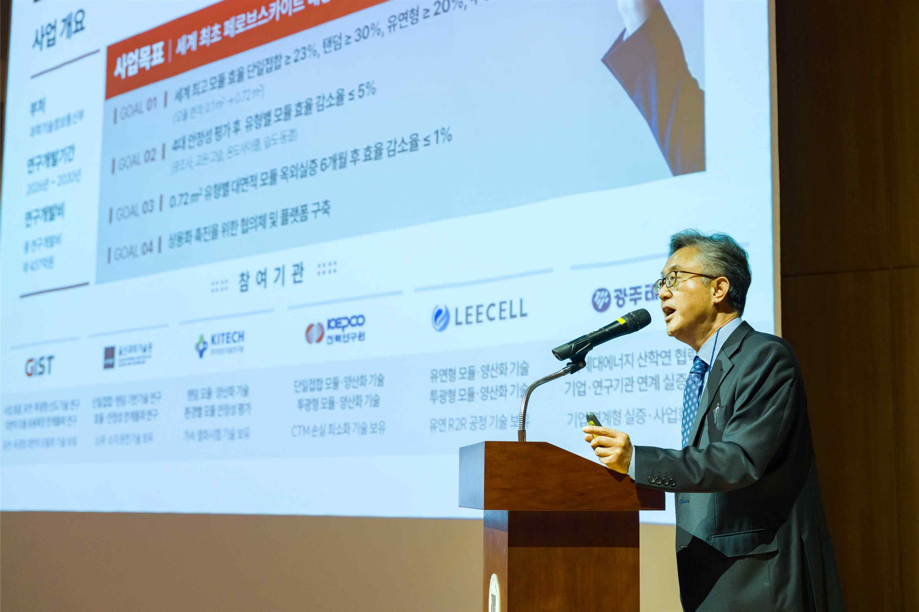
▲ Professor Kwanghee Lee, Head of the World's First Perovskite Solar Cell Commercialization Strategy Research Group (Professor of Materials Science and Engineering), is presenting the implementation plan.
Professor Kwanghee Lee, Head of the Strategic Research Project Group, stated, “Commercializing perovskite solar cells as a strategic technology to lead the world in an era of great transformation centered on renewable energy is a task given to us,” adding, “We will take the lead in securing global competitiveness by establishing a networking platform in the fields of technology, certification and standards, industrialization, and investment centered on the project group, and by completing commercial technologies for large-area applications.”
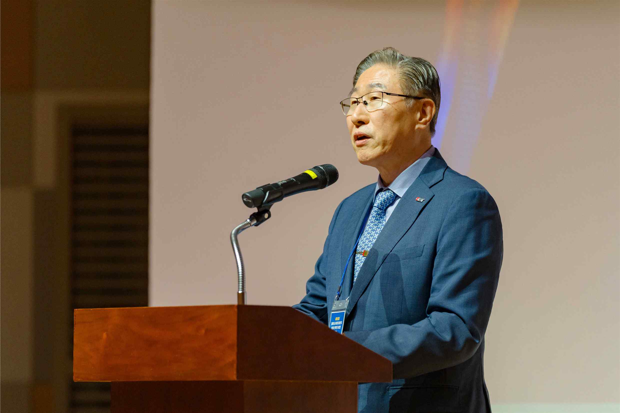

▲ President Kichul Lim delivers the welcoming address at the launching ceremony of the ‘World’s First Perovskite Solar Cell Commercialization Strategy Research Group.’
President Kichul Lim stated, “Perovskite solar cells are more than just a next-generation technology; they are a key to accelerating the transition to a carbon-neutral society.” He added, “We will proceed without setbacks with the full-cycle research and development for the commercialization of perovskite solar cells and the long journey toward energy transition based on a cooperative system involving industry, academia, research institutes, and government, aiming to achieve the world’s first commercialization results.”

