GIST invites Professor Jae Gwan Kim to lecture at Breakfast Forum... Shedding light on the current state of dementia research
- 62nd GIST Academy Breakfast Forum Held… Professor Jae Gwan Kim of GIST’s Department of Biomedical Science and Engineering introduces AI and deep learning-based technology for dementia stage classification and mild cognitive impairment prediction
- Emphasizes paradigm shift in dementia treatment centered on precision medicine, from FDA-Approved new drugs to non-invasive brain stimulation
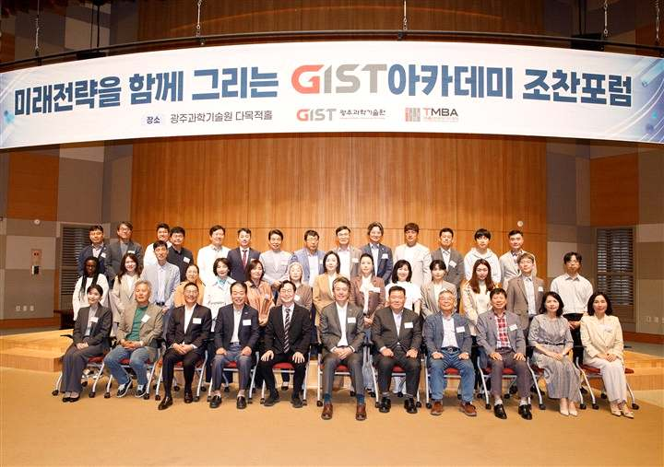

▲ GIST Academy held its 62nd Breakfast Forum on Monday, May 11, at Oryong Hall, inviting Professor Jae Gwan Kim of the Department of Biomedical Science and Engineering (Co-CEO of TeddyMedi Co., Ltd.).
The Gwangju Institute of Science and Technology (GIST, President Kichul Lim) announced that it held the 62nd GIST Academy Breakfast Forum at Oryong Hall on Monday, May 11. This forum addressed the fundamental human issue of "memory loss," sharing the latest research trends ranging from the early diagnosis of dementia to changes in treatment paradigms.
The lecture was delivered by Professor Jae Gwan Kim of the Department of Biomedical Science and Engineering at GIST under the theme "How to Hold Onto Fading Fragments of Memory: The Current State of Conquering Dementia."
Professor Kim is a medical engineering expert who majored in biomedical engineering and is a researcher who has led both biomedical engineering-based research and technology commercialization.
Professor Kim, together with Professor Tae Kim (Department of Psychiatry, MD-PhD) from the same department, established TeddyMedi Co., Ltd., a faculty startup that researches sleep and dementia using near-infrared-based brain science technology and develops digital therapeutic solutions, and serves as co-CEO.
Furthermore, he has spearheaded academic exchange and research collaboration by serving as an Academic Committee member of the Korean Dementia Association, an Organizing Committee member of the International Symposium on Aging, and President of the Photonics Convergence Research Society. In addition, he accumulated extensive research experience in the fields of biomedical optics and biomedical engineering while working as a research professor at the Beckman Laser Institute in the United States, a world-renowned laser research institution.
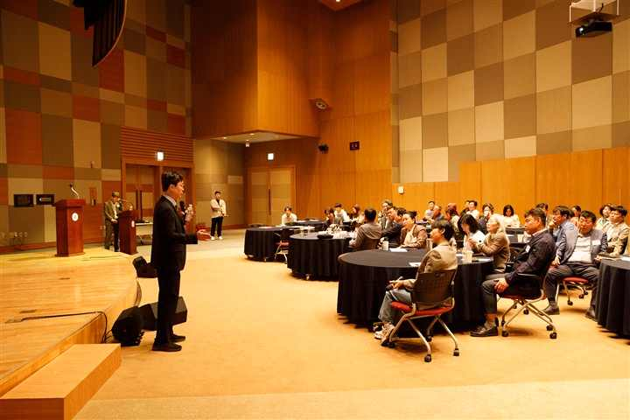
▲ Professor Jae Gwan Kim is giving a lecture titled "How to Hold Onto Fading Fragments of Memory: The Current State of Conquering Dementia" at the GIST Academy May Breakfast Forum.
In this lecture, Professor Kim explained that dementia should be understood not merely as a phenomenon of aging, but as a complex neurological disease, emphasizing the importance of early diagnosis and prediction technologies.
In particular, he introduced the latest research that predicts mild cognitive impairment by analyzing data on brain responses to olfactory stimuli and changes in blood flow and oxygen levels using AI. He also facilitated the attendees' understanding by providing an easy-to-understand explanation of deep learning technology capable of classifying dementia stages with up to 90% accuracy. The lecture also covered the paradigm shift in dementia treatment.
Along with the latest drug treatments for Alzheimer's disease approved by the U.S. FDA—such as aducanumab, recanemab, and donanemab—non-invasive brain stimulation technologies utilizing electricity, ultrasound, and light were introduced.
Furthermore, it was explained that dementia treatment is evolving away from a traditional drug-centered approach toward a direction encompassing ▴ early diagnosis, ▴ personalized management, and ▴ non-drug therapies. It was also noted that a new trend in treatment centered on precision medicine is spreading into actual clinical practice and daily life.
Professor Jae Gwan Kim stated, “Diseases that can affect the entire nervous system, such as shingles, can lead to various neurological symptoms depending on the site of occurrence and the degree of damage.” He added, “Dementia is not merely a phenomenon of aging, but a disease involving the complex interplay of declining vascular function, changes in sensory function, and nervous system damage; therefore, early diagnosis and prevention-focused management are crucial.”
Meanwhile, the Technology Management Academy (GTMBA), a flagship program of the GIST Academy which operates GIST’s non-degree educational courses, marked its 16th cohort this year. The GIST Academy regularly hosts breakfast forums every March, May, June, September, and October to share the latest trends and insights in various fields—including science and technology, industry, policy, humanities, and culture—with local business leaders and alumni.

