GIST holds ‘University Collaboration Integrity Special Lecture’ with Anti-Corruption and Civil Rights Commission
- Conducting tangible integrity activities through participatory education incorporating culture and arts and a relay campaign among the four leading science and technology institutes
- Practicing ethical management based on the independent implementation system ‘I-CARE’… Achieved results in improving the overall integrity index
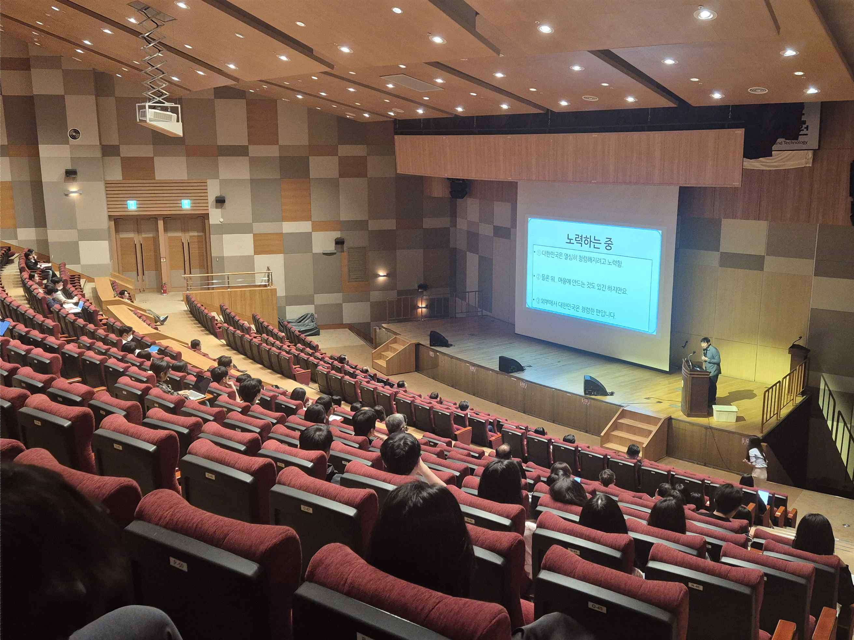

▲ GIST held a special lecture on integrity through university collaboration jointly with the Anti-Corruption and Civil Rights Commission on Thursday, May 7, at Dasan Hall in Oryong Hall.
The Gwangju Institute of Science and Technology (GIST, President Kichul Lim) announced that it held a "Special Lecture on Integrity Through University Collaboration" jointly with the Anti-Corruption and Civil Rights Commission (Chairperson Il-yeon Jeong) on Thursday, May 7, at Dasan Hall in Oryong Hall.
This special lecture was organized as part of the "Memorandum of Understanding for the Dissemination of a Culture of Integrity" signed between GIST and the Anti-Corruption and Civil Rights Commission last May. The purpose is to foster anti-corruption and integrity awareness within the organization by conveying the value of integrity in a more accessible and familiar manner.
Approximately 150 members of the GIST community attended the event, including President Lim Ki-chul, Vice President for Academic Affairs Jung Sung-ho, key administrators, current students, and faculty and staff.
Breaking away from the traditional one-way lecture format, the event incorporated cultural performances and real-time participatory quizzes, receiving a positive response from the attendees.
In particular, an expert lecturer on integrity education enhanced the participants' understanding by explaining anti-corruption systems, such as the Whistleblower Protection Act—which can otherwise be dry—through real-life examples.
Su-hyeok Lee, a third-year student in the Department of Mechanical and Robotics Engineering and a member of the GIST Integrity Supporters who participated in the overall operation of the event, shared his thoughts, stating, “Thanks to the special lecture accompanied by traditional Korean music performances, integrity felt much closer to me,” and added, “I will faithfully fulfill my role as a bridge to spread the value of integrity to fellow researchers from a student’s perspective.”
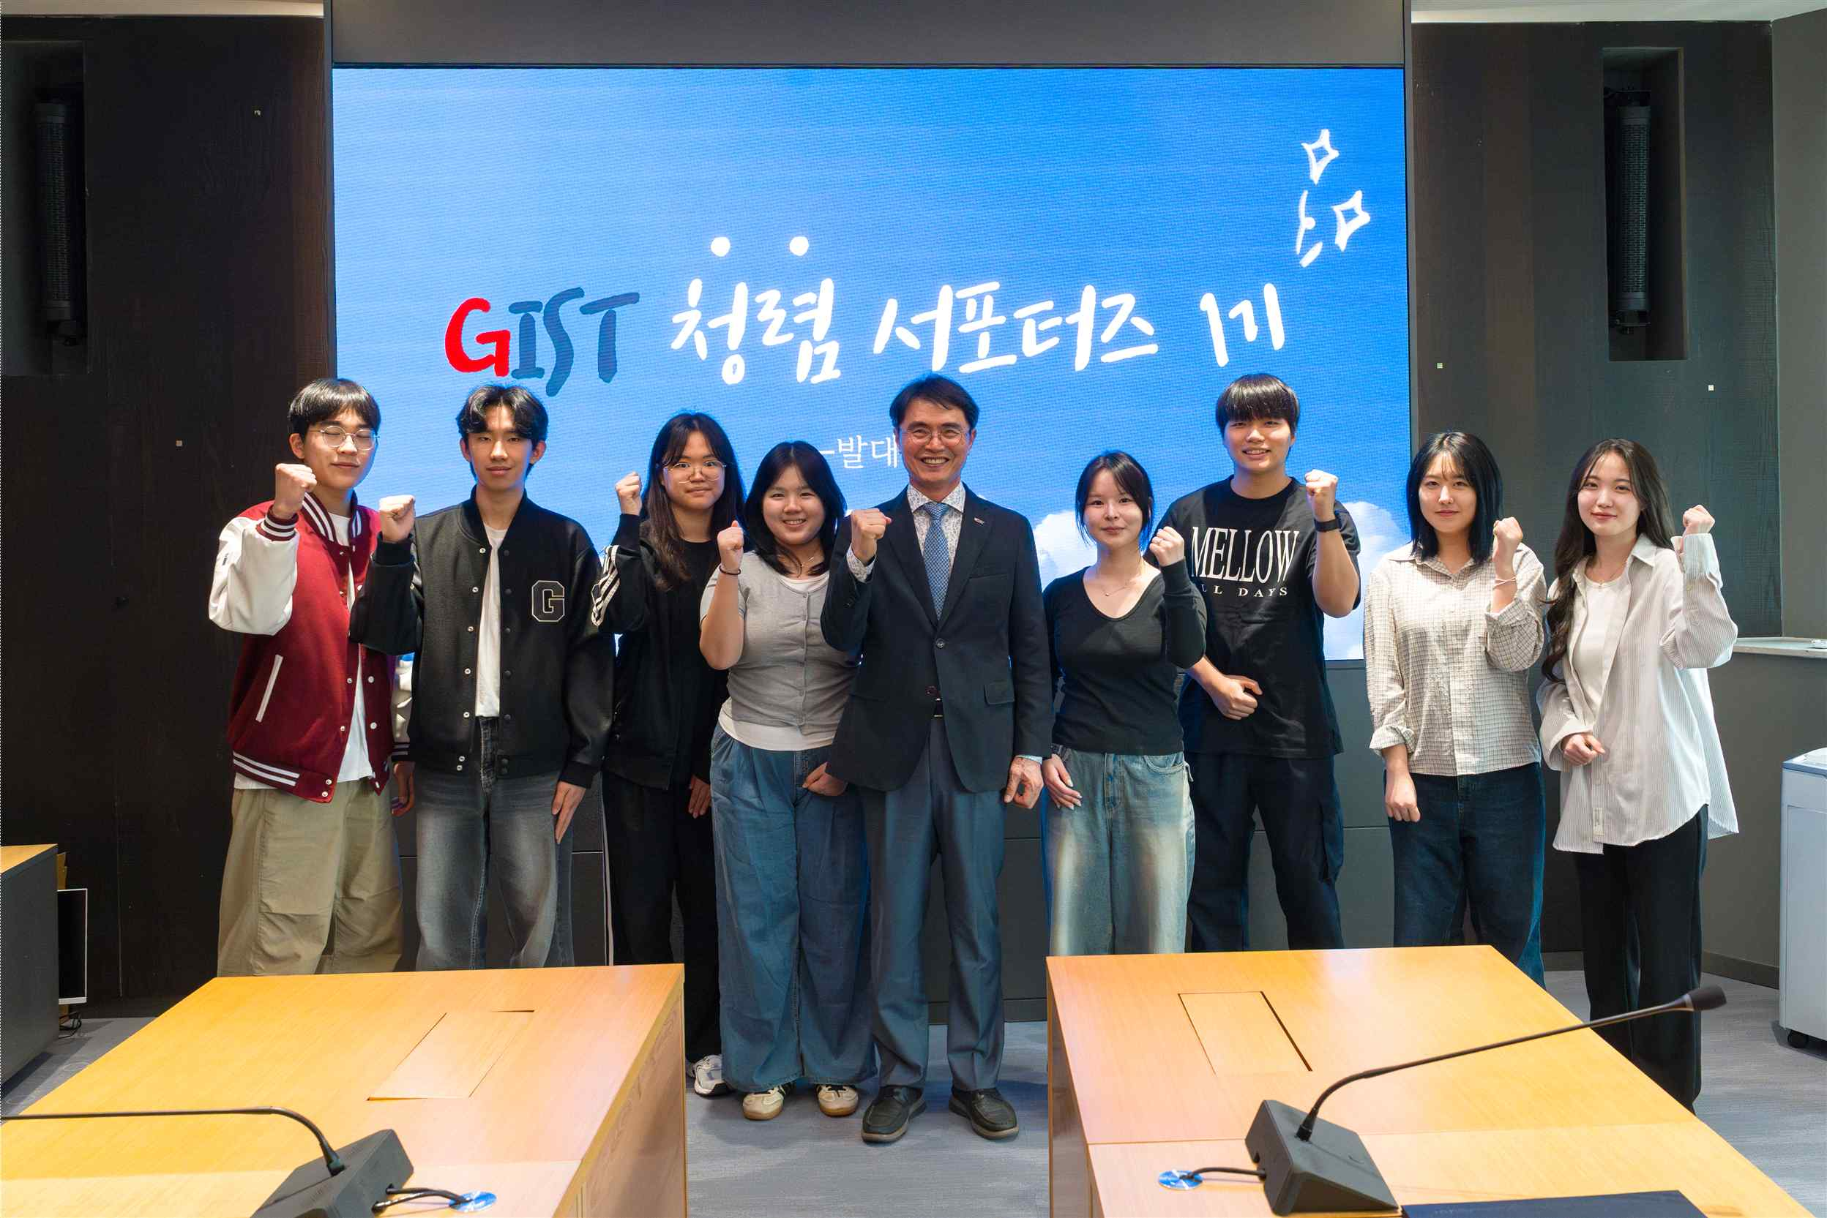

▲ GIST is promoting activities to spread a culture of integrity through the direct participation of university members, such as operating the first cohort of Integrity Supporters composed of current students.
GIST and the Anti-Corruption and Civil Rights Commission have maintained multifaceted cooperation, including the "University Collaboration Integrity Special Lecture."
Based on this partnership, they have taken the lead in establishing a culture of integrity in daily life by operating ▴ integrity plays, ▴ integrity Taekwondo performances, and ▴ special lectures on anti-corruption laws and systems.
As a result, GIST achieved Grade 3 in the "2025 Comprehensive Integrity Assessment of Public Institutions" conducted by the Anti-Corruption and Civil Rights Commission, a one-step improvement from the previous year. In particular, in the "Integrity Effort" category, which evaluates an institution's performance in implementing anti-corruption policies, GIST obtained Grade 2—a two-step improvement from the previous assessment—demonstrating that strong reform efforts at the university level led to tangible improvements in indicators.
Among the detailed categories, the institution recorded a score 8.4 points higher than the average for national and public universities in the field of ‘the head of the institution’s interest in and efforts toward integrity.’ Furthermore, it was recognized for the excellence of establishing an ‘anti-corruption and integrity promotion system’ and was evaluated as a model case by the Anti-Corruption and Civil Rights Commission.
In addition, starting with the ‘2026 Anti-Corruption and Integrity Pledge Ceremony’ held on Tuesday, April 21, the institution plans to further expand activities involving direct participation from its members, such as promoting a ‘Relay Integrity Declaration Campaign’ involving the four major science and technology institutes (GIST, KAIST, DGIST, and UNIST).
President Kichul Lim emphasized, “GIST has established and is operating ‘I-CARE,’ a unique integrity promotion system that encompasses everything from the head of the institution’s responsible management to prevention-oriented corruption blocking.” He added, “Through the ‘I-CARE’ model, which embodies the meaning of individual members taking an interest in and practicing integrity, we will establish an organizational culture where integrity naturally permeates and solidify our position as a university trusted by the public.”

