GIST hosts 'Startup for All' Talk Concert to promote youth entrepreneurship in the Honam region
- Vice Minister Yong-seok Noh of the Ministry of SMEs and Startups attends… Discusses field-oriented growth support measures, including sharing know-how from senior entrepreneurs
- GIST, equipped with know-how from a 7.5 billion KRW fund and numerous listed companies, accelerates the advancement of the Honam region's startup ecosystem by deploying a team of 30 expert mentors… Recruiting public participants for technology startups until the 15th
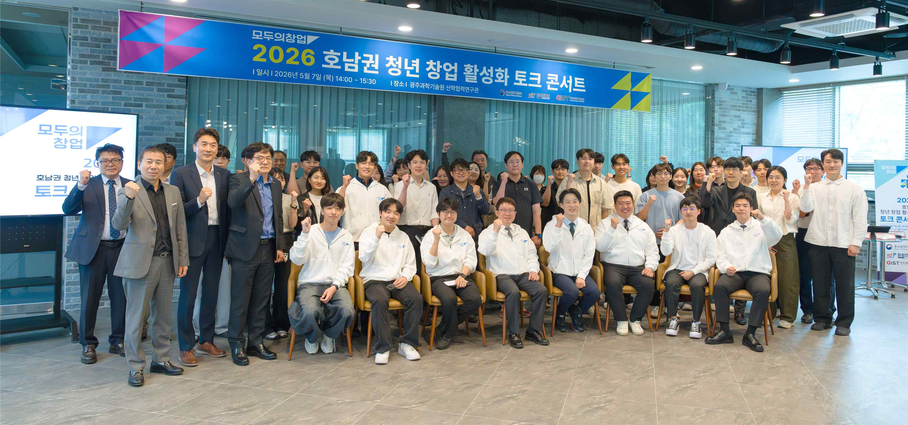

▲ Attendees pose for a commemorative photo after the "Startup for All" Talk Concert, held to promote entrepreneurship among youth in the Honam region, at the Coworking Zone on the first floor of the GIST Industry-Academic Cooperation Center on Thursday, May 7.
The Gwangju Institute of Science and Technology (GIST, President Kichul Lim) announced that it held the "Startup for All" Talk Concert on Thursday, May 7, at the Coworking Zone on the first floor of the GIST Industry-Academic Cooperation Center to inspire the entrepreneurial spirit of youth in the Honam region and to listen to voices from the field.
Organized to encourage participation in the "Startup for All" project, hosted by the Ministry of SMEs and Startups, the event was attended by approximately 70 people, including Yong-seok Noh, Vice Minister of SMEs and Startups; Kichul Lim, GIST President; Yong-Chul Kim, Vice President for R&DB; as well as senior entrepreneurs, prospective entrepreneurs, and current students.
The event proceeded in the order of a business briefing, welcoming remarks, a talk concert, and a Q&A session.
In his opening remarks, Vice Minister Yong-seok Noh stated, “Starting a business is the most active way of life; it is a process of spreading ideas to the world and becomes a powerful asset in one’s life.” He added, “As technology-based startups are the core driving force leading future new industries, I urge young people to actively take on challenges at the center of dynamic change, and we will continue to supplement the support needed on the ground.”
The talk concert, personally led by Vice Minister Yong-seok Noh, was conducted in an interactive format under the theme of “Starting, Growing, and Needed Support for Entrepreneurship as Told by Young GIST Entrepreneurs,” and received a positive response from the attendees.
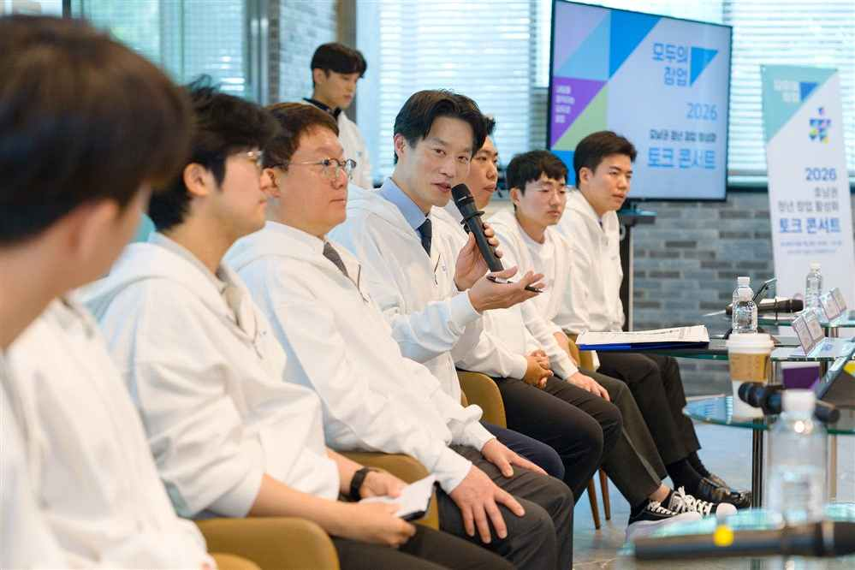

▲ Noh Yong-seok, First Vice Minister of the Ministry of SMEs and Startups, answers questions from attendees at the talk concert.
In the first session, senior entrepreneurs (CEO Ji-sung Jung of SOS Lab, CEO Jong-won Lee of Icarus, and CEO Ju-sung Park of Assist) and prospective entrepreneurs running startup clubs (students Jae-won Choi and Dong-woo Kim from the Department of Electrical Engineering and Computer Science, and student Yun-gu Song from the Department of Biomedical Science and Engineering) served as panelists to share their experiences and know-how on starting a business.
Following this, in the second session, Vice Minister Noh interacted directly with the attendees, engaging in a Q&A session covering the entire startup process, including ▴ methods for commercializing ideas at the initial idea stage, ▴ the importance of identifying potential customers and markets, ▴ technology verification strategies for deep tech startups, ▴ growth support programs for each stage of the startup, and ▴ investment linkages.
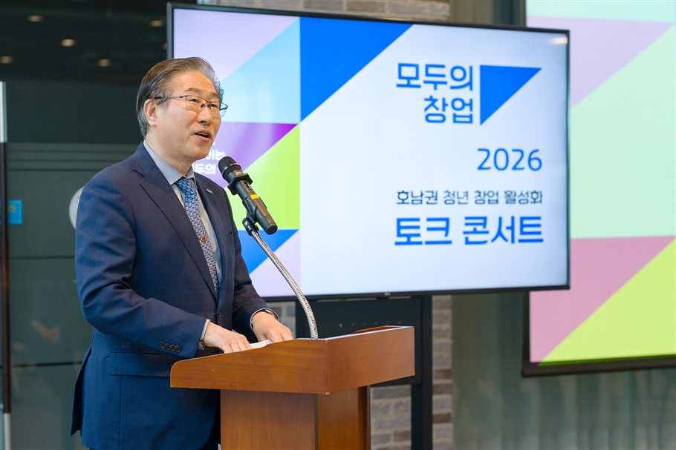

▲ GIST President Kichul Lim delivers a welcoming address at the "Startup for All" Talk Concert aimed at revitalizing entrepreneurship among youth in the Honam region.
Based on its outstanding research achievements and specialized science and technology personnel, GIST has supported technology-based startups through various programs, including the Startup Incubation Center and the Pre-Startup and Leap Startup Packages.
In particular, GIST Technology Holdings Co., Ltd. (GIST Holdings) achieved the shortest timeframe among university technology holding companies by being selected as a fund manager for a 5 billion won fund just one year and four months after its establishment. Furthermore, it demonstrated unrivaled investment capabilities by being consecutively selected for the first and second rounds of the Korea Venture Fund's regular investment programs, managing a fund totaling 7.5 billion won.
President Kichul Lim emphasized, "A spirit of challenge that does not fear failure is the greatest asset of the startup ecosystem," adding, "GIST will advance the full-cycle startup ecosystem through cooperation with the Korea Startup Foundation and serve as a hub for youth startups in the Honam region by linking with the 'Startup for All' initiative."
Meanwhile, "Startup for All," organized by the Ministry of SMEs and Startups and managed by GIST for the technology startup sector, is a nationwide startup support project that allows any citizen interested in entrepreneurship to take on the challenge with just an idea.
Selected teams will receive comprehensive support to help their ideas translate into actual commercialization, including expert mentoring, prototype production assistance, and linkages with follow-up investments.
In particular, GIST plans to leverage its expertise in producing numerous KOSDAQ-listed companies—such as Anygen, Genome & Company, BioFDNC, SOS Lab, and Neurofit—to deploy a dedicated mentoring team composed of 30 field experts to provide close support throughout the entire process of technology startups.
Applications are open until 4:00 PM on the upcoming 15th, and any citizen with a startup idea can apply through the "Startup for All" platform.

