“Space, AI, Robots… The Future Drawn by Children’s Fingertips” GIST hosts 3rd Science Imagination Children’s Art Contest
- Children's Imagination Art Contest on the theme of future science and technology at the lawn plaza in front of GIST Central Library on Saturday, May 16
- Registration for 250 participants on a first-come, first-served basis... Family-friendly activities to be held on the day of the event, and winning entries to be exhibited at Oryong Art Hall
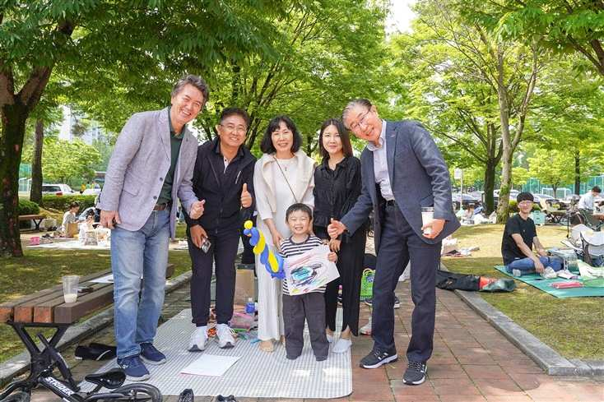

▲ President Kichul Lim (first on the right) and Vice President for Public Affairs Yonghwa Chung (first on the left) are posing for a photo with the families of participating children at the 2nd GIST Science Imagination Children's Art Contest held last year.
The Gwangju Institute of Science and Technology (GIST, President Kichul Lim) announced that it will hold the "3rd GIST Science Imagination Children's Art Contest" from 10:00 AM to 1:00 PM on Saturday, May 16, at the lawn plaza in front of the GIST Central Library and the surrounding area.
This year marks the third edition of the contest, which is being held under the joint sponsorship of the GIST Foundation and the Gwangju Metropolitan Office of Education.
Under the vision of "adding the value of sharing to science and technology," the GIST Office of International & Public Affairs has been holding the contest annually since 2024. This year, the number of participants has been increased by 50 compared to last year to broaden the base of science culture.
The event is open to kindergarteners and elementary school students (including those of the same age group) nationwide. The recruitment quota is 50 for the kindergarten group and 100 each for the lower elementary grades (grades 1–3) and upper elementary grades (grades 4–6), for a total of 250 participants.
Online registration began on Thursday, April 30, and due to high interest, it may close early.
Participants will be provided with 8-size drawing paper and snacks; however, they must bring their own drawing tools, mats, and other items.
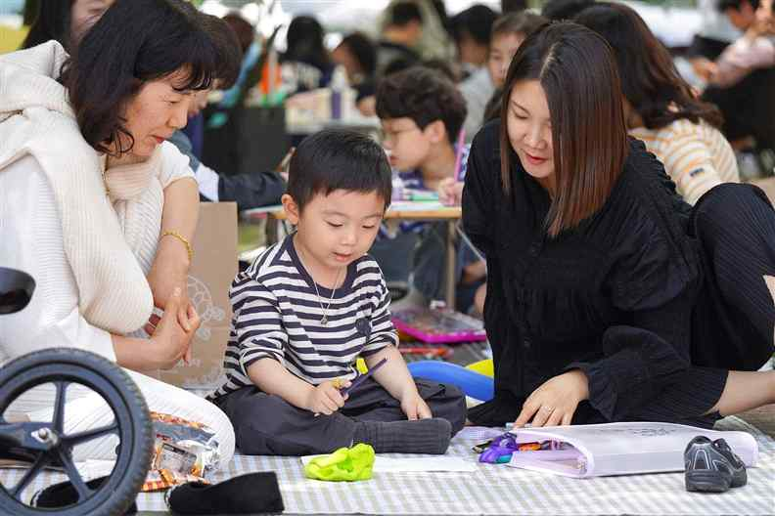

▲ A participating child is drawing at the 2nd GIST Science Imagination Children's Art Contest held last year.
The contest is conducted by encouraging participants to freely imagine and express the future approaching our daily lives, based on key future science and technology fields such as space, AI, robotics, mobility, and energy.
Submitted works undergo a review by art experts and are comprehensively evaluated based on ▴ creativity, ▴ expressiveness, and ▴ completeness.
A total of 56 winning entries will be selected from among 200 elementary school participants, and the winning works are scheduled to be exhibited for one month on the 3rd floor of the GIST Oryong Art Hall.
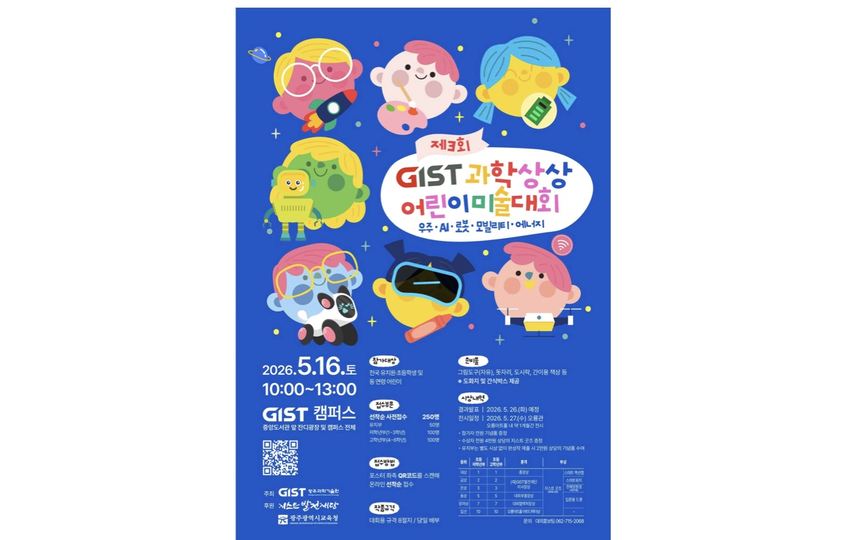

▲ Event poster for the 3rd GIST Science Imagination Children's Art Contest
On the day of the event, hands-on programs for family visitors will also be available.
Events include "Capturing a Family Photo," where participants can take a photo with the campus as a backdrop and have it instantly printed, as well as cotton candy and balloon art activities.
A small souvenir will be provided to all participating children.
Vice President for Public Affairs Yonghwa Chung stated, "This art competition is an opportunity for children to freely imagine and express the future through science and technology," adding, "GIST will continue to strive to spread scientific culture and foster creative talent."
Further details can be found on the GIST website (GISTian > Notices > Events), and inquiries can be directed to the External Public Relations Team (062-715-2068).

