“Give like water, be free like clouds” Dr. Kwang-heung Koh Donates to the GIST Development Fund, embodying his philosophy of life
- A 40-year water resources expert’s ‘Noblesse Oblige’… Generous donation for fostering future talent and improving the research environment
- The Advanced Photonics Research Institute Director auditorium named ‘Suun Hall’ after Dr. Koh’s Pen Name
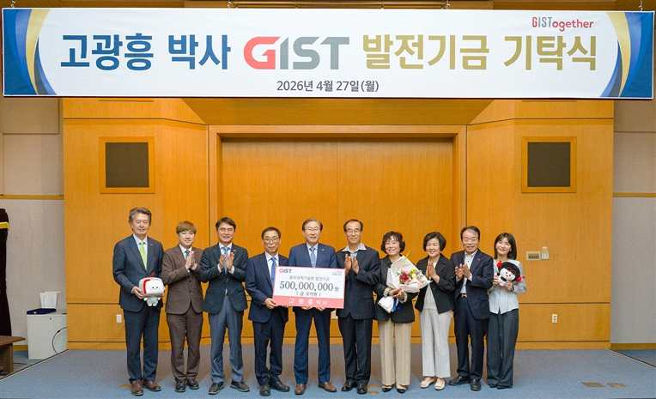

▲ Attendees pose for a commemorative photo after the donation ceremony for the development fund by Dr. Kwang-heung Koh (fifth from the right) held in the main conference room of the Administration Building on Monday, April 27.
The Gwangju Institute of Science and Technology (GIST, President Kichul Lim) announced that on Monday, April 27, it held a donation ceremony for a 500 million won development fund from Dr. Kwang-heung Koh in the main conference room of the Administration Building, followed by an unveiling ceremony for "Suun Hall," named after his pen name "Suun," in front of the auditorium of the Advanced Photonics Research Institute (APRI).
The event was attended by GIST executives, including President Kichul Lim, Vice President for Academic Affairs Sungho Jeong, Vice President for Public Affairs Yonghwa Chung, APRI Director Yeung Lak Lee, and Office of International and Public Affairs Dean Eunji Lee, as well as key officials such as Eun-mo Choi, Chairman of the GIST Development Foundation, and Jeong-ju Ko, Chairman of KBI Hanam (Honorary Doctor of Engineering at GIST).
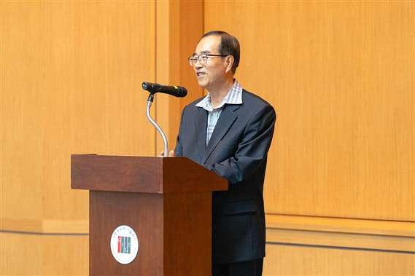

▲ Dr. Kwang-heung Koh delivers a speech at the development fund donation ceremony held in the main conference room of the Administration Building on Monday, April 27.
Dr. Kwang-heung Koh is a water resources expert who contributed to industrial development through activities that bridged academia and practical field experience, having worked for approximately 40 years at the Seoul Metropolitan Government Waterworks Headquarters and the Korea Water Resources Corporation.
Based on the expertise he accumulated in the field, he contributed to the management efficiency and policy improvement of the public sector by conducting policy research, such as determining optimal rates for metropolitan water supply systems and analyzing the national economic effects of multi-purpose dams.
Furthermore, he has devoted himself to fostering future generations of scholars and professional personnel through practice-oriented lectures at universities including Jangan University, Chungnam National University, and Hanbat University.
This donation was made possible as Dr. Koh, who has dedicated his life to the field of water resources, bridging the gap between the public and academic sectors, expressed his desire to practice "Noblesse Oblige" and contribute to fostering future talent and improving the research environment at GIST.
In particular, the donation gained further significance as Chairman Jeong-ju Ko—a senior from Dr. Ko’s hometown of Jangseong-gun, Jeollanam-do, who previously donated 1 billion won to GIST in 2022—supported Dr. Koh’s decision.
In his remarks, Chairman Jeong-ju Ko stated, "Dr. Kwang-heung Koh’s donation is the most valuable choice for the talents who will lead the future of science and technology in Korea," adding, "This noble act of sharing, imbued with a philosophy of life, will serve as a great source of courage for future generations and be remembered for a long time."
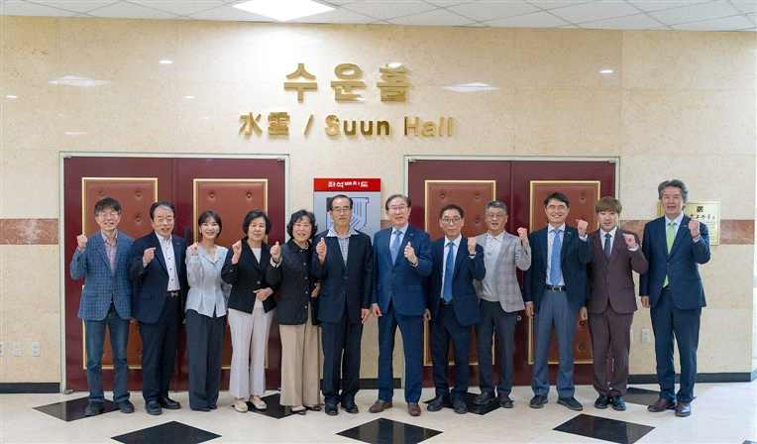

▲ On Monday, April 27, GIST named the auditorium of the Institute of Advanced Photonics and Photonics ‘Suun Hall’ in honor of Dr. Koh Kwang-heung (sixth from the left) and held an unveiling ceremony.
To honor the legacy of Dr. Koh, GIST named the auditorium of the Advanced Photonics Research Institute ‘Suun Hall’ and held an unveiling ceremony.
“Suun” embodies the meaning of “giving like water and living freely like clouds,” and it symbolizes the condensed life philosophy of his life, which has emphasized sharing, freedom, and public values.
GIST plans to honor the significance of his donation by bestowing his pen name upon its educational and research spaces, and to continuously spread the value of sharing.
Dr. Kwang-heung Koh stated, “This donation stems from my life philosophy that ‘water flows to the lowest places to benefit everyone, and clouds linger freely without attachment before dispersing.’ As the advancement of science and technology is the most important driving force transforming human life and the foundation of the convenience we enjoy, I hope GIST will grow into a university that contributes to the development of humanity by fostering world-class scientific and technological talent.”
President Kichul Lim responded, “Dr. Kwang-heung Koh’s meaningful decision will be a great driving force for GIST’s leap forward,” adding, “I look forward to the values ​​of sharing and cooperation spreading throughout the GIST campus, centered around ‘Suun Hall,’ which embodies the spirit of sharing, and to the continuation of educational and research activities that will lead the future.”
Meanwhile, the 500 million won in development funds donated this time will be used to build research infrastructure for optical science and technology at the Advanced Photonics Research Institute and to improve living environments, such as remodeling student dormitories.

