GIST unveils AI technologies to change future daily life at '2026 Korea Science Festival'
- From ‘real-time dubbing’ to ‘medical diagnostic assistance’ and ‘precision assembly robots’… Next-generation AI solutions collaborating with humans draw attention
- Over 700 visitors attend experiential future technology exhibition
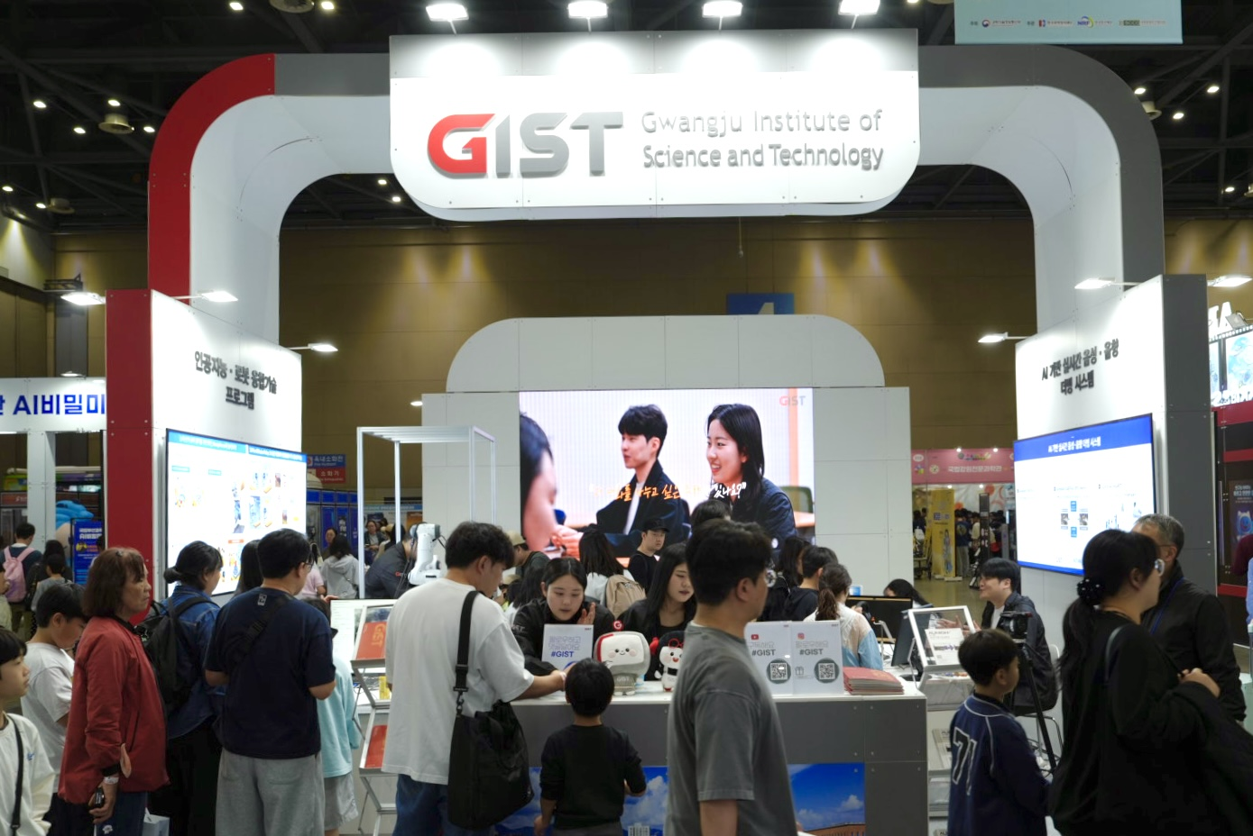

▲ A view of the booth operated by GIST at the ‘2026 Korea Science Festival in Gyeonggi’ from April 24 (Fri) to 26 (Sun).
The Gwangju Institute of Science and Technology (GIST, President Kichul Lim) announced that it participated in the ‘2026 Korea Science Festival in Gyeonggi,’ held from April 24 (Fri) to April 26 (Sun) at Hall 4 of Exhibition Center 1, KINTEX, Goyang-si, Gyeonggi-do.
The ‘2026 Korea Science Festival,’ hosted by the Ministry of Science and ICT and co-organized by the Korea Foundation for Science and Creativity, the National Research Foundation of Korea, and the Private Science Culture Council, is the largest science culture event in the country. Marking its 30th anniversary this year, the festival is being held across four regions nationwide: the Seoul Metropolitan Area, Chungcheong, Yeongnam, and Honam.
Under the theme of "AI that Hears, Understands, and Moves: Real-time Voice Dubbing and Intelligent Robots," GIST showcased the research achievements of Professor Hong Kook Kim (CEO of AunionAI Co., Ltd.) of the Department of Electrical Engineering and Computer Science and Director Kyoobin Lee (Professor of AI Convergence).
"AunionAI-DUB," an AI real-time automatic dubbing solution developed by Professor Hong Kook Kim, an expert in the field of voice and audio AI, implements multilingual automatic dubbing by integrating translation, speech synthesis, and lip-syncing based on a multi-agent system.
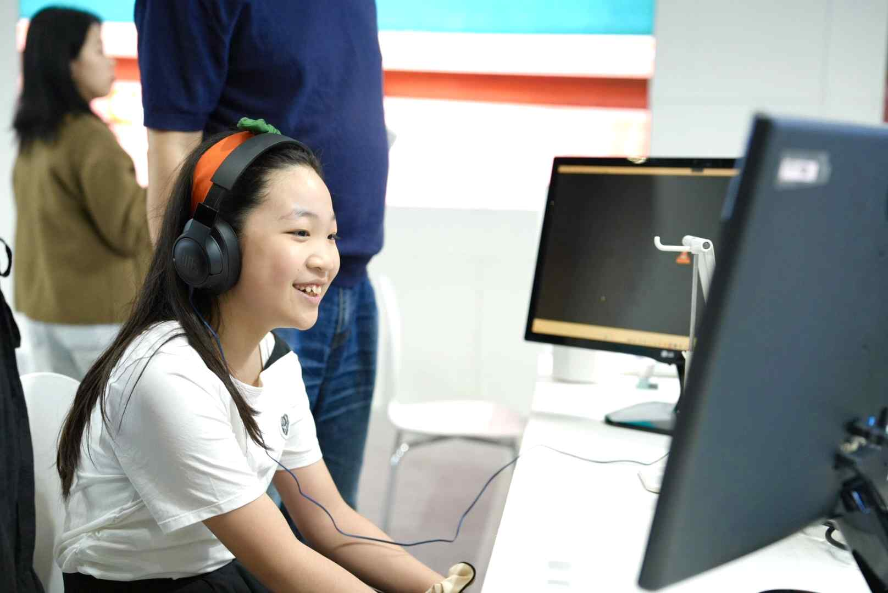

▲ A student visiting the GIST booth at the ‘2026 Korea Science Festival in Gyeonggi’ is experiencing the AI ​​real-time automatic dubbing solution, ‘AunionAI-DUB.’
It is characterized by providing natural-sounding results that resemble a real human voice by going beyond simple translation to reflect context, situation, and spatial awareness. Furthermore, it enhances the immersion and realism of the video through technology that automatically generates and applies sound effects (SFX) by analyzing the environment and situation of each scene.
This technology, which achieves high immersion by utilizing Large-Scale Language Models (LLM) while maintaining the speaker's timbre, was also showcased at ‘CES 2026,’ the world’s largest information technology (IT) and electronics exhibition held in Las Vegas last January, where it garnered attention as a promising example of AI technology.
Ha-yul Jeong (a 5th grader at Hansu Elementary School in Goyang) said, “I was amazed that the ambient sounds generated by AI based solely on footage of basketball being played in a gymnasium sounded so real. The technology that dubs movie scenes into other languages ​​using my voice, which I spoke briefly, was also really fascinating and fun.”
Among the technologies introduced by the research team led by Director Kyoobin Lee were ‘ManipForce,’ an AI technology that performs precise manipulation by learning the ‘sense of force,’ and ‘Doctor Assistant AI,’ which maximizes the efficiency of medical care in the field.
‘ManipForce’ is a technology in which a robot learns and reproduces the minute changes in force felt by a person during work. It collects force and rotation data through sensors attached to the worker’s wrist and work videos, and utilizes 3D markers and the device’s gravity compensation function to precisely extract only the force generated from the actual contact of a skilled worker.
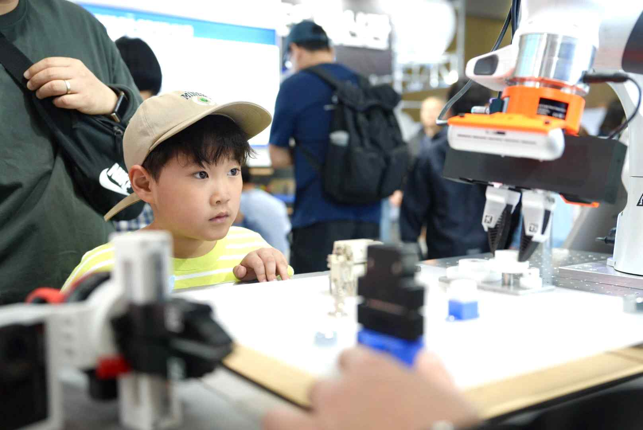

▲ A student visiting the GIST booth at the ‘2026 Korea Science Festival in Gyeonggi’ observes ‘ManipForce,’ an AI technology that performs precise manipulation by learning the ‘sense of force.’
At the science festival, a demonstration was conducted in which a robotic arm and a hand assembled gear components to mesh precisely. A visitor, who identified himself as working in the construction field, remarked, “If this is applied to tasks where fine force control is critical, it seems it could significantly improve construction accuracy and automation levels.”
The ‘Doctor Assistant AI,’ which assists in diagnosis based on medical data, was demonstrated by utilizing pre-taken dental X-ray images to identify abnormal signs and suggest treatment directions prior to the dentist’s final review.
This system garnered attention as a technology that detects uncertainty in the medical diagnostic process, requests additional verification from medical staff, and enhances diagnostic accuracy by learning from various medical data.
Office of International and Public Affairs Dean Eunji Lee stated, “This Korea Science Festival was a meaningful opportunity to meet the public through hands-on experiences with GIST’s AI technology, demonstrating that research achievements can be extended into daily life.” She added, “We will continue to promote scientific culture so that all citizens can experience it firsthand.”
Meanwhile, during the event, approximately 700 visitors visited the GIST booth to experience the AI ​​technology firsthand, showing great interest. Additionally, on the opening day of the event, April 24 (Fri), Representative Hyun Kim, Secretary of the National Assembly Science, Technology, Information and Communications Committee, visited the GIST booth to personally experience the exhibited technology.

