GIST opens 'On-site Solution Channel' for energy companies at 'KEET 2026'
- Combining expert relay lectures and 1:1 consultations… ‘One-stop’ support tailored to corporate needs
- Expanding the foundation of the local energy ecosystem through the operation of a joint booth by energy cluster institutions and citizen participation education
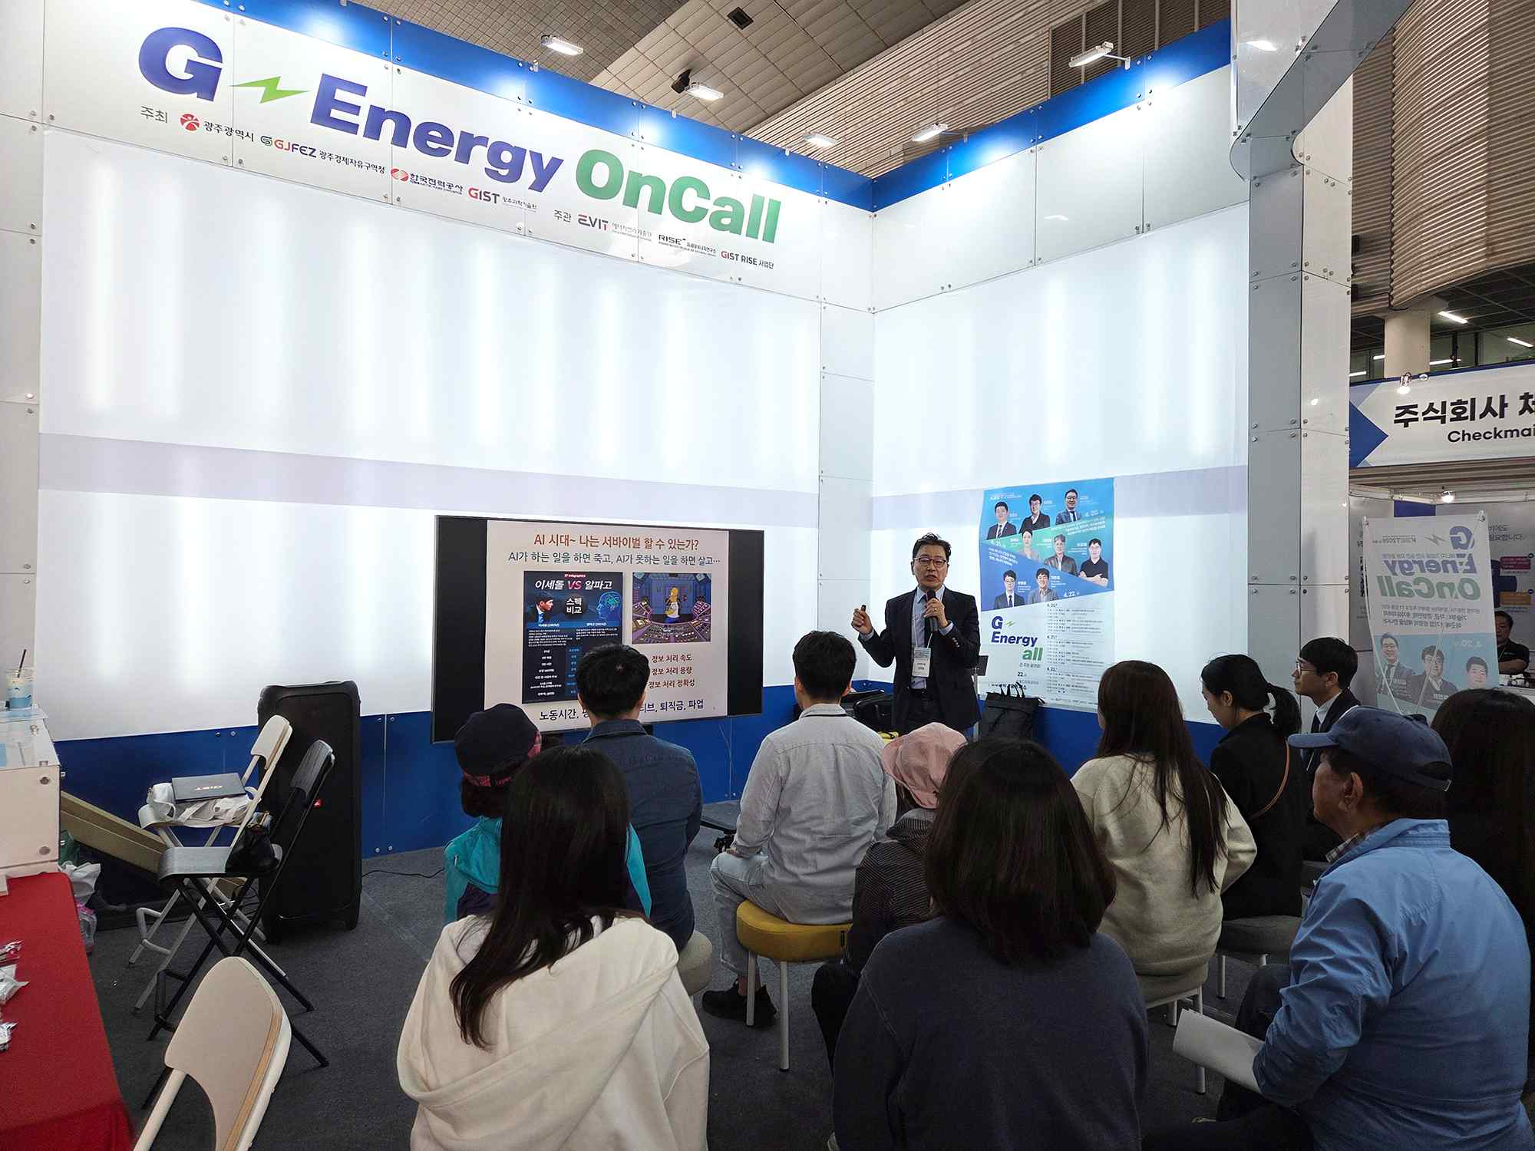

▲ Tae-won Kim, a senior researcher at the Energy Nano Group of the Korea Institute of Industrial Technology (KITECH), is giving a lecture on the topic of "How Will Our Companies Survive in the AI ​​Era?" on Monday, April 20.
The Gwangju Institute of Science and Technology (GIST, President Kichul Lim) announced that it participated in the "2026 Korea Climate, Environment, and Energy Exhibition (KEET 2026)," held in Yeosu, Jeollanam-do from Monday, April 20 to Wednesday, April 22, and operated "G-Energy OnCall," a field-oriented expert network program encompassing the entire energy industry.
"G-Energy OnCall" is an ongoing "On-Call" program in which experts from various fields participate in a relay format to provide consultation and advice tailored to on-site needs, focusing on key themes for the growth stages of the energy industry, such as corporate operations, investment attraction, and technology development.
This program was operated in the form of a joint booth centered around the GIST Research Institute for Solar and Sustainable Energies, in collaboration with Gwangju Techno Park and the Korea Institute of Photonics Technology. Through this, visitors were able to access energy technology and industry information in one place and confirm the potential of an integrated support system based on inter-agency cooperation.
‘G-Energy On-Call’ was conducted in a ‘one-stop’ manner, combining on-site lectures by experts and 1:1 consultations covering the entire corporate lifecycle—from startups to operations, investment, and technology development—and attracted significant interest from entrepreneurs and prospective founders in need of practical support.
Chan-hee Lee, CEO of the Jeonnam Regional University Alliance Startup Technology Holding Company, presented comprehensive implementation plans to startup employees, covering everything from initial startup strategies to operations and management.
For entrepreneurs grappling with organizational operations and human resource management since founding their businesses, Jun-su Kim, Representative of Yonsei Labor Attorney Office, and Ye-ji Moon, a certified labor attorney, delivered lectures on HR and labor strategies and practical applications for sustainable organizational management.
Additionally, Kwan-hee Lee, Head of the Gwangju Center for Creative Economy Innovation, introduced a step-by-step investment preparation process and strategies from an investor's perspective to help entrepreneurs seeking investment strengthen their practical capabilities.
In addition, Jung-je Woo, Head of the Gwangju Eco-friendly Energy Research Center at the Korea Institute of Energy Research, presented technology development directions and response strategies centered on battery recycling and resource circularity to professionals in the battery industry.
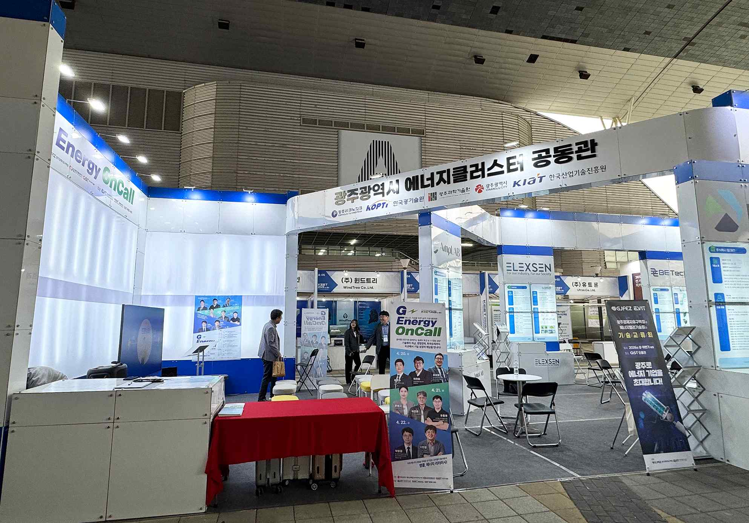

▲ A view of the ‘G-Energy OnCall’ booth, operated as a joint pavilion by the GIST Next Generation Energy Research Institute, Gwangju Techno Park, and the Korea Institute of Photonics Technology at ‘KEET 2026’ from April 20 (Mon) to 22 (Wed).
On the final day of the event, the significance of the program was expanded with the GIST RISE (Regional Innovation-Centered University Support System) Group’s ‘Encore, Energy Literacy!’, held for citizens and youth.
‘Encore, Energy Literacy!’ is an experiential education program utilizing self-developed textbooks and solar power and battery kits, designed to help youth and citizens easily understand the principles and utilization processes of energy.
Lectures on the themes of ‘Power Systems’ and ‘Solar Power’ were also delivered by Byeong-cheol Park, Principal Researcher at the Energy Conversion Research Center of the Korea Electronics and Technology Institute (KETI), and Hyeon-cheol Ki, Director of the Photonic Energy Components Research Center at the Korea Institute of Photonics Technology (KIPAT), raising understanding and interest in the future energy industry.
Kwanghee Lee, Director of the GIST Energy Valley Institute of Technology, said, “‘G-Energy OnCall’ is a growth support platform that encompasses technology, management, and investment for energy companies in Gwangju and Jeonnam. It served as an opportunity for key institutions of the Gwangju Energy Cluster to participate together, strengthen the foundation for cooperation, and promote the capabilities of the regional energy ecosystem to the outside world,” adding, “We will continue to work closely with the local industry to expand the open innovation ecosystem.”

