GIST holds '2026 Anti-Corruption and Integrity Pledge Ceremony'
- On Tuesday, April 21, key officials including President Kichul Lim gathered at the GIST Administration Building to pledge to practice integrity
- Jointly promoting the ‘Relay Integrity Declaration Campaign’ among the Four Leading Science and Technology Institutes... Spreading a culture of integrity throughout the science and technology sector
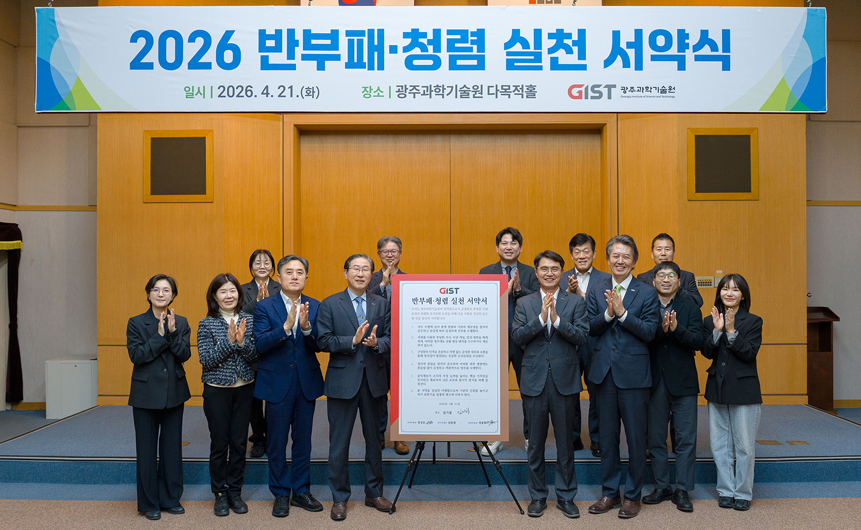

▲ A commemorative photo is being taken after the "2026 Anti-Corruption and Integrity Pledge Ceremony," held on April 21 (Tue) in the Conference Room of the Administration Building to reaffirm anti-corruption commitment and spread a culture of integrity.
The Gwangju Institute of Science and Technology (GIST, President Kichul Lim) announced that it held the "2026 Anti-Corruption and Integrity Pledge Ceremony" on April 21 (Tue) in the Conference Room of the Administration Building to reaffirm its anti-corruption commitment and spread a culture of integrity.
This pledge ceremony was organized as part of GIST's integrity implementation framework (I-CARE*), which aims to preemptively block corruption risks and spread the value of integrity based on ethical management grounded in leaders leading by example.
* I-CARE: I (Initiative Leadership, responsible management of integrity led by the head of the institution), C (Control Reinforcement, enhancing execution capabilities through strengthened internal controls), A (Advance Risk Fields, proactive identification and intensive improvement of vulnerable areas), R (Risk Prevention, blocking corruption risks through the operation of preventive systems), E (Expansion & Engagement, internalization of integrity values ​​and expansion of external cooperation and exchange).
President Kichul Lim, Vice President for Academic Affairs Sungho Jeong, Vice President for Public Affairs Yonghwa Chung, and key administrators attended the pledge ceremony to sign the ‘Anti-Corruption and Integrity Pledge’ aimed at fostering a transparent and healthy organizational culture, and reaffirmed their commitment to practicing integrity.
The pledge includes content ranging from practical measures for anti-corruption and integrity to ethical management, such as ▴ compliance with laws and institutional regulations, ▴ exclusion of improper instructions, ▴ intervention in vested interests, and ▴ solicitation for mediation, ▴ prohibition of accepting money, entertainment, or conveniences, ▴ fostering a healthy organizational culture through respect for dignity and fair treatment, ▴ adherence to political neutrality, ▴ protection of whistleblowers and ▴ prevention of disadvantages to strengthen the institution's self-purification capabilities, and ▴ enhancement of national scientific and technological competitiveness through increased institutional credibility.


▲ GIST President Kichul Lim delivers a welcoming speech to the attendees, emphasizing the importance of practicing integrity.
President Lim stated, “Integrity is a fundamental value that the entire organization must practice together, and spreading a culture of integrity through leaders leading by example is of paramount importance.” He urged attendees to “make every effort to ensure that GIST takes another leap forward as a trusted institution through sound research and responsible operations, using this pledge ceremony as an opportunity.”
Meanwhile, the four leading science and technology institutes (GIST, KAIST, UNIST, and DGIST) plan to launch a ‘Relay Integrity Declaration Campaign’ to spread a culture of integrity throughout the science and technology sector.
Starting with GIST, this campaign will proceed by sequentially producing relay videos containing integrity messages from each institution. Through this initiative, GIST plans to collaborate with the four institutes to contribute to the spread of a culture of integrity across the scientific and technological community.

