GIST, Chonnam National University, and KENTECH establish triangular cooperation... ‘Korean-style Research Triangle’ model launched amidst the era of Jeonnam and Gwangju integration
- Responding to the Era of Jeonnam and Gwangju Integration… Presidents of three universities join forces to fully launch science and technology cooperation platforms sharing cooperation strategies in semiconductor, AI, and energy sectors, and emphasizing the importance of attracting anchor companies
- Initiating the establishment of an innovation ecosystem in the Honam Region through the ‘Korean-style Research Triangle,’ a research and industry-academic cooperation ecosystem connecting GIST, Chonnam National University, and KENTECH
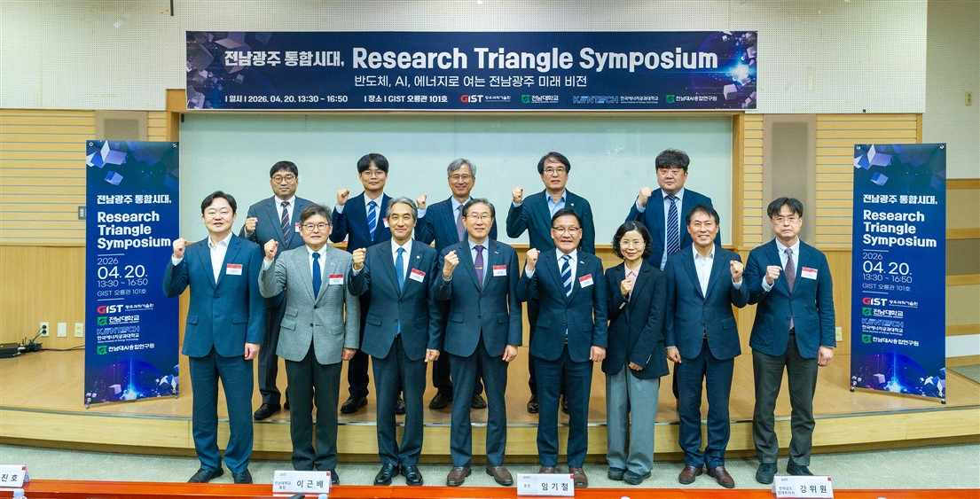

▲ Officials attending the "Jeonnam-Gwangju Integrated Era, Research Triangle Symposium," held at GIST Oryong Hall on Monday, April 20, are posing for a commemorative photo. (From the second person from the left in the front row to the right) Jin-ho Park, Acting President of KENTECH; Geun-bae Lee, President of Chonnam National University; Kichul Lim, President of GIST; Wi-won Kang, Vice Governor for Economic Affairs of Jeollanam-do; and Ki-sook Kim, Director General of the Education and Youth Bureau of Gwangju Metropolitan City.
The Gwangju Institute of Science and Technology (GIST, President Kichul Lim) announced that on Monday, April 20, it held the "Jeonnam-Gwangju Integrated Era, Research Triangle Symposium" at GIST's Oryong Hall together with Chonnam National University (President Geun-bae Lee) and Korea National Institute of Energy and Engineering (KENTECH, Acting President Jin-ho Park). The university stated that it has officially launched the establishment of a "Korean-style Research Triangle" by strengthening the foundation for research cooperation among the three universities.
The "Research Triangle" is a concept inspired by the "Research Triangle Park (RTP)" model, a research and industry-academia cooperation ecosystem that connects the regions of Raleigh, Durham, and Chapel Hill in North Carolina, USA, in a triangle. In this region, a world-class innovation cluster has been formed with close linkages between universities, research institutes, and companies, centered around three research-focused universities: Duke University, the University of North Carolina at Chapel Hill, and North Carolina State University. The ‘Korean-style Research Triangle’ proposed at this symposium is based on the vision of Chonnam National University President Geun-bae Lee, and is a collaborative model in which GIST, Chonnam National University, and KENTECH combine their respective specialized research capabilities to foster the Honam region as a hub for future science and technology innovation. In particular, it aims to establish a region-led innovation platform that organically links joint research, talent development, and technology commercialization, centering on the Honam region’s core strategic industries such as semiconductors, artificial intelligence (AI), and energy.
Key officials attended the symposium, including GIST President Kichul LIm and Dean of Research Chanho Pak; Chonnam National University President Geun-bae Lee and Vice Dean of Industry-Academic Cooperation Bong-gi Lee; KENTECH Acting President Jin-ho Park, Research Director Seung-il Moon, and Dean of Research Chang-hee Kim; as well as Jeollanam-do Vice Governor for Economic Affairs Wi-won Kang and Director General of Strategic Industries Ki-hong Kim; Gwangju Metropolitan City Director General of Education and Youth Ki-sook Kim; Jeonnam Technopark President Ik-hyun Oh; Gwangju Technopark Acting President Cheol-seung Lee; and AI Industry Convergence Center (AICA) Director Sang-jin Oh.
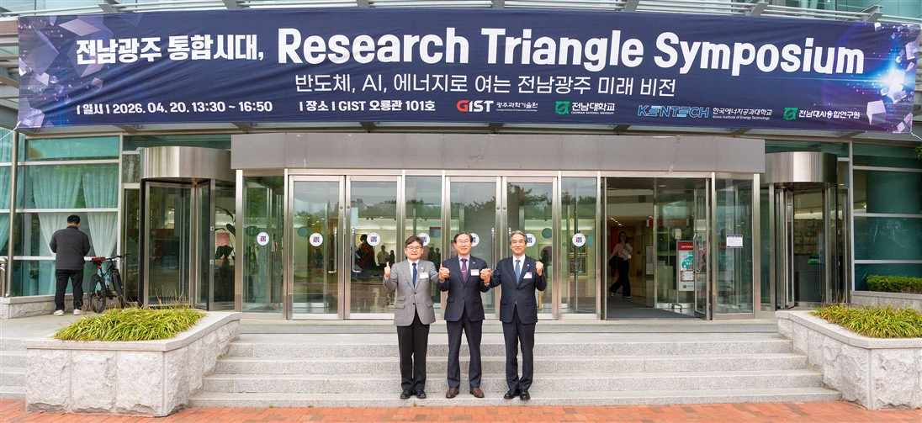

▲ (From left) KENTECH Acting President Jin-ho Park, GIST President Kichul Lim, and Chonnam National University President Geun-bae Lee pose for a photo after the symposium.
In his congratulatory remarks, Chonnam National University President Geun-bae Lee stated, “Gwangju and Jeonnam are leaping forward as a single intelligent economic zone based on strategic industries,” adding that “the ‘Research Triangle’ of the three universities will lead this transition and drive the nation’s future competitiveness.”
Furthermore, KENTECH Acting President Jin-ho Park emphasized, “I hope the three universities will create a new growth axis encompassing research, technology commercialization, and entrepreneurship,” and urged, “Let us realize a ‘Korean-style Research Triangle’ that jointly responds to national energy policies through the formation of a K-Grid Talent and Startup Valley.”
The presidents of the three universities reached a consensus that attracting anchor companies, in addition to inter-university cooperation, is a key element for the success of the ‘Research Triangle’ model. They explained that IBM, a global IT and consulting firm, is also playing the role of an anchor company at the ‘Research Triangle Park (RTP)’ in North Carolina, USA.
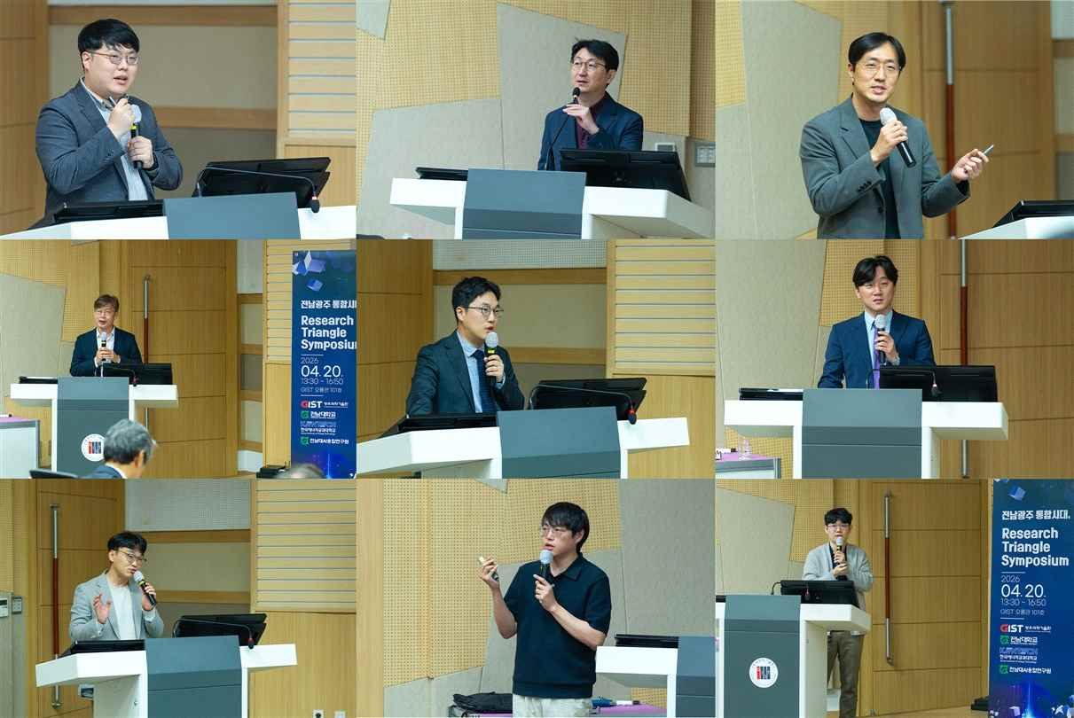

▲ ▴(First row, from left to right) Professor Dong-Ho Kang of the Department of Semiconductor Engineering at GIST, Director Kyoobin Lee of the AI ​​Research Institute (Professor of AI Convergence), and Professor Yun-Su Kim of the Department of Electrical Engineering and Computer Science ▴(Second row, from left to right) Professor Sang-wan Ryu of the Department of Physics at Chonnam National University, Professor Chan-soo Kim of the Department of Future Mobility, and Professor Young-si Jeon of the School of Chemical Engineering ▴(Third row, from left to right) Professor Hye-min Kang, Professor Sum-yung Ahn, and Professor Jin-oh Lee of the School of Energy Engineering at KENTECH
In the presentation session, researchers from GIST, Chonnam National University, and KENTECH in the fields of semiconductors, AI, and energy presented the latest research trends and collaboration strategies. The presenters outlined concrete visions for securing future growth engines based on the industrial and research infrastructure possessed by Jeonnam and Gwangju.
In the semiconductor field, Professor Sang-wan Ryu of the Department of Physics at Chonnam National University analyzed the opportunity and threat factors for the semiconductor industry in the Southwest region and presented key strategies including: intensive fostering and advancement of specialized fields; workforce training and infrastructure development; and the convergence of the optics industry and silicon technology.
Professor Ryu emphasized, “We must foster Jeonnam and Gwangju into a semiconductor innovation hub where talent and companies grow together through strategic responses centered on system semiconductors, such as back-end processing and fabless design.”
Professor Dong-Ho Kang of the Department of Semiconductor Engineering at GIST introduced the ‘GIST Advanced AI Semiconductor Fab for the Establishment of the Southwest Semiconductor Cluster,’ while Professor Hye-min Kang of the Department of Energy Engineering at KENTECH presented ‘Jeollanam-do’s Strategy for Fostering the Power Semiconductor Industry and Technology.’
In the field of AI, Kyoobin Lee, Director of the AI ​​Research Institute at GIST (and Professor of AI Convergence), emphasized the need for data accumulation, technological advancement, and the establishment of revenue-generating systems to achieve the generalization of physical AI.
Director Lee stated, “Universities are the key players in developing cutting-edge technologies and fostering talent,” and suggested that “institutional support is urgently needed to resolve on-site constraints, such as providing subsidies for robot introduction and simplifying equipment review processes.”
Professor Chan-soo Kim of the Department of Future Mobility at Chonnam National University presented on “AI-based Integrated Autonomous Driving and Verification Pipelines,” while Professor Ahn Su-myeong of the School of Energy Engineering at KENTECH emphasized measures to secure the scalability and reliability of AI through his presentation titled “Robust AI: Beyond Reliable AI to the Robustness of Energy Infrastructure.”
In the energy sector, Professor Jin-oh Lee of the School of Energy Engineering at KENTECH highlighted the importance of verifying distributed energy technologies and emphasized the potential for Jeonnam and Gwangju to leap forward as a “Distributed Energy System Demonstration Cluster.” Professor Lee stated, “It is crucial to establish a demonstration environment capable of comprehensively verifying technologies across the entire lifecycle of the power grid.”
Professor Young-si Jeon of the Department of Chemical Engineering at Chonnam National University presented a ‘Multi-layered Distributed Energy Optimization System,’ while Professor Kim Yun-su of the Department of Electrical Engineering and Computer Science at GIST introduced a ‘Plan for the Development of Fully Unmanned Power Grid Autonomous Operation Technology.’
GIST President Kichul Lim stated, “This symposium marks a meaningful starting point for regional universities to consolidate their research capabilities and build a win-win cooperation model,” adding, “I hope the three universities will establish a foundation for shared growth and continue practical research collaboration to contribute to the advancement of science and technology in Korea.”
President Lim further remarked, “This event is highly significant in that it preemptively presented a region-led science and technology cooperation model in conjunction with discussions on the integration of Jeonnam and Gwangju,” and assessed the event as “a venue that demonstrated the potential to develop into a multi-layered innovation ecosystem involving universities, industry, local governments, and research institutions.”
Furthermore, President Lim emphasized, “Our cooperation must not stop at research collaboration but lead to the creation of tangible value through technology commercialization,” adding, “To achieve this, it is crucial to expand the industrial ecosystem, including linkages with anchor companies.”

