GIST unveils hands-on energy education program at Gwacheon Science Festival
- Participated in the National Gwacheon Science Museum’s ‘Happy Science Festival’… Operated the ‘Energy Literacy & Makerthon’ program
- Continued to expand achievements through the expert network ‘G-Energy Oncall’ at ‘KEET 2026’
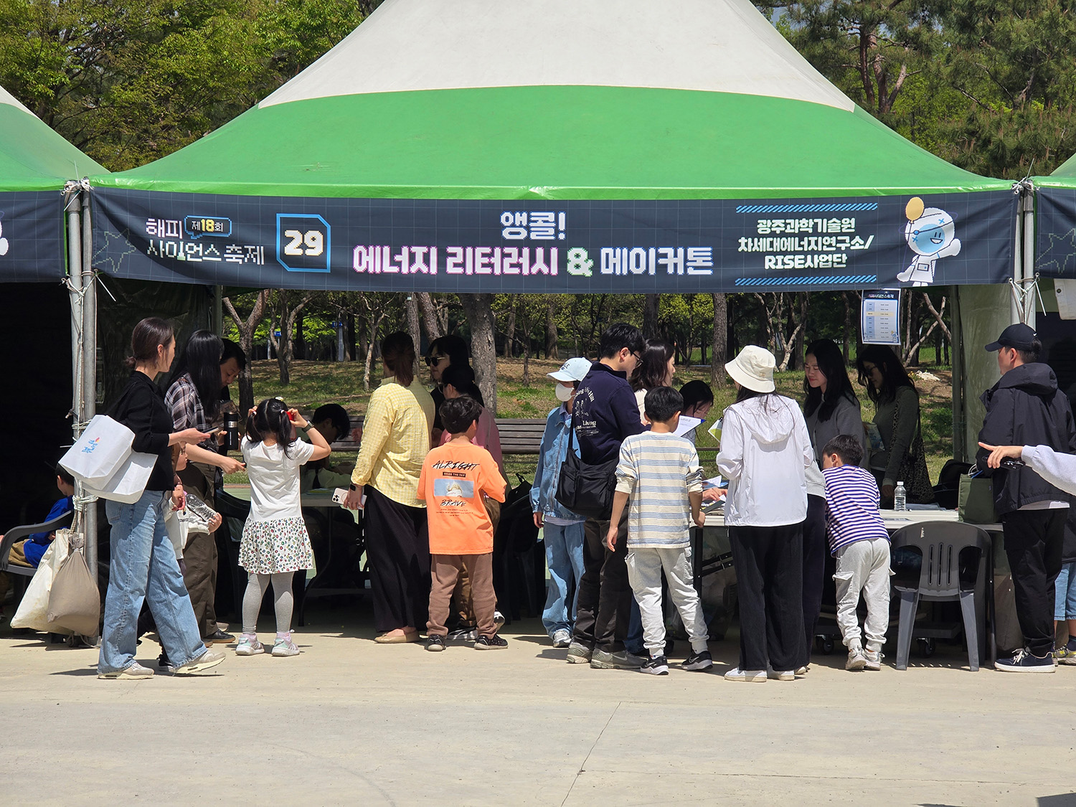

▲ The GIST RISE Project Team participated in the 18th ‘Happy Science Festival’ held at the Gwacheon National Science Museum and operated the ‘Encore, Energy Literacy & Makeathon.’
The Gwangju Institute of Science and Technology (GIST, President Kichul Lim) announced that it participated in the 18th ‘Happy Science Festival,’ held from Saturday, April 18 to Sunday, April 19, and operated the ‘Encore, Energy Literacy & Makeathon’ by the GIST RISE (Regional Innovation-Centered University Support System) Project Team.
The ‘Energy Literacy & Makeathon’ is an experiential education program where participants learn energy concepts and, based on that knowledge, create and experiment with them firsthand. The ‘Happy Science Festival,’ hosted and organized by the Gwacheon National Science Museum, is a nationwide science and culture event that combines science experiences with cultural content. The participation of the GIST RISE Project Group (Director Inchan Kwon) was arranged as part of the ‘Urban Campus Living Lab’ initiative to widely disseminate the achievements of energy education that has been pursued since 2025.
The GIST RISE Project Group has continuously operated the ‘Energy Literacy & Makerthon’ education model, which combines theory and practice, focusing on the four core sectors of the future energy industry: solar power, batteries, hydrogen energy, and power systems.
In particular, the operation of this program is significant in that the energy education content developed and promoted by the GIST RISE Project Group with the support of Gwangju Metropolitan City is being directly implemented at the Gwacheon National Science Museum’s science festival site, expanding it into a nationwide science and culture program.
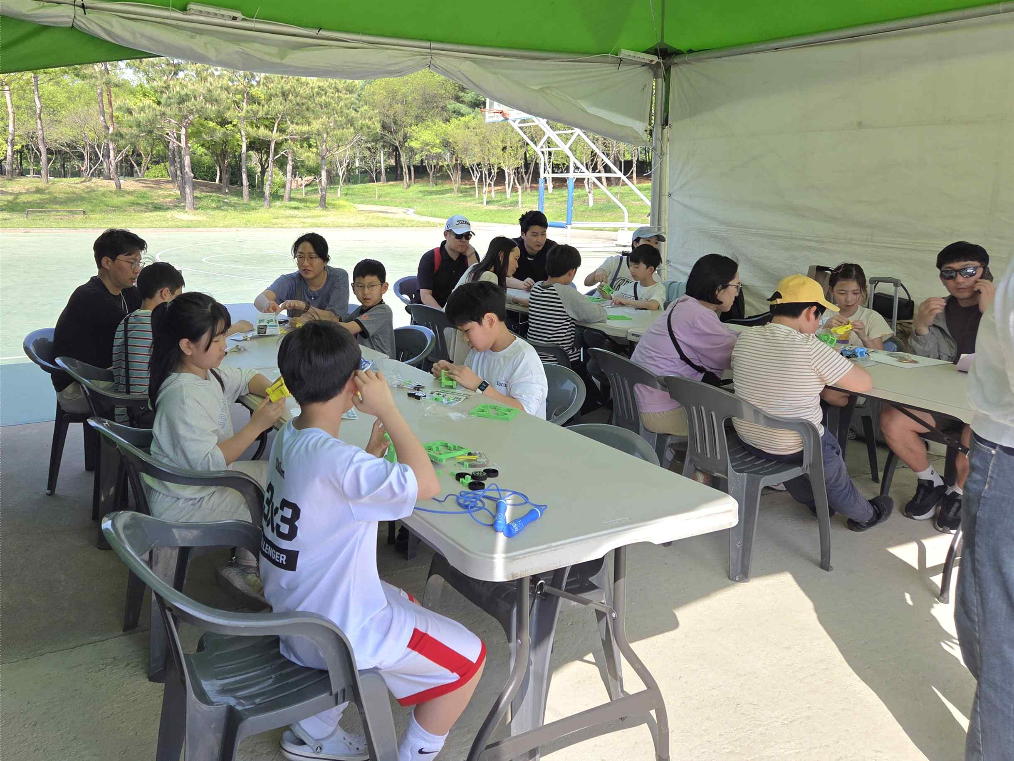

▲ Children, teenagers, and their families are participating in a makerthon workshop using solar-powered car kits at the "Encore, Energy Literacy & Makerthon" organized by the GIST RISE Project Group.
"Encore, Energy Literacy & Makerthon" was held at the outdoor experience zone of the Gwacheon National Science Museum through on-site registration and voluntary participation. It operated as an open educational program where children, teenagers, and their families from across the country participated together.
The curriculum consisted of theoretical energy literacy classes using self-developed textbooks and makerthon workshops utilizing solar-powered car kits, enhancing the balance between learning and experience.
The program ran for a total of 12 sessions over two days, with 16 participants per session, to increase participant engagement. Researchers from the GIST Next Generation Energy Research Institute and the Energy Valley Technology Institute participated as assistant instructors, adding expertise to the program.
Through this operation, a total of 192 people participated over the two days, confirming the competitiveness of energy education content based on high interest and satisfaction. Kwon In-chan, Director of the GIST RISE Project Group, stated, “We prepared this program to spread the high level of interest and passion of local youth, confirmed through various energy education programs last year, to the entire nation,” adding, “We will continuously enhance our content so that Gwangju can establish itself as a hub for energy education and demonstration.”
Hongkyu Kang, Deputy Director of the GIST Research Institute for Solar and Sustainable Energies and the project leader for the ‘Urban Campus Living Lab’ under the GIST RISE Project Group, said, “Our self-developed teaching materials are being recognized for their effectiveness in various fields,” and added, “We will actively incorporate feedback from the field to further develop energy literacy education content, and through this, strive to increase the number of students and citizens who understand future energy issues and possess the capacity to solve them.”
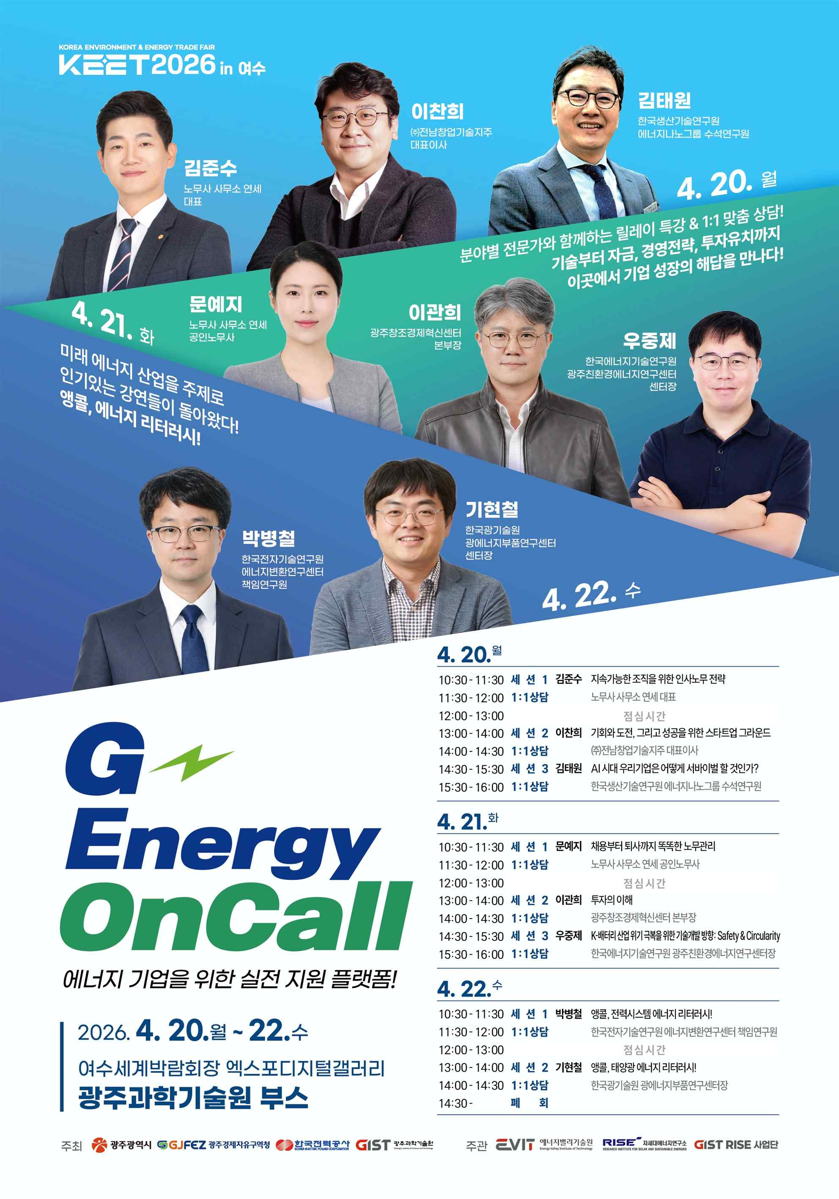

▲ Poster for the "G-Energy On-Call" event, scheduled to be jointly operated by the GIST RISE Project Group, the Next Generation Energy Research Institute, and the Energy Valley Technology Institute.
Meanwhile, the GIST RISE Project Group will also participate in the "2026 Korea Climate, Environment, and Energy Exhibition (KEET 2026)," which will be held from April 20 (Mon) to April 22 (Wed) at the Expo Digital Gallery in the Yeosu World Expo Center, Jeonnam.
At "KEET 2026," the group plans to continue expanding the achievements of energy education by operating the "G-Energy On-Call" program jointly with the GIST Next Generation Energy Research Institute and the Energy Valley Technology Institute.
‘G-Energy OnCall’ is an on-call expert network program in which different experts participate in a relay format every day, focusing on topics related to key growth stages of the energy industry such as corporate operations, investment attraction, and technology development, to provide consultation and advice tailored to on-site needs. Its purpose is to support problem-solving and technology diffusion in the energy industry.

