Art museums that the visually impaired can enjoy without a companion... GIST AI autonomous driving robot-based exhibition viewing support
- Pilot operation of an AI autonomous robot-based exhibition viewing support service for the visually impaired for 10 days starting April 20… At the exhibition “The Art of Relationships: Willingly and Inevitably Leaning” at ‘Modu Art Space’ in front of Seoul Station
- Application of R&D results to actual exhibition sites… Promotion of advancement of cultural technology service models capable of public dissemination
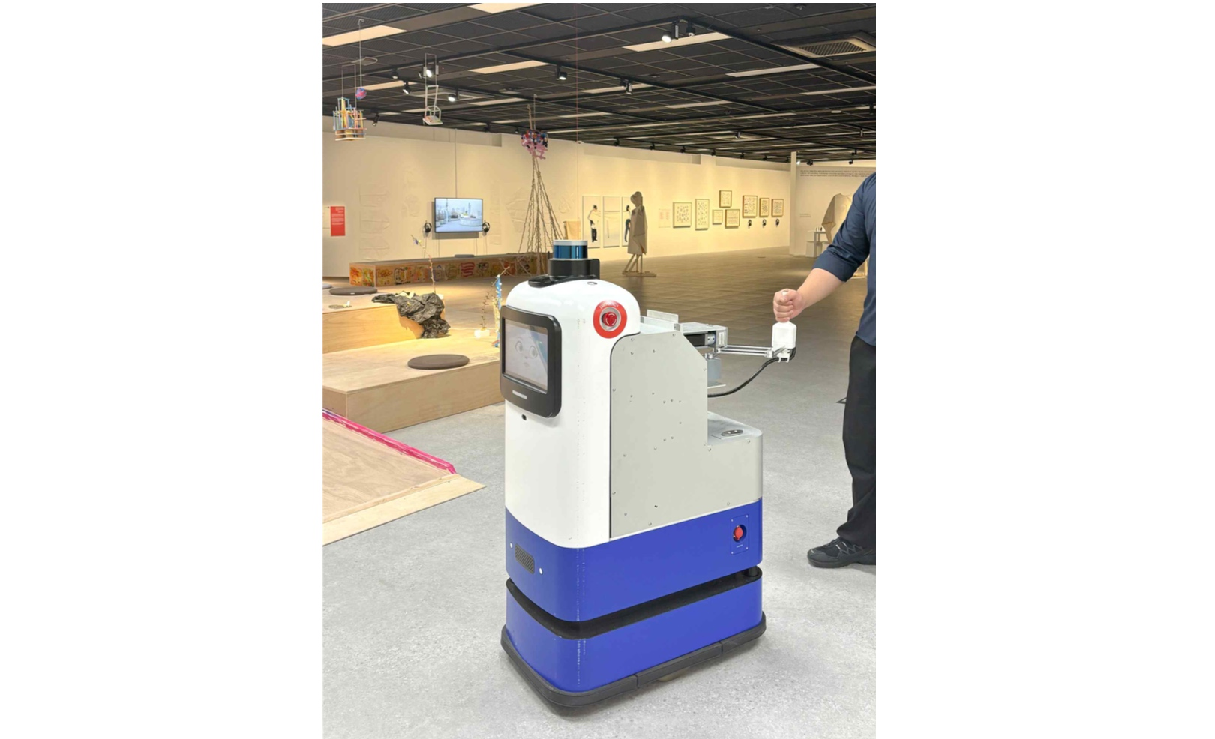

▲ An exhibition guide robot for the visually impaired. It supports visually impaired individuals in moving safely and freely while experiencing the exhibition.
The Gwangju Institute of Science and Technology (GIST, President Kichul Lim) announced that the Korea Culture Technology Institute (Director Jungwon Yoon), in collaboration with the Modu Art Space of the Korea Disabled Persons Culture and Arts Center (Chairman Gwi-hee Bang), is piloting a "robot-based exhibition viewing support service" to improve exhibition accessibility for visually impaired visitors.
"Modu Art Space" is an exhibition space of the Korea Disabled Persons Culture and Arts Center located in front of Seoul Station, operated to enhance access to culture and arts for people with disabilities. Since its opening in December 2024, it has been continuously promoting programs to improve the exhibition viewing environment and provide accessibility support tailored to different types of disabilities, including visual and auditory impairments.
This operation is significant as it represents the application of technology secured through a Ministry of Culture, Sports and Tourism R&D project conducted by the Korea Institute of Culture Technology (Project Title: Development of a Personalized Exhibition Viewing Concierge Service for the Visually Impaired, Aug. 1, 2023 – Dec. 31, 2025) to an actual exhibition site, marking the first step in realizing research results into a practical cultural service.
The AI ​​autonomous driving robot-based exhibition viewing support service will be piloted for 10 days starting April 20 for the 2026 Modugonggam Special Exhibition, "The Art of Relationships: Willingly and Inevitably Leaning."
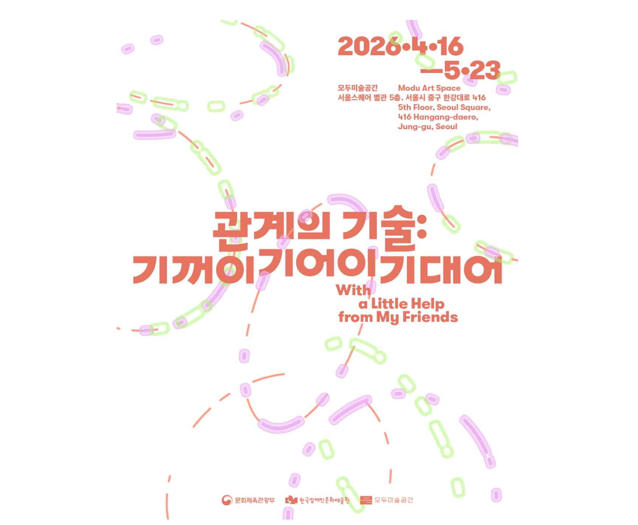

▲ Event poster for the 2026 Modugonggam Special Exhibition "The Art of Relationships: Willingly and Inevitably Leaning."
This exhibition highlights the value of "relationship building"—observing and caring for others—with the themes of living by leaning on one another and consideration that respects each other's pace.
In particular, it reinterprets disability not as a problem to be overcome by the individual, but as a communal foundation for connecting with one another and living together, and explores ways to coexist within relationships while maintaining one's unique identity.
This pilot operation was launched based on the Memorandum of Understanding (MOU) signed by the Institute with the Korea Disabled Persons Culture and Arts Center on January 29, and is part of a collaboration aimed at expanding the right of the visually impaired to enjoy culture and arts and enhancing exhibition accessibility.
This service supports visually impaired visitors in autonomously viewing exhibitions without the need for a separate accompaniment by having robots guide visitors along their movement paths and automatically providing audio commentary tailored to their location and the exhibition context.
Furthermore, based on a system that links exhibition space and artwork information, it is expected to provide personalized guidance and enhance visitors' understanding of the exhibition through detailed audio descriptions of the artworks and spaces.
Another feature is its operational structure, which is designed to allow exhibition operators to directly create and modify service content, enabling flexible responses to changes in exhibition themes and environments.
Through this pilot operation, the institute plans to systematically analyze user experience and service effectiveness, and based on the findings, further refine the service model to expand it to exhibition venues and public institutions.
Jungwon Yoon, Director of the Korea Culture Technology Institute, stated, "This pilot operation marks an important starting point for connecting research and development achievements to actual field services," adding, "We will continue to develop various cultural technologies, including exhibition viewing support, to ensure they lead to the creation of social value and commercialization."
Meanwhile, the GIST Korea Culture Technology Institute has been designated as the lead research institution for culture technology under the Ministry of Culture, Sports and Tourism pursuant to Article 17-5 of the Cultural Industry Promotion Act, and is focusing on core culture technology research and development to strengthen the competitiveness of the national culture industry.

