"From lab to industry, and back to campus"... GIST partners with SOSLAB to conduct campus demonstrations of 'spatial intelligence robots'
- Promoting campus demonstration of LiDAR-based spatial intelligence platform ‘SPADI’
- Collaborating with campus startups… Presenting a model for advanced robot technology and a virtuous cycle between industry and academia
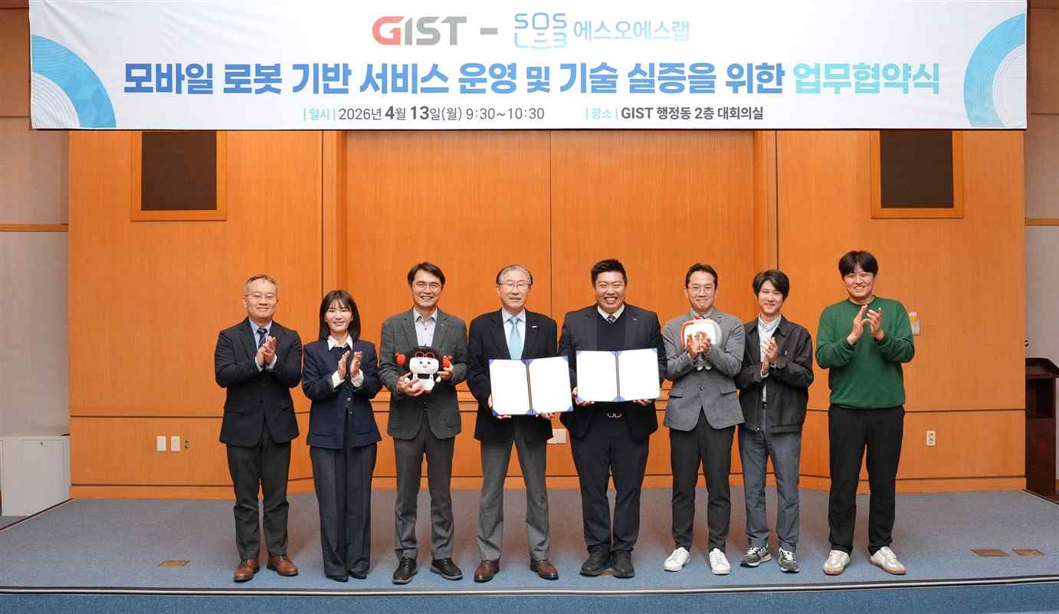

▲ On Monday, April 13, key officials from GIST and SOSLAB Co., Ltd. are taking a commemorative photo after signing a business agreement for the operation and technology demonstration of mobile robot services in the main conference room of the GIST Administration Building.
The Gwangju Institute of Science and Technology (GIST, President Kichul Lim) announced that it signed a Memorandum of Understanding (MOU) on Monday, April 13, at the main conference room of the GIST Administration Building with SOSLAB (CEO Ji-sung Jung), a leading company in LiDAR sensors—a core area of the fourth industrial revolution, including autonomous driving, robotics, and smart cities—for the operation of mobile robot services and the demonstration of technology.
Through this agreement, SOSLAB plans to expand and advance the scope of technology application by combining its unique technological competitiveness in the LiDAR hardware field with GIST's research environment and infrastructure.
The signing ceremony was attended by GIST President Kichul Lim, Vice President for Academic Affairs Sungho Jeong, and Office of International and Public Affairs Dean Eunji Lee, as well as SOSLAB CEO Ji-sung Jung, Director Jong-kyu Jung, Principal Researcher Sung-mo Kang, and Senior Researcher Seung-jae Park, along with other officials from both institutions. Under this agreement, GIST plans to provide ▴ places and resources for the storage and passage of robots ▴ support for communication and the minimization of regulations necessary for the operation and demonstration of robot services for SOSLAB Co., Ltd.'s mobile robot services.
SOSLAB Co., Ltd. plans to carry out the following: ▴ managing robot movement paths within pre-agreed driving sections and times; ▴ protecting vehicles and pedestrians through compliance with GIST regulations and the Personal Information Protection Act; ▴ establishing an on-site management system based on continuous monitoring; and ▴ reviewing cooperation and joint research related to robot services proposed by GIST.
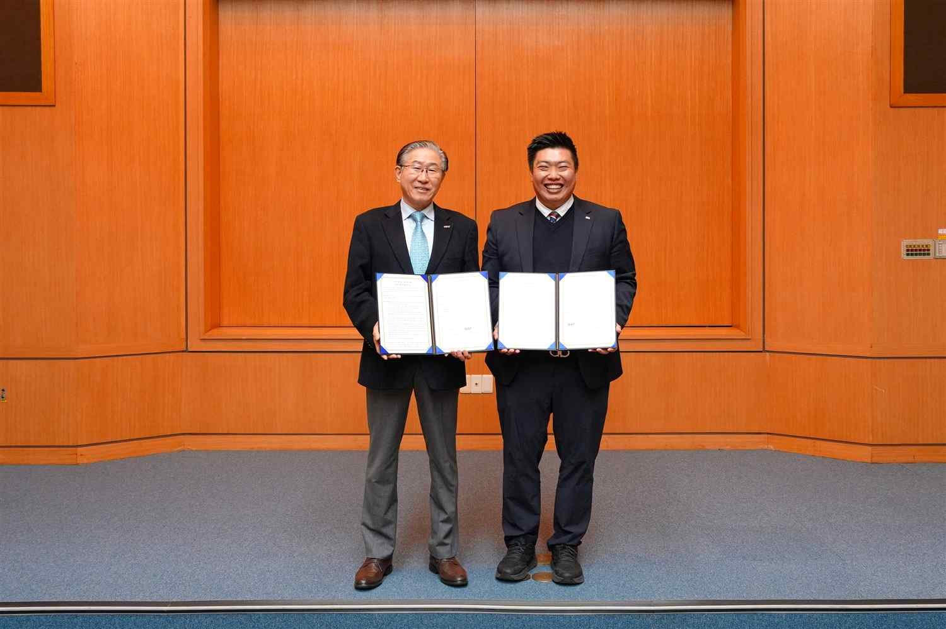

▲ GIST President Kichul Lim (left) and SOSLAB CEO Ji-sung Jung (right) pose for a commemorative photo after signing a business agreement.
This agreement is highly significant in that a representative alumni company, which was founded at GIST and successfully listed on KOSDAQ, is pursuing technological advancement through cooperation with its alma mater.
CEO Ji-sung Jung founded SOSLAB Co., Ltd. in 2016 with fellow researchers while pursuing a doctoral degree in the Department of Mechanical Engineering (currently the Department of Mechanical and Robotics Engineering) at GIST, and is recognized as a prime example of an on-campus startup that succeeded in listing on KOSDAQ through continuous technology development and commercialization.
SOSLAB Co., Ltd. has established itself as a key component supplier in the fields of autonomous vehicles and smart cities by developing world-class compact, high-precision Lidar sensors. In particular, it is recognized for its competitiveness in the global market based on its technological capabilities that simultaneously secure high performance and price competitiveness.
Currently, SOSLAB is accelerating the development of "SPADI," a spatial intelligence platform that combines Lidar ("eyes") with artificial intelligence (AI, "brain") to enable robots to "see, think, and judge" on their own. Through this agreement, the company plans to equip mobile robots with the system and conduct a demonstration on the GIST campus.
This is noteworthy for demonstrating a virtuous cycle model that goes beyond simple industry-academia collaboration, where technology originating in universities grows in industrial settings and then returns to the research field to drive demonstration and expansion.
* lidar (Light Detection and Ranging): A sensor technology that precisely determines the distance and shape of target objects by emitting laser light and measuring the time it takes for it to reflect back. It is utilized as a core technology for perceiving the surrounding environment in three dimensions across various fields, including autonomous vehicles, drones, and smart cities.
* spatial-physical agentic device interface (SPADI): A complete spatial intelligence pipeline that fuses multimodal sensors (LiDAR, cameras, IMUs) with AI to reconstruct 3D space, understand meaning, and autonomously reason and make judgments. Its key differentiator is the integration of multi-agent-based "autonomous reasoning," going beyond the existing level of simple 3D scanning or perception.
CEO Ji-sung Jung stated, “We are embarking on the challenge of completing the ‘brain’ of a robot by combining the ‘eyes’ of LiDAR with the ‘brain’ of AI.” He added, “I am pleased to demonstrate our technology at GIST, which boasts the best research environment, and I hope this agreement will serve as an important milestone in ushering in the era of physical AI.”
President Kichul Lim said, “I hope the GIST campus will become a stage for demonstrating cutting-edge robot technology and present a new model for industry-academia collaboration.” He added, “SOSLAB’s innovative spatial intelligence technology, combined with GIST’s research capabilities, will contribute significantly to the development of the robot industry.”

