GIST simultaneously launches wind and thermal energy research centers... Full-scale research on 'production + efficiency' energy transition begins
- GIST Research Institute for Solar and Sustainable Energies establishes full energy lifecycle research system encompassing wind power and thermal management
- From technology verification to commercialization through industry-academic-research collaboration… Promoting linkage with RE100 industrial complexes
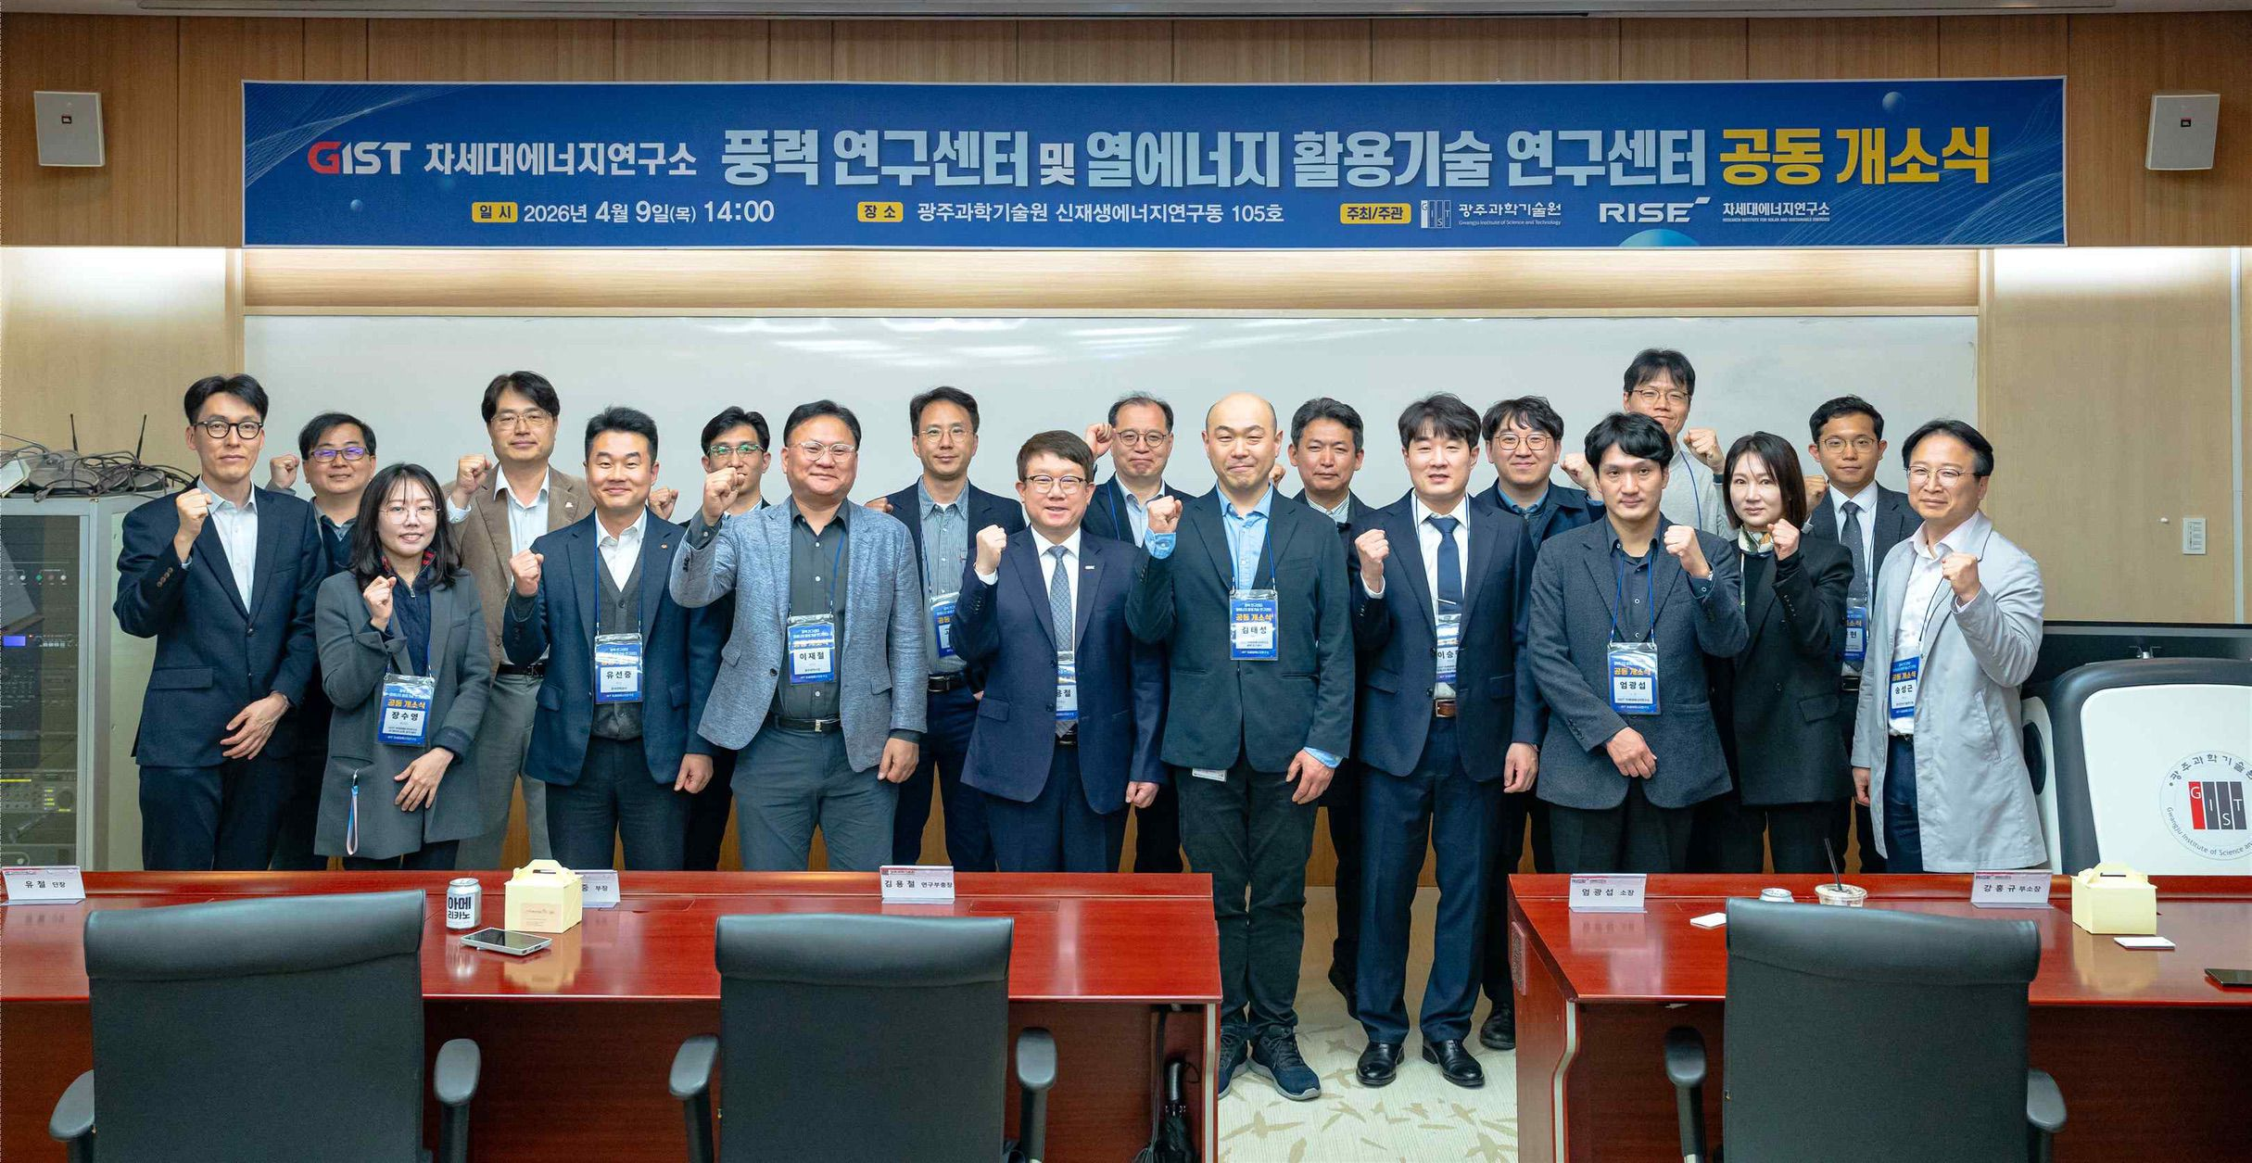

▲ Attendees pose for a commemorative photo at the joint opening ceremony of the GIST Wind and Thermal Energy Utilization Technology Research Centers.
The Gwangju Institute of Science and Technology (GIST, President Kichul Lim) announced the opening of the ‘Wind Research Center (Director Taeseong Kim)’ and the ‘Thermal Energy Utilization Technology Research Center (Director Seunghyun Lee)’ under the Research Institute for Solar and Sustainable Energies. The purpose of these centers is to strengthen technological competitiveness in the next-generation energy sector and to proactively secure a foundation for demonstration and evaluation in response to national energy transition policies.
The opening ceremony, held on Thursday, April 9 at the GIST Research Institute for Solar and Sustainable Energies, was attended by approximately 50 key officials, including Jae-chul Lee, Team Leader of the Energy Industry Division of Gwangju Metropolitan City; Seung-chan Jang, Head of the Korea Energy Agency; Cheol Yoo, Director of the Korea Institute of Energy Research; Seon-jung Yoo, Department Head of the Korea Electric Power Corporation; as well as GIST Vice President for R&DB Yong-Chul Kim and Research Institute for Solar and Sustainable Energies Director KwangSup Eom.
The opening ceremony began with a welcoming address by Research Institute for Solar and Sustainable Energies Director KwangSup Eom, followed by congratulatory remarks from Vice President for R&DB Yong-Chul Kim and distinguished guests. Center Directors Taeseong Kim and Seunghyun Lee then presented the direction, research plans, and demonstration-linked strategies for their respective centers.
Attendees agreed that enhancing the operational efficiency of wind power generation and developing thermal management technologies for advanced industries are key challenges in the era of energy transition, and shared the need to expand cooperation through demonstration, evaluation, and policy linkages.
The two research centers plan to focus on securing core technologies in the wind and thermal energy sectors, as well as conducting demonstration and evaluation research for actual field application.
The Wind Power Research Center plans to enhance the design and operational efficiency of domestic wind power complexes and advance their maintenance systems through the development of technologies spanning the entire wind power generation lifecycle, including integrated wind turbine design and performance analysis, drone-based facility inspection, power plant control and health management (PHM*), and power generation forecasting.
The Thermal Energy Utilization Technology Research Center will focus on developing high-efficiency thermal management and thermal energy utilization technologies for high-density industries such as batteries, data centers, and semiconductors, while pursuing research on heat transfer at the nanoscale and the optimization of thermal system designs.
In addition, the two research centers plan to establish a campus-based demonstration environment in conjunction with national demonstration projects and create a research framework that extends from technology verification to commercialization through industry-academia-research collaboration.
* Health Management (PHM): A technology that evaluates the likelihood of failure by continuously monitoring the current state of facilities or systems. Through this, it is possible to predict the remaining lifespan of devices, such as power plants, and optimize the timing and methods of maintenance.
Faculty members from GIST’s Department of Mechanical and Robotics Engineering serve as directors for the two research centers, which have established an operational system that combines an academic foundation with practical demonstration research.
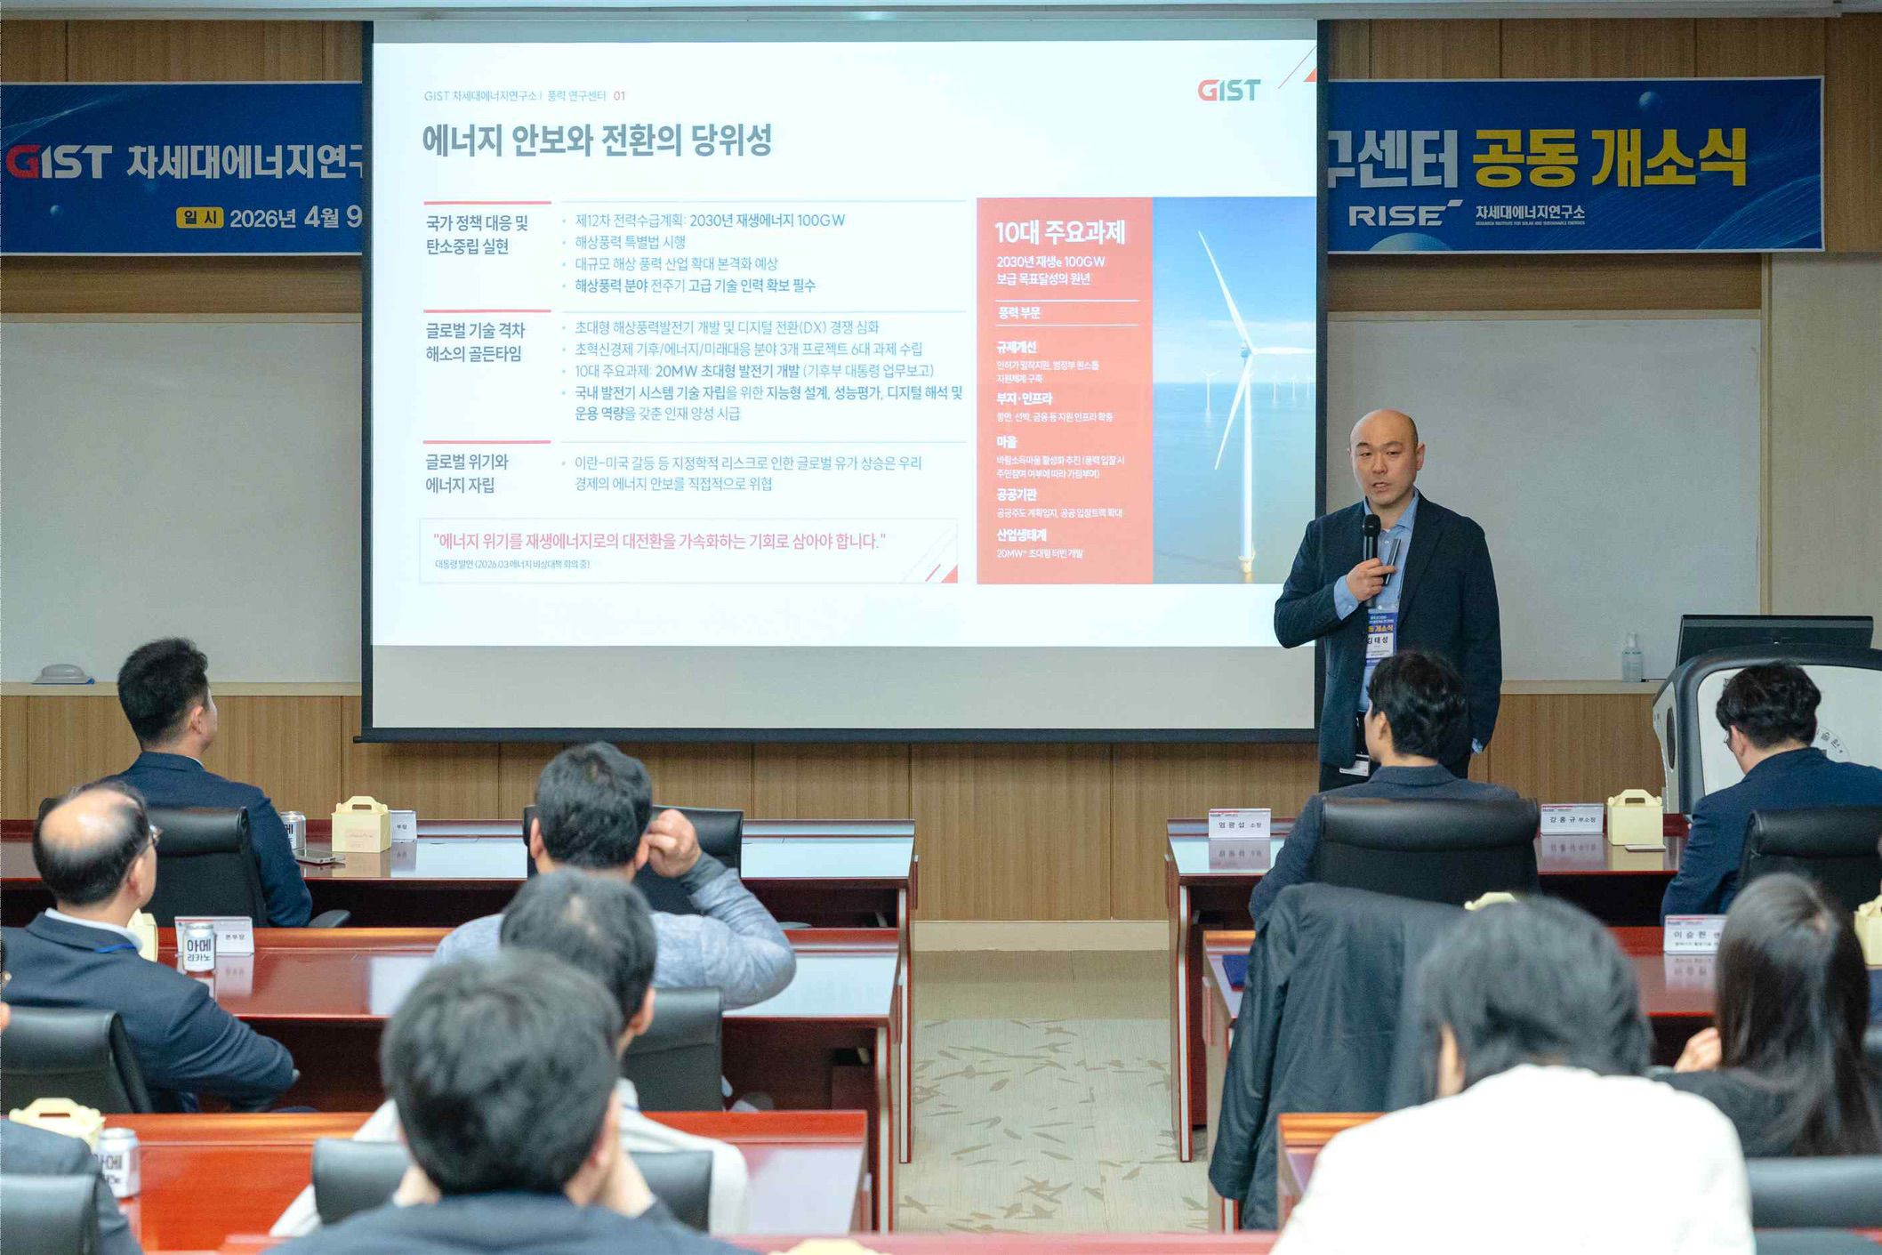

▲ Taeseong Kim, Director of the GIST Wind Power Research Center, introduces the center's vision and plans for research and demonstration to attendees at the opening ceremony.
Taeseong Kim, Director of the Wind Power Research Center, is an expert who has conducted world-class research in the field of wind power while serving as a professor at the RISSOE National Laboratory in Denmark, the Technical University of Denmark, and Loughborough University in the UK. He has continued his research in key areas such as ▴ the analysis of aerodynamic-structural interactions in wind turbines, ▴ the design of ultra-large wind turbines, and ▴ control technology for floating offshore wind power.
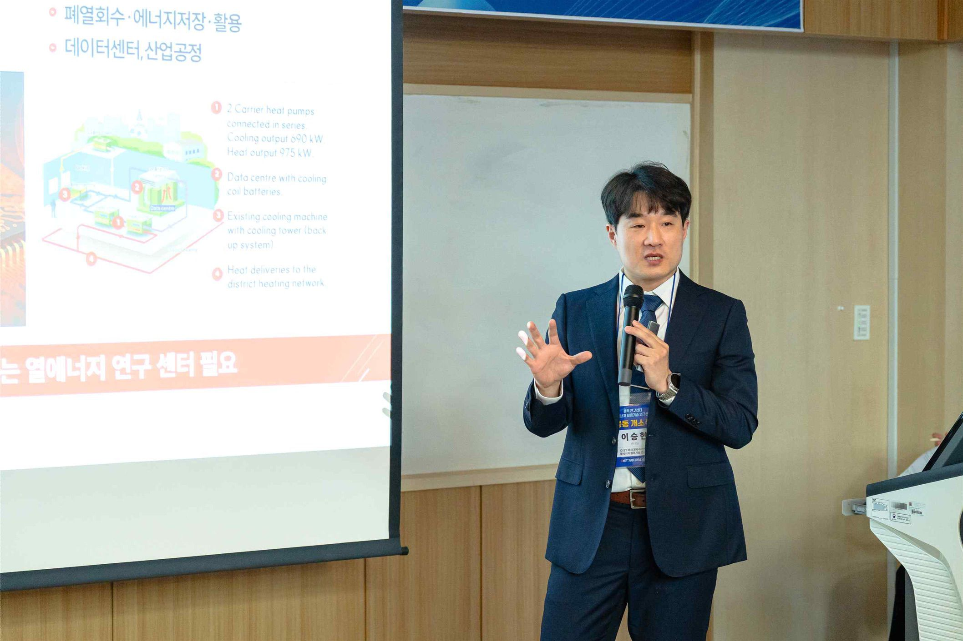

▲ Seunghyun Lee, Director of the Thermal Energy Utilization Technology Research Center at GIST, introduces the center's vision and research and demonstration plans to attendees at the opening ceremony.
Seunghyun Lee, Director of the Thermal Energy Utilization Technology Research Center, is an expert who has researched thermal management technologies based on anomalous fluids (liquid and gas) since earning his Ph.D. from Purdue University in the United States. He is leading research in the field of advanced thermal management based on his experience in researching thermal management technologies for ultra-fast electric vehicle charging and working on NASA's spacecraft thermal control system project.
Taeseong Kim, Director of the Wind Power Research Center, stated, "Wind energy is a key resource for expanding renewable energy, and establishing a stable supply chain and improving the efficiency of power generation complexes are crucial." He added, "We will secure core integrated analysis and design technologies to enhance the reliability of next-generation ultra-large wind turbine systems and contribute to the development of floating offshore wind power technology."
Seunghyun Lee, Director of the Thermal Energy Utilization Technology Research Center, remarked, "Thermal energy management is a core technology directly linked to the performance of advanced industries such as data centers, batteries, and semiconductors." He further stated, "We will contribute to improving energy efficiency across all industries through high-efficiency thermal management and energy utilization technologies." With the opening of this research center, GIST plans to expand its campus demonstration infrastructure and continuously pursue wind and thermal energy technology demonstrations and joint research linked to local industries.
Through this, the university intends to establish an energy technology demonstration hub centered on Gwangju and Jeonnam, and in conjunction with RE100 (Renewable Energy 100%) industrial complexes aiming for 100% renewable energy use, it plans to conduct various demonstration studies, including improving the operational efficiency of power plants, optimizing energy management, and developing heat recovery systems.

