GIST Department of Environment and Energy Engineering hosts '2026 Sports Day' for all
- 114 participated in a harmonious gathering of all members, including graduate students, undergraduate students, faculty, and staff
- Four teams formed: Eco, Chemistry, Aqua, and Ensemble… Symbolically embracing the department’s core values
- Strengthening member bonds through participatory programs… Expected to enhance collaborative culture and research synergy
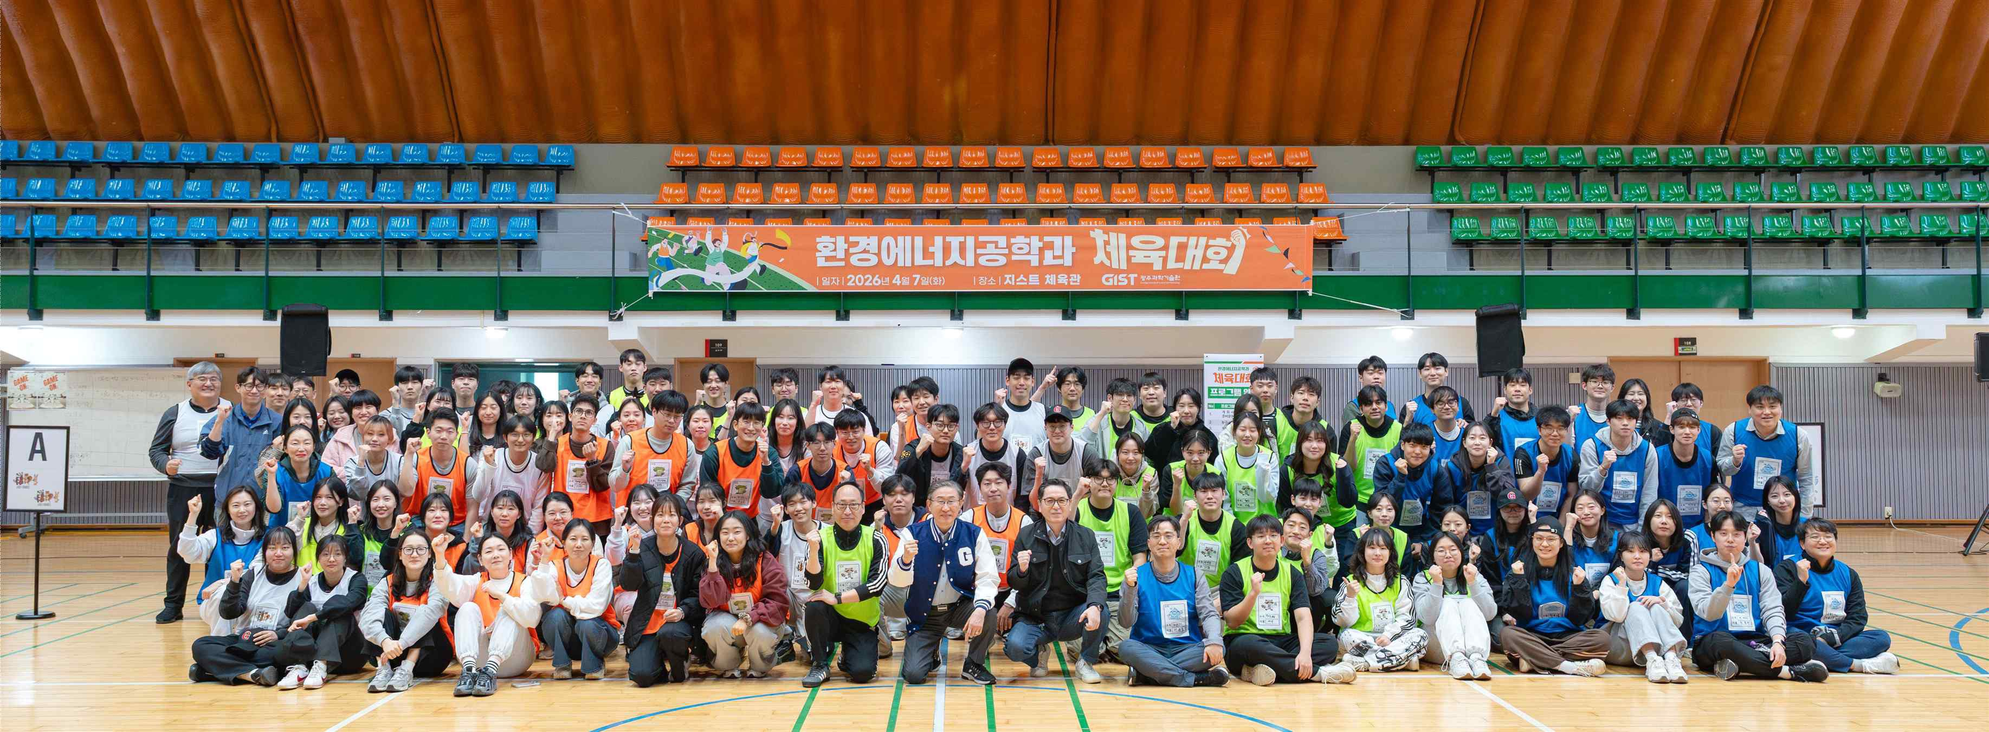

▲ Participants are taking a group commemorative photo at the GIST Gymnasium on Tuesday, April 7.
The Gwangju Institute of Science and Technology (GIST, President Kichul Lim) announced that it held the ‘2026 Environmental and Energy Engineering Sports Day’ at the GIST Gymnasium on Tuesday, April 7.
The event was a great success, with a total of 114 participants, including 78 graduate students, 23 undergraduate students, 6 professors, and 7 staff members from the Department of Environment and Energy Engineering.
The event was organized to strengthen communication and bonds among members and to share the values ​​of cooperation and convergence pursued by the department.
In particular, the sports day was made even more meaningful by being operated with four teams symbolizing the department's core values. The event was divided into four teams: ‘Eco,’ symbolizing sustainable environment and ecological conservation; ‘Chemi,’ representing chemical technology that serves as the foundation for solving energy and environmental problems; ‘Aqua,’ embodying the importance of water resources; and ‘Ensemble,’ signifying the harmony of diverse members. This division naturally incorporated a message of interdisciplinary convergence and cooperation.
The event began with a welcome address by President Kichul Lim and an opening speech by Department Dean Youngjune Park. It proceeded in a colorful manner, featuring a blend of athletic programs—such as free-throw basketball, table tennis, dodgeball, and shoe archery—and participatory activities like card flipping, tug-of-war, and OX quizzes.
Through these diverse activities, participants took time away from their busy daily lives of academics and research to interact with one another and build camaraderie.
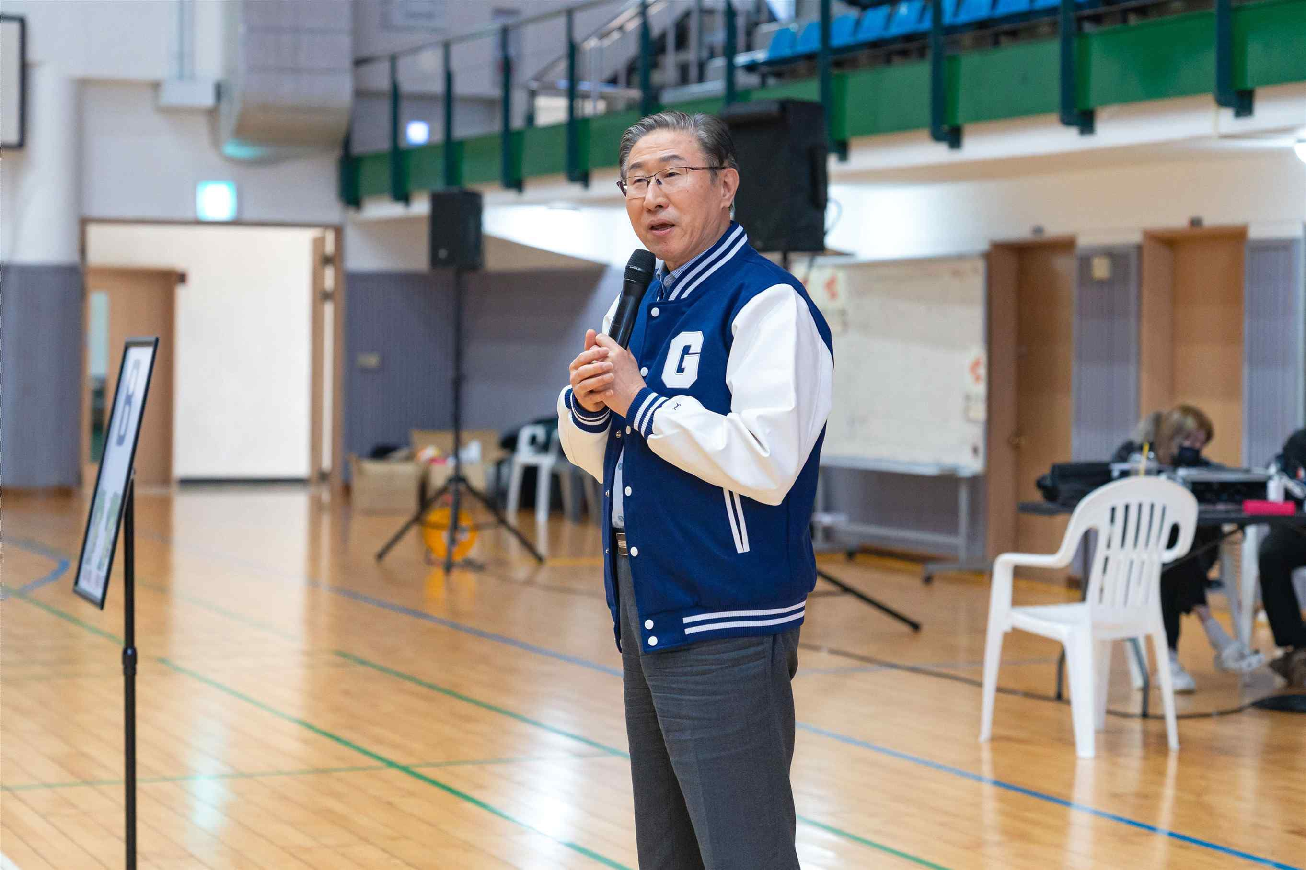

▲ President Kichul Lim delivers a welcoming address at the ‘2026 Environmental and Energy Engineering Sports Day.’
Kim Su-bin, a student in the integrated master’s and doctoral program, shared her thoughts, stating, “It was meaningful to be able to interact directly with professors and fellow students whom I usually do not see often due to my dedication to research.” She added, “I believe the experience of running and laughing together today will be a great source of strength for future research collaboration and departmental life.”
In his welcoming address, President Kichul Lim stated, “Today is a day for everyone to run, laugh, and enjoy together, without distinction between professors and students.” He expressed his hope that “the culture of communication and cooperation within the Department of Environment and Energy Engineering will become the driving force behind excellent research and the development of the department.”
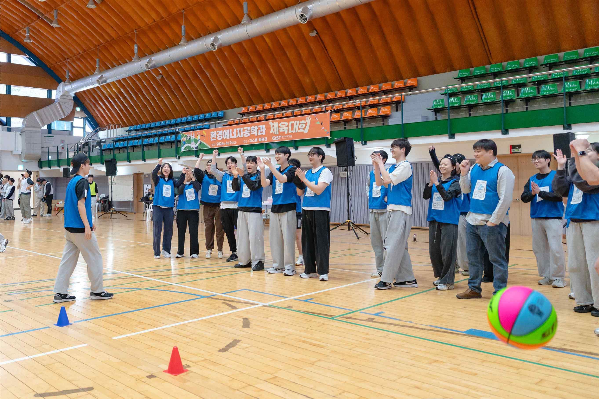

▲ The ‘2026 Environmental and Energy Engineering Sports Day’ was a great success, with a total of 114 participants, including 78 graduate students, 23 undergraduate students, 6 professors, and 7 staff members from the Department of Environmental and Energy Engineering.
Department Dean Youngjune Park stated, “This athletic meet was a valuable occasion where professors and students mingled together and personally experienced the department’s spirit of unity and cooperation,” adding, “I hope that all members will encourage one another based on their pride in the Department of Environmental and Energy Engineering and produce meaningful research results.”
Meanwhile, the GIST Department of Environment and Energy Engineering, which leads core research in the field of sustainable energy, was selected last year as a ‘Graduate School Specialized in AI Circular Economy Clustering’ by the Ministry of Climate, Energy and Environment.
Receiving up to 4.75 billion KRW (approximately 950 million KRW per year) in research funding over the next five years, the department is accelerating the cultivation of global high-level talent and the development of future technologies by integrating artificial intelligence (AI) with the five major fields of the circular economy (carbon, resources, water, ecology, and energy circulation).

