GIST hosts 2026 AI-ACE InnoCORE Research Group Workshop: Held in Busan for two days… Technical exchange and networking between mentors and fellows take place
- Development of source technologies for the early diagnosis of brain diseases based on AI and nanotechnology convergence, and fostering convergent research personnel
- Strengthening research collaboration and exploring commercialization possibilities through expert lectures, achievement sharing, and poster presentations
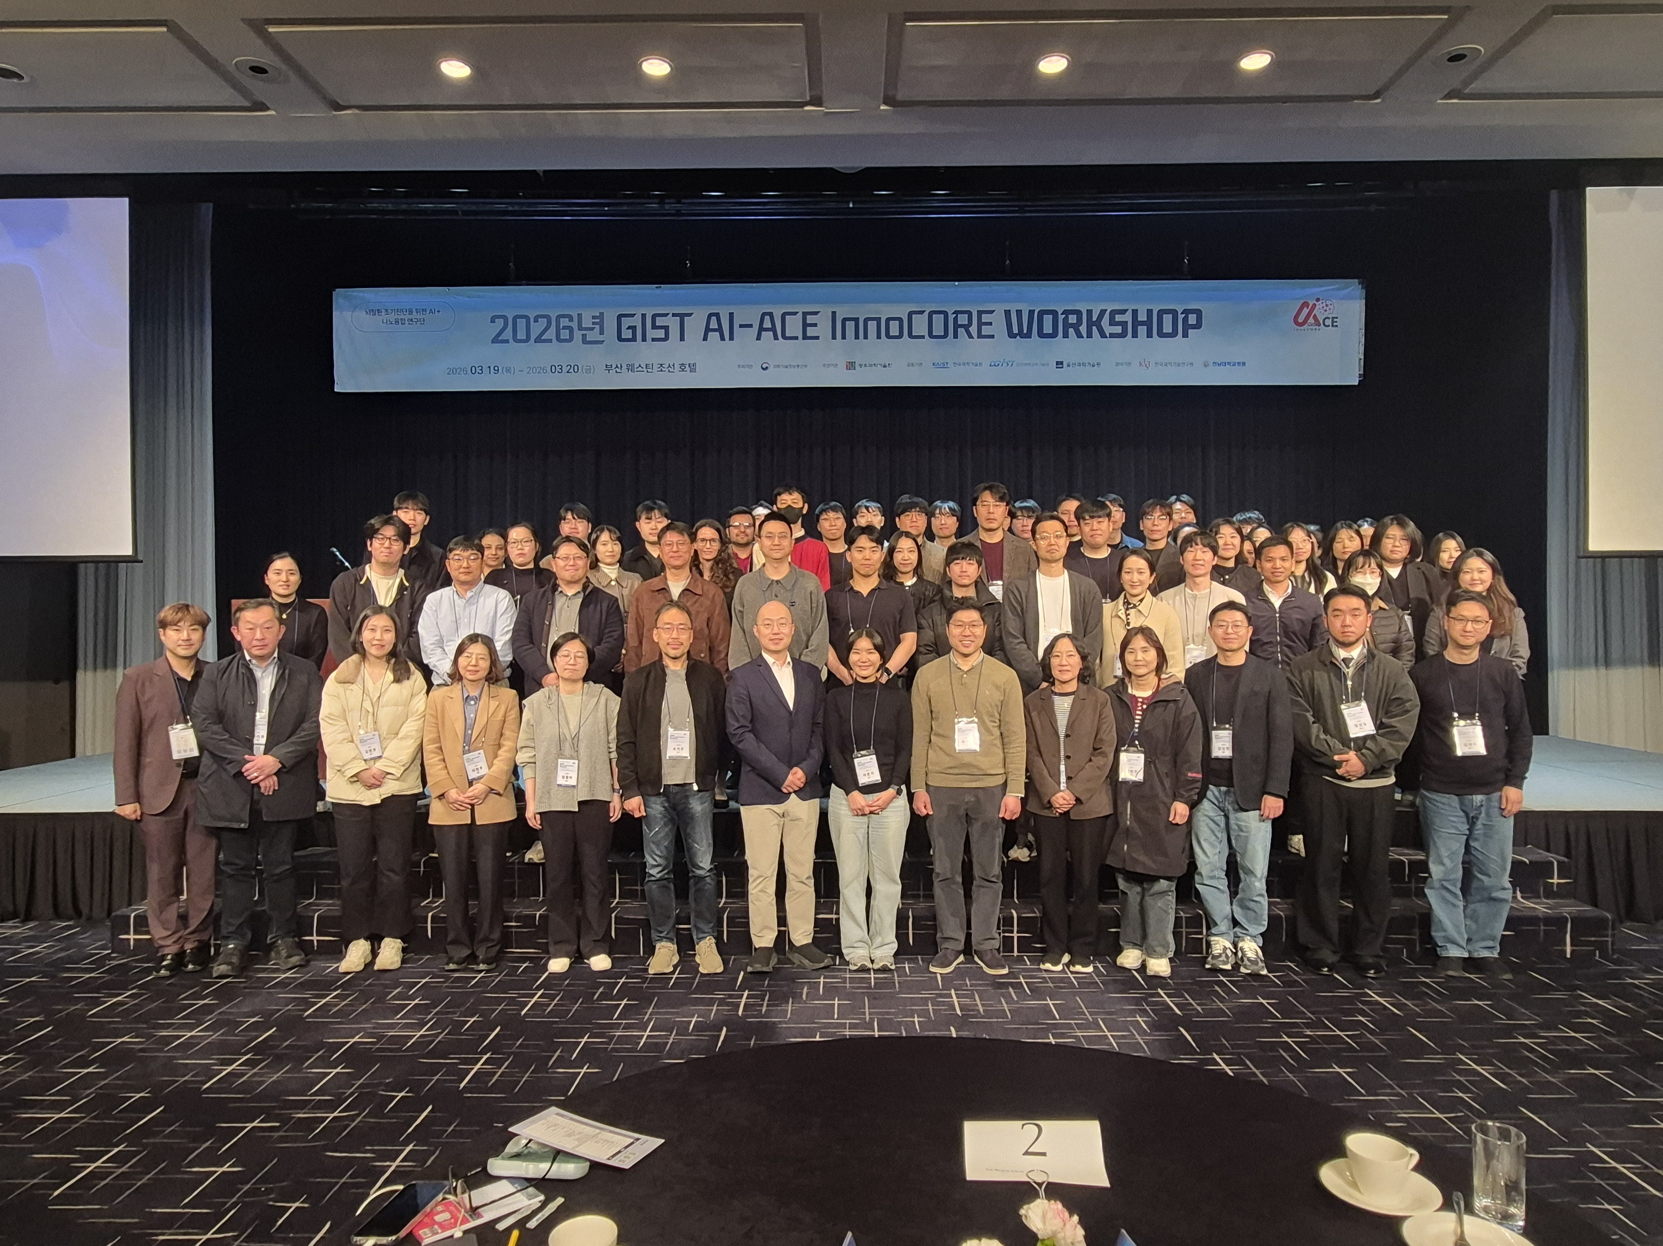

▲ Attendees pose for a commemorative photo at the "GIST AI-ACE InnoCORE Research Group Workshop," held in Busan from Thursday, March 19 to Friday, March 20.
The Gwangju Institute of Science and Technology (GIST, President Kichul Lim) announced that the AI+Nano-Convergence (AI-ACE InnoCORE) Research Group for the Early Diagnosis of Brain Diseases (Director Eunji Lee) held the "2026 GIST AI-ACE InnoCORE Research Group Workshop" in Busan for two days, from Thursday, March 19 to Friday, March 20.
The "AI-ACE InnoCORE Research Group" was launched on November 1 of last year at the GIST campus to foster core research personnel who will lead innovation in the field of artificial intelligence (AI) convergence, and to intensively attract convergent talents combining AI and science and technology.
With support from the Ministry of Science and ICT, the research group is pursuing the development of source technologies for the early diagnosis of brain diseases by integrating AI and nanotechnology, with a core research team composed of postdoctoral researchers possessing experience and expertise from both domestic and international sources.
This workshop was organized by the research group to strengthen networking between mentors and fellows—composed of industry experts in various AI fields—and to maximize research outcomes through the exchange of technology and research.
The event began with opening remarks by Research Group Leader Eunji Lee, followed by a special lecture by Professor Yong-Keun Park of the Department of Physics at the Korea Advanced Institute of Science and Technology (KAIST), and it consisted of a performance sharing session and poster presentations organized into three sessions. Additionally, discussions and mentoring sessions were held with a total of 65 experts participating, including 24 mentors and 41 mentees from the research group.
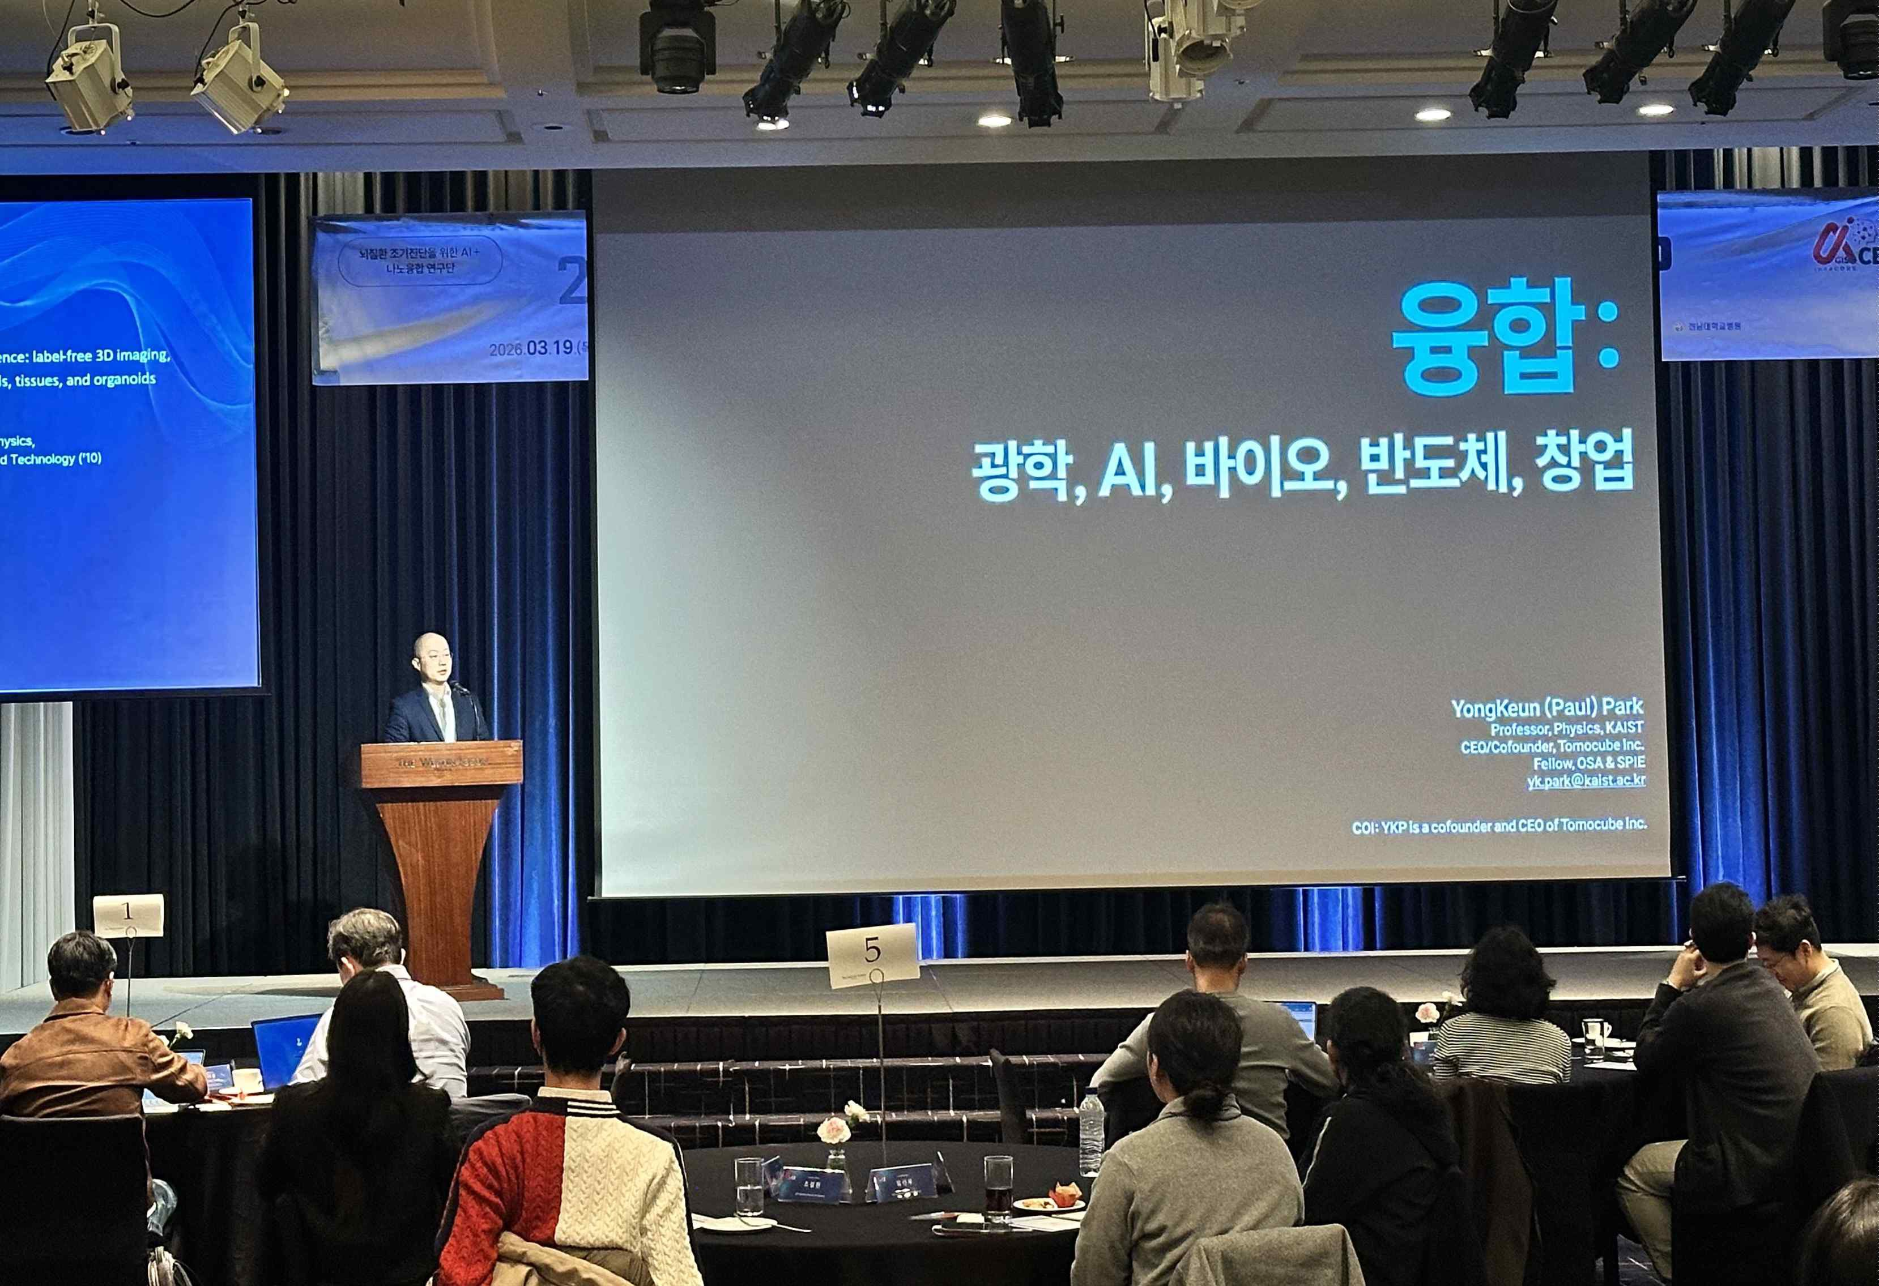

▲ Professor Yong-Keun Park of the Department of Physics at KAIST (CEO of Tomocube) is delivering a special lecture to mentors and fellows on the topic of "Convergence: Optics, AI, Bio, Semiconductors, and Entrepreneurship."
On the first day of the workshop, Professor Yong-Keun Park of the Department of Physics at KAIST delivered a special lecture on the topic of "Convergence: Optics, AI, Bio, Semiconductors, and Entrepreneurship." Professor Park founded "Tomocube," a company that manufactures diagnostic and research equipment utilizing holotomography technology, also known as a biological microscope.
At the subsequent performance sharing session, Professor Jae Young Lee of the Department of Materials Science and Engineering, Professor Hyunju Lee of the Department of AI Convergence, and Professor Hyeon-Ho Jeong of the Department of Electrical Engineering and Computer Science—the leaders of the three research divisions of the AI-ACE InnoCORE Research Group—presented their achievements.
In addition, during the poster presentation and networking sessions, postdoctoral researchers developed practical collaboration strategies, such as introducing research results by project, establishing strategies for promoting convergence research, and formulating plans for operating a Co-Lab.
On the second day, Dong-Hyeon Kim, CEO of Neurofit Co., Ltd., a company specializing in AI solutions for the diagnosis and treatment of brain diseases, delivered a special lecture on the creation of research results and commercialization potential from an entrepreneurial perspective.
CEO Kim garnered significant attention from the attendees by introducing the background of establishing Neurofit Co., Ltd. in 2016 with Co-CEO Jun-gil Bin, who has conducted research on electrical brain stimulation simulations for the treatment of brain diseases. The two CEOs are alumni of the Graduate School of Electrical Engineering and Computer Science at GIST.
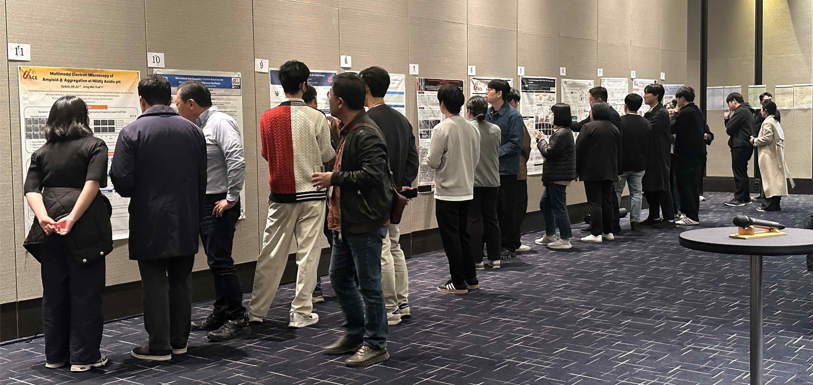

▲ Fellows engage in a Q&A session with mentors in front of posters showcasing their research achievements during the "Poster Presentation and Networking," a key session of the workshop.
Postdoctoral Researcher Ga-eun Park stated, "The workshop was of great help in understanding each other's research, generating new ideas, and concretizing our research direction." She added, "Based on the ideas shared at this workshop, we plan to expand our research to accumulate data necessary for AI learning, select relevant materials, and observe their transformation processes."
Eunji Lee Lee, Head of the AI-ACE InnoCORE Research Group (Professor in the Department of Materials Science and Engineering), said, “This workshop is a meaningful occasion where next-generation researchers in the field of AI gather to share research results and discuss future visions,” adding, “We will actively support them so that they can present a new paradigm for AI convergence research and produce research results with global competitiveness through close exchange between mentors and fellows.”

