Mentees who nurtured their dreams in their communities now enroll at gist as mentors... GIST student social contribution group 'Pium' 6th cohort continues the virtuous cycle of sharing
- 39 current students selected to expand educational opportunities for local youth through science mentoring and outreach camps
- Mentors from high school participate as mentors after entering GIST… A virtuous cycle connecting ‘mentee to mentor’ draws attention
- Since its launch in 2021, approximately 230 mentors and 770 mentees have participated
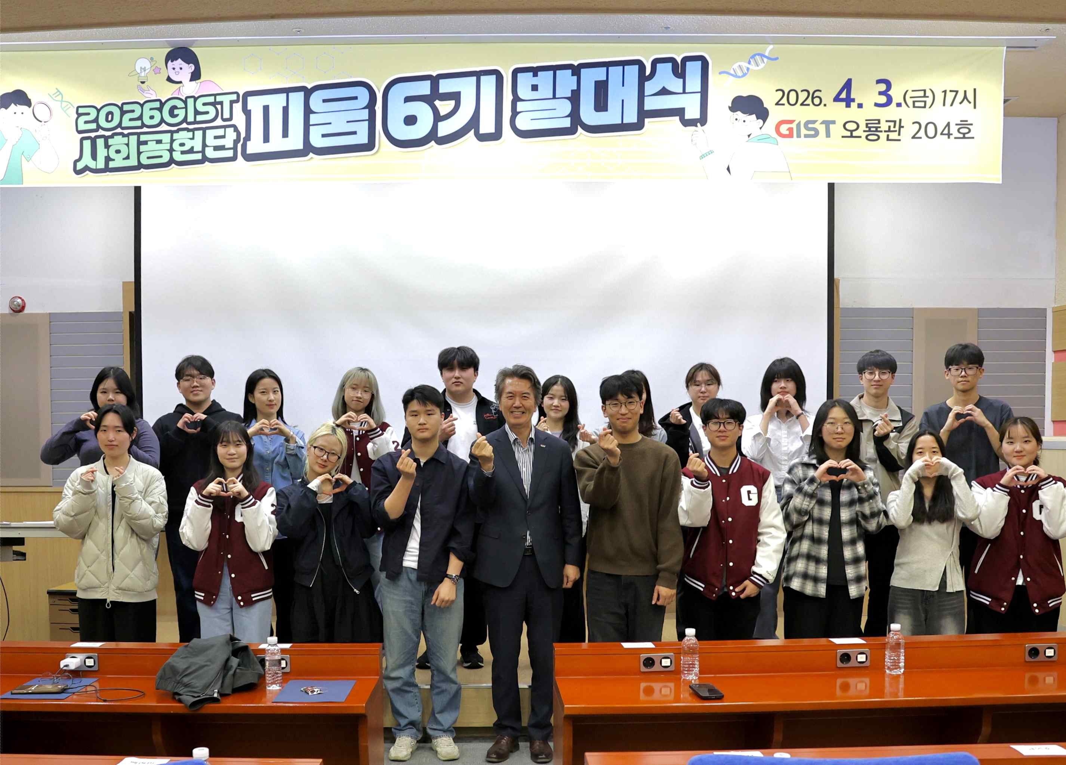

▲ A commemorative photo is being taken at the launching ceremony for the 6th cohort of GIST’s social contribution group, ‘PIUM,’ held at Oryong Hall on Friday, April 3.
The Gwangju Institute of Science and Technology (GIST, President Kichul Lim) announced that it held the launching ceremony for the 6th cohort of its student social contribution group, ‘PIUM,’ at Oryong Hall at 5 p.m. on Friday, April 3.
The ceremony was attended by students selected for the 6th cohort, Vice President for Public Affairs Yonghwa Chung, and officials from the Public Relations Team, the organizing department. They shared the direction of activities aimed at expanding science education opportunities and supporting career exploration for local youth, and reaffirmed their commitment ahead of the start of full-scale activities.
Notably, this 6th cohort demonstrated a virtuous cycle where students who participated as mentees during high school are now serving as mentors after entering GIST. This showed that ‘PIUM’ is a program that goes beyond simple volunteering to foster the growth and feedback of local talent.
Seung-mo Kang, a freshman in the 2026 academic year (Challenge & Exploration Program), graduated from elementary, middle, and high school in Buyeo-gun, Chungnam. While attending Buyeo High School, a local general high school, he participated as a PIUM mentee and received guidance from a GIST student mentor, which helped him concretize his career path. Through this, he developed motivation for his studies and entered GIST, and now he is stepping forward to serve as a mentor.
Student Seung-mo Kang stated, “Through meeting my mentor, I was able to set academic goals, and that experience led to my admission to GIST,” adding, “I now want to share the experience of dreaming together back then with the local community.”
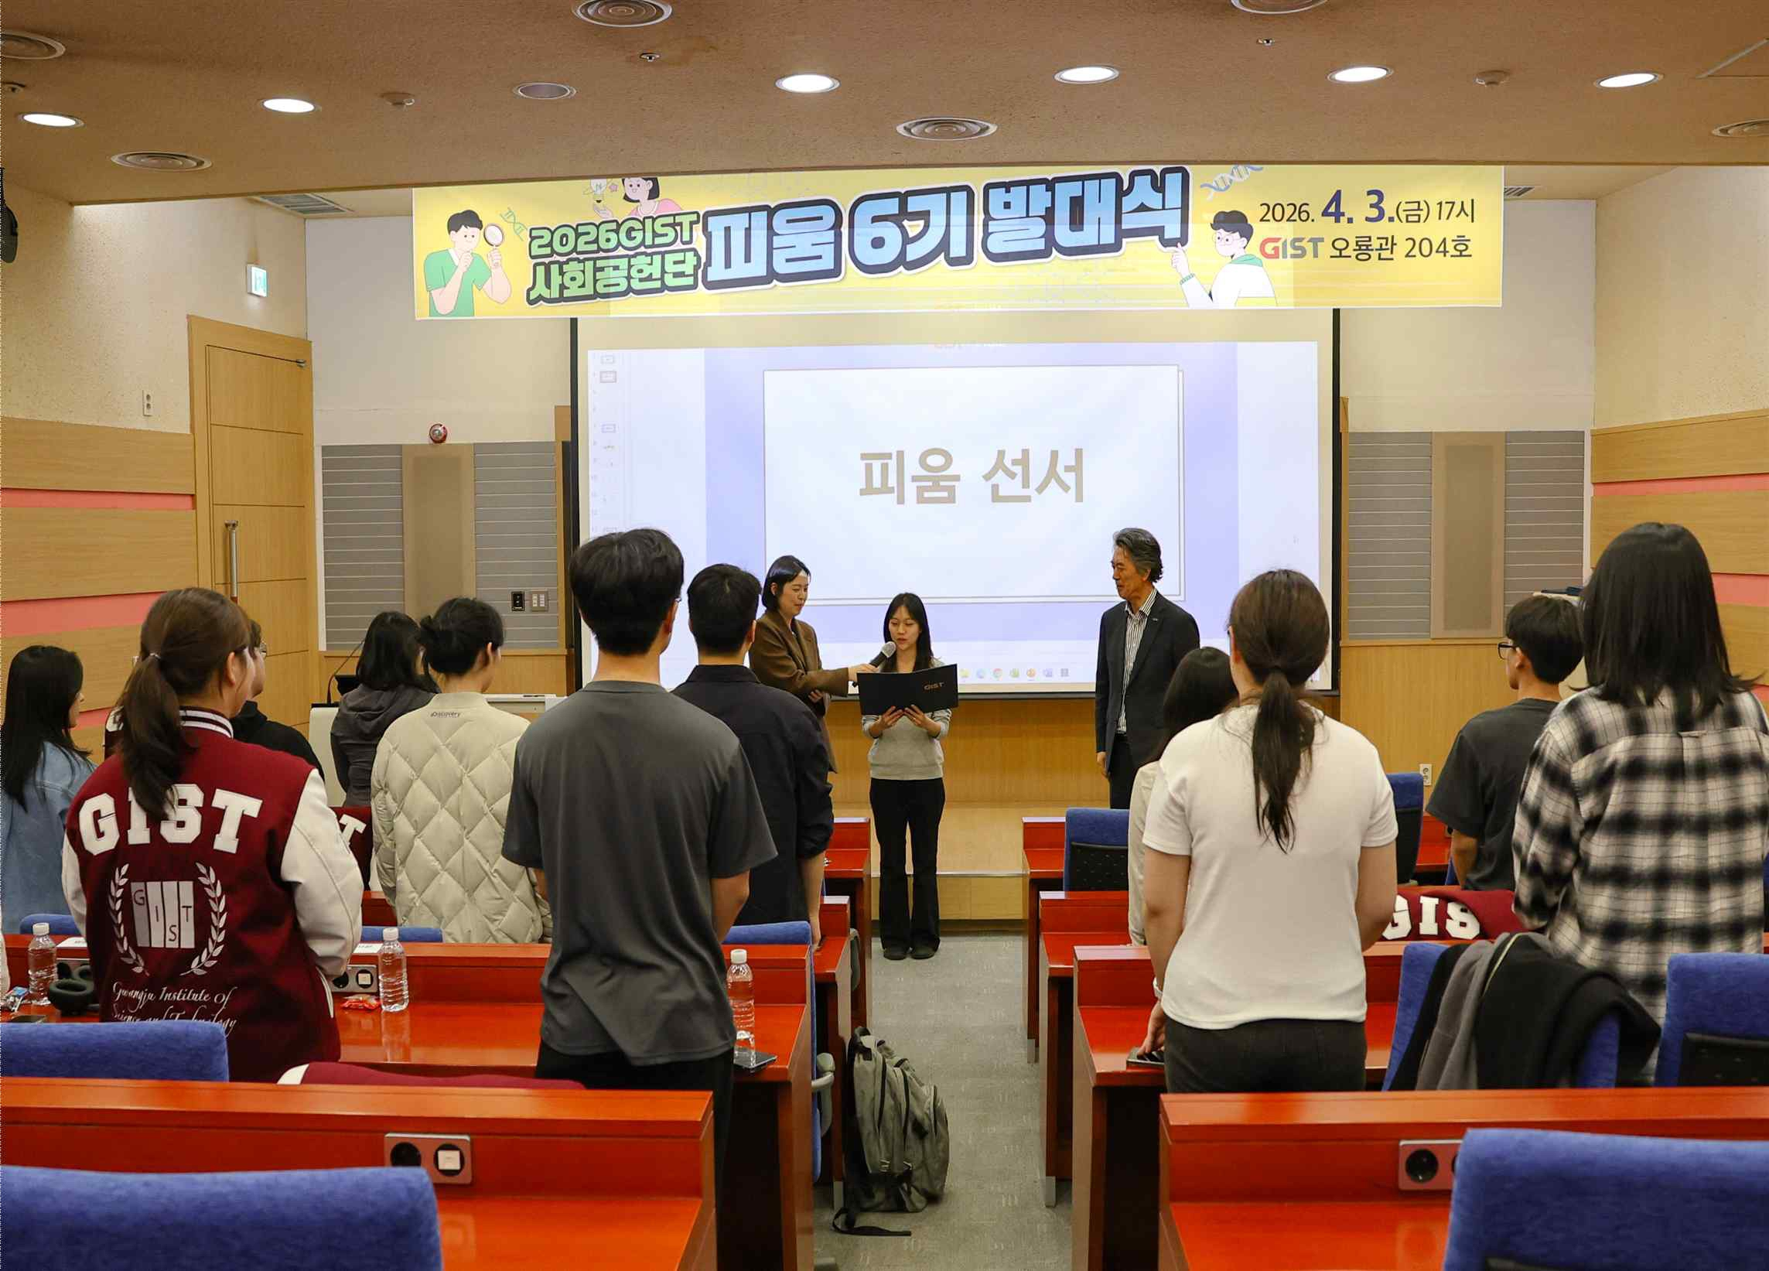

▲ Student Hae-rim Yoo (Department of Materials Science and Engineering), the General Mentor for the 6th cohort of ‘PIUM,’ is reciting the PIUM oath.
Named after the meaning of ‘to make flowers bloom’ and the first letters of the English words Positive, Interaction, Understanding, and Mind, PIUM is a social contribution group in which current students participate as both mentors and organizers, taking a leading role in the entire process from program planning to execution and evaluation.
Through various programs such as ▴ Junior Science Mentoring (online mentor-mentee classes), ▴ Visiting Science Camp (visiting schools in towns and villages), ▴ GIST Science Camp (inviting general youth), and ▴ GIST Science Talk Talk (inviting local science talents), the organization is expanding science education opportunities and supporting career exploration for local youth, while continuing customized activities for educationally vulnerable groups.
Operating on a national scale and attracting participation from students in diverse regions, PIUM is currently running educational programs centered on towns and villages in the Honam region due to increasing demand. Through this, it is enhancing educational accessibility by maintaining continuous communication with youth in areas where science education opportunities are relatively limited.
Interest in these activities is high; a total of 325 people applied for the ‘Junior Science Mentoring’ mentee recruitment held last March, and 190 were ultimately selected. This year, 17 of the 39 selected mentors are ‘career mentors’ who are participating again following last year, and the continued participation of current students who consistently engage in social contribution activities despite their busy academic schedules is noteworthy.
In particular, students Su-rin Lee (graduate school, Department of AI Convergence) and Choi Jeong-eun (Department of Electrical Engineering and Computer Science) have participated in PIUM since its second cohort and have continued their activities for five consecutive years through this year, personally putting into practice the program's sustainability and the value of sharing.
Student Seong-hwan Kim (Department of Mechanical and Robotics Engineering), who has participated for three consecutive years since 2024, said, “Participating in PIUM activities encourages continuous ‘observation’ of the local community and prompts me to contemplate the role I can play in contributing.” He added, “I hope that this process of contemplation and practice will accumulate to serve as a foundation to help the growth of more mentee students.”
Student Tae-yeon Lim (Department of Materials Science and Engineering) joined the program to support the learning and growth of local youth through science and mathematics education, drawing on the experience he gained while serving as president of the mathematics club "HEXAGON" at Sangsan High School. In addition to him, GIST students from diverse backgrounds are participating, including doctoral students and those who joined the 6th cohort of PIUM after performing educational volunteer work in Cambodia as part of the 2025 World Friends IT Volunteer Corps.
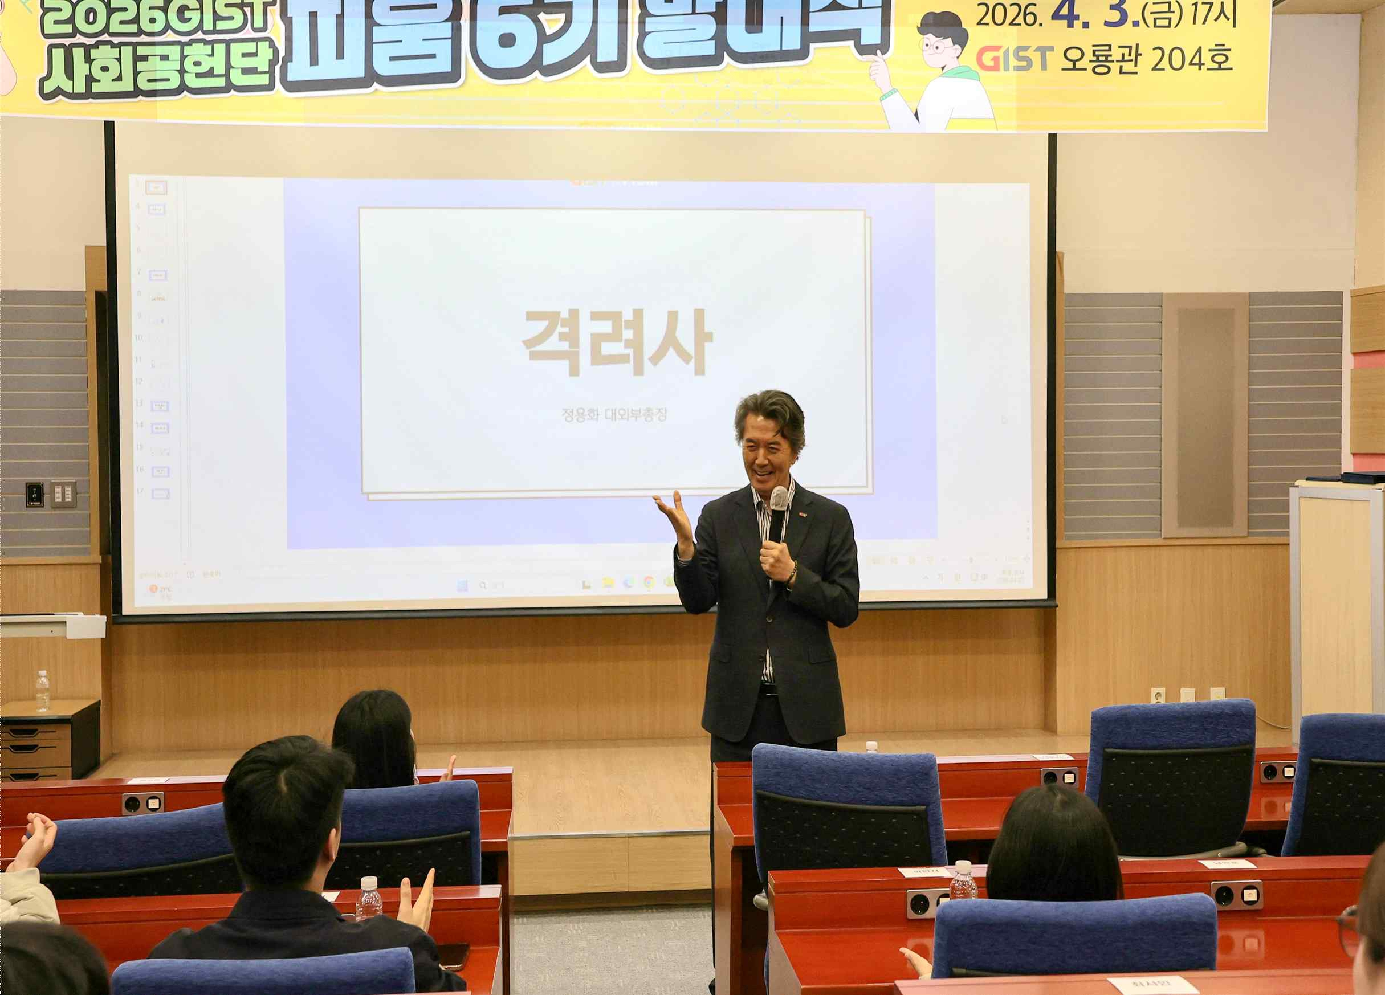

▲ Vice President for External Affairs Chung Yong-hwa delivers a congratulatory speech at the inauguration ceremony for the 6th cohort of GIST’s social contribution group, "PIUM."
Vice President for Public Affairs Yonghwa Chung stated, "PIUM is creating a virtuous cycle where the experience goes beyond helping local youth grow; it leads to career exploration and academic motivation, spreading beyond individual growth to the region and national society as a whole." He added, "We will continue to provide active support to ensure it develops into a representative social contribution program where the university and the local community grow together."
Starting with the inauguration ceremony, the 39 members of the 6th cohort of PIUM plan to spread a culture of volunteering and sharing through various social contribution activities for approximately nine months until December of this year, and to create sustainable social value based on cooperation with the local community.
Meanwhile, PIUM, which was launched in 2021, has so far seen approximately 230 GIST undergraduate students and about 770 middle and high school students participate as mentors and mentees, respectively.

