GIST selected as lead institution for 3rd cohort of ‘TeX-Corps’... 7.5 billion won in support for startups from research labs in the Honam region over 5 years
- Connecting research outcomes from universities and government-funded research institutes to the market… Providing full-cycle startup support including market validation, mentoring, and overseas market exploration
- Accumulating successful technology startup cases, such as the KOSDAQ listing of SOS Lab… Expected to expand the startup ecosystem in the Honam region


▲ A panoramic view of GIST. GIST has been selected as the lead organization for the 3rd TeX-Corps project by the Ministry of Science and ICT and will receive approximately 1.5 billion won annually from this year until 2030, totaling 7.5 billion won in project funding.
The Gwangju Institute of Science and Technology (GIST, President Kichul Lim) announced that it has been finally selected as the lead organization for the 3rd "Laboratory Startup Innovation Group" of the "2026 Public Technology-Based Market-Linked Startup Exploration Support Project (TeX-Corps)," promoted by the Ministry of Science and ICT and the Korea Science and Technology Commercialization Agency (COMPA).
With this selection, GIST plans to expand support for laboratory startups based on public research outcomes by receiving project funding totaling 7.5 billion won, with approximately 1.5 billion won provided annually from 2026 to 2030. ‘TeX-Corps’ stands for ‘Tech eXploration-Corps’ and is a deep-tech startup exploration program signifying a ‘special task force exploring markets and the future through technology.’
This initiative provides services such as customer discovery, startup education, mentoring, and prototype production support to enable research results accumulated in university and government-funded research institute laboratories to be utilized in the actual market. Introduced by benchmarking the ‘I-Corps’ model, a startup support program by the U.S. National Science Foundation (NSF), the program aims to verify the commercialization potential of research results and revitalize technology-based startups.
GIST has contributed to the creation of a university research laboratory-based startup ecosystem by operating the 2nd Laboratory Startup Innovation Group from 2021 to 2025.
Each year, approximately 20 laboratory-based startup exploration teams were selected to operate startup education and mentoring programs focused on market validation.
In-taek Jung (Ph.D. candidate in the Department of AI Convergence), CEO of AI Academy Co., Ltd.—a company developing an online lecture learning assistant service based on generative AI—who participated in the 2nd cohort of the project, stated, “Thanks to GIST’s follow-up investment linkages and support for technology commercialization, I was able to start my career within the regional deep-tech startup ecosystem.”
With its selection as the lead organization for the 3rd TeX-Corps project, GIST plans to serve as a hub for systematically supporting startups based on public research achievements in the Honam region.
Participation is open to prospective startup teams composed of undergraduate, master's, and doctoral students (including those on leave of absence), postdoctoral researchers, and researchers from government-funded research institutes at universities in the Honam region who wish to start a business. The selected teams will undergo a customer discovery process centered on potential customer interviews and refine their business models (BMs) through close guidance from investment experts, industry mentors, and technology commercialization experts.
GIST plans to operate a multifaceted startup support program for these teams, including ▴ customized intensive mentoring, ▴ funding for startup exploration to produce prototypes (approximately 40 million KRW per team), ▴ support for completing domestic and international startup education programs, and ▴ opportunities for overseas market validation.
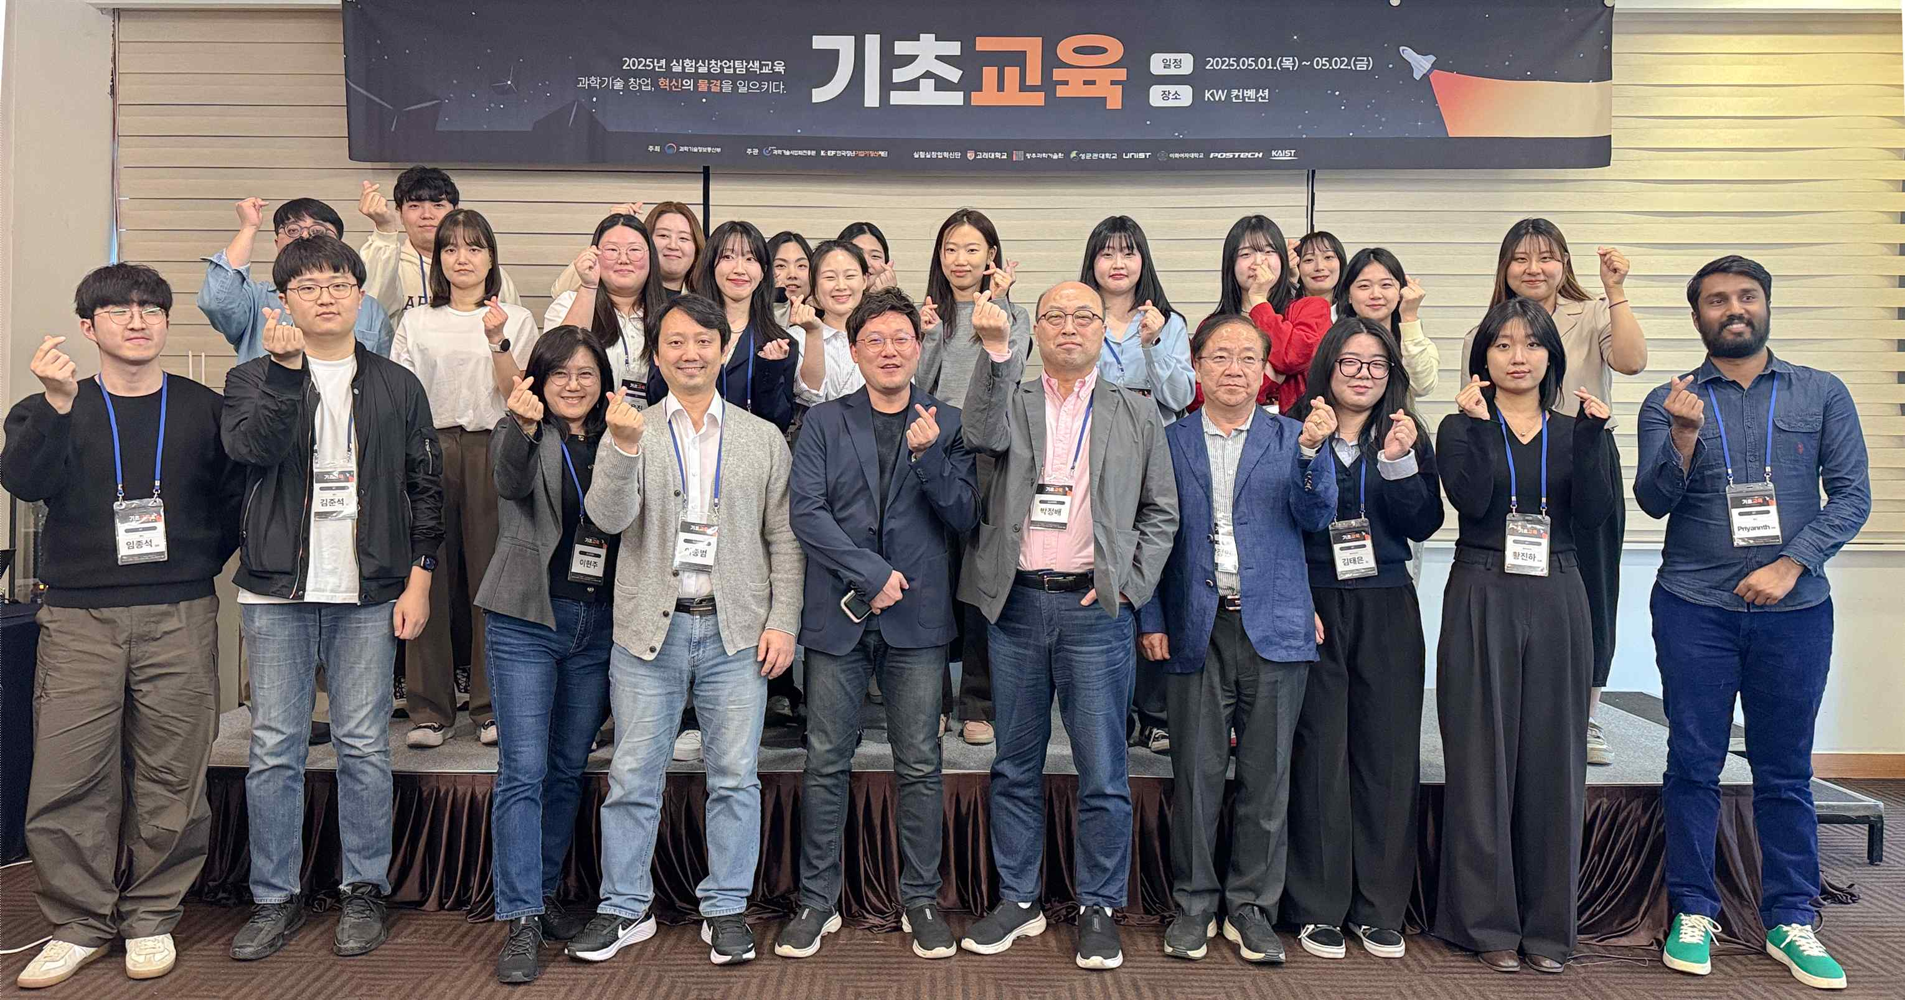

▲ On May 1, 2025, participants of the Laboratory Startup Exploration Education are taking a commemorative photo after completing the basic training.
Inchan Kwon, Director of the GIST Technology Institute (GTI), stated, “Through the selection for the 3rd Texcore project, GIST has once again received recognition for the startup support capabilities it has accumulated.” He added, “We will do our utmost to foster deep-tech startups equipped with market competitiveness by supporting excellent public research achievements from universities and research institutions in the Honam region so that they do not remain in laboratories but are verified and grow in the actual market.”
Meanwhile, the GIST GIST Technology Institute, centered around the Startup Promotion Office, is striving to spread a technology-based startup culture and cultivate prospective entrepreneurs by operating various startup support programs, including Startup Supporters, student startup clubs, Startup Mini-Schools, and practical and mock startup programs.
Through these startup support programs, technology-based startups are entering the market and achieving results, including AI Academy Co., Ltd., SOAL Co., Ltd. (CEO Ji-sung Jung, Ph.D. in Mechanical and Robotics Engineering), which developed high-resolution LiDAR sensors for autonomous driving and robots and succeeded in listing on KOSDAQ in 2024, and Icarus Co., Ltd. (CEO Jong-won Lee, master's in Mechanical and Robotics Engineering), which implements low-cost ultra-high-speed communication services based on long-endurance unmanned airships in the stratosphere.

