The GIST Techno Management Business Academy (GTMBA) held its 16th entrance ceremony, welcoming 47 students, including professional managers
- 16 years since its launch in 2010... Cultivating integrated leaders for the era of great transformation through integrated training for technology management professionals
- 15th Alumni Association President Han-sang Jang, CEO of Hyundai Conveyor Co., Ltd., donates 10 million won to the development fund
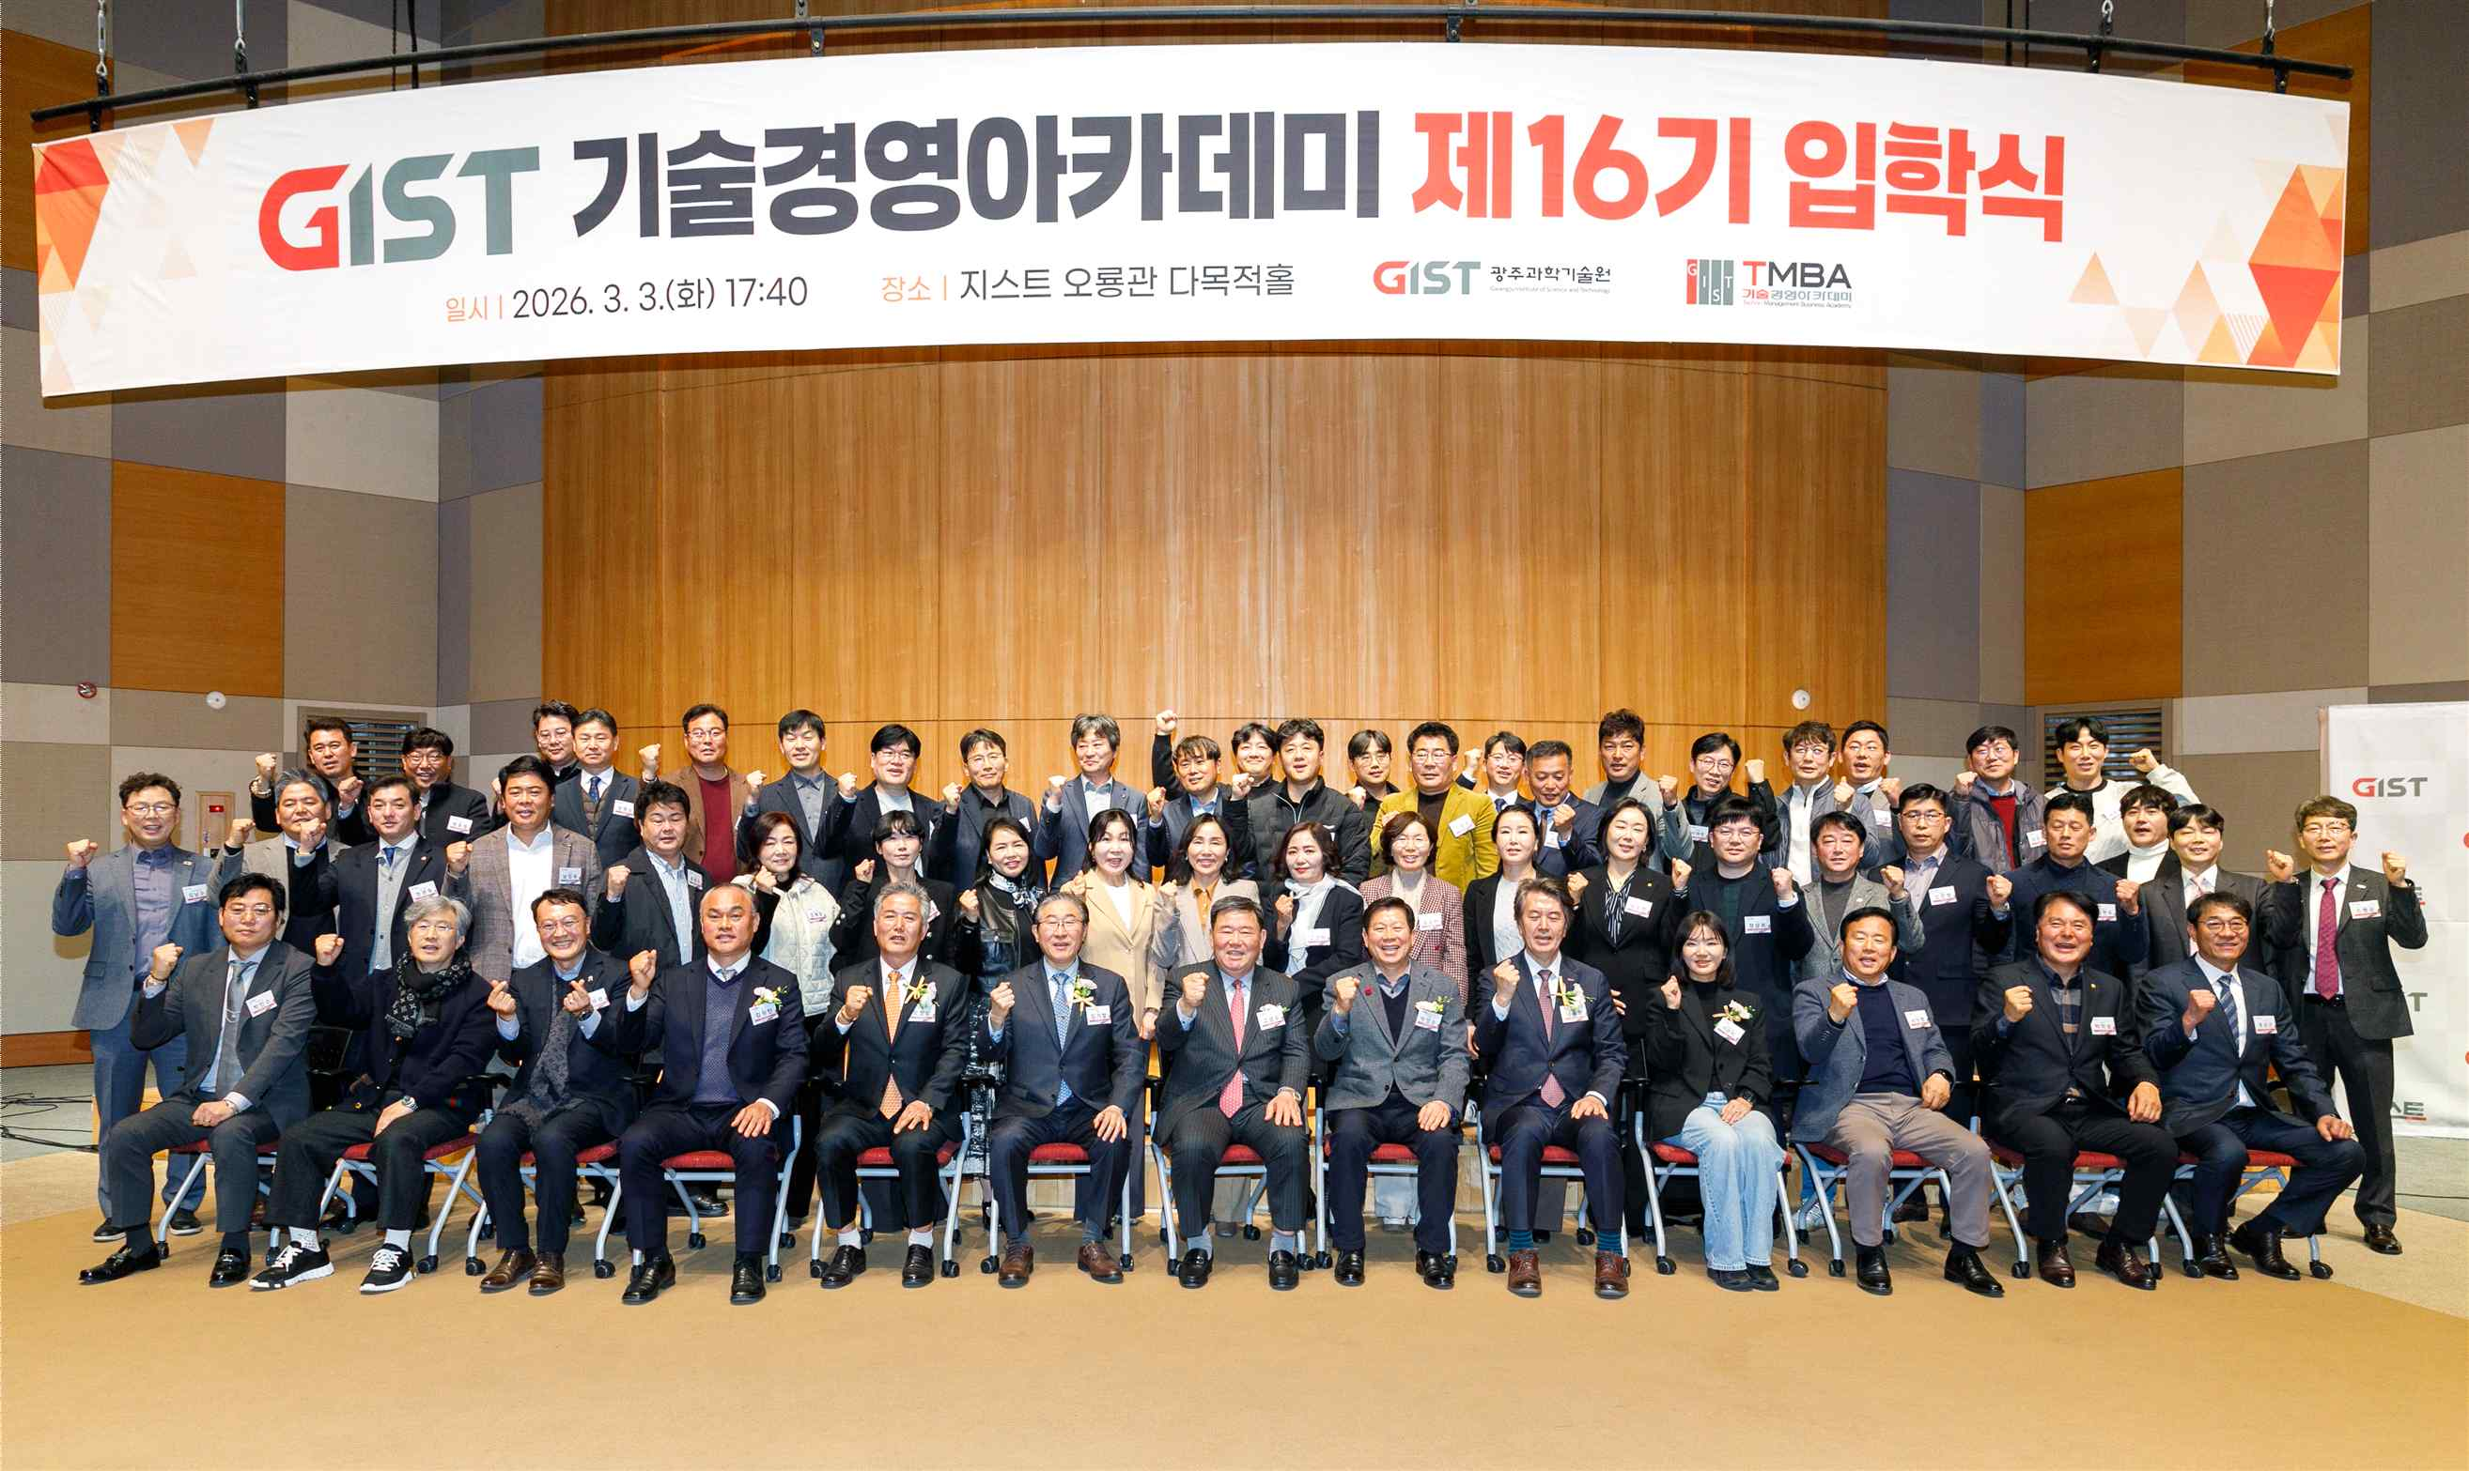

▲ The GIST Techno Management Business Academy (GTMBA) held its 16th entrance ceremony at Oryong Hall on Tuesday, March 3rd, and a commemorative photo was taken.
The Gwangju Institute of Science and Technology (GIST, President Kichul Lim) announced that it held the 16th entrance ceremony of the GIST Techno Management Business Academy (GTMBA) at Oryong Hall on Tuesday, March 3rd.
The ceremony was attended by President Kichul Lim, Vice President for Public Affairs (GTMBA Director) Yonghwa Chung, GIST Development Foundation Director Won-man Kim, and other key officials, as well as 47 incoming students from the 16th class.
The event also featured a donation ceremony for the development fund by Han-sang Jang, CEO of Hyundai Conveyor Co., Ltd. and 15th Alumni Association President. The 10 million won donated by Chairman Jang will be used for projects promoting cooperation and mutual growth with the local community.
Since founding Hyundai Corporation, the predecessor of Hyundai Conveyor Co., Ltd. in 1993, Chairman Jang has specialized in the production and supply of high-quality conveyor parts both domestically and internationally, and has built customized equipment optimized for industrial applications. Based on a quality-centered management philosophy, he has contributed to strengthening the competitiveness of manufacturing and logistics automation.
In his opening remarks, Chairman Han-sang Jang stated, "I have decided to donate to the development fund with the hope that GIST will grow into a world-class educational institution and contribute to the development of the local and national economy."
He added, "I am confident that if GTMBA alumni practice sharing and giving as a core force in the local community, we will achieve even greater growth alongside GIST."
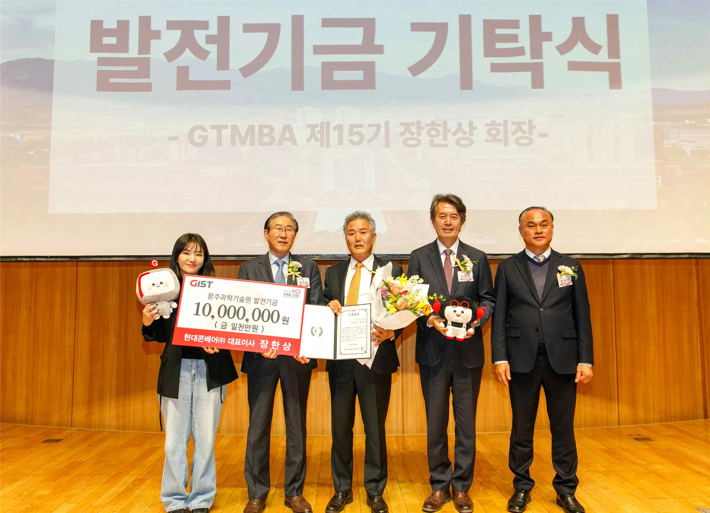

▲ The 16th GIST Techno Management Business Academy (GTMBA) entrance ceremony also featured a donation ceremony for the development fund by Han-sang Jang, CEO of Hyundai Conveyor Co., Ltd., the 15th alumni association president.
President Kichul Lim stated in his welcoming address, "GTMBA will serve as a platform for leaders from all sectors of society to share cutting-edge industrial technologies and knowledge, enabling them to successfully conduct business in the era of artificial intelligence (AI) transformation through a convergent curriculum that encompasses not only technology and management but also humanities and artistic insights."
He also emphasized, "GIST will further strengthen its foundation for training technology management experts and continue to lay the foundation for growth for professional managers through industry-academia-research collaboration and expanded global competitiveness."
Since launching its Chief Technology Officer (CTO) program in 2010, the GIST Academy, now in its 16th year, has served as a regional business hub and industry-academia collaboration through its systematic CEO training program. To date, the school has produced approximately 620 alumni, who are active as global leaders in various fields of society, including industry, economy, and public sector.

