GIST and Samsung Electronics are recruiting industry-academic scholarship students for the spring 2026 semester through the "Intelligent Motor Track"
- Samsung Electronics DA Division recruitment linkage, selecting up to 15 master's degree program industry-academic scholarship recipients annually
- Support for scholarships, internships, and global programs… 9 people have been hired by Samsung Electronics
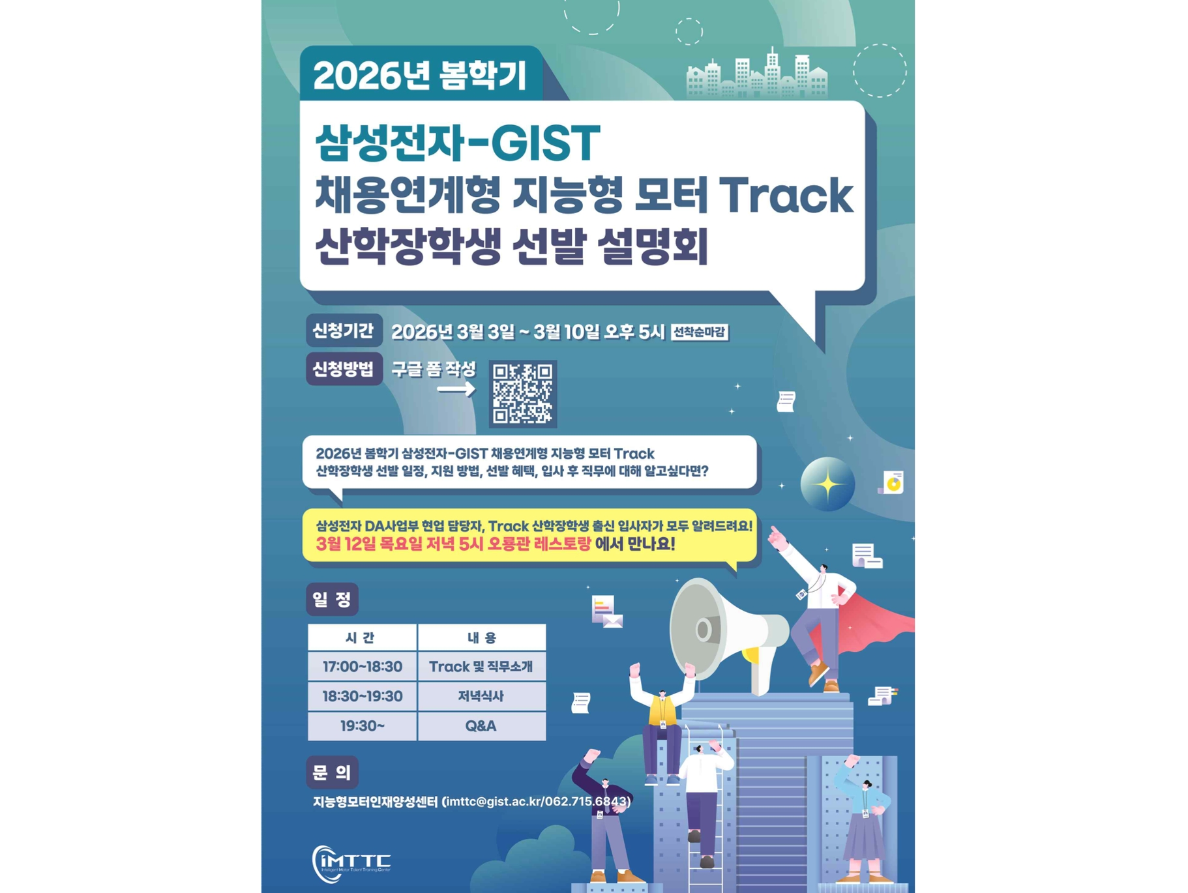

▲ Promotional poster for the 2026 Spring Semester Intelligent Motor Track
The Gwangju Institute of Science and Technology (GIST, President Kichul Lim) announced that it is recruiting new students for the 2026 Spring Semester for the "Intelligent Motor Track," operated in conjunction with Samsung Electronics' Digital Appliances (DA) Division recruitment program. Up to 15 students will be accepted annually, all of whom will receive industry-academic scholarships.
Applications for this spring semester's Industry-Academic Scholarship program will be accepted from March 3 to March 10, with additional detailed application forms available from March 13 to 23. The selection process will include various programs, including information sessions, lunch talks, and hackathons.
Eligible applicants are students currently enrolled in the first or second year of the master's program in the Department of AI Convergence, Department of Mechanical and Robotics Engineering, or Department of Electrical Engineering and Computer Science at GIST. Applicants who are scheduled to enroll in the master's program in the fall semester of 2026 are also eligible to apply.
Applicants must have an official English proficiency score of OPIC IL or higher or TOEIC Speaking Level 5 (110 points) or higher before the interview. Male applicants must have completed or been exempted from military service. Selected students must complete the regular curriculum of the Intelligent Motor Track before receiving their master's degree.
Students receiving the Industry-Academic Scholarship will receive scholarships and tuition assistance equivalent to tuition. They will also be eligible to participate in a one-time, six-week internship with Samsung Electronics' Digital Assistant (DA) Division during the summer or winter break before graduation. Furthermore, students will gain diverse global experience through participation in major domestic and international academic conferences and visits to overseas research centers and partner companies.
Last summer, students visited the Samsung Electronics Osaka Research Center in Osaka, Japan, and its partner companies to share the latest technological trends in the intelligent motor field and expand their global industry network.
Furthermore, a "Motor Boot Camp" will be held during the winter break to enhance undergraduate students' understanding and capabilities in the motor field. Tech forums and field trip programs, including visits to Samsung Electronics' Suwon and Gwangju plants, will also be offered.
The Industry-Academic Scholarship program is selected twice a year, in the spring and fall semesters, and operates separately from Samsung Electronics' open recruitment process. However, applications for both the open recruitment and the Intelligent Motor Track are not permitted.
Professor Pilwon Hur of the Department of Mechanical and Robotics Engineering, who serves as the Director of the Intelligent Motor Talent Development Center, stated, "The 'Intelligent Motor Track' is a program designed to cultivate GIST talent into industry experts. Samsung Electronics executives are directly involved in strengthening field-oriented training. We will actively support students to develop into motor experts with practical experience."
Meanwhile, GIST has been operating the 'Intelligent Motor Track' for master's students since April 2023, with the goal of fostering specialized talent in the field of intelligent motors. The first graduating class was produced in February 2024.
This track integrates related majors such as mechanical engineering, electrical and electronic computer engineering, and artificial intelligence (AI), and requires students to earn 15 credits in the fields of ▴ control, ▴ signal processing, ▴ design, ▴ convergence, and ▴ AI.
As of March 2026, nine students have completed GIST's Intelligent Motor Track, and based on their outstanding research achievements, they have secured positions at Samsung Electronics.

