GIST hosts 'Global Flag Raising Ceremony', bringing together international students from over 30 countries
- Held for the second time since last year… Emphasizes the international campus identity that respects diversity
- Enhances international students' sense of belonging and pride, and highlights the significance of cultural exchange and solidarity
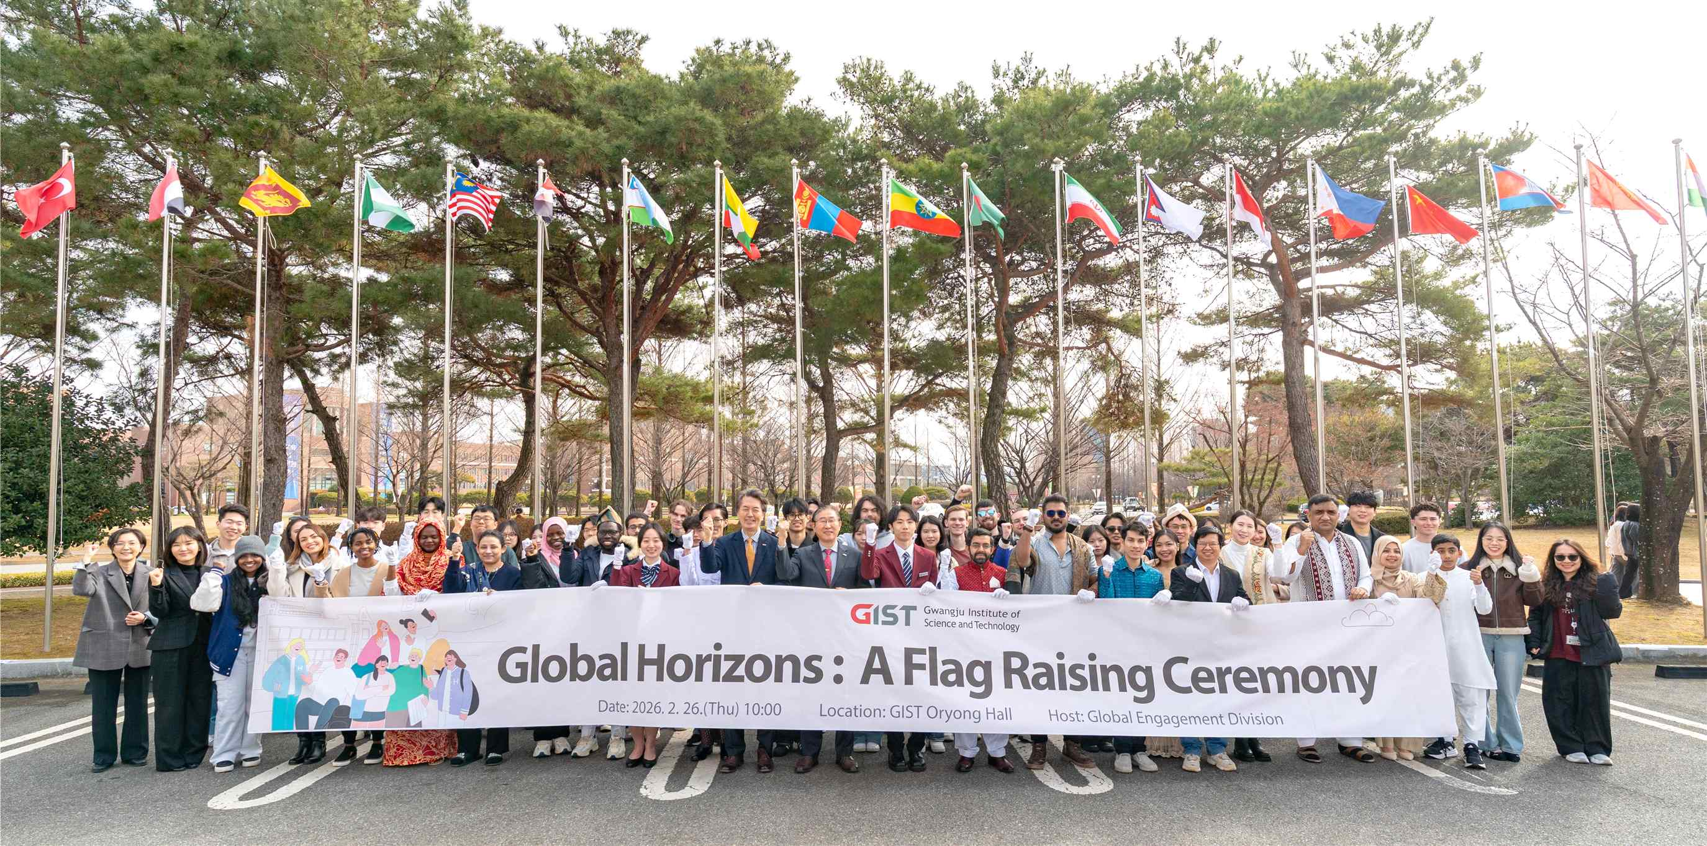

▲ Participants in the "Global Flag Raising Ceremony" held at GIST Oryong Hall on Thursday, February 26th pose for a commemorative photo.
The Gwangju Institute of Science and Technology (GIST, President Kichul Lim) announced that it held "Global Horizons: A Flag Raising Ceremony" at Oryong Hall on Thursday, February 26th.
This was the second such event, following last year. It was designed to foster a sense of belonging and pride among international students ahead of the 2026 entrance ceremony held on the same day, and to reflect on the significance of students of diverse nationalities uniting as one community.
The flags of approximately 30 countries, including Korea, Ghana, Germany, Mexico, Egypt, Turkey, Kazakhstan, and the Philippines, were raised at the ceremony. GIST President Kichul Lim, Vice President for Public Affairs Yonghwa Chung, International and Public Affairs Dean Eunji Lee, Student Affairs and Admissions Dean Soo Jong Lee, and approximately 30 international students attended.
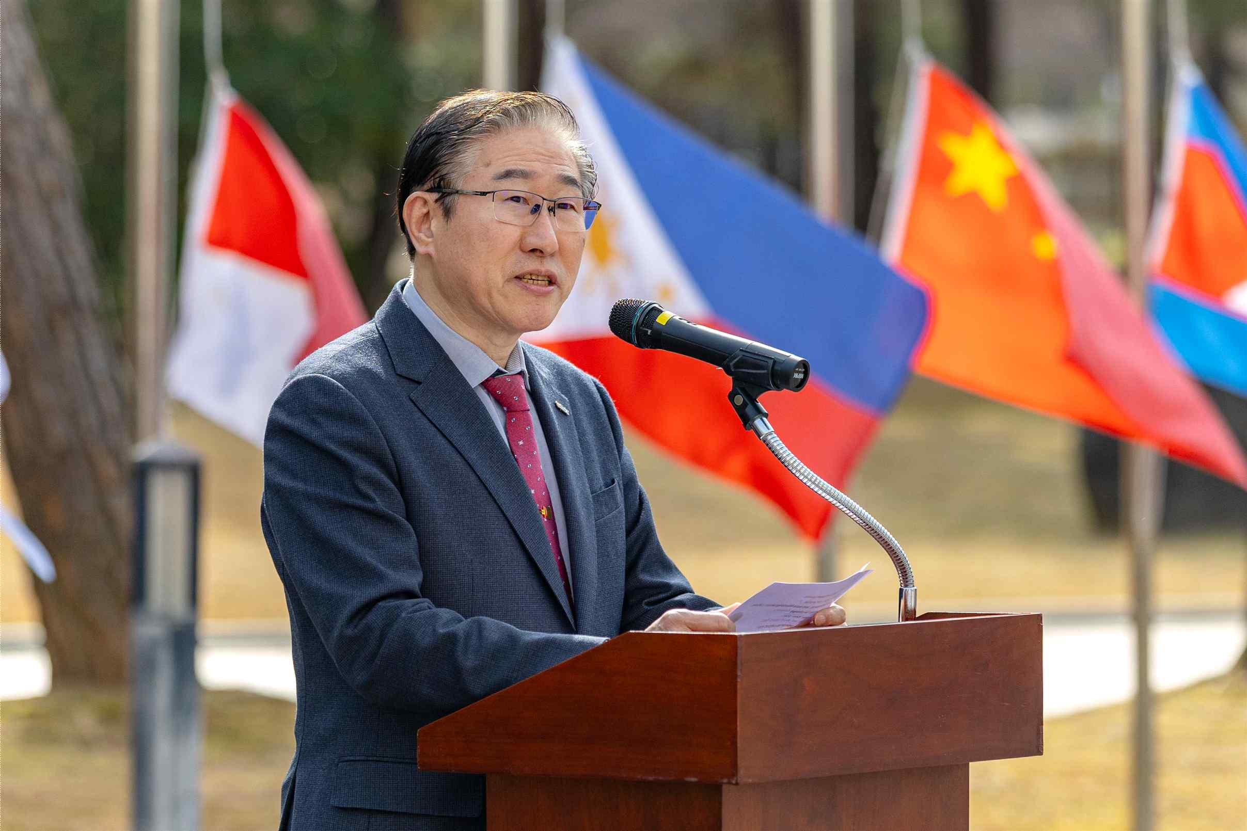

▲ President Kichul Lim delivers the opening remarks at the "Global Flag Raising Ceremony," held at GIST's Oryong Hall on Thursday, February 26th.
The event began with President Lim's opening remarks, followed by a welcoming address by Muhammad Umar Tahir (Pakistan), a doctoral student in the Department of AI Convergence and a representative of international students. This was followed by a flag-raising ceremony and commemorative photo session with students representing each country.
President Kichul Lim stated, "The Global Flag Raising Ceremony is a symbolic moment where members from different starting points come together as a single community. Respecting each other's cultures and identities and interacting with each other leads to new learning and innovation."
He added, "GIST will continue to support students across all aspects of their studies and lives, enabling them to grow through diverse challenges and experiences. We will also create an open campus connected to the world."
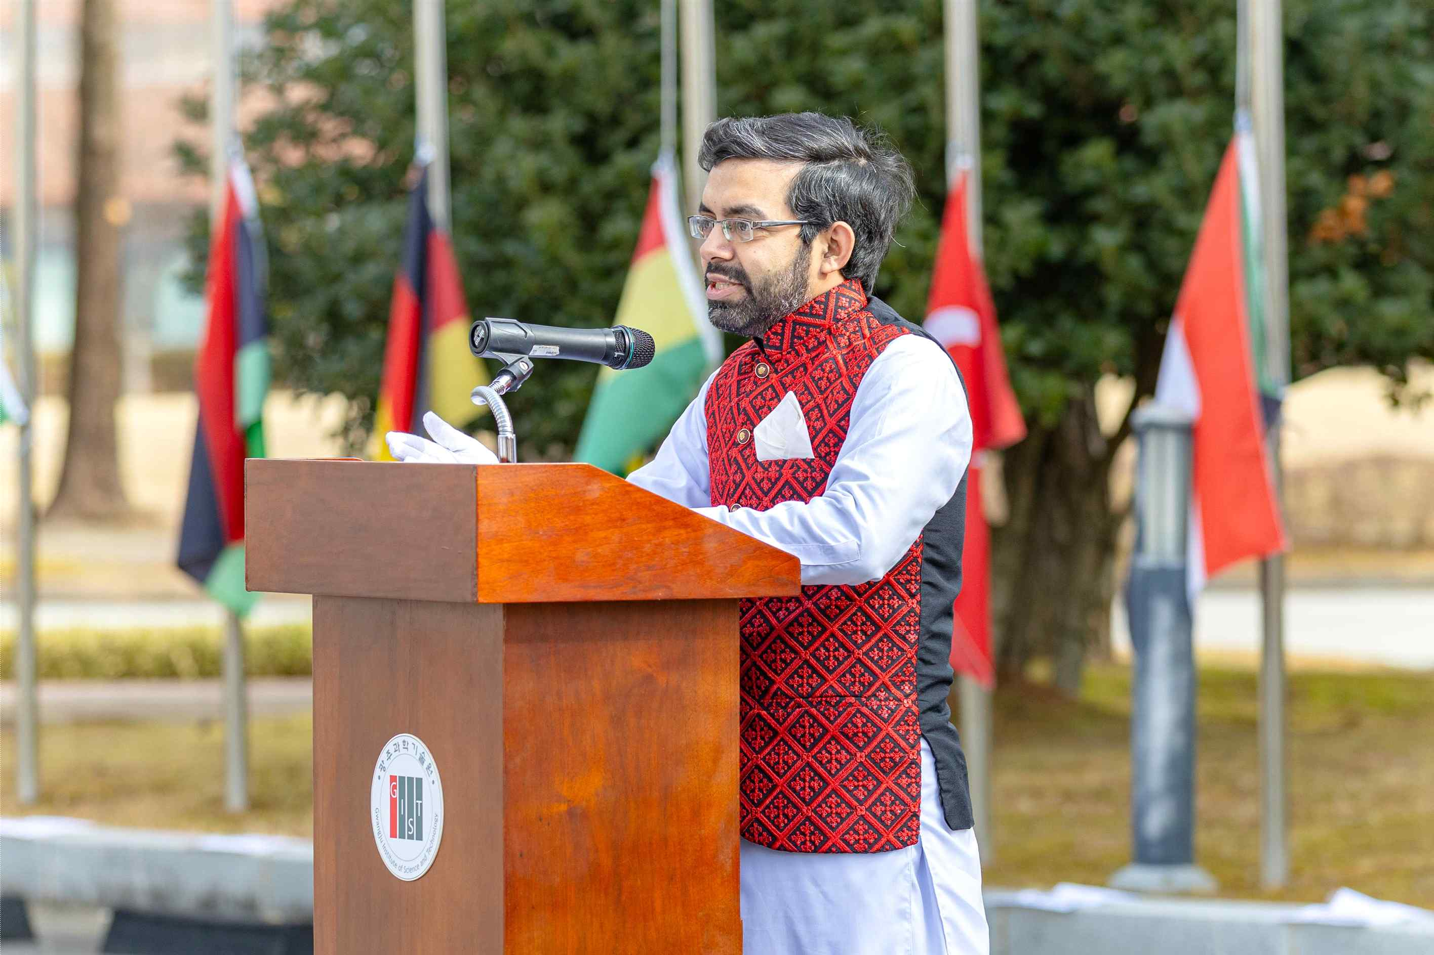

▲ Muhammad Umar Tahir, a doctoral student representing international students, delivers a welcoming address.
Muhammad Umar Tahir said, "For many international students, GIST is not just a university; it's a second home." He added, "Students from different countries learn together, collaborate, and build a community."
He added, "Let's reflect on the value of a global campus where diverse cultures collaborate and grow toward a common goal, and together, let's create meaningful change in the world."
Meanwhile, GIST awarded degrees to a total of 308 students at its 2025 commencement ceremony held on February 20th, including 70 doctoral students, 130 master's students, and 108 bachelor's degrees.
This brings the cumulative number of graduates to 9,166, of which 630 are foreign graduates, including 202 doctoral graduates, 415 master's graduates, and 13 bachelor's graduates.

