GIST launches the IBS Microbiome-Body-Brain Physiology Research Group, accelerating the development of talent in the field of convergent neurophysiology
- Launch of the third IBS research center on campus to elucidate the principles of microbiome-body-brain interactions
- Establishing research group-department linkages… Linking basic science achievements to fostering next-generation convergence talent
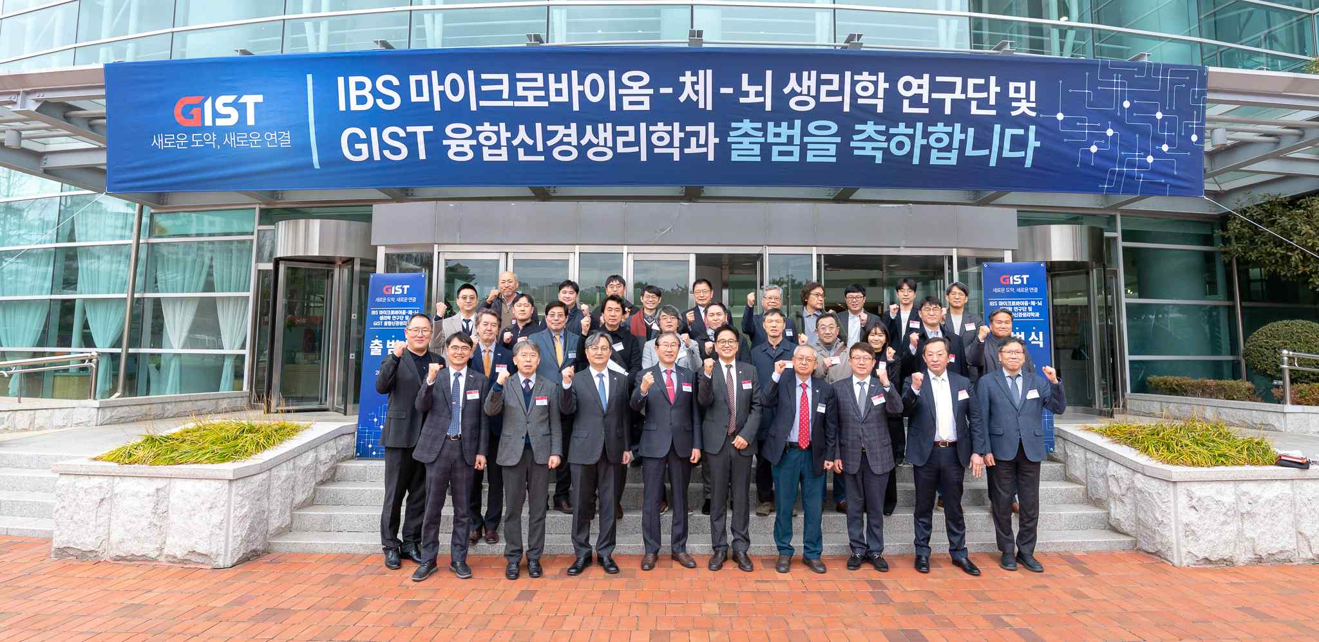

▲ Attendees pose for a commemorative photo at the launch ceremony of the IBS Center for Microbiome-Body-Brain Physiology and the GIST Department of Convergence Neurophysiology
The Gwangju Institute of Science and Technology (GIST, President Kichul Lim) announced that it held a joint ceremony for the IBS Center for Microbiome-Body-Brain Physiology and the launch ceremony for the GIST Department of Integrated Neuroscience & Physiology at 3:00 PM on Thursday, February 26th, in Oryong Hall.
This event officially announced the launch of a new IBS campus research center that will lead next-generation convergence neurophysiology research, and also marked the beginning of a specialized talent development system based on this center.
By establishing the Department of Integrated Neuroscience & Physiology within the College of Life Sciences & Medical Engineering in conjunction with the center's establishment, GIST has established a virtuous cycle where basic research results lead to education and talent development.
The event was attended by approximately 100 people, including Acting Vice President Soon-ki Chae of the IBS, President Pan-gil Seo of the Korea Brain Research Institute (KBRI), President Kichul Lim of GIST, Vice President for R&DB Yong-Chul Kim, and Department of Integrated Neuroscience & Physiology Dean Zee-Yong Park.
The IBS Center for Microbiome-Body-Brain Physiology officially launched on December 1, 2025, and is the third IBS campus research center to be established at GIST. Following the previously established IBS Center for Quantum Conversion Research (Director Yousoo Kim) and the IB IBS Center for Relativistic Laser Science (Director Kyung Taec Kim), this expansion into the life sciences has given GIST a more multifaceted basic science research portfolio.
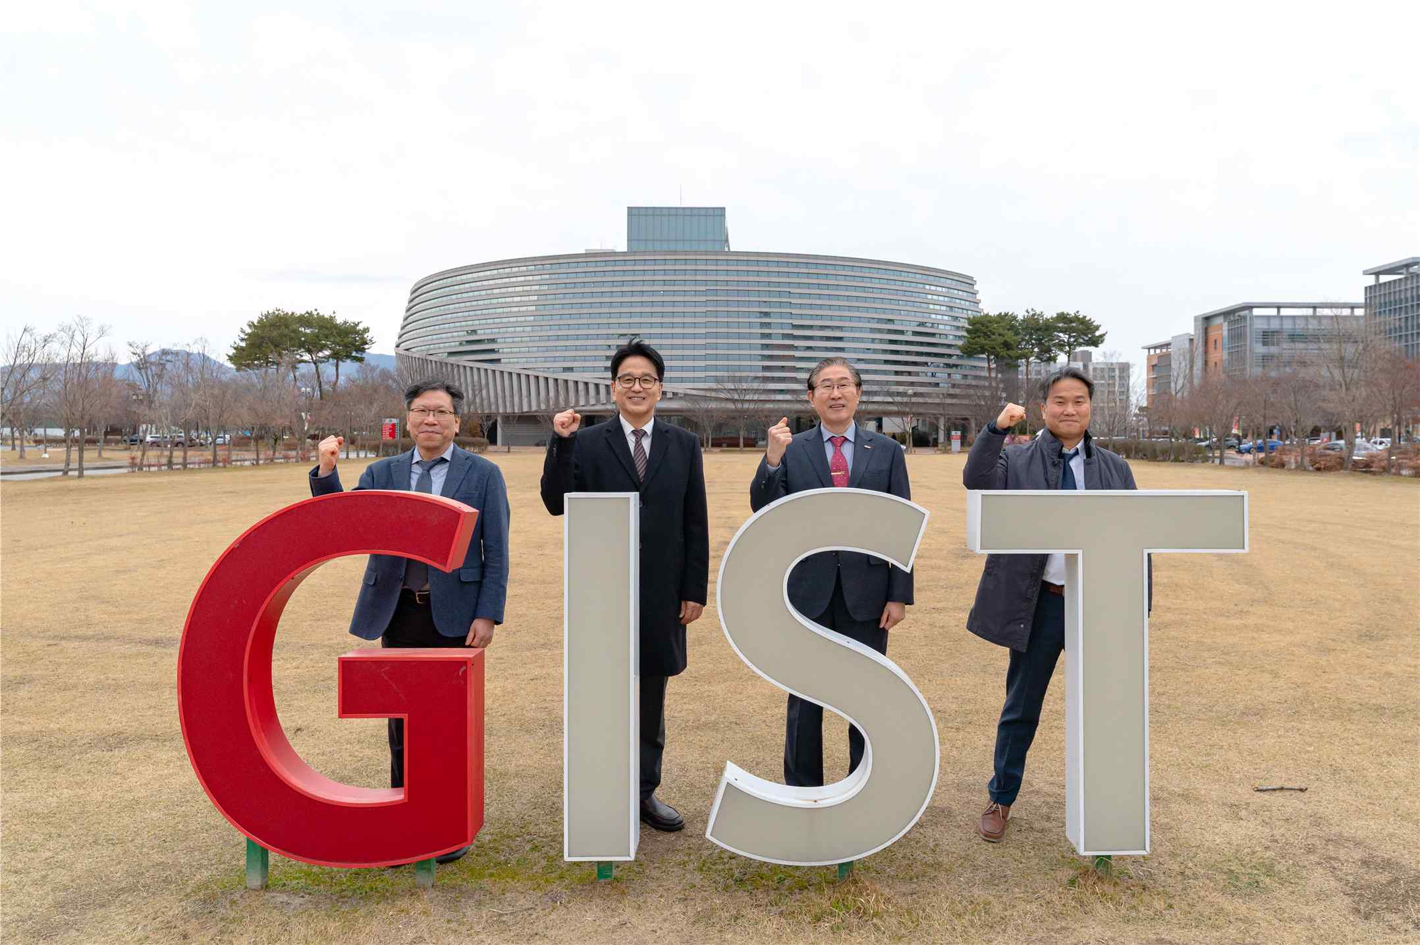

▲ (From left) IBS Director Yousoo Kim of the Center for Quantum Conversion Research; Director Seong-Bae Suh of the Center for Microbiome-Body-Brain Physiology; GIST President Kichul Lim; and Director Kyung Taec Kim of the Center for Relativistic Laser Science.
The research group's core goal is to elucidate the operating principles of microbiome-body-brain interactions, the series of processes by which the body detects nutrients, transmits them to neural circuits, and subsequently triggers hormonal responses.
The GIST Department of Integrated Neuroscience & Physiology, in close collaboration with research centers, will establish an integrated education and research system that fundamentally understands key physiological phenomena facing humanity, such as eating disorders, obesity, diabetes, and aging, and systematically elucidates the mechanisms of connection between the brain and body organs.
In particular, the group proposes a virtuous cycle where the group's basic scientific achievements directly lead to the training of next-generation researchers through a curriculum encompassing life sciences, engineering, medical science, and information science.
President Kichul Lim said, “IBS Center for Microbiome-Body-Brain Physiology and the Department of Integrated Neuroscience & Physiology will become hubs leading the next generation of convergence research and talent development in the field of life sciences,” and “GIST will strategically foster the bio field, one of the five major game changers in the country, to lead the paradigm shift in future brain science research.”
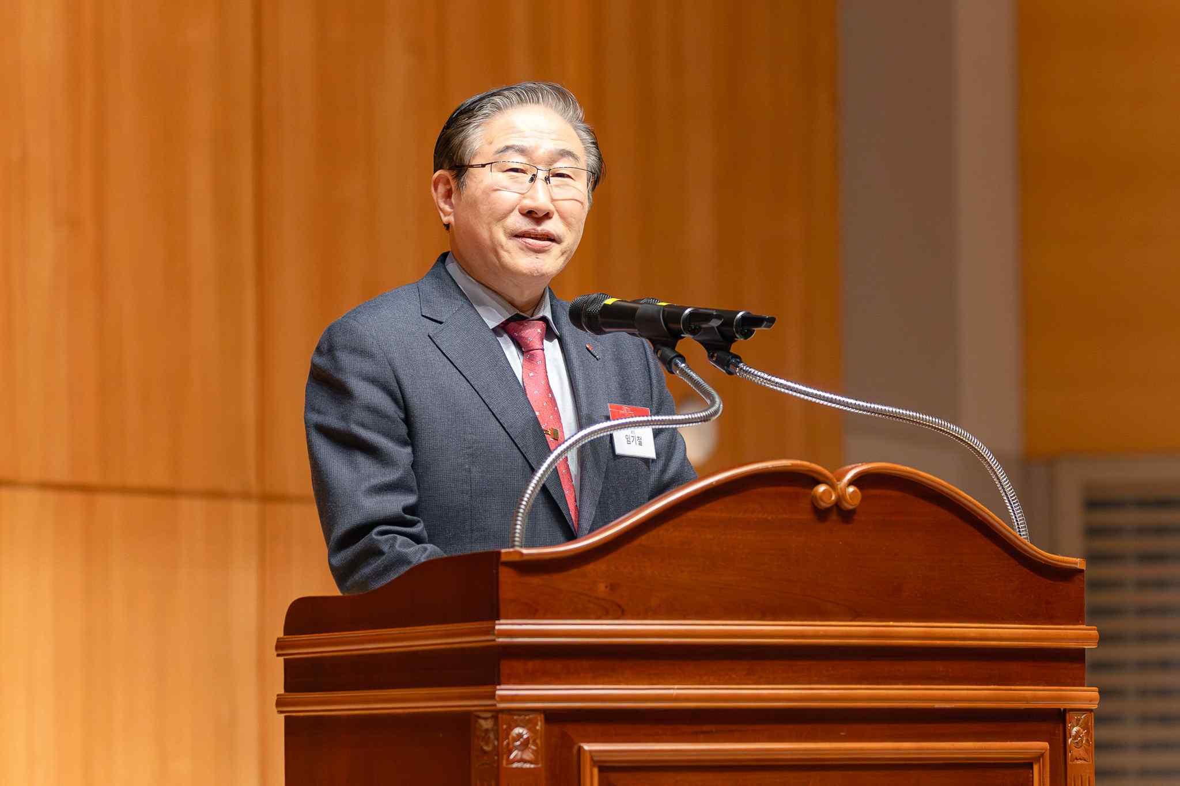

▲ President Lim Ki-cheol delivers a welcoming address at the launch ceremony for the research center.
IBS Acting Vice President Soon-ki Chae said, "The launch of the new research center and department will open new horizons and lay a solid foundation for cooperation between the government and research institutions." He added, "Just as basic science has expanded human understanding, I hope the two organizations will create synergy and lead to a virtuous cycle of national development."
Korea Brain Research Institute President Pan-gil Seo stated, "Just as AI is a catalyst for interdisciplinary communication, complementary evolution is essential for the brain and AI. I encourage GIST to transcend disciplinary barriers and integrate life sciences, engineering, medicine, and information science into a single platform, ushering in an era of multidisciplinary convergence science."
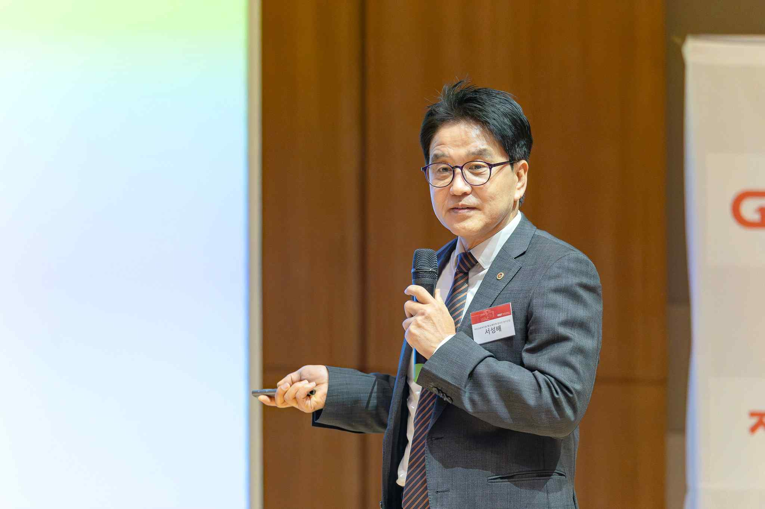

▲ Director Seong-Bae Suh of the IBS Center for Microbiome-Body-Brain Physiology the research center.
Director Seong-Bae Suh, who studies the operating principles of the internal sensory nerves connecting the brain and internal organs, is recognized as a pioneer in the field of sensory and neurophysiological research. Using the fruit fly model, he has meticulously elucidated the principles of the brain-gut neural circuitry involved in feeding, metabolism, and hormone regulation, earning international recognition for his original research.
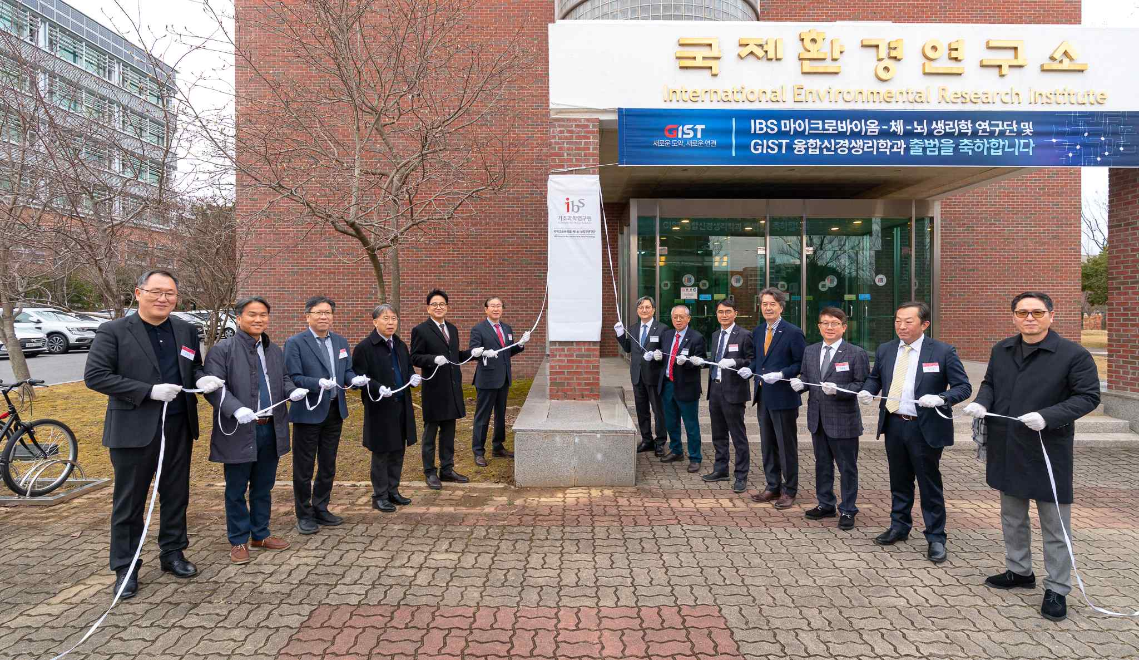

▲ Unveiling a plaque at the opening ceremony of the IBS Microbiome-Body-Brain Physiology Research Group.
Director Seo said, “If we can elucidate the principles of internal senses, we can gain a deeper understanding of major physiological phenomena such as eating, obesity, diabetes, and aging.” He added, “Just as all bodies connected to the brain communicate bidirectionally, we will communicate with the world and create lasting achievements through integrated and systematic research on brain nerves and body physiology.”

