GIST holds 2026 Entrance Ceremony: "Continuously Ask Why You Do Research"
- 527 freshmen take their first steps, with over 200 family members celebrating
- Freshman Camp prepares students for college life with English classes, safety training, club introductions, and networking with seniors and juniors
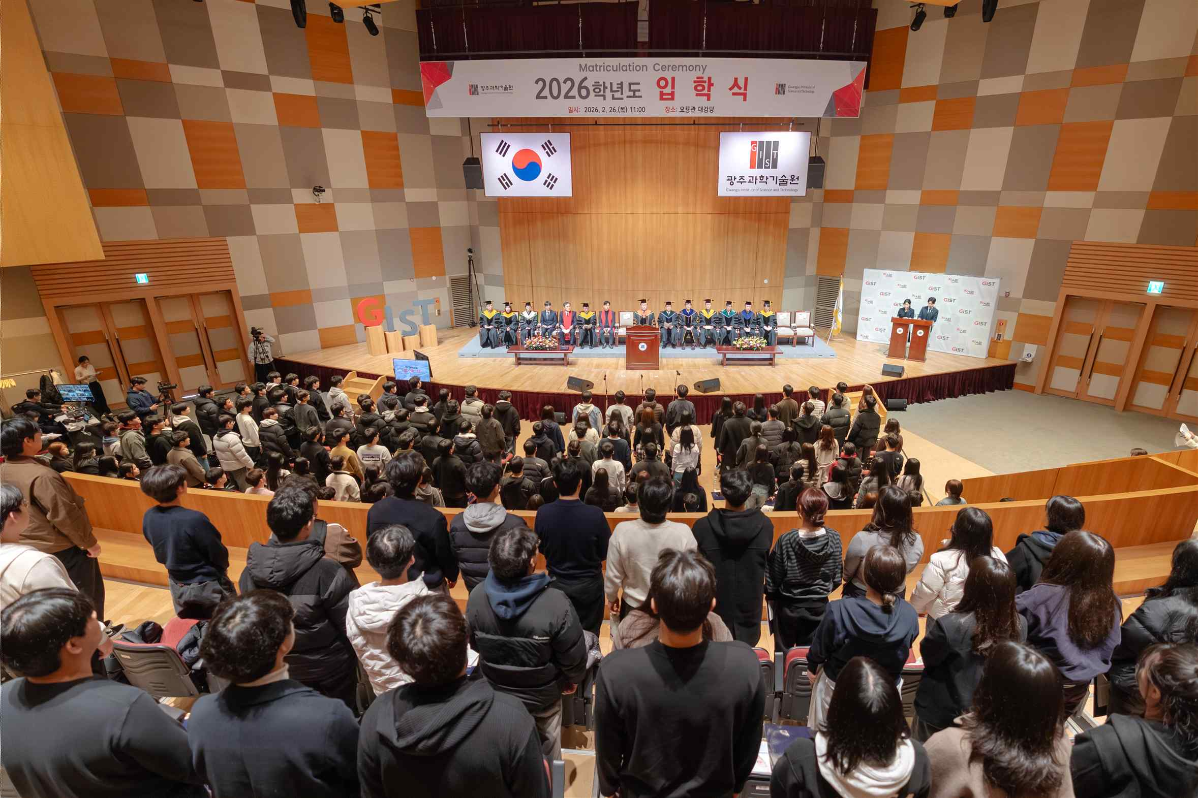

▲ GIST held its 2026 entrance ceremony at 11:00 AM on Thursday, the 26th, in the Oryong Hall auditorium.
The Gwangju Institute of Science and Technology (GIST, President Kichul Lim) announced that it held its 2026 entrance ceremony at 11:00 AM on Thursday, the 26th, in the Oryong Hall auditorium.
A total of 527 new students were admitted that day, including 290 undergraduate students, 150 master's students, 57 integrated master's and doctoral students, and 30 doctoral students. Approximately 200 parents and family members also attended to celebrate their new beginnings.
The entrance ceremony began with an academic report by Dean of Academic Affairs Keun-Young Kim, followed by the president's declaration of acceptance, a freshman representative's oath of admission, and a recitation of the "GIST Spirit" by all new students.
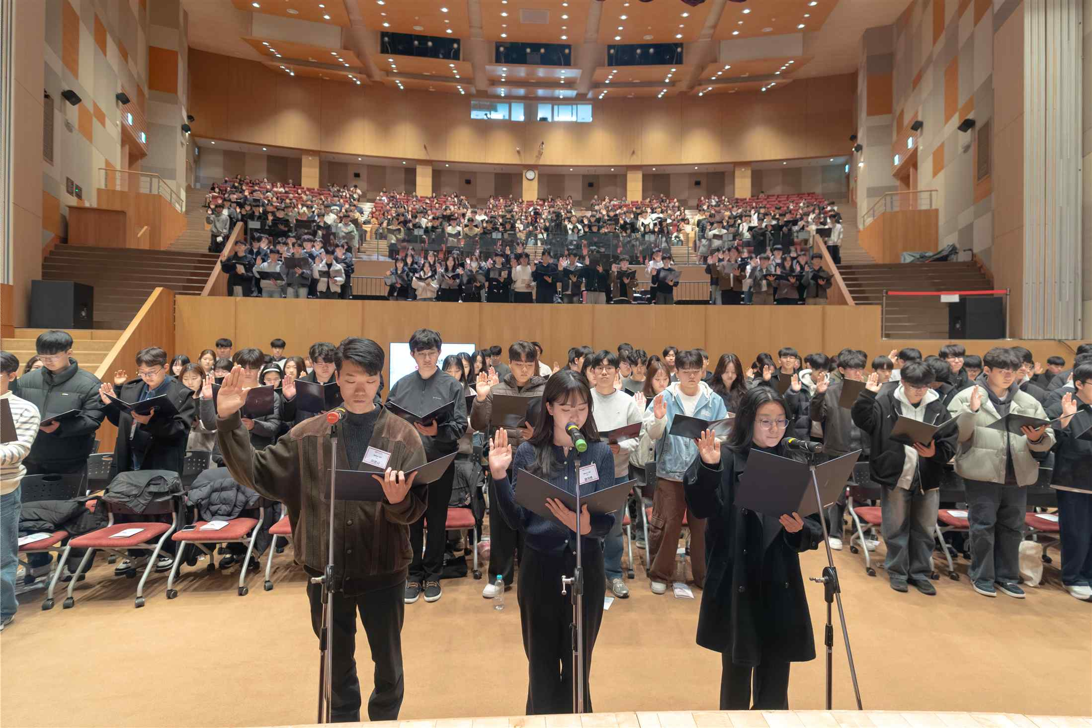

▲ Freshmen reciting the ‘GIST Spirit’ at the GIST 2026 entrance ceremony
Twenty-four students with excellent entrance exam scores were awarded Presidential Scholarships.
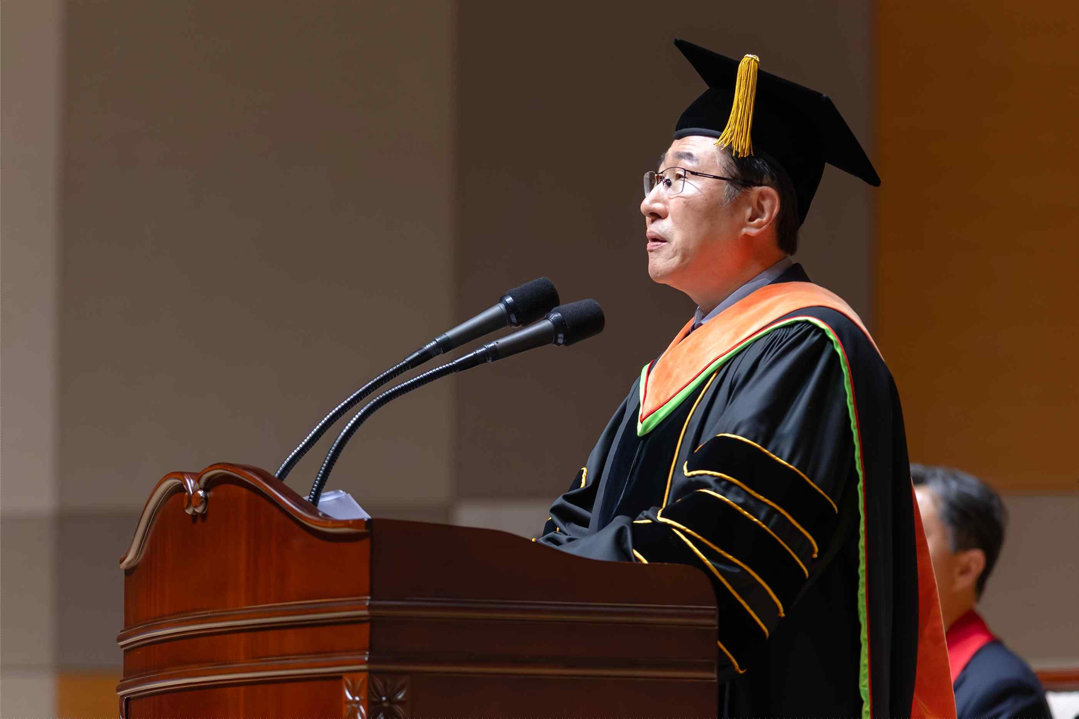

▲ President Kichul Lim addresses the GIST 2026 Entrance Ceremony.
In the welcoming address, Kyung-hoon Jang, CEO of Innocep, a membrane technology-based medical and environmental solutions company who graduated from the doctoral program in GIST's Department of Environment and Energy Engineering, and Tae-gyun Lee, a PhD graduate of the Department of Physics and Photon Science, gave words of encouragement to the incoming students.
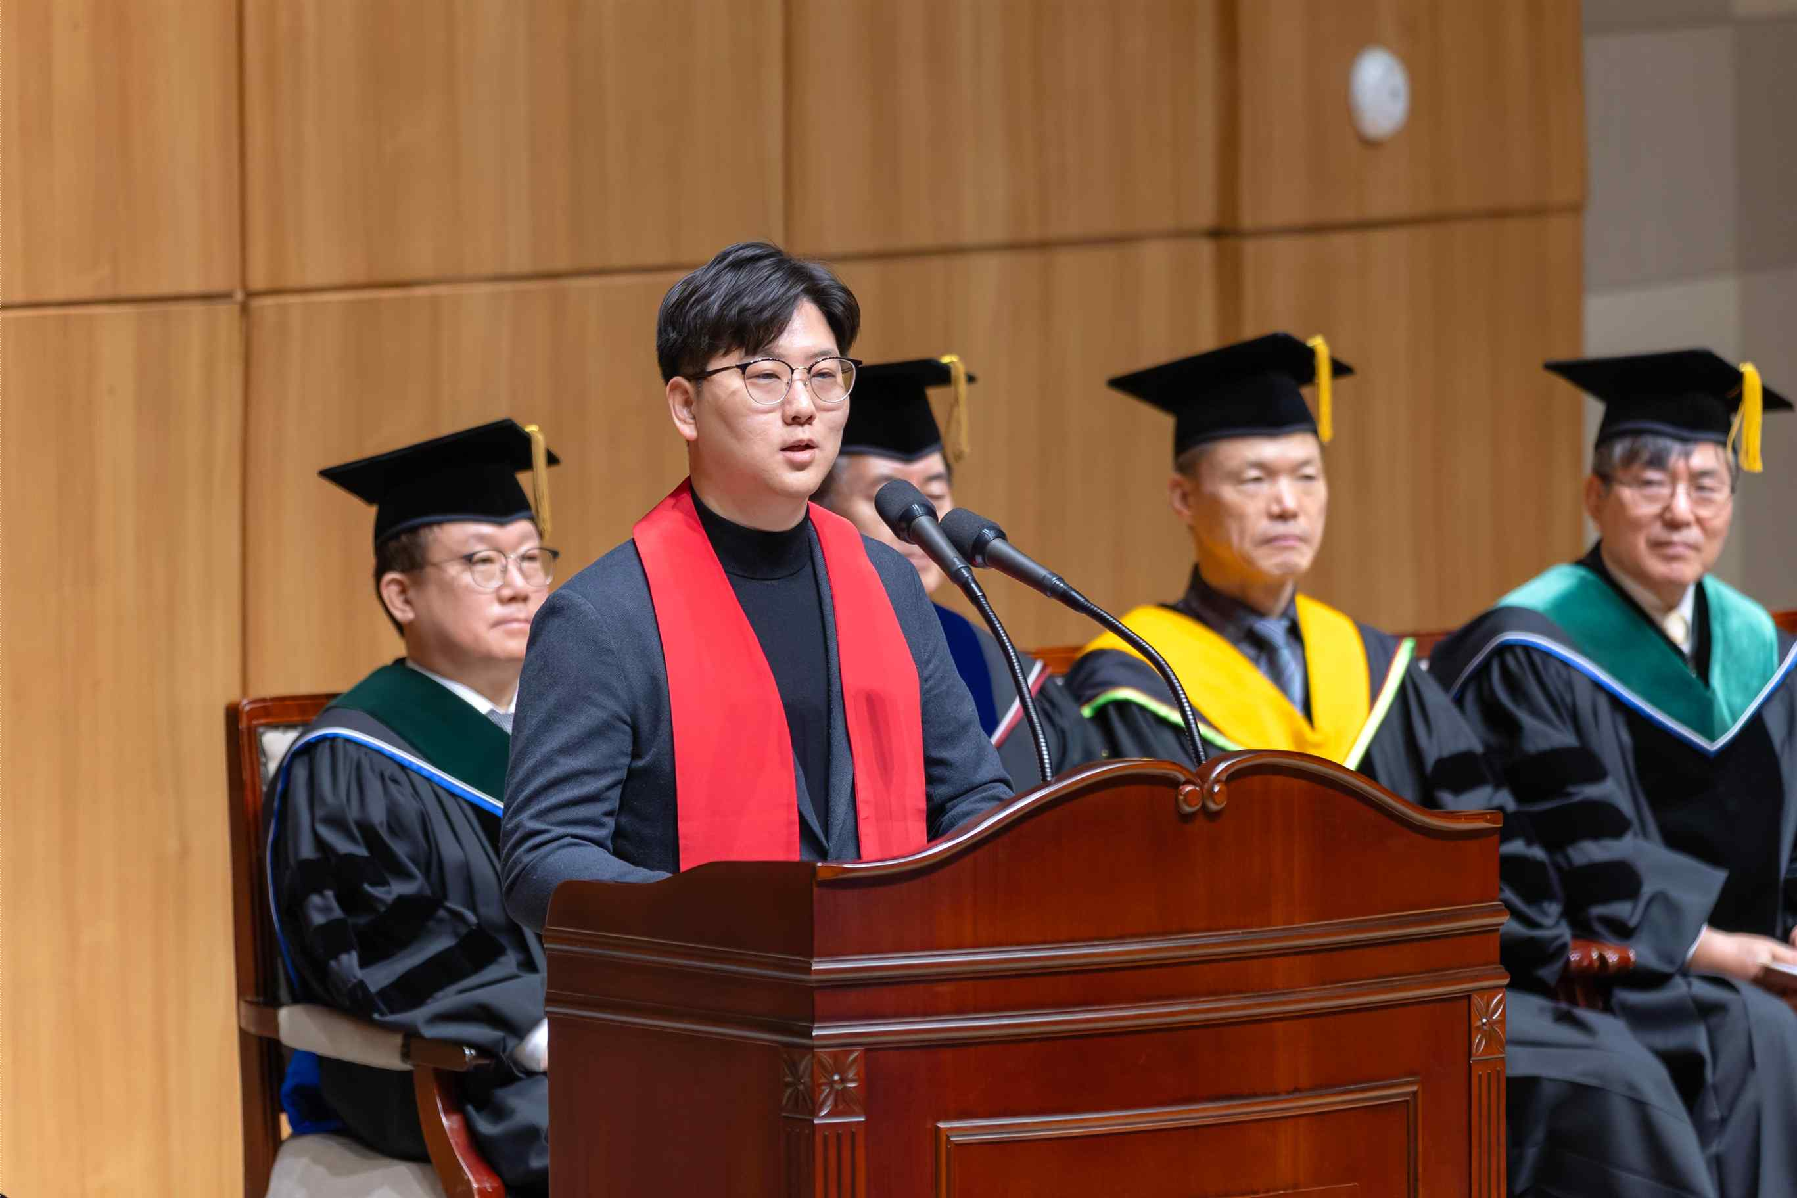

▲ Kyung-hoon Jang, CEO of Innocep, gives encouragement to the incoming students at the GIST 2026 entrance ceremony.
Jang stated, "At crossroads, I hope you will grow into people who take responsibility for their choices, rather than wasting time fearing regret or lacking courage." He urged them to "use the weight of responsibility as a learning opportunity and actively utilize the school's research infrastructure and network of colleagues to take on new challenges."
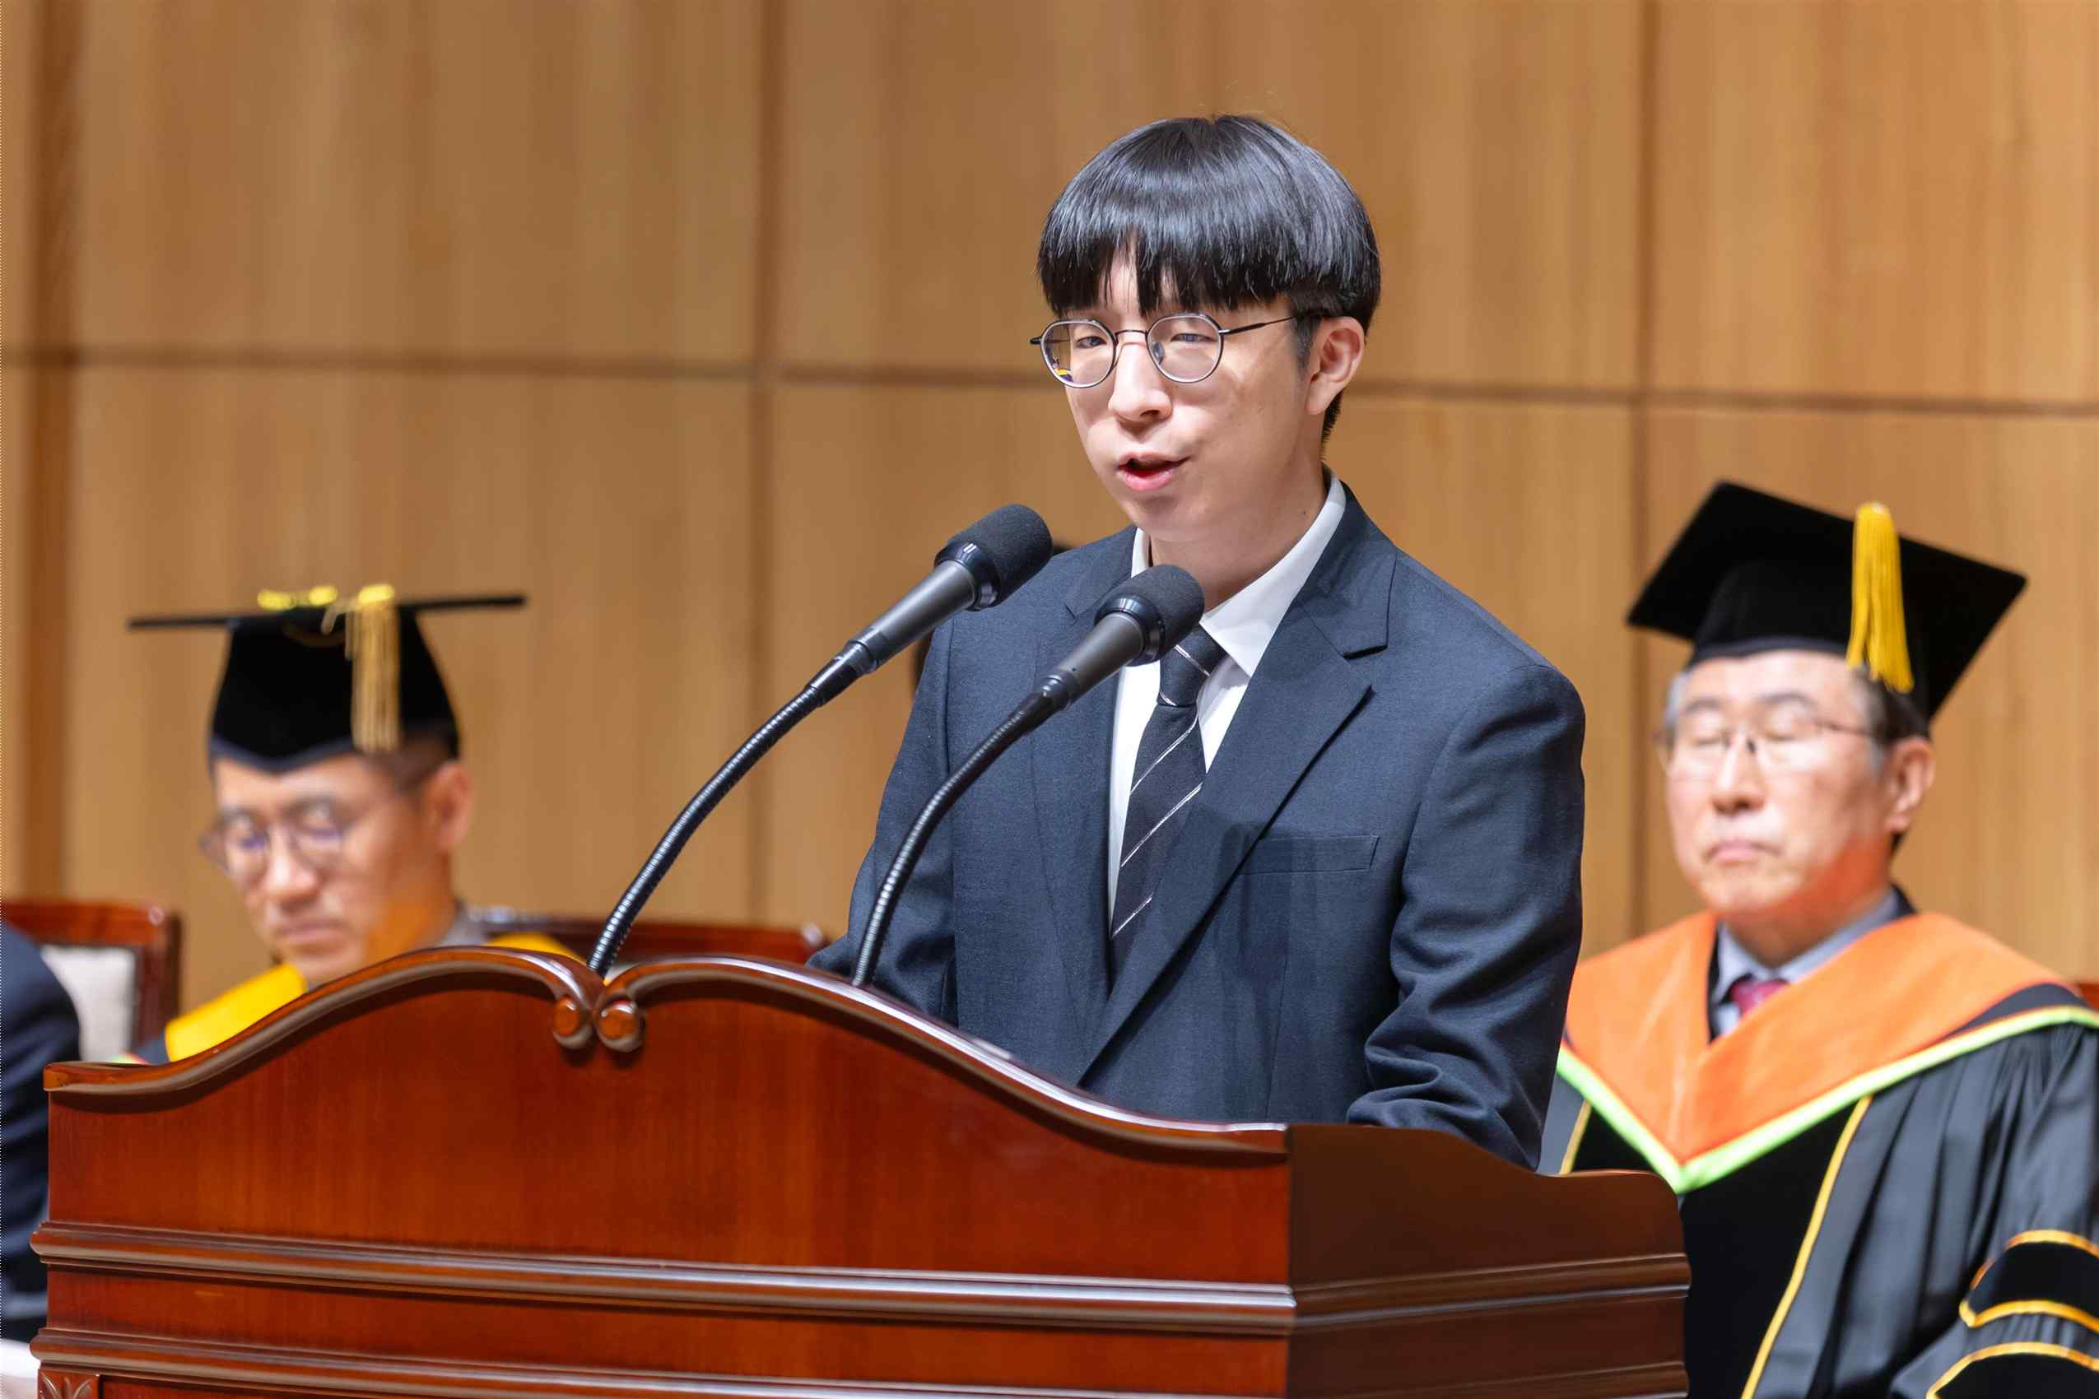

▲ Tae-gyun Lee, a graduate of the Department of Physics and Photon Science, encourages incoming freshmen at the GIST 2026 entrance ceremony.
During his time at the school, Tae-gyun Lee attracted academic attention by publishing a convergence research paper interpreting poet Yi Sang's "The Five Senses Poem No. 4" from an electromagnetic perspective. He stated, "GIST is a university where students and professors are close, allowing them to take on diverse opportunities. I hope you will not hesitate, take initiative, and fill your college years with challenges."
President Kichul Lim emphasized at the entrance ceremony, "In the era of AI transformation, the future of humanity and the nation depends on the choices and judgments of science and technology talent. Technology is merely a means, and ultimately, it is people who determine direction. Therefore, it is crucial to constantly ask, 'Why do we conduct this research?'"
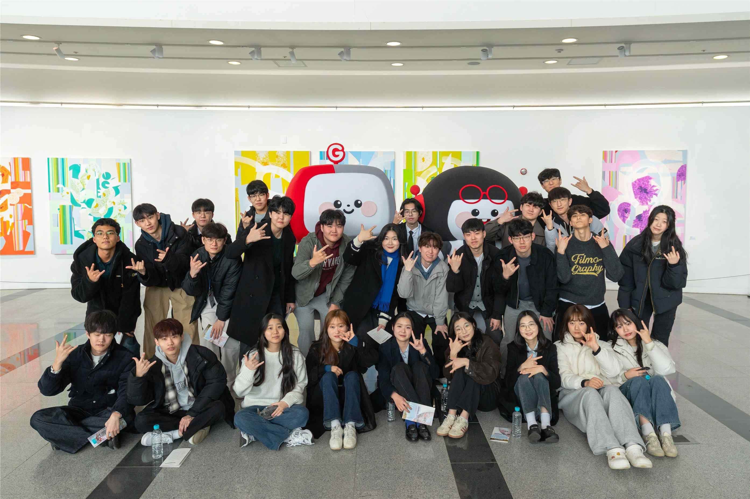

▲ Students pose for a commemorative photo at the GIST 2026 entrance ceremony.
He continued, "I hope that you will not fear failure and grow into talents who will brighten the future of humanity here, where a journey of innovation will unfold, including the establishment of the AI ​​College, the GIST-Arm School, and the AI ​​Semiconductor Research Institute."
Meanwhile, incoming undergraduate students will move into the dormitories before matriculation and participate in the "Freshman Camp" from February 19th to 27th to help them adjust to university life.
The camp consists of a variety of interactive programs, including ▴ intensive English classes, ▴ academic and living guidance, ▴ lab safety and violence prevention training, special lectures for current students, ▴ group mentoring, ▴ club introductions, and ▴ performance events. Through this program, freshmen will gain early access to academic preparation and campus activities, and will naturally interact with their peers and seniors.

