The GIST Techno Management Business Academy (GTMBA) held an inauguration ceremony for its alumni association president and a 100 million won donation ceremony for the Development Fund
- Seong-soo Ko, the 9th President of the Alumni Association, succeeds Jeong-soon Park, the 8th President... The inauguration ceremony will be held at Oryong Hall on Tuesday, the 24th
- Seong-soo Ko, CEO of Sungwon Engineering, donated 100 million won worth of his company's metal window products, selected as excellent government procurement products, to GIST... "This donation will contribute to the driving force behind the local economy and technological innovation"
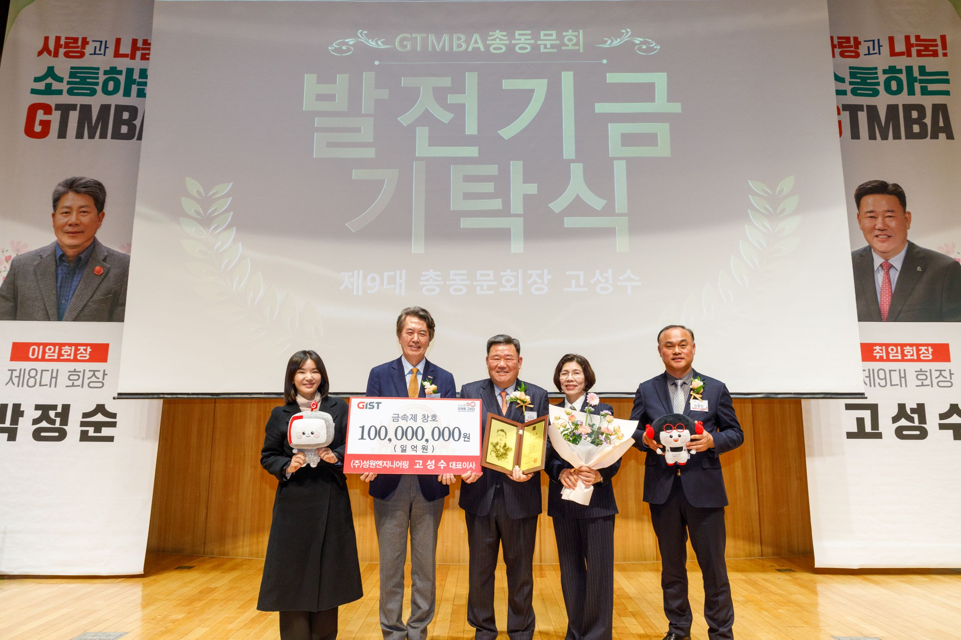

▲ The GIST Techno Management Business Academy (GTMBA) Alumni Association held a ceremony to inaugurate the 8th and 9th GTMBA Alumni Association presidents and a donation ceremony for the development fund at Oryong Hall on Tuesday, the 24th.
The Gwangju Institute of Science and Technology (GIST, President Kichul Lim) Techno Management Business Academy (GTMBA) Alumni Association (President Seong-soo Ko) announced that it held a ceremony to inaugurate the 8th and 9th GTMBA Alumni Association presidents and a donation ceremony for the development fund at Oryong Hall on Tuesday, the 24th.
Approximately 100 people attended the event, including GIST President Kichul Lim, Vice President for Public Affairs Yonghwa Chung, and executives from the Development Foundation. Seong-soo Ko, CEO of Sungwon Engineering, was elected as the 9th Alumni Association president.
Chairman Ko, who was inaugurated as the 9th President of the Alumni Association, is a professional manager who has dedicated himself to technological innovation and quality improvement in the fields of metal structures, windows, greenhouse construction, civil engineering, and water and sewage facilities since founding the company in 1995.
Based on his management philosophy of "prioritizing a world where people and nature coexist in harmony" and his vision of "creating a beautiful living environment," Chairman Ko has maintained steady growth over the past 30 years since its founding. His contributions have been recognized externally, including the Silver Tower Order of Industrial Service Merit in 2022, the Deputy Prime Minister and Minister of Strategy and Finance Award in 2021, the Governor of South Jeolla Province Award in 2022, and the Commissioner of the Public Procurement Service Award in 2023.
Furthermore, Sungwon Engineering Co., Ltd. has proven its technological prowess by being the first in the domestic window industry to pass seismic performance tests using the Kobe Earthquake Wave* and Artificial Earthquake Wave*. Based on its continuous research and development achievements, the company has been recognized for its competitiveness, including being selected as an excellent product for government procurement.
* Kobe Earthquake Wave: This seismic wave is based on actual earthquake records observed during the 1995 Southern Hyogo Prefecture Earthquake (Great Hanshin-Awaji Earthquake) in Japan. It reflects actual earthquake data and serves as a valuable reference indicator for verifying the safety and reliability of products and structural systems.
* Artificial Earthquake Wave: This seismic wave is based on actual earthquake records or artificially generated according to design standards. It can reproduce various seismic conditions and load scenarios, making it useful for evaluating the seismic performance of structures and building materials.
Chairman Ko stated, "I truly feel that leading the GTMBA Alumni Association is a position filled with great trust and expectation." He added, "I will work with the executive board to create a more robust and advanced alumni association, ensuring that the dedicated efforts of those who have dedicated themselves to the association will not be in vain."
He continued, "I will fulfill my central responsibility to ensure that the meetings and collaborations of the alumni association expand beyond one-time events into sustainable exchanges and growth."
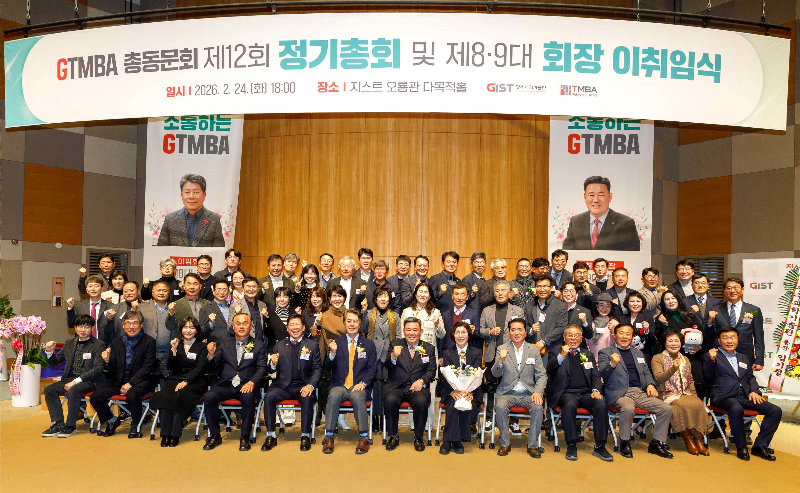

▲ The GIST Techno Management Business Academy (GTMBA) Alumni Association held an inauguration ceremony and development fund donation ceremony for the 8th and 9th GTMBA Alumni Association presidents on Tuesday, the 24th, at Oryong Hall.
At the event, Chairman Ko donated 100 million won worth of his company's metal window products an in-kind contribution to the Development Fund, fulfilling his responsibility as president and contributing to the development of his alma mater. The Development Fund donation ceremony held in conjunction with the inauguration ceremony was attended by approximately 100 people, including GTMBA alumni association executives and alumni members, who brightened the event.
Chairman Ko stated the purpose of his donation, stating, "As a member of the 10th GTMBA alumni class, I hope to contribute to the development of the school and to GIST's educational environment, which fosters future science and technology talent."
He added, "GIST's development is a driving force behind the local economy and technological innovation, and I hope this will contribute to the GIST environment, which is a crucial foundation for nurturing future talent."
President Jeong-soon Park, the 8th President of the Alumni Association, donated 100 million won to the Development Fund upon taking office in February 2025 and led the Alumni Association for a year. In her farewell address, she stated, "GTMBA's development stems from the hard work and passion of each and every alumni, and the strong bonds and cooperation among alumni have been a key foundation for GTMBA's growth."
He expressed his gratitude to the GTMBA alumni, saying, "Thanks to the alumni who quietly and responsibly worked despite their busy schedules, we were able to continue the organization's operations steadily throughout the year."
GIST operates the GTMBA (Global Techno Management Business Academy, a non-degree program launched in 2010) for executives from various fields. The 16th GTMBA entrance ceremony will be held on Tuesday, March 3rd.
GIST supports executives in various fields to understand the changing corporate environment and global management strategies through lectures by leading domestic experts. With a network of 623 alumni across 15 classes, GIST contributes to the regional economy and industry-academia cooperation.

