GIST, Gwangju Metropolitan City, and KEPCO jointly held a briefing session on the integrated future vision for Gwangju and South Jeolla Province
- GIST, Gwangju Metropolitan City, and the Korea Electric Power Corporation (KEPCO) jointly hosted a forum to share 16 key points of the Gwangju-Jeonnam Integrated Special Act on Energy Special Measures... Strategies for the power grid, RE100, hydrogen, and secondary batteries were presented
- Expanding the scope of renewable energy permits and supporting the national transmission and substation network are expected to strengthen the industrial foundation... The plan emphasized the establishment of a broad-based energy industry ecosystem based on the bill passed by the National Assembly's Legislation and Judiciary Committee
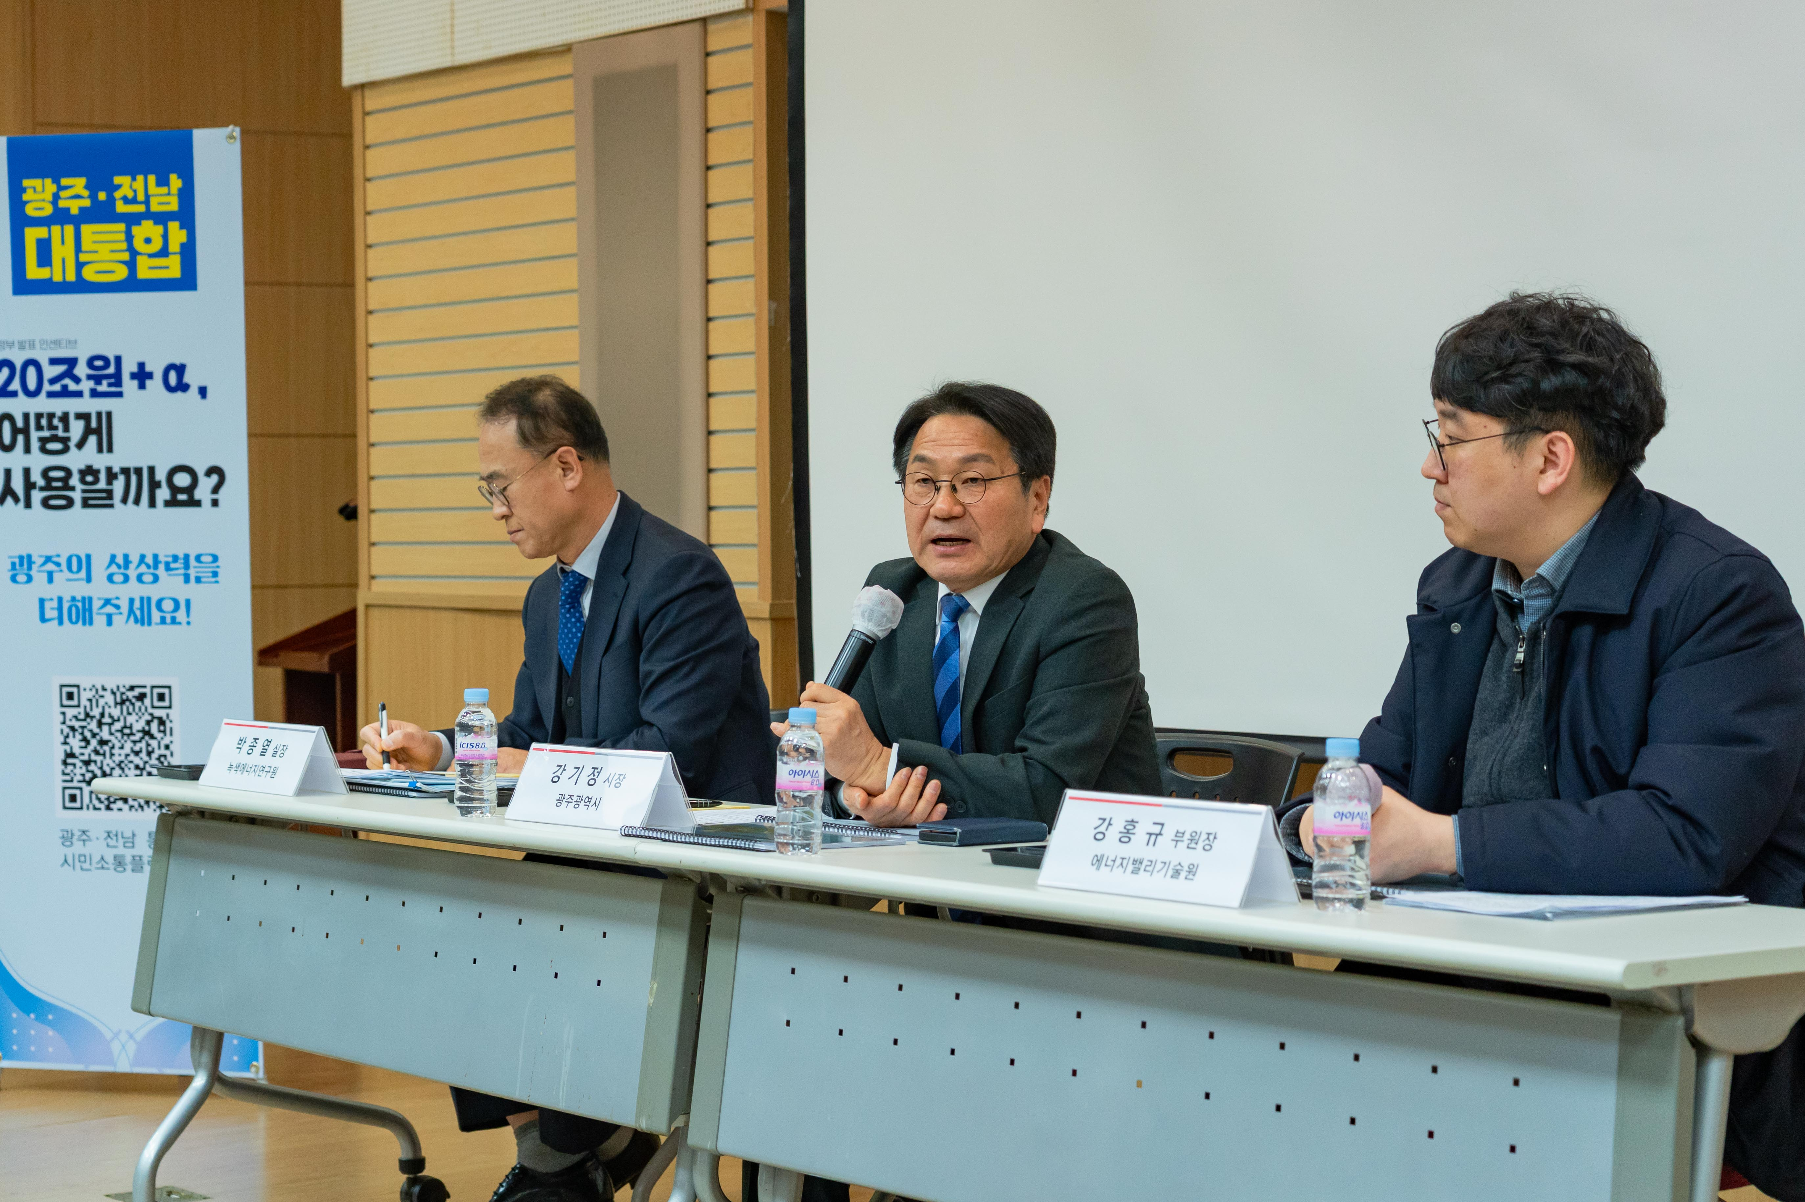

▲ The "Gwangju-Jeonnam Integrated Future Vision Briefing" is being held at GIST Oryong Hall on Tuesday, February 24th.
The Gwangju Institute of Science and Technology (GIST, President Kichul Lim) announced that it held the "Gwangju-Jeonnam Integrated Future Vision Briefing" at 3:00 PM on Tuesday, February 24th in Room 101 of Oryong Hall.
This briefing, co-hosted by GIST, Gwangju Metropolitan City, and Korea Electric Power Corporation (KEPCO) and organized by the GIST Energy Valley Institute, aimed to share the changes and future strategies that the key energy-related special provisions included in the Gwangju-Jeonnam Administrative Integration Special Act (hereinafter referred to as the "Special Act") will bring to regional industries, businesses, and the economy.
Attendees included Gwangju Mayor Ki-jung Kang, GIST Vice President for Public Affairs Yonghwa Chung, GIST Energy Valley Institute Director Kwanghee Lee and Assistant Director Hongkyu Kang, and Green Energy Institute Director Jong-yeol Park. Participants discussed policy directions and cooperation plans.
The special bill was proposed on January 30th with the goal of establishing a foundation for sustainable growth and strengthening regional competitiveness in Gwangju Metropolitan City and South Jeolla Province. After extensive discussion and consultation, it passed the National Assembly's Legislation and Judiciary Committee on February 23rd.
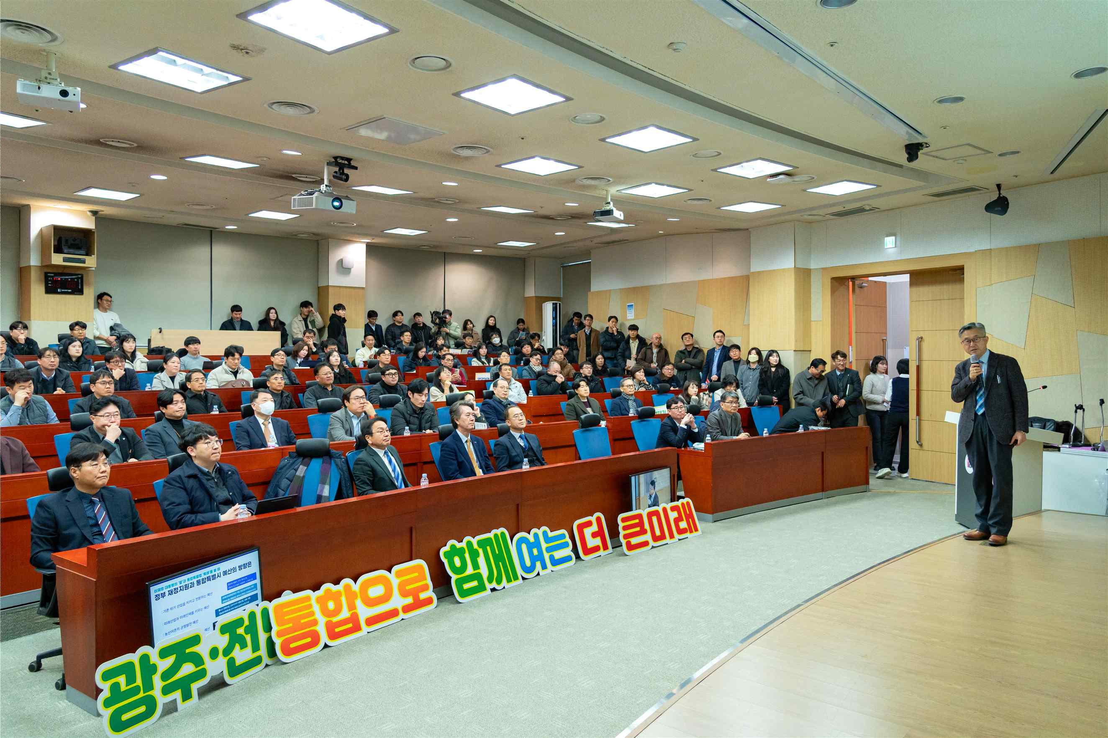

▲ On Tuesday, February 24th, the "Gwangju-Jeonnam Integrated Future Vision Briefing Session" was held at the GIST Oryong Hall.
Of the 399 special provisions in the special law, 16 fall under the energy sector, and are considered a key institutional foundation for securing ultra-wide-area energy competitiveness.
Key provisions include: ▴ Fostering and Supporting the Hydrogen Industry (Article 183); ▴ Creating Energy Self-Sufficient Cities (Article 228); ▴ Special Provisions Regarding the Electricity Business (Article 229); ▴ Special Provisions Regarding the Designation of Preliminary Zones for Offshore Wind Farms (Article 230); ▴ Special Provisions Regarding Port Designation and Development (Article 232); ▴ Fostering the Floating Solar Power Industry (Article 236); ▴ Special Provisions Regarding Support for the Construction of Power Grids to Promote Distributed Energy (Article 235); and ▴ Special Provisions Regarding the Promotion of the Secondary Battery Industry (Article 261).
The briefing session began with a presentation by GIST Energy Valley Technology Institute Director Kwanghee Lee on the progress of administrative integration and the energy industry vision, followed by a policy explanation and Q&A session.
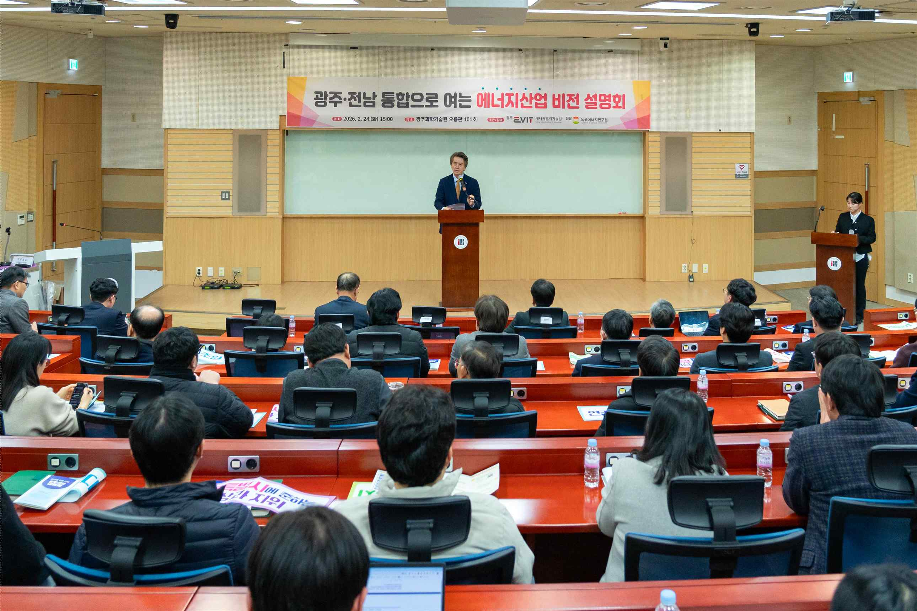

▲ On Tuesday, February 24th, the "Gwangju-Jeonnam Integrated Future Vision Briefing" was held at the GIST Oryong Hall.
Director Kwanghee Lee presented six key initiatives for the energy industry, a key pillar of the ultra-wide area's high-tech industrial ecosystem: ▴ energy transition and power grid, ▴ expansion of renewable energy, ▴ public acceptance and benefit sharing, ▴ public leadership and public finance, ▴ offshore wind power industrial belt, and ▴ fostering advanced strategic industries. He explained the industrial structural changes and future growth scenarios brought about by the special legislation.
He also presented the expected benefits of key initiatives aimed at transforming the Gwangju-Jeonnam Integrated Special City (hereinafter "Gwangju Special City") into an energy self-sufficient city, including ▴ strengthening energy authority, ▴ expanding the power grid, ▴ establishing the RE100 Industrial Complex, and ▴ fostering the hydrogen and secondary battery industries.
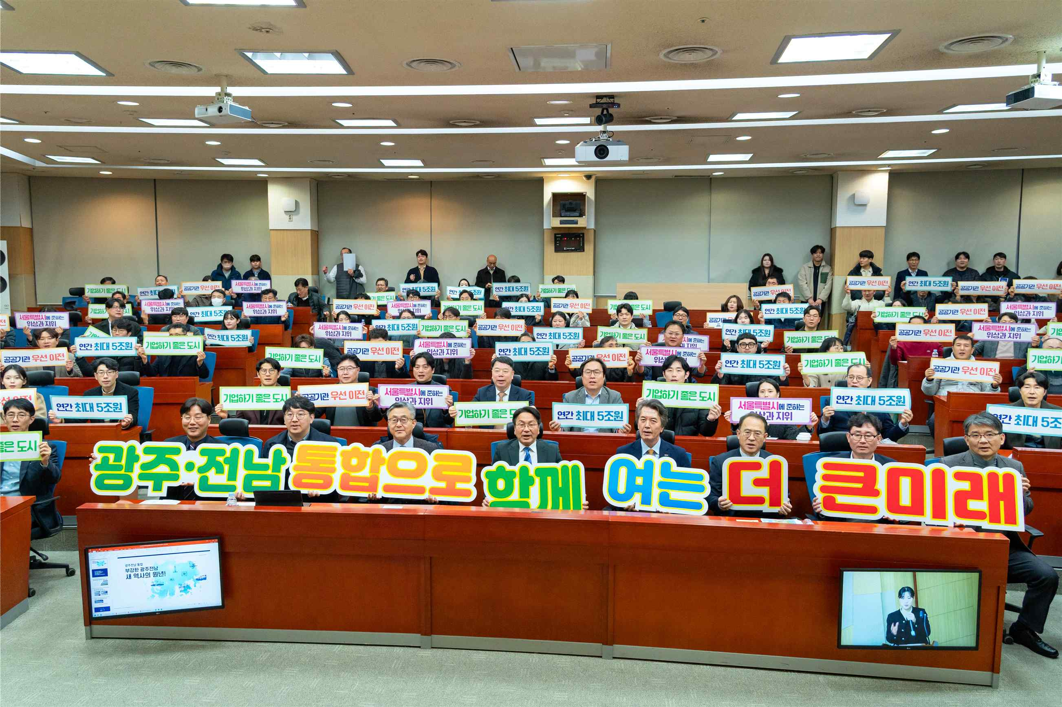

▲ On Tuesday, February 24th, the "Gwangju-Jeonnam Integrated Future Vision Briefing" was held at the GIST Oryong Hall.
This briefing was significant in that it went beyond simply discussing administrative authority adjustments and shared the institutional foundation for a fundamental restructuring of the regional energy industry.
In the renewable energy sector, in particular, the scope of solar and wind power project permits was expanded from 3MW (megawatts) to 20MW or less, broadening the scope of projects eligible for simplified procedures from small to medium-sized. Furthermore, plans for prioritizing the installation of national transmission and substation networks and providing national financial support for the expansion of renewable energy grids were presented, demonstrating the potential for strengthened energy autonomy and a stable power supply.
Furthermore, it was emphasized that the special national support for alleviating renewable energy saturation is expected to be a decisive opportunity to transform the potential of Jeonnam's offshore wind and solar energy into tangible industrial competitiveness.
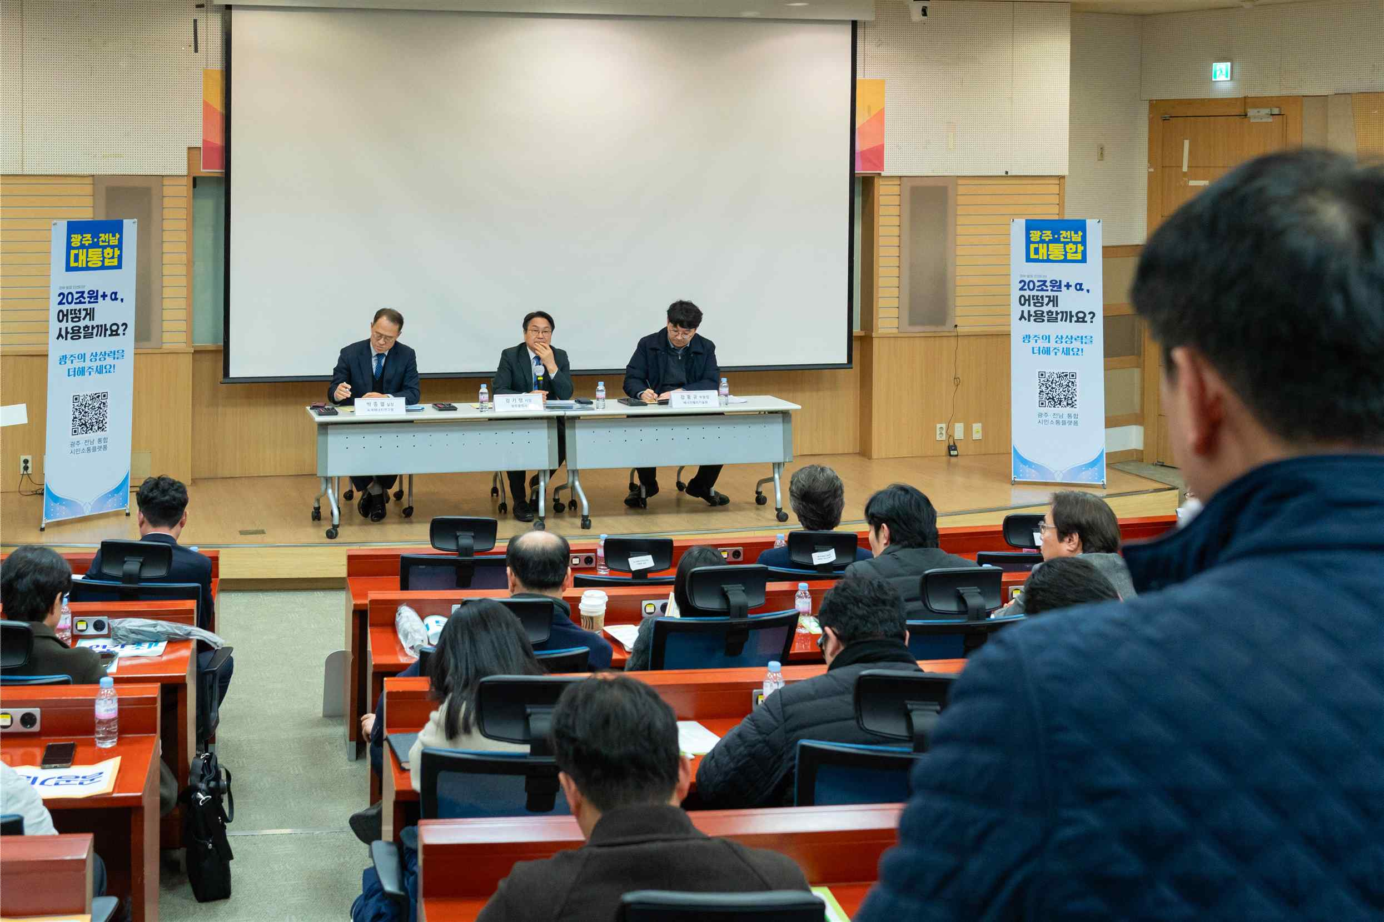

▲ On Tuesday, February 24th, the "Gwangju-Jeonnam Integrated Future Vision Briefing Session" was held at GIST Oryong Hall.
Meanwhile, the GIST Energy Valley Technology Institute is developing a phased implementation strategy for special measures to proactively respond to the administrative integration of Gwangju and Jeonnam.
Through the Hydrogen Planning Committee's operation in December 2025, the Institute published a planning report outlining hydrogen policy response strategies and implementation plans. Furthermore, the Institute plans to strengthen the foundation for leading the development of a regional energy industry ecosystem following the launch of the Gwangju Metropolitan City, including the formation of the "RE100 Industrial Complex Planning Committee" to develop an RE100 industrial complex.

