"Beyond the lab, into the world... Science and technology talents leading startups and social innovation" GIST holds 2025 commencement ceremony, producing 308 graduates leading the transition to AI civilization
- On Friday, the 20th, at 2:00 PM, a total of 308 degrees were awarded, including 70 doctorates, bringing the cumulative number of science and technology talents to 9,166... Papers were presented at the most prestigious international AI conference, highlighting research achievements that address real-world problems and meet societal needs
- Congratulatory remarks were delivered by In-gyu Park, Director of the Science and Technology Innovation Division of the Ministry of Science and ICT; GIST Chairman Woo-seung Kim; and Neurofit CTO Dong-hyun Kim... Director In-gyu Park stated, "With pride in contributing to the Republic of Korea and human society, we will boldly take on challenges at the forefront of innovation"
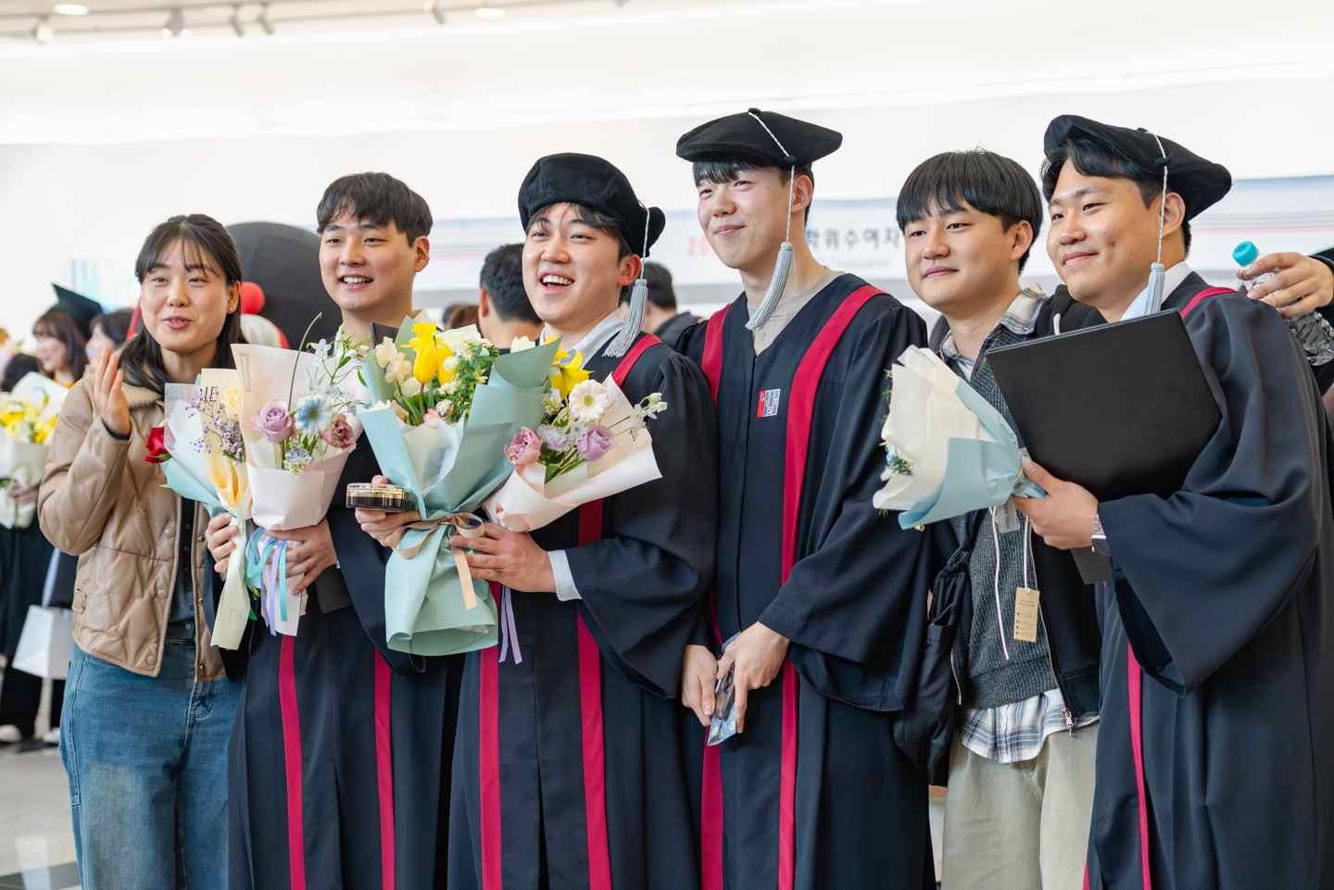
▲ Graduates and their parents pose for a commemorative photo with GIST's official mascots, Genie and Us, at the 2025 Commencement Ceremony.
The Gwangju Institute of Science and Technology (GIST, President Kichul Lim) announced that it held its 2025 Commencement Ceremony at 2:00 PM on Friday, the 20th, in the Oryong Hall auditorium.
A total of 308 students received degrees, including 70 doctorates, 130 masters, and 108 bachelor's degrees. Since its founding in 1993, GIST has produced a total of 9,166 key science and technology talents, including 2,165 doctorates, 5,401 masters, and 1,600 bachelor's degrees.
At the commencement ceremony, In-gyu Park, Director of the Science and Technology Innovation Division at the Ministry of Science and ICT; Kim Woo-seung, President of GIST; and Kim Dong-hyun, Co-CEO and CTO of Neurofit, Inc., took the stage to congratulate and encourage the graduates.
Director In-gyu Park stated, "The answer to the contemporary challenge of competing for global technological supremacy ultimately lies with each and every scientist and engineer." He urged the students, "With pride in the fact that each step you take contributes to the Republic of Korea and human society, I hope you will fully embrace the challenges of innovation at the forefront." He continued, "As you embark on a new journey into a broader world, I hope you will never forget the dreams you held when you first entered this campus, and I hope you will grow into scientists and engineers who are unafraid of failure."
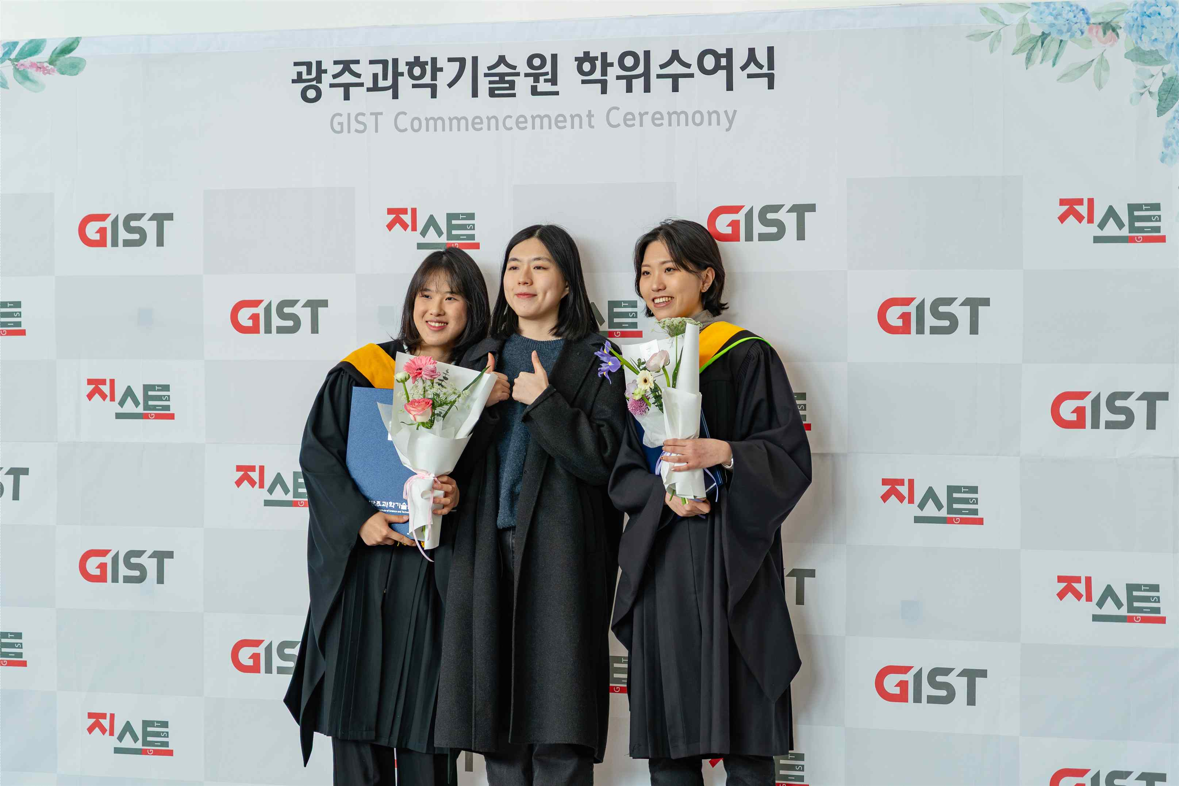

▲ GIST graduates pose for a commemorative photo at the 2025 commencement ceremony.
Chairman Woo-seung Kim emphasized, "In an era where AI provides answers, empathy and creativity, the uniquely human strengths, are crucial." He urged them to "ask 'why?' to seemingly obvious things, and cultivate the depth of your thinking with imagination and unafraid of failure." He also said, "A good life depends not on qualifications, but on the 'story' you write yourself." He added, "I hope you will realize your dreams and use the time you have given to create your own meaningful life narratives."
GIST's Dong-hyun Kim, an entrepreneur and a graduate of the Department of Electrical Engineering and Computer Science, co-founded Neurofit Inc. in 2016, which develops AI-based brain imaging analysis and treatment planning support technology. Following its KOSDAQ listing last year, he rapidly grew the company and established it as a leading AI healthcare company in Korea. Reflecting on his entrepreneurial journey, he shared the realization that "anxiety in the face of challenges is not fear, but a sign of growth." He then encouraged the graduates, saying, "I hope you will cherish the connections you made at GIST, both as colleagues and as alumni, and become a source of strength for one another in society."
The 70 PhD recipients published a total of 341 papers in SCI (Science Citation Index)-indexed journals during their studies, averaging 4.5 papers per student.

▲ GIST graduates pose for a commemorative photo at the 2025 commencement ceremony.
GIST, which established the Graduate School of AI (now the Department of AI Convergence) in 2019 and the Graduate School of AI Policy and Strategy last year, is accelerating its efforts to cultivate talent who will lead future AI governance. The contributions of AI talent have also been noteworthy.
Dr. Young-jae Park (Department of AI Convergence), who received the Minister of Science and ICT Award that day, has garnered international attention from the academic community for his research on AI algorithms aimed at solving social problems. He has published a total of nine papers at world-class AI conferences and international journals, and has been selected for outstanding papers and oral presentations at international conferences for his research on applying AI to real-world problems such as climate change response. He also applied for and registered four patents related to AI-based risk detection and anomaly detection technologies, demonstrating the potential for practical application of his research findings. In recognition of his research capabilities, he was appointed a professor in the Department of Information Convergence at Kwangwoon University upon graduation, where he plans to continue teaching and research in the field of applied AI research.
GIST also received numerous awards reflecting its human-centered educational philosophy, which encourages students to contribute their talents and engage in social contribution activities.
Jun-ho Kim, a graduate of the Department of Electrical Engineering and Computer Science, served as the team leader of the World Friends Korea IT Volunteer Group in Laos, hosted by the National Intelligence Service (NIA). He led IT education for local students and the establishment of a database of beneficiary organizations. His work earned him second place in the Outstanding Activities category and was featured on local broadcasts. He was also recognized for his contributions to sharing science with the local community, serving as the general mentor for GIST's social contribution group, "Pium," and participating in educational volunteer activities at the Gwangju National Science Museum. He stated, "I believe that science and technology are truly complete when they transcend performance and lead to value. Let's become researchers who grow together with society and share that value."
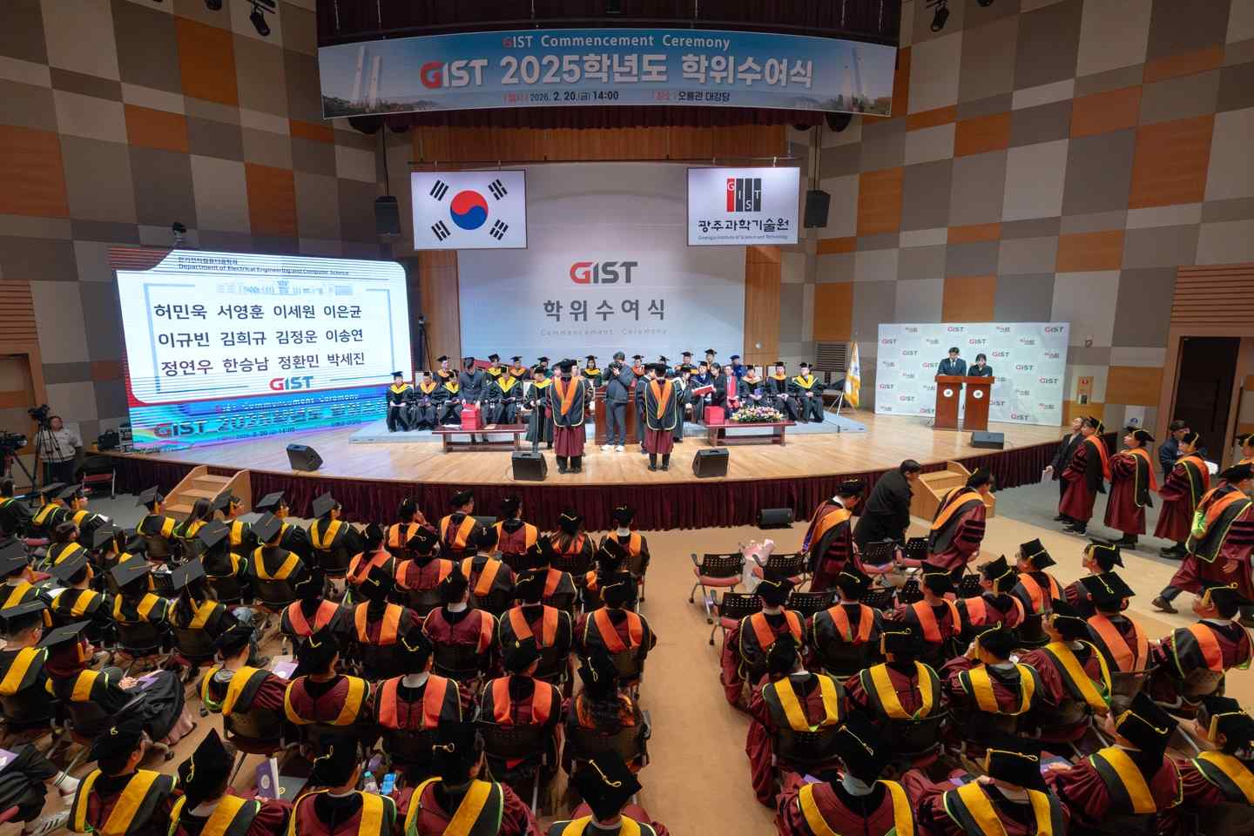

▲ GIST held the 2025 Commencement Ceremony in the Oryong Hall Auditorium at 2:00 PM on Friday, the 20th.
GIST's educational philosophy of encouraging students to engage in entrepreneurship and social problem-solving is also leading to the discovery of future talent.
Jaehee Lee, a graduate of the Department of Electrical Engineering and Computer Science, developed her sharing and communication skills through her work as a peer counselor at a counseling center, a mentor for the social contribution group "Pium," and a support program for international freshmen. Building on these experiences, she won awards at AI-based social problem-solving competitions and Makerthons. She also participated as a founding member of the donation platform "Angel Search Group," where she applied for a recommendation system patent. She was also selected as a Presidential Science Scholar, receiving the Future Talent Award in recognition of her academic, research, and entrepreneurial achievements. "I learned that technology is most meaningful when it's geared toward people," she said. "I want to continue learning in a way that benefits society."
□ The GIST Development Foundation Chairman's Award, first presented at the commencement ceremony in February of last year, was presented at this year's ceremony for the third time, following the one in August of last year. It was presented to Dr. Ho-taek Joo of the Department of AI Convergence.
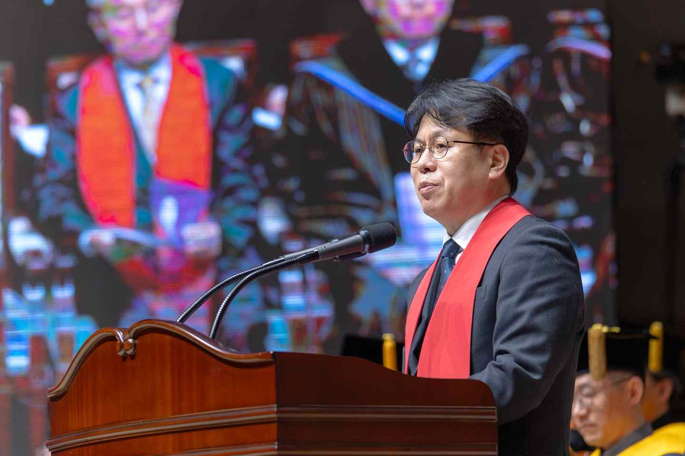
▲ Director In-gyu Park of the Science, Technology, and Innovation Division of the Ministry of Science and ICT delivers a congratulatory address at the GIST 2025 commencement ceremony.
Dr. Joo systematically developed his entrepreneurial capabilities by participating as a leader in various programs at the GIST Entrepreneurship Promotion Center. Building on this experience, he has achieved significant results in implementing deep-tech-based technologies, including the planning of an AI video conversion service and the development of an automated AI filming system for eSports broadcasting. Furthermore, he has been selected for eight government and major institutional startup support projects starting in 2023, securing approximately 300 million won in commercialization funding, demonstrating the potential for technology commercialization. He stated, "Entrepreneurship is a process of continuous challenge and learning. I hope to leverage my experience to explore new possibilities and continue technology-based innovation."
President Kichul Lim addressed the graduates, stating, "The world has entered a period of civilizational transformation centered on AI." He emphasized, "Today's competition is shifting to a question of who will build technology, talent, and innovation systems, and how." He added, "Amidst this shift, the selection and role of science and technology talent is becoming a crucial factor, not only influencing individual career paths, but also influencing the direction of society as a whole."
President Lim continued, "Even in the age of AI, the center must always be human." He added, "Technology is a means, not an end. I hope you will constantly question how science and technology can benefit people, and never lose the attitude of taking responsibility for your own choices."
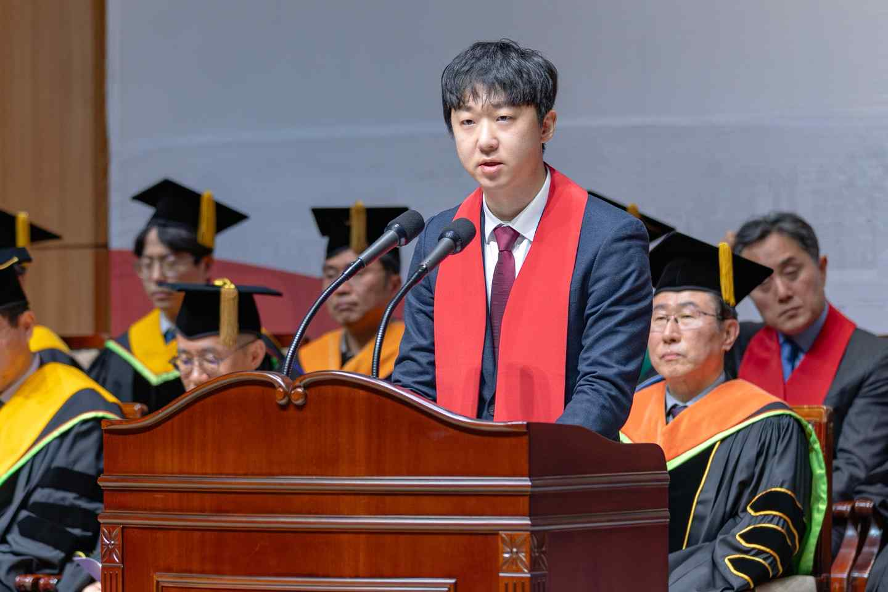
▲ Neurofit CEO Dong-hyun Kim delivers a congratulatory address at the GIST 20205 Commencement Ceremony.
Meanwhile, GIST is actively pursuing an innovation strategy encompassing education, research, and entrepreneurship, in line with President Kichul Lim's emphasis on "the role of universities in the AI ​​transition." Through a reorganization of the undergraduate system, GIST has strengthened its foundation for interdisciplinary convergence and collaborative research. It is also pursuing campus innovation that integrates research capabilities from basic science to cutting-edge technology.
Additionally, following the establishment of the Department of AI Convergence and the Graduate School of Al Policy and Strategy, preparations are underway to open an affiliated AI Gifted High School, thereby building a comprehensive AI talent development system. Furthermore, through the establishment of GIST Holdings and the opening of the Graduate School of Technology Management, efforts are accelerating to foster an ecosystem where research outcomes lead to entrepreneurship and industrial applications.

