GIST's RISE Project-linked "AI Science Camp" successfully held: 319 elementary school students in Gwangju participated... expanding access to science and technology education
- Promoting community-linked education programs based on the Ministry of Education's "Regional Innovation-Oriented University Support System (RISE)" project... Thematic science camps will be held from October 2025 to February 2026
- Establishing a foundation for fostering future talent through experiential education integrating AI, supercomputing, and the environment... "As a university that grows alongside the local community, we will continue to expand diverse educational and experiential opportunities for future generations"
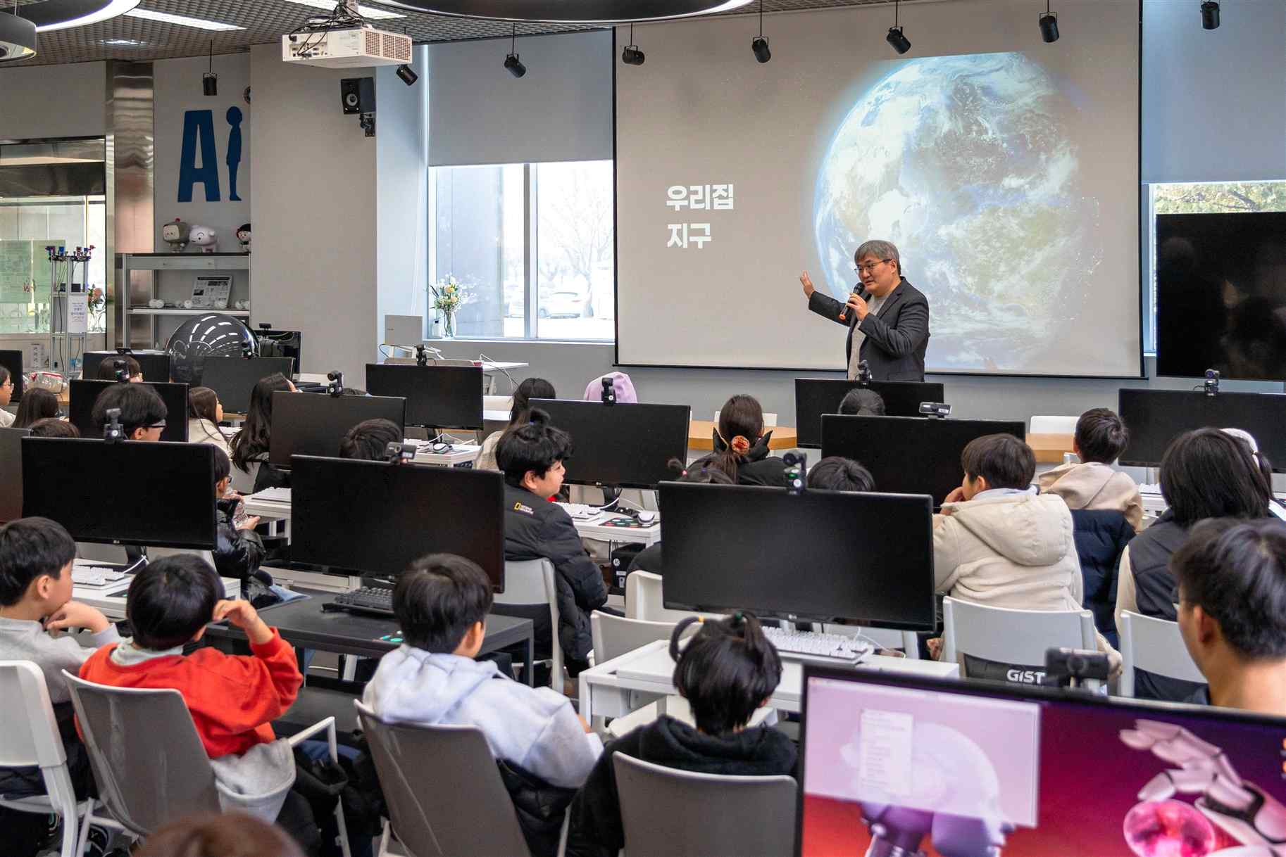

▲ Professor Jin-Ho Yoon of the Department of Environment and Energy Engineering is teaching at "Meet the Changing Face of the Earth through S.O.S."
The Gwangju Institute of Science and Technology (GIST, President Kichul Lim) announced that the GIST RISE Project Group (Director Inchan Kwon), part of the Ministry of Education's "Regional Innovation-Oriented University Support System (RISE)" project, successfully held the "AI Science Camp" for elementary school students in Gwangju Metropolitan City from October 2025 to this month.
The "AI Science Camp" is a program operated through the "Neulbom Think Tank University" project, one of six subprojects being implemented by the GIST RISE Project Group. It is designed to help elementary school students easily and enjoyably learn about AI, develop scientific thinking skills, and grow into future science and technology talent.
This ‘AI Science Camp’ was comprised of “AI Science Camp: Meet the Supercomputer!” held in October and November 2025 and “AI Science Camp: Meet the Changing Face of the Earth through S.O.S.” held in January and February 2026, with a total of 319 elementary school students participating.
The "AI Science Camp: Meet the Changing Face of the Earth through S.O.S.," held seven times from January to February 2026, attracted a significant amount of interest, with a total of 240 participants, including elementary school students from local children's centers in Gwangju and individual applicants.
"AI Science Camp: Meet the Changing Face of the Earth through S.O.S." consisted of experiential classes that integrated AI, supercomputing, and environmental issues. Key programs included: ▴ "Model Zoo & Playground," which uses a zoo metaphor to understand the concept of AI models; ▴ "Computer Stories: Changing the World in a Tick-Tock Tick-Tock," which explores the role and application of supercomputers; and ▴ "Save the Earth!", which involved experiencing global warming and climate change through the environmental simulation "SPEAR."
Notably, the camp presented complex AI technologies and environmental data in an engaging and accessible way, designed to help elementary school students understand the connections between science and technology and environmental issues.
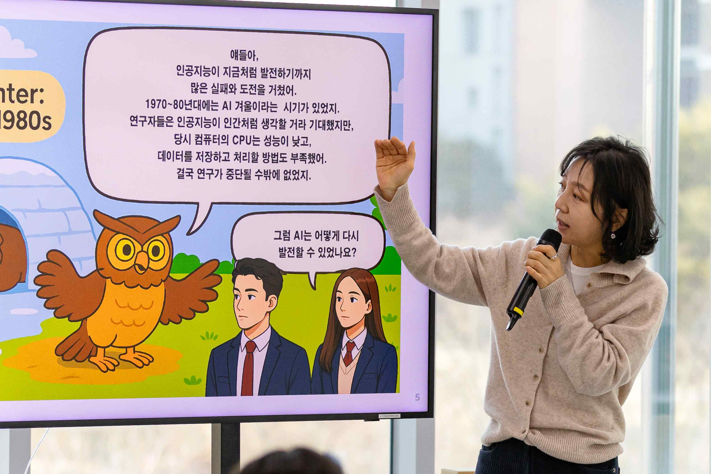

▲ Professor Huisu Kim of the Department of AI Convergence is teaching at "AI Science Camp: Meet the Changing Face of the Earth through S.O.S."
The instructors, including Professor Jin-Ho Yoon of the Department of Environment and Energy Engineering at GIST, Professor Huisu Kim of the Department of AI Convergence, and researchers Hyu-jun Kim and Eun-ho Yoo of the Supercomputing Center, enhanced the quality of the training based on their expertise.
Prior to this, 79 elementary school students and children from local children's centers in Gwangju participated in the "AI Science Camp: Meet the Supercomputer!" program, which ran from October to November 2025.
"AI Science Camp: Meet the Supercomputer!" included theoretical classes covering the basic concepts of AI and supercomputers, as well as hands-on activities such as ▴ creating science kits with mentors, ▴ experiences with "AI Composer Lee Bom," ▴ practical training with Amazon Web Services (AWS) autonomous minicars, and ▴ AI and drone demonstrations. The program received a great response.
GIST RISE Project Group Director Inchan Kwon said, “The GIST AI Science Camp is a program designed to help children understand AI and supercomputing technology naturally by connecting them to real-life topics such as environmental issues, rather than finding them difficult.” He added, “As a university that grows together with the local community, GIST will continue to expand various educational and experiential opportunities so that future generations can understand and lead changes in the world through science and technology.”

