GIST and Arm Sign MOU to cultivate global AI semiconductor design talent
- On Wednesday, the 11th, the GIST Administration Building will host the "GIST-Arm School," a program focused on fostering hands-on talent in the fabless semiconductor industry... The "GIST-Arm School" will begin operations in earnest, establishing a model for global semiconductor design education cooperation
- President Kichul Lim: "A semiconductor research and demonstration will serve as a key foundation for the expanding southern semiconductor cluster"
- Sun-wook Hwang, President of Arm Korea: "We anticipate a substantial contribution to fostering global semiconductor design talent"
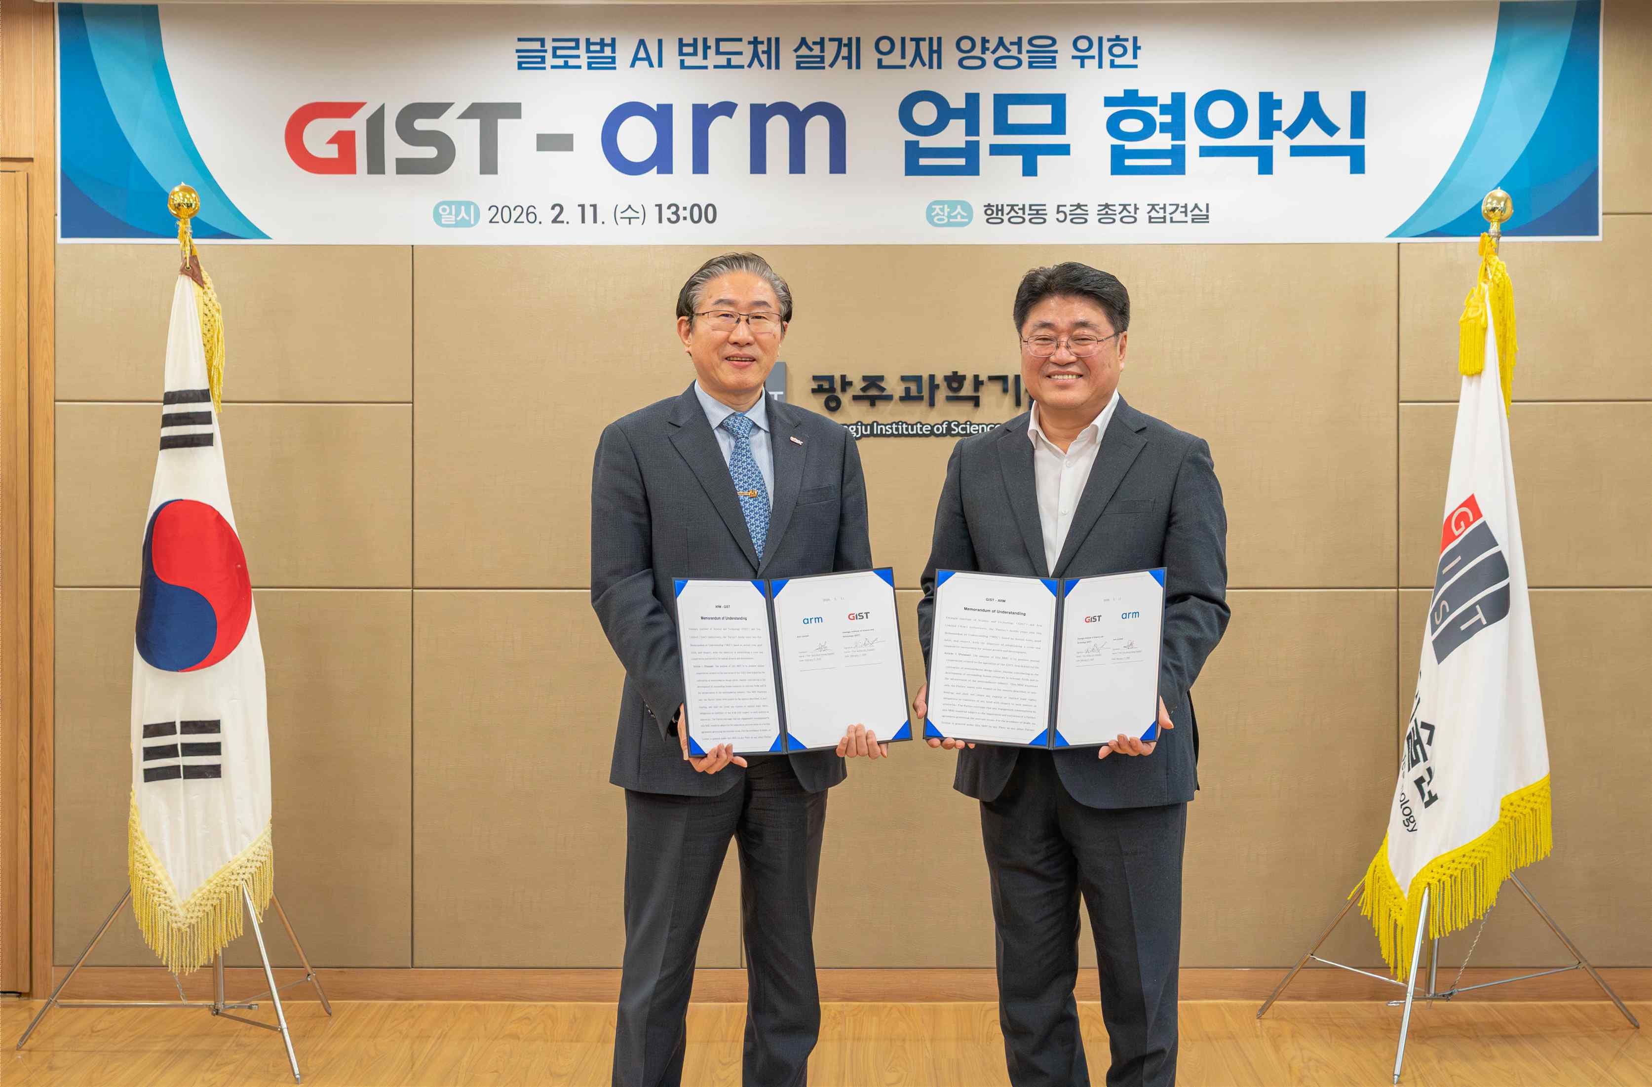

▲ (From left) GIST President Kichul Lim and Arm Korea President Sun-wook Hwang pose for a commemorative photo after signing a business agreement to foster global AI semiconductor design talent.
On Wednesday, February 11, the Gwangju Institute of Science and Technology (GIST, President Kichul Lim) signed a Memorandum of Understanding (MOU) with Arm Limited (hereinafter referred to as Arm), a global leader in compute platform IP, in the GIST Administration Building to foster AI semiconductor design talent and strengthen cooperation in semiconductor education.
This agreement is significant in that it represents an example of international collaboration, linking GIST's research and education capabilities with Arm's world-class semiconductor technology, education, and research assets. The "GIST-Arm School" serves as an educational collaboration model for systematically fostering key talent with semiconductor design capabilities.
GIST and Arm will jointly plan an Arm IP-based design curriculum (Arm Academic Program) centered around the "GIST-Arm School" and provide educational content and learning materials. Arm's differentiated portfolio of educational and research materials is expected to further strengthen industry connectivity across GIST's semiconductor design education ecosystem and infrastructure.
Furthermore, the two plan to explore various collaborative opportunities to support the development of talent required in the industrial field through project-based learning, industry-academia collaboration, and competency assessments tailored to industry needs.
The signing ceremony was attended by GIST President Kichul Lim, Vice President for Academic Affairs Sungho Jeong, Vice President for R&DB Yong-Chul Kim, Professor Minjae Lee, Arm Korea President Sun-wook Hwang, Managing Director Young-seok Kim, and General Manager Min-ki Kim, as well as representatives from both sides.
The key contents of the agreement include: ▴ joint planning and collaboration for the development of the "GIST–Arm School" curriculum and establishment of educational infrastructure; ▴ utilization of educational and research content and materials based on the Arm Academic Program; and ▴ collaboration in the design and operation of industry-research projects and industry-academia collaboration programs.
GIST will establish completion criteria for the "GIST–Arm School" in conjunction with its undergraduate, master's, and doctoral programs. Following consultation and review by Arm, the two companies will discuss ways to certify educational achievements and formally recognize completion. This will ensure that the educational outcomes are directly translated into applicable capabilities in the industrial field.
Arm will support the operation of the 'GIST–Arm School' by utilizing educational and research resources, such as educational content, learning materials, IP, and software from the Arm Academic Access program, within the scope of the Arm Academic Program.
Both companies plan to promote external collaboration and dissemination of results by jointly leveraging the GIST and Arm brands, and share educational and research outcomes domestically and internationally, thereby developing the 'GIST–Arm School' into a leading global semiconductor education collaboration model.
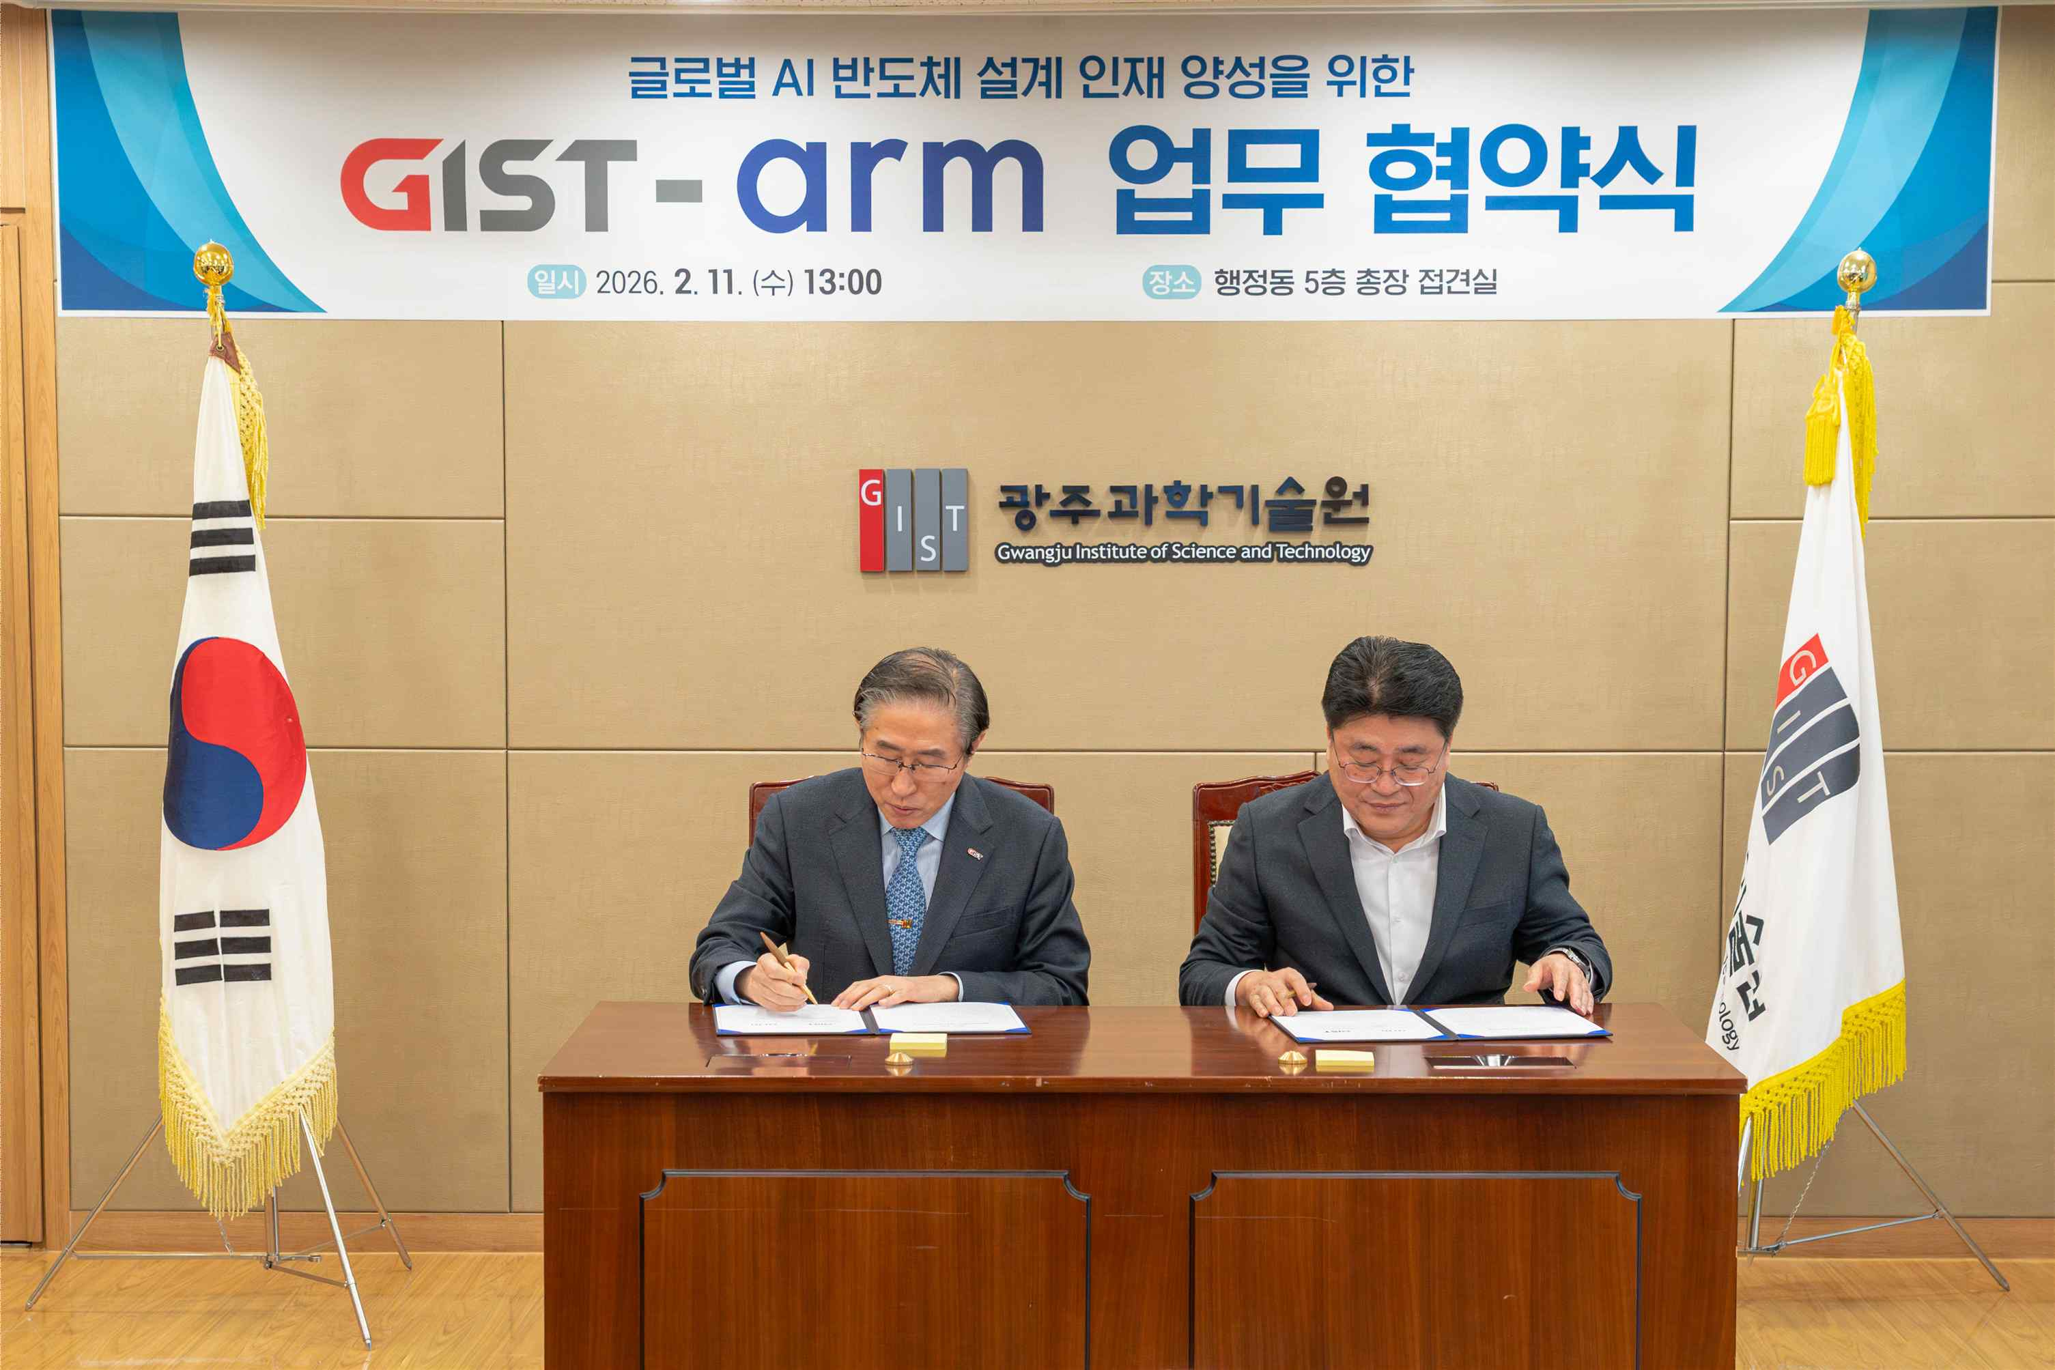

▲ (From left) GIST President Lim Ki-cheol and Arm Korea President Hwang Sun-wook sign a business agreement in the GIST administration building to foster AI semiconductor design experts and strengthen cooperation in semiconductor education.
GIST President Kichul Lim stated, "This agreement marks a significant milestone in establishing a world-class strategy for fostering advanced semiconductor talent in the era of AI transformation." He added, "The 'GIST-Arm School' will serve as a core foundation for the southern region's semiconductor cluster, starting with design-focused education and expanding into AI semiconductor research and demonstration."
Arm Korea President Sun-wook Hwang stated, "We are honored to collaborate with GIST to build an educational environment where next-generation semiconductor design talent can thrive within the Arm ecosystem. We hope this agreement will make a tangible contribution to fostering semiconductor talent globally, including in Korea."
This agreement is significant in that it establishes a model for international cooperation, building a design-focused education system based on world-standard semiconductor IP computing technology in collaboration with domestic research-oriented universities. It also proactively establishes a talent pipeline for the southern semiconductor cluster.
In particular, the "GIST-Arm School" is expected to serve as a hub for cultivating field-ready talent ready for immediate deployment in the fabless and AI semiconductor industries through systematic education linked to GIST's undergraduate, master's, and doctoral programs.
Furthermore, it is expected to contribute to the development of the southern semiconductor cluster into a self-sufficient ecosystem with global competitiveness centered on AI and system semiconductor design and talent development.

